Laplace Transform
The Laplace transform is an integral transform perhaps second only to the Fourier transform in its utility in solving physical problems. The Laplace transform is particularly useful in solving linearordinary differential equations such as those arising in the analysis of electronic circuits.
The (unilateral) Laplace transform (not to be confused with the Lie derivative, also commonly denoted ) is defined by
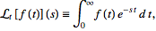 | (1)
where is defined for (Abramowitz and Stegun 1972). The unilateral Laplace transform is almost always what is meant by "the" Laplace transform, although a bilateral Laplace transformm is sometimes also defined as
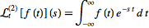 | (2)
(Oppenheim et al. 1997). The unilateral Laplace transform is implemented in Mathematica asLaplaceTransform[f[t], t, s].
The inverse Laplace transform is known as the Bromwich integral, sometimes known as the Fourier-Mellin integral (see also the related Duhamel's convolution principle).
A table of several important one-sided Laplace transforms is given below.
conditionss
1
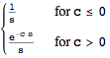
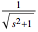
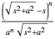
In the above table, is the zeroth-order Bessel function of the first kind, is the delta function, and is the Heaviside step function.
The Laplace transform has many important properties. The Laplacetransform existence theorem states that, if is piecewise continuous on every finite interval in satisfying
(3)
for all , then exists for all . The Laplacetransform is also unique, in the sense that, given two functions and with the same transform so that
(4)
then Lerch's theorem guarantees that the integral
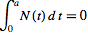 | (5)
vanishes for all for a null function defined by
(6)
The Laplace transform is linear since
 |  | 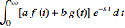 | (7)
 |  | 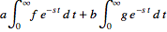 | (8)
 |  |  | (9)
The Laplace transform of a convolution is given by
(10)
(11)
Now consider differentiation. Let be continuously differentiable times in . If , then
(12)
This can be proved by integration by parts,
 |  | 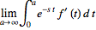 | (13)
 |  | 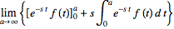 | (14)
 |  |  | (15)
 |  | 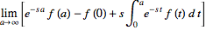 | (16)
 |  |  | (17)
 |  |  | (18)
Continuing for higher-order derivatives then gives
(19)
This property can be used to transform differential equations into algebraic equations, a procedure known as the Heaviside calculus, which can then be inverse transformed to obtain the solution. For example, applying the Laplace transform to the equation
(20)
gives
(21)
(22)
which can be rearranged to
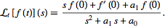 | (23)
If this equation can be inverse Laplace transformed, then the original differential equation is solved.
The Laplace transform satisfied a number of useful properties. Consider exponentiation. If for (i.e., is the Laplace transform of ), then for . This follows from
 |  | 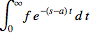 | (24)
 |  | 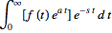 | (25)
 |  |  | (26)
The Laplace transform also has nice properties when applied to integrals of functions. If is piecewise continuous and , then
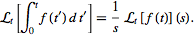

Z TRANSFORM
The (unilateral) -transform of a sequence is defined as
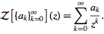 | (1)
This definition is implemented in Mathematica as ZTransform[a,n, z]. Similarly, the inverse -transform is implemented asInverseZTransform[A, z, n].
"The" -transform generally refers to the unilateral Z-transform. Unfortunately, there are a number of other conventions. Bracewell (1999) uses the term "-transform" (with a lower case) to refer to the unilateral -transform. Girling (1987, p. 425) defines the transform in terms of samples of a continuousfunction. Worse yet, some authors define the -transform as the bilateral Z-transform.
In general, the inverse -transform of a sequence is not unique unless its region of convergence is specified (Zwillinger 1996, p. 545). If the -transform of a function is known analytically,the inverse -transform can be computed using the contour integral
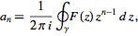 | (2)
where is a closed contour surrounding the origin of the complex plane in the domain of analyticity of (Zwillinger 1996, p. 545)
The unilateral transform is important in many applications because the generating function of a sequence of numbers is given precisely by , the -transformof in the variable (Germundsson 2000). In other words,the inverse -transform of a function gives precisely the sequence of terms in the series expansion of . So, for example, the terms of the series of are given by
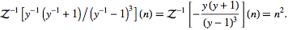 | (3)
Girling (1987) defines a variant of the unilateral -transformthat operates on a continuous function sampled at regular intervals ,
(4)
where is the Laplace transformm,
 |  |  | (5)
 |  | 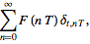 | (6)
the one-sided shah function with period is given by
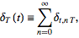 | (7)
and is the Kronecker delta, giving
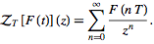 | (8)
An alternative equivalent definition is
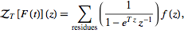 | (9)
where
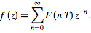 | (10)
This definition is essentially equivalent to the usual one by taking.
The following table summarizes the -transforms for some common functions (Girling 1987, pp. 426-427; Bracewell 1999). Here, is the Kronecker delta, is the Heaviside step function, and is the polylogarithm.
1
1
The -transform of the general power function can be computed analytically as
 |  | 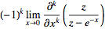 | (11)
 |  | 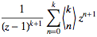 | (12)
 |  | 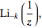 | (13)
where the are Eulerian numbers and is a polylogarithm. Amazingly, the -transforms of are therefore generators for Euler's number triangle.
The -transform satisfies a number of important properties, including linearity
(14)
translation
 |  |  | (15)
 |  |  | (16)
 |  |  | (17)
 |  | 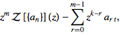 | (18)
scaling
(19)
and multiplication by powers of
 |  | 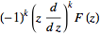 | (20)
 |  | 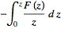 | (21)
(Girling 1987, p. 425; Zwillinger 1996, p. 544).
The discrete Fourier transform is a special case of the -transform with
(22)
and a -transform with
(23)
for is called a fractional Fourier transform.

