GATE Material for Instrumentation Engineering
Engineering Mathematics
- Linear Algebra
- Calculus
- Complex Analysis
- Vector Calculus
- Differential Equations
- Probability - I
- Probability (continued)
- Numerical Methods
(above topics are successfully completed in mathematics part)
TRANSFORM THEORY
- Fourier Transform
- Laplace Transform
- Z-Transform
Fourier Transform:
The Fourier transform is a generalization of the complex Fourier series in the limitas . Replace the discrete with the continuous while letting . Then change the sum to an integral, and the equations become
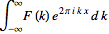
(1)
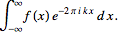
(2)
Here,
(3)
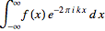
(4)
is called the forward () Fourier transform, and
(5)
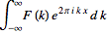
(6)
is called the inverse () Fourier transform. The notation is introduced in Trott (2004, p. xxxiv), and and are sometimes also used to denote the Fourier transform and inverse Fourier transform, respectively (Krantz 1999, p. 202).
Note that some authors (especially physicists) prefer to write the transform in terms of angular frequency instead of the oscillation frequency . However, this destroys the symmetry, resulting in the transform pair
(7)
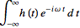
(8)
(9)
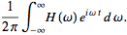
(10)
To restore the symmetry of the transforms, the convention
(11)
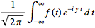
(12)
(13)
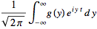
(14)
is sometimes used (Mathews and Walker 1970, p. 102).
In general, the Fourier transform pair may be defined using two arbitrary constants and as
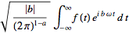
(15)
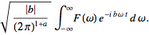
(16)
The Fourier transform of a function is implemented asFourierTransform[f, x, k], and different choices of and can be used by passing the optional FourierParameters-> a, b option. By default, Mathematicatakes FourierParameters as . Unfortunately, a number of other conventions are in widespread use. For example, is used in modern physics, is used in pure mathematics and systems engineering, is used in probability theory for the computation of the characteristic function, is used in classical physics, and is used in signal processing. In this work, following Bracewell (1999, pp. 6-7), it is always assumed that and unless otherwise stated. This choice often results in greatly simplified transforms of common functions such as 1, , etc.
Since any function can be split up into even and odd portions and ,
(17)
(18)
a Fourier transform can always be expressed in terms of the Fourier cosinetransform and Fourier sine transform as
(19)
A function has a forward and inverse Fourier transform such that
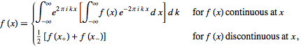
(20)
provided that
1. exists.
2. There are a finite number of discontinuities.
3. The function has bounded variation. A sufficient weaker condition is fulfillment of the Lipschitz condition
(Ramirez 1985, p. 29). The smoother a function (i.e., the larger the number ofcontinuous derivatives), the more compact its Fourier transform.
The Fourier transform is linear, since if and have Fourier transforms and , then
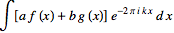 |  | 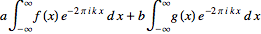 | (21)
 |  |  | (22)
Therefore,
(23)
(24)
The Fourier transform is also symmetric since implies.
Let denote the convolution, then the transforms of convolutions of functions have particularly nice transforms,
(25)
(26)
(27)
(28)
The first of these is derived as follows:
 |  | 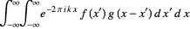 | (29)
 |  | 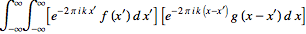 | (30)
 |  | 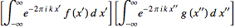 | (31)
 |  |  | (32)
where .
There is also a somewhat surprising and extremely important relationship between the autocorrelation and the Fourier transform known as the Wiener-Khinchin theorem. Let , and denote the complex conjugate of , then the Fourier transform of the absolute square of is given by
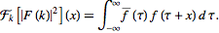 | (33)
The Fourier transform of a derivative of a function is simply related to the transform of the function itself. Consider
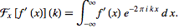 | (34)
Now use integration by parts
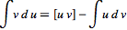 | (35)
with
(36)
(37)
and
(38)
(39)
then
(40)
The first term consists of an oscillating function times . But if the function is bounded so that
(41)
(as any physically significant signal must be), then the term vanishes, leaving
 |  | 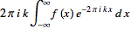 | (42)
 |  |  | (43)
This process can be iterated for the th derivative to yield
(44)
The important modulation theorem of Fourier transforms allows to be expressed in terms of as follows,
 |  | 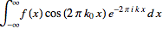 | (45)
 |  |  | (46)
 |  | 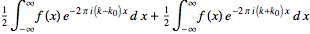 | (47)
 |  |  | (48)
Since the derivative of the Fourier transform is given by
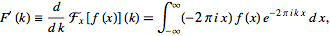 | (49)
it follows that
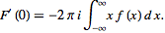 | (50)
Iterating gives the general formula
 |  | 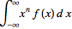 | (51)
 |  |  | (52)

