7. Storage Systems

- Explain various types of storage devices

Types of Storage Devices
There are various types of Storage devices such as magnetic disks, magnetic tapes, automated tape libraries, CDs, and DVDs.
The First Storage device magnetic disks have dominated nonvolatile storage since 1965. Magnetic disks play two roles in computer systems:
- Long Term, nonvolatile storage for files, even when no programs are running
- A level of the memory hierarchy below main memory used as a backing store for virtual memory during program execution.
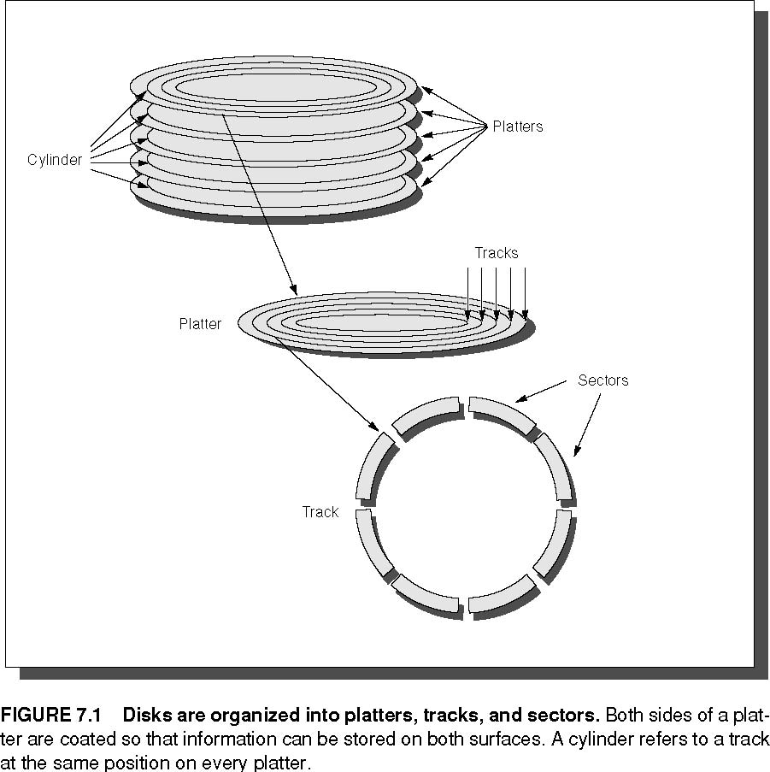

A magnetic disk consists of a collection of platters (generally 1 to 12), rotating on a spindle at 3,600 to 15,000 revolutions per minute (RPM). These platters are metal or glass disks covered with magnetic recording material on both sides, so 10 platters have 20 recording surfaces.
The disk surface is divided into concentric circles, designated tracks. There are typically 5,000 to 30,000 tracks on each surface. Each track in turn is divided into sectors that contain the information; a track might have 100 to 500 sectors. A sector is the smallest unit that can be read or written. IBM mainframes allow users to select the size of the sectors, although most systems fix their size, typically at 512 bytes of data. The sequence recorded on the magnetic media is a sector number, a gap, the information for that sector including error correction code, a gap, the sector number of the next sector, and so on.
To read and write information into a sector, a movable arm containing a read/ write head is located over each surface. To read or write a sector, the disk controller sends a command to move the arm over the proper track. This operation is called a seek, and the time to move the arm to the desired track is called seek time.
Average seek time is the subject of considerable misunderstanding. Disk manufacturers report minimum seek time, maximum seek time, and average seek time in their manuals. The first two are easy to measure, but the average was open to wide interpretation.
The time for the requested sector to rotate under the head is the rotation latency or rotational delay. The average latency to the desired information is obviously halfway around the disk; if a disk rotates at 10,000 revolutions per minute (RPM), the average rotation time is therefore
Average Rotation Time = 0.5/10,000RPM = 0.5/(10,000/60)RPM = 3.0ms
The next component of disk access, transfer time, is the time it takes to transfer a block of bits, typically a sector, under the read-write head. This time is a function of the block size, disk size, rotation speed, recording density of the track, and speed of the electronics connecting the disk to computer. Transfer rates in 2001 range from 3 MB per second for the 3600 RPM, 1-inch drives to 65 MB per second for the 15000 RPM, 3.5-inch drives.

The Future of Magnetic Disks
The disk industry has concentrated on improving the capacity of disks. Improvement in capacity is customarily expressed as improvement in areal density, measured in bits per square inch:
Areal Density = (Tracks/Inch) on a disk surface X (Bits/Inch) on a track

Through about 1988 the rate of improvement of areal density was 29% per year, thus doubling density every three years. Between then and about 1996, the rate improved to 60% per year, quadrupling density every three years and matching the traditional rate of DRAMs. From 1997 to 2001 the rate increased to 100%, or doubling every year. In 2001, the highest density in commercial products is 20 billion bits per square inch, and the lab record is 60 billion bits per square inch.
Optical Disks:
One challenger to magnetic disks is optical compact disks, or CDs, and its successor, called Digital Video Discs and then Digital Versatile Discs or just DVDs. Both the CD-ROM and DVD-ROM are removable and inexpensive to manufacture, but they are read-only mediums. These 4.7-inch diameter disks hold 0.65 and 4.7 GB, respectively, although some DVDs write on both sides to double their capacity. Their high capacity and low cost have led to CD-ROMs and DVD-ROMs replacing floppy disks as the favorite medium for distributing software and other types of computer data.
The popularity of CDs and music that can be downloaded from the WWW led to a market for rewritable CDs, conveniently called CD-RW, and write once CDs, called CD-R. In 2001, there is a small cost premium for drives that can record on CD-RW. The media itself costs about $0.20 per CD-R disk or $0.60 per CD-RW disk. CD-RWs and CD-Rs read at about half the speed of CD-ROMs and CD-RWs and CD-Rs write at about a quarter the speed of CD-ROMs.
Magnetic Tape:
Magnetic tapes have been part of computer systems as long as disks because they use the similar technology as disks, and hence historically have followed the same density improvements. The inherent cost/performance difference between disks and tapes is based on their geometries:
- Fixed rotating platters offer random access in milliseconds, but disks have a limited storage area and the storage medium is sealed within each reader.
- Long strips wound on removable spools of “unlimited” length mean many tapes can be used per reader, but tapes require sequential access that can take seconds.
One of the limits of tapes had been the speed at which the tapes can spin without breaking or jamming. A technology called helical scan tapes solves this problem by keeping the tape speed the same but recording the information on a diagonal to the tape with a tape reader that spins much faster than the tape is moving. This technology increases recording density by about a factor of 20 to 50. Helical scan tapes were developed for low-cost VCRs and camcorders, which brought down the cost of the tapes and readers.

Automated Tape Libraries
Tape capacities are enhanced by inexpensive robots to automatically load and store tapes, offering a new level of storage hierarchy. These nearline tapes mean access to terabytes of information in tens of seconds, without the intervention of a human operator.

Flash Memory
Embedded devices also need nonvolatile storage, but premiums placed on space and power normally lead to the use of Flash memory instead of magnetic recording. Flash memory is also used as a rewritable ROM in embedded systems, typically to allow software to be upgraded without having to replace chips. Applications are typically prohibited from writing to Flash memory in such circumstances.
Like electrically erasable and programmable read-only memories (EEPROM), Flash memory is written by inducing the tunneling of charge from transistor gain to a floating gate. The floating gate acts as a potential well which stores the charge, and the charge cannot move from there without applying an external force. The primary difference between EEPROM and Flash memory is that Flash restricts write to multi-kilobyte blocks, increasing memory capacity per chip by reducing area dedicated to control. Compared to disks, Flash memories offer low power consumption (less than 50 milliwatts), can be sold in small sizes, and offer read access times comparable to DRAMs. In 2001, a 16 Mbit Flash memory has a 65 ns access time, and a 128 Mbit Flash memory has a 150 ns access time.

- Buses : Connecting I/O Devices to CPU/Memory
Buses were traditionally classified as CPU-memory buses or I/O buses. I/O buses may be lengthy, may have many types of devices connected to them, have a wide range in the data bandwidth of the devices connected to them, and normally follow a bus standard. CPU-memory buses, on the other hand, are short, generally high speed, and matched to the memory system to maximize memory-CPU bandwidth. During the design phase, the designer of a CPU-memory bus knows all the types of devices that must connect together, while the I/O bus designer must accept devices varying in latency and bandwidth capabilities. To lower costs, some computers have a single bus for both memory and I/O devices. In the quest for higher I/O performance, some buses are a hybrid of the two. For example, PCI is relatively short, and is used to connect to more traditional I/O buses via bridges that speak both PCI on one end and the I/O bus protocol on the other. To indicate its intermediate state, such buses are sometimes called mezzanine

Bus Design Decisions
The design of a bus presents several options, as Figure 7.8 shows. Like the rest of the computer system, decisions depend on cost and performance goals. The first three options in the figure are clear—separate address and data lines, wider data lines, and multiple-word transfers all give higher performance at more cost.
Option | High performance | Low cost
Bus width | Separate address and data lines | Multiplex address and data lines
Data width | Wider is faster (e.g., 64 bits) | Narrower is cheaper (e.g., 8 bits)
Transfer size | Multiple words have less bus overhead | Single-word transfer is simpler
Bus masters | Multiple (requires arbitration) | Single master (no arbitration)
Split transaction? | Yes—separate request and reply packets get higher bandwidth (need multiple masters) | No—continuous connection is cheaper and has lower latency
Clocking | Synchronous | Asynchronous

The next item in the table concerns the number of bus masters. These devices can initiate a read or write transaction; the CPU, for instance, is always a bus master. A bus has multiple masters when there are multiple CPUs or when I/O devices can initiate a bus transaction. With multiple masters, a bus can offer higher bandwidth by using packets, as opposed to holding the bus for the full transaction. This technique is called split transactions.
The final item in Figure 7.8, clocking, concerns whether a bus is synchronous or asynchronous. If a bus is synchronous, it includes a clock in the control lines and a fixed protocol for sending address and data relative to the clock. Since little or no logic is needed to decide what to do next, these buses can be both fast and inexpensive.

Bus Standards
Standards that let the computer designer and I/O-device designer work independently play a large role in buses. As long as both designers meet the requirements, any I/O device can connect to any computer. The I/O bus standard is the document that defines how to connect devices to computers.
- The Good
  - Let the computer and I/O-device designers work independently
  - Provides a path for second party (e.g. cheaper) competition
- The Bad
  - Become major performance anchors
  - Inhibit change
- How to create a standard
  - Bottom-up
    - Company tries to get standards committee to approve it’s latest philosophy in hopes that they’ll get the jump on the others (e.g. S bus, PC-AT bus, ...)
    - De facto standards
  - Top-down
    - Design by committee (PCI, SCSI, ...)
Some sample bus designs are shown below
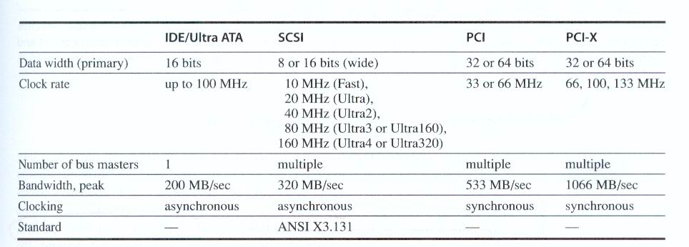

Interfacing Storage Devices to the CPU
The I/O bus is connected to the main memory bus is shown in figure 7.15

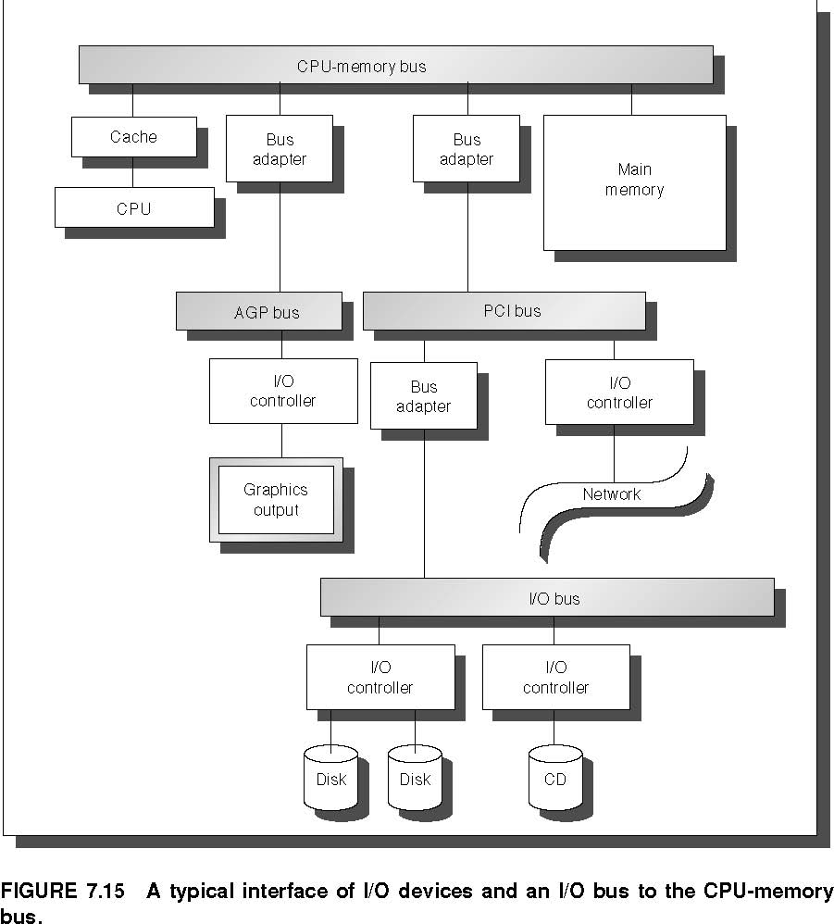

Processor interface with i/o bus can be done with two techniques one using interrupts and second using memory mapped I/O
- I/O Control Structures
  - Polling
  - Interrupts
  - DMA
  - I/O Controllers
  - I/O Processors

The simple interface, in which the CPU periodically checks status bits to see if it is time for the next I/O operation, is called polling.

Interrupt-driven I/O, used by most systems for at least some devices, allows the CPU to work on some other process while waiting for the I/O device. For example, the LP11 has a mode that allows it to interrupt the CPU whenever the done bit or error bit is set. In general-purpose applications, interrupt-driven I/O is the key to multitasking operating systems and good response times.
The drawback to interrupts is the operating system overhead on each event. In real-time applications with hundreds of I/O events per second, this overhead can be intolerable. One hybrid solution for real-time systems is to use a clock to periodically interrupt the CPU, at which time the CPU polls all I/O devices
The DMA hardware is a specialized processor that transfers data between memory and an I/O device while the CPU goes on with other tasks. Thus, it is external to the CPU and must act as a master on the bus. The CPU ﬁrst sets up the DMA registers, which contain a memory address and number of bytes to be transferred. More sophisticated DMA devices support scatter/gather, whereby a DMA device can write or read data from a list of separate addresses. Once the DMA transfer is complete, the DMA controller interrupts the CPU. There may be multiple DMA devices in a computer system.

- RAID : Redundant Arrays of Inexpensive Disks
An innovation that improves both dependability and performance of storage systems is disk arrays. One argument for arrays is that potential throughput can be increased by having many disk drives and, hence, many disk arms, rather than one large drive with one disk arm. Although a disk array would have more faults than a smaller number of larger disks when each disk has the same reliability, dependability can be improved by adding redundant disks to the array to tolerate faults. That is, if a single disk fails, the lost information can be reconstructed from redundant information. The only danger is in having another disk fail between the time the ﬁrst disk fails and the time it is replaced (termed mean time to repair, or MTTR). Since the mean time to failure (MTTF) of disks is tens of years, and the MTTR is measured in hours, redundancy can make the measured reliability of 100 disks much higher than that of a single disk. These systems have become known by the acronym RAID, stand-ing originally for redundant array of inexpensive disks, although some have re-named it to redundant array of independent disks
The several approaches to redundancy have different overhead and perfor-mance. Figure 7.17 shows the standard RAID levels. It shows how eight disks of user data must be supplemented by redundant or check disks at each RAID level. It also shows the minimum number of disk failures that a system would survive.
RAID level | Minimum number of Disk faults survived | Example Data disks | Corresponding Check disks | Corporations producing RAID products at this level
0 Non-redundant striped | 0 | 8 | 0 | Widely used
1 Mirrored | 1 | 8 | 8 | EMC, Compaq (Tandem), IBM
2 Memory-style ECC | 1 | 8 | 4
3 Bit-interleaved parity | 1 | 8 | 1 | Storage Concepts
4 Block-interleaved parity | 1 | 8 | 1 | Network Appliance
5 Block-interleaved distributed parity | 1 | 8 | 1 | Widely used
6 P+Q redundancy | 2 | 8 | 2
FIGURE 7.17 RAID levels, their fault tolerance, and their overhead in redundant disks.
No Redundancy (RAID 0)
This notation is refers to a disk array in which data is striped but there is no redundancy to tolerate disk failure. Striping across a set of disks makes the collection appear to software as a single large disk, which simpliﬁes storage management. It also improves performance for large accesses, since many disks can operate at once. Video editing systems, for example, often stripe their data.
RAID 0 something of a misnomer as there is no redundancy, it is not in the original RAID taxonomy, and striping predates RAID. However, RAID levels are often left to the operator to set when creating a storage system, and RAID 0 is often listed as one of the options. Hence, the term RAID 0 has become widely used.
Mirroring (RAID 1)
This traditional scheme for tolerating disk failure, called mirroring or shadowing, uses twice as many disks as does RAID 0. Whenever data is written to one disk, that data is also written to a redundant disk, so that there are always two copies of the information. If a disk fails, the system just goes to the “mirror” to get the desired information. Mirroring is the most expensive RAID solution, since it requires the most disks.
The RAID terminology has evolved to call the former RAID 1+0 or RAID 10 (“striped mirrors”) and the latter RAID 0+1 or RAID 01 (“mirrored stripes”).
Bit-Interleaved Parity (RAID 3)
The cost of higher availability can be reduced to 1/N, where N is the number of disks in a protection group. Rather than have a complete copy of the original data for each disk, we need only add enough redundant information to restore the lost information on a failure. Reads or writes go to all disks in the group, with one extra disk to hold the check information in case there is a failure. RAID 3 is popular in applications with large data sets, such as multimedia and some scientific codes.
Parity is one such scheme. Readers unfamiliar with parity can think of the redundant disk as having the sum of all the data in the other disks. When a disk fails, then you subtract all the data in the good disks from the parity disk; the remaining information must be the missing information. Parity is simply the sum modulo two. The assumption behind this technique is that failures are so rare that taking longer to recover from failure but reducing redundant storage is a good trade-off.

Block-Interleaved Parity and Distributed Block-Interleaved Parity (RAID 4 and RAID 5)
In RAID 3, every access went to all disks. Some applications would prefer to do smaller accesses, allowing independent accesses to occur in parallel. That is the purpose of the next RAID levels. Since error-detection information in each sector is checked on reads to see if data is correct, such “small reads” to each disk can occur independently as long as the minimum access is one sector.
Writes are another matter. It would seem that each small write would demand that all other disks be accessed to read the rest of the information needed to recalculate the new parity, as in Figure 7.18. A “small write” would require reading the old data and old parity, adding the new information, and then writing the new parity to the parity disk and the new data to the data disk.

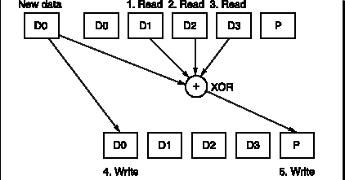

RAID 4 efﬁciently supports a mixture of large reads, large writes, small reads, and small writes. One drawback to the system is that the parity disk must be updated on every write, so it is the bottleneck for back-to-back writes. To fix the parity-write bottleneck, the parity information can be spread throughout all the disks so that there is no single bottleneck for writes. The distributed parity organization is RAID 5.

D0
D1
D2
D3
P
D0'
+
+
D0'
D1
D2
D3
P'
new
data
old
data
old
parity
XOR
XOR
(1. Read)
(2. Read)
(3. Write)
(4. Write)

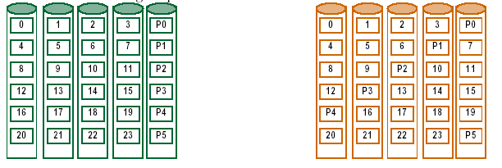

Figure 7.19 shows how data are distributed in RAID 4 vs. RAID 5. As the organization on the right shows, in RAID 5 the parity associated with each row of data blocks is no longer restricted to a single disk. This organization allows multiple writes to occur simultaneously as long as the stripe units are not located in the same disks. For example, a write to block 8 on the right must also access its parity block P2, thereby occupying the ﬁrst and third disks. A second write to block 5 on the right, implying an update to its parity block P1, accesses the second and fourth disks and thus could occur at the same time as the write to block 8. Those same writes to the organization on the left would result in changes to blocks P1 and P2, both on the fifth disk, which would be a bottleneck.
P+Q redundancy (RAID 6)
Parity based schemes protect against a single, self-identifying failures. When a single failure is not sufficient, parity can be generalized to have a second calculation over the data and another check disk of information. Yet another parity block is added to allow recovery from a second failure. Thus, the storage overhead is twice that of RAID 5. The small write shortcut of Figure 7.18 works as well, ex-cept now there are six disk accesses instead of four to update both P and Q information.
Errors and Failures in Real Systems
Publications of real error rates are rare for two reasons. First academics rarely have access to significant hardware resources to measure. Second industrial, researchers are rarely allowed to publish failure information for fear that it would be used against their companies in the marketplace. Below are four exceptions.
Berkeley’s Tertiary Disk
The Tertiary Disk project at the University of California created an art-image server for the Fine Arts Museums of San Francisco. This database consists of high quality images of over 70,000 art works. The database was stored on a clus-ter, which consisted of 20 PCs containing 368 disks connected by a switched Ethernet. It occupied in seven 7-foot high racks.
Component | Total in System | Total Failed | % Failed
SCSI Controller | 44 | 1 | 2.3%
SCSI Cable | 39 | 1 | 2.6%
SCSI Disk | 368 | 7 | 1.9%
IDE Disk | 24 | 6 | 25.0%
Disk Enclosure -Backplane | 46 | 13 | 28.3%
Disk Enclosure - Power Supply | 92 | 3 | 3.3%
Ethernet Controller | 20 | 1 | 5.0%
Ethernet Switch | 2 | 1 | 50.0%
Ethernet Cable | 42 | 1 | 2.3%
CPU/Motherboard | 20 | 0 | 0%

FIGURE 7.20 Failures of components in Tertiary Disk over eighteen months of operation.

Figure 7.20 shows the failure rates of the various components of Tertiary Disk. In advance of building the system, the designers assumed that data disks would be the least reliable part of the system, as they are both mechanical and plentiful. As Tertiary Disk was a large system with many redundant components, it had the potential to survive this wide range of failures. Components were connected and mirrored images were placed no single failure could make any image unavailable. This strategy, which initially appeared to be overkill, proved to be vital.
This experience also demonstrated the difference between transient faults and hard faults. Transient faults are faults that come and go, at least temporarily fixing themselves. Hard faults stop the device from working properly, and will continue to misbehave until repaired.
Tandem
The next example comes from industry. Gray [1990] collected data on faults for Tandem Computers, which was one of the pioneering companies in fault tolerant computing. Figure 7.21 graphs the faults that caused system failures between 1985 and 1989 in absolute faults per system and in percentage of faults encoun-tered. The data shows a clear improvement in the reliability of hardware and maintenance. Disks in 1985 needed yearly service by Tandem, but they were re-placed by disks that needed no scheduled maintenance. Shrinking number of chips and connectors per system plus software’s ability to tolerate hardware faults reduced hardware’s contribution to only 7% of failures by 1989. And when hardware was at fault, software embedded in the hardware device (ﬁrmware) was often the culprit. The data indicates that software in 1989 was the major source of reported outages (62%), followed by system operations (15%).

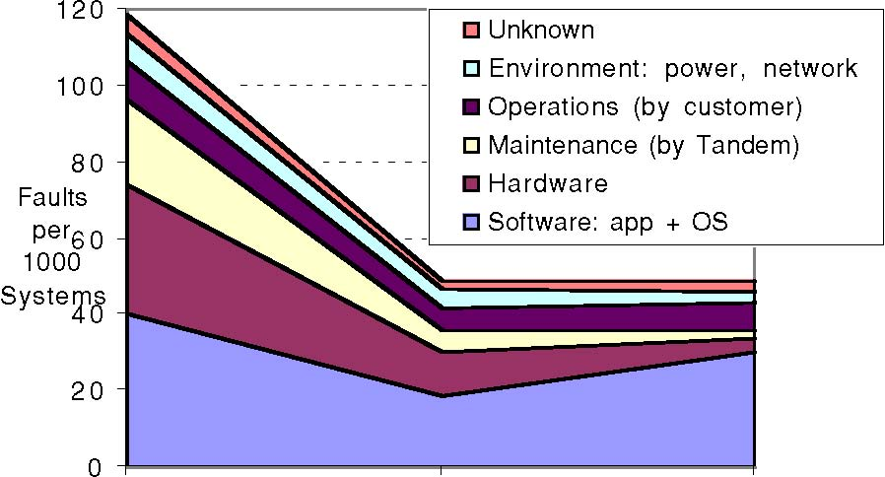
1985 1987 1989
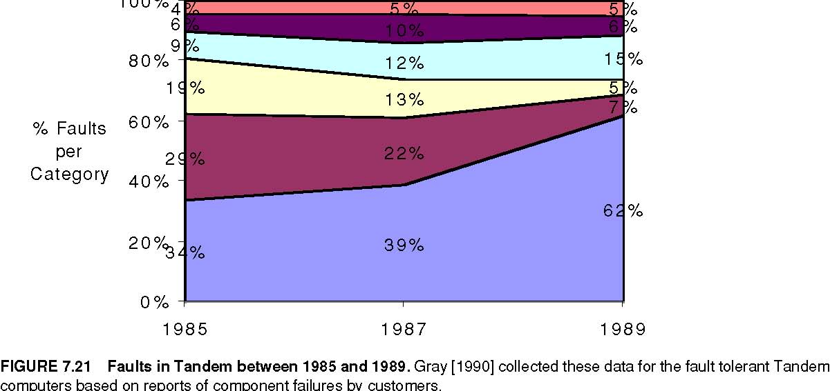
The problem with any such statistics are that these data only refer to what is reported; for example, environmental failures due to power outages were not reported to Tandem because they were seen as a local problem.
VAX
The next example is also from industry. Murphy and Gent [1995] measured faults in VAX systems. They classified faults as hardware, operating system, system management, or application/networking. Figure 7.22 shows their data for 1985 and 1993. They tried to improve the accuracy of data on operator faults by having the system automatically prompt the operator on each boot for the reason for that reboot. They also classified consecutive crashes to the same fault as operator fault. Note that the hardware/operating system went from causing 70% of the failures in 1985 to 28% in 1993. Murphy and Gent expected system management to be the primary dependability challenge in the future.
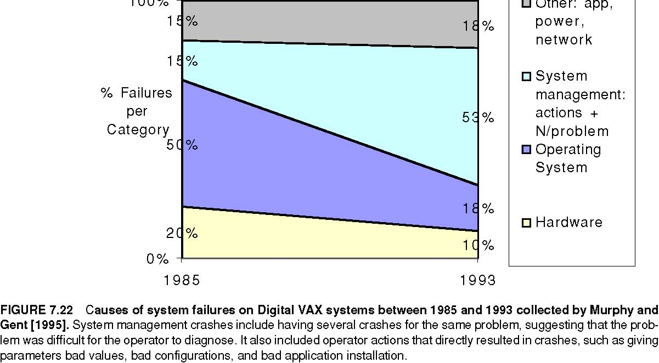
FCC
The final set of data comes from the government. The Federal Communications Commission (FCC) requires that all telephone companies submit explanations when they experience an outage that affects at least 30,000 people or lasts thirty minutes. These detailed disruption reports do not suffer from the self-reporting problem of earlier figures, as investigators determine the cause of the outage rather than operators of the equipment. Kuhn [1997] studied the causes of outages between 1992 and 1994 and Enriquez [2001] did a follow-up study for the ﬁrst half of 2001. In addition to reporting number of outages, the FCC data includes the number of customers affected and how long they were affected. Hence, we can look at the size and scope of failures, rather than assuming that all are equally important. Figure 7.23 plots the absolute and relative number of customer-outage minutes for those years, broken into four categories:
  - Failures due to exceeding the network’s capacity (overload).
  - Failures due to people (human).
  - Outages caused by faults in the telephone network software (software).
  - Switch failure, cable failure, and power failure (hardware).
These four examples and others suggest that the primary cause of failures in large systems today is faults by human operators. Hardware faults have declined due to a decreasing number of chips in systems, reduced power, and fewer connectors. Hardware dependability has improved through fault tolerance techniques such as RAID. At least some operating systems are considering reliability implications before new adding features, so in 2001 the failures largely occur elsewhere.

- Benchmarks of storage performance and availability

Benchmarks of Storage Performance and Availability
Transaction Processing Benchmarks
Transaction processing (TP, or OLTP for on-line transaction processing) is chiefly concerned with I/O rate: the number of disk accesses per second, as opposed to data rate, measured as bytes of data per second. TP generally involves changes to a large body of shared information from many terminals, with the TP system guaranteeing proper behavior on a failure. Suppose, for example, a bank’s computer fails when a customer tries to withdraw money. The TP system would guarantee that the account is debited if the customer received the money and that the account is unchanged if the money was not received. Airline reservations systems as well as banks are traditional customers for TP.
This report led to the Transaction Processing Council, which in turn has led to seven benchmarks since its founding.

Benchmark | Data Size (GB) | Performance Metric | Date of First Results
A: Debit Credit (retired) | 0.1 to 10 | transactions per second | July, 1990
B: Batch Debit Credit (retired) | 0.1 to 10 | transactions per second | July, 1991
C: Complex Query OLTP | 100 to 3000 (minimum 0.07 * tpm) | new order transactions per minute | September, 1992
D: Decision Support (retired) | 100, 300, 1000 | queries per hour | December, 1995
H: Ad hoc decision support | 100, 300, 1000 | queries per hour | October, 1999
R: Business reporting decision support | 1000 | queries per hour | August, 1999
W: Transactional web benchmark | ≈ 50, 500 | web interactions per second | July, 2000

FIGURE 7.31 Transaction Processing Council Benchmarks. The summary results include both the performance metric and the price-performance of that metric. TPC-A, TPC-B, and TPC-D were retired.

The TPC benchmarks were either the first, and in some cases still the only ones, that have these unusual characteristics:
Price is included with the benchmark results. The cost of hardware, software, and five-year maintenance agreements is included in a submission, which en-ables evaluations based on price-performance as well as high performance.
The data set generally must scale in size as the throughput increases. The benchmarks are trying to model real systems, in which the demand on the sys-tem and the size of the data stored in it increase together. It makes no sense, for example, to have thousands of people per minute access hundreds of bank ac-counts.
The benchmark results are audited. Before results can be submitted, they must be approved by a certiﬁed TPC auditor, who enforces the TPC rules that try to make sure that only fair results are submitted. Results can be challenged and disputes resolved by going before the TPC council.
Throughput is the performance metric but response times are limited. For ex-ample, with TPC-C, 90% of the New-Order transaction response times must be less than 5 seconds.
An independent organization maintains the benchmarks. Dues collected by TPC pay for an administrative structure including a Chief Operating Ofﬁce. This organization settles disputes, conducts mail ballots on approval of changes to benchmarks, hold board meetings, and so on.
SPEC System-Level File Server (SFS) and Web Benchmarks :
The SPEC benchmarking effort is best known for its characterization of processor performance, but has created benchmarks for other fields as well. In 1990 seven companies agreed on a synthetic benchmark, called SFS, to evaluate systems running the Sun Microsystems network file service NFS. This benchmark was upgraded to SFS 2.0 (also called SPEC SFS97) to include support for NSF version 3, using TCP in addition to UDP as the transport protocol, and making the mix of operations more realistic.
Figure 7.32 shows average response time versus throughput for four systems. Unfortunately, unlike the TPC benchmarks, SFS does not normalize for different price configurations. The fastest system in Figure 7.32 has 7 times the number of CPUs and disks as the slowest system, but SPEC leaves it to you to calculate price versus performance. As performance scaled to new heights, SPEC discovered bugs in the benchmark that impact the amount of work done during the measurement periods. Hence, it was retired in June 2001.
SPEC WEB is a benchmark for evaluating the performance of World Wide Web servers. The SPEC WEB99 workload simulates accesses to a web service provider, where the server supports home pages for several organizations. Each home page is a collection of ﬁles ranging in size from small icons to large docu-ments and images, with some ﬁles being more popular than others. The workload deﬁnes four sizes of ﬁles and their frequency of activity:
less than 1 KB, representing an small icon: 35% of activity
1 to 10 KB: 50% of activity
10 to 100 KB: 14% of activity
100 KB to 1 MB: representing a large document and image,1% of activity

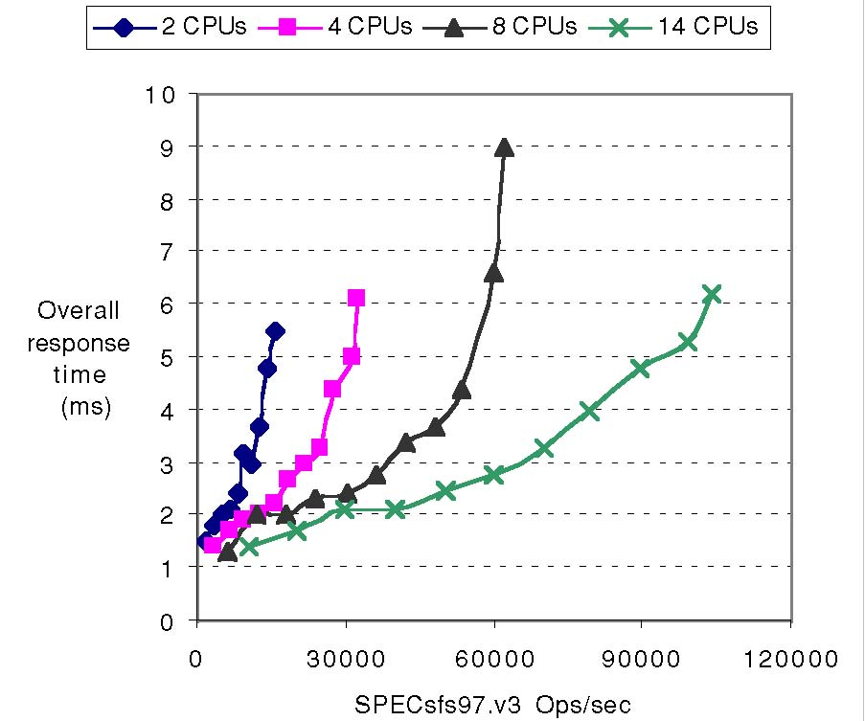
Figure 7.33 shows results for Dell computers. The performance result represents the number of simultaneous connections the web server can support using the predefined workload. As the disk system is the same, it appears that the large memory is used for a file cache to reduce disk I/O.

System Name | Result | CPUs | Result/ CPU | HTTP Version/OS | Pentium III | DRAM
PowerEdge 2400/667 | 732 | 1 | 732 | IIS 5.0/Windows 2000 | 667 MHz EB | 2 GB
PowerEdge 2400/667 | 1270 | 1 | 1270 | TUX 1.0/Red Hat Linux 6.2 | 667 MHz EB | 2 GB
PowerEdge 4400/800 | 1060 | 2 | 530 | IIS 5.0/Windows 2000 | 800 MHz EB | 4 GB
PowerEdge 4400/800 | 2200 | 2 | 1100 | TUX 1.0/Red Hat Linux 6.2 | 800 MHz EB | 4 GB
PowerEdge 6400/700 | 1598 | 4 | 400 | IIS 5.0/Windows 2000 | 700 MHz Xeon | 8 GB
PowerEdge 6400/700 | 4200 | 4 | 1050 | TUX 1.0/Red Hat Linux 6.2 | 700 MHz Xeon | 8 GB

FIGURE 7.33 SPEC WEB99 results in 2000 for Dell computers. Each machine uses five 9GB, 10,000 RPM disks except the fifth system, which had seven disk. The first four have 256 KB of L2 cache while the last two have 2 MB of L2 cache.

- Design and I/O System in Five Easy Pieces

The art of I/O system design is to find a design that meets goals for cost, dependability, and variety of devices while avoiding bottlenecks to I/O performance. Avoiding bottlenecks means that components must be balanced between main memory and the I/O device, because performance and hence effective cost/performance can only be as good as the weakest link in the I/O chain. Finally, storage must be dependable, adding new constraints on proposed designs.
In designing an I/O system, analyze performance, cost, capacity, and availability using varying I/O connection schemes and different numbers of I/O devices of each type. Here is one series of steps to follow in designing an I/O system. The answers for each step may be dictated by market requirements or simply by cost, performance, and availability goals.

- List the different types of I/O devices to be connected to the machine, or list the standard buses that the machine will support.
- List the physical requirements for each I/O device. Requirements include size, power, connectors, bus slots, expansion cabinets, and so on.
- List the cost of each I/O device, including the portion of cost of any controller needed for this device.
- List the reliability of each I/O device.
- Record the CPU resource demands of each I/O device. This list should include

    - Clock cycles for instructions used to initiate an I/O, to support operation of an I/O device (such as handling interrupts), and complete I/O
    - CPU clock stalls due to waiting for I/O to finish using the memory, bus, or cache
    - CPU clock cycles to recover from an I/O activity, such as a cache flush
- List the memory and I/O bus resource demands of each I/O device. Even when the CPU is not using memory, the bandwidth of main memory and the I/O bus is limited.
- The final step is assessing the performance and availability of the different ways to organize these I/O devices. Performance can only be properly evaluated with simulation, though it may be estimated using queuing theory. Reliability can be calculated assuming I/O devices fail independently and are that MTTFs are exponentially distributed. Availability can be computed from reliability by estimating MTTF for the devices, taking into account the time from failure to repair.

You then select the best organization, given your cost, performance, and availability goals.
Cost/performance goals affect the selection of the I/O scheme and physical design. Performance can be measured either as megabytes per second or I/Os per second, depending on the needs of the application. For high performance, the only limits should be speed of I/O devices, number of I/O devices, and speed of memory and CPU. For low cost, the only expenses should be those for the I/O devices themselves and for cabling to the CPU. Cost/performance design, of course, tries for the best of both worlds. Availability goals depend in part on the cost of unavailability to an organization.
To make these ideas clearer, the next dozen pages go through ﬁve examples. Each looks at constructing a disk array with about 2 terabytes of capacity for user data with two sizes of disks. To offer a gentle introduction to I/O design and evaluation, the examples evolve in realism.

To try to avoid getting lost in the details, let’s start with an overview of the ﬁve examples:
- Naive cost-performance design and evaluation: The first example calculates cost-performance of an I/O system for the two types of disks. It ignores dependability concerns, and makes the simplifying assumption of allowing 100% utilization of I/O resources. This example is also the longest.
- Availability of the first example: The second example calculates the poor availability of this naive I/O design.
- Response times of the first example: The third example uses queuing theory to calculate the impact on response time of trying to use 100% of an I/O resource.

- More realistic cost-performance design and evaluation: Since the third example shows the folly of 100% utilization, the fourth example changes the design to obey common rules of thumb on utilization of I/O resources. It then evaluates cost-performance.
- More realistic design for availability and its evaluation: Since the second example shows the poor availability when dependability is ignored, this final example uses a RAID 5 design. It then calculates availability and performance.

