Candidates who are applied for assistant engineer post electrical for APGENCO and APTRANSCOcan check it out this previous question paper which will help for your preparation for your exam

1. In a dc shunt motor the terminal voltage is halved while the torque is kept constant. The resulting approximate variation in speed ” ω” and armature current “I_{a}‘” will be
(A) Both ω and I_{a}are doubled.
(B) ω is constant and I_{a} is doubled
(C) w is doubled while I_{a} is halved
(D) w is constant but I_{a} is halved
Ans: B
2.The current from the stator of an alternator is taken out to the external load circuit through
(A) slip rings.
(B) commutator segments.
(C) solid connections.
(D) carbon brushes.
Ans: C

3.A motor which can conveniently be operated at lagging as well as leading power factors is the
(A) squirrel cage induction motor.
(B) wound rotor induction motor.
(C) synchronous motor.
(D) DC shunt motor.
Ans: C

4 The frequency of the rotor current in a 3 phase 50 Hz, 4 pole induction motor at full load speed is about
(A) 50 Hz.
(B) 20 Hz.
(C) 2 Hz.
(D) Zero.
Ans: C

5.The size of a conductor used in power cables depends on the
(A) operating voltage. (B) power factor.
(C) current to be carried. (D) type of insulation used.
Ans: C

6. The most suitable servomotor for low power applications is
(A) a dc series motor.
(B) a dc shunt motor.
(C) an ac two-phase induction motor.
(D) an ac series motor.
Ans: B

7.A two-winding single phase transformer has a voltage regulation of 4.5% at full-load and unity power-factor. At full-load and 0.80 power-factor lagging load the voltage regulation will be
(A) 4.5%. (B) less than 4.5%. (C) more than 4.5%. (D) 4.5% or more than 4.5%.Ans: C
8 When a synchronous motor is running at synchronous speed, the damper winding produces
(A) damping torque.
(B) eddy current torque.
(C) torque aiding the developed torque.
(D) no torque.
Ans: D

9 If a transformer primary is energised from a square wave voltage source, its output voltage will be
(A) A square wave.
(B) A sine wave.
(C) A triangular wave.
(D) A pulse wave.
Ans: A

10 In a d.c. series motor the electromagnetic torque developed is proportional to
(A) I_{a}
(B) (I_{a})²
(C) 1/I_{a}
(D) 1/(I_{a})²
Ans: B

11.The two windings of a transformer is
(A) conductively linked.
(B) inductively linked.
(C) not linked at all.
(D) electrically linked.
Ans : B

12.In a 3 – phase induction motor running at slip ‘s’ the mechanical power developed in terms of air gap power
(A) (s-1)P_{g}
( B) P_{g}/(1-s)
(C) (1-s)P_{g}
(D) s.P_{g}
Ans: C

13. In a 3 – phase induction motor the maximum torque
(A) is proportional to rotor resistance r₂
(B) does not depend on r₂
(C) is proportional to sqrt(r₂₎
(D) is proportional to (r₂)²
Ans: B

13 In a d.c. machine, the armature mmf is
(A) stationary w.r.t. armature.
(B) rotating w.r.t. field.
(C) stationary w.r.t. field.
(D) rotating w.r.t. brushes.
Ans: C

14 In a transformer the voltage regulation will be zero when it operates at
(A) unity p.f.
(B) leading p.f.
(C) lagging p.f.
(D) zero p.f. leading.
Ans: B

15. A salient pole synchronous motor is running at no load. Its field current is switched off. The motor will
(A) come to stop.
(B) continue to run at synchronous speed.
(C) continue to run at a speed slightly more than the synchronous speed.
(D) continue to run at a speed slightly less than the synchronous speed.
Ans: B

16.The maximum power in cylindrical and salient pole machines is obtained respectively at load angles of
(A) 90⁰,90⁰
(B) <90⁰,90⁰
(C) 90⁰,>90⁰
(D) 90⁰,<90⁰
Ans: D

17. A stepper motor is
(A) a dc motor. (B) a single-phase ac motor. (C) a multi-phase motor. (D) a two phase motor.
Ans: D

18.The primary winding of a 220/6 V, 50 Hz transformer is energised from 110 V, 60 Hz supply. The secondary output voltage will be
(A) 3.6 V.
(B) 2.5 V.
(C) 3.0 V.
(D) 6.0 V.
Ans: C

19.In a stepper motor the angular displacement
(A) can be precisely controlled.
(B) it cannot be readily interfaced with micro computer based controller.
(C) the angular displacement cannot be precisely controlled.
(D) it cannot be used for positioning of work tables and tools in NC machines.
Ans: A

20.The emf induced in the primary of a transformer
(A) is in phase with the flux.
(B) lags behind the flux by 90 degree.
(C) leads the flux by 90 degree.
(D) is in phase opposition to that of flux.
Ans: C

21.The d.c. series motor should always be started with load because
(A) at no load, it will rotate at dangerously high speed.
(B) it will fail to start.
(C) it will not develop high starting torque.
(D) all are true.
Ans: A

22.The relative speed between the magnetic fields of stator and rotor under steady state operation is zero for a
(A) dc machine.
(B) 3 phase induction machine.
(C) synchronous machine.
(D) single phase induction machine.
Ans: all options are correct

23.The power factor of a squirrel cage induction motor is
(A) low at light load only.
(B) low at heavy load only.
(C) low at light and heavy load both.
(D) low at rated load only.
Ans: A

24. A hysteresis motor
(A) is not a self-starting motor.
(B) is a constant speed motor.
(C) needs dc excitation.
(D) can not be run in reverse speed.
Ans: B

25.Out of the following methods of heating the one which is independent of supply frequency is
(A) electric arc heating (B) induction heating (C) electric resistance heating (D) dielectric heating
Ans: C
26. A balanced three-phase, 50 Hz voltage is applied to a 3 phase, 4 pole, induction motor. When the motor is delivering rated output, the slip is found to be 0.05. The speed of the rotor m.m.f. relative to the rotor structure is
(A) 1500 r.p.m.
(B) 1425 r.p.m.
(C) 25 r.p.m.
(D) 75 r.p.m.
Ans: D

27.An alternator is delivering rated current at rated voltage and 0.8 power-factor lagging case. If it is required to deliver rated current at rated voltage and 0.8 power-factor leading, the required excitation will be
(A) less.
(B) more.
(C) more or less.
(D) the same.
Ans: B

28.The generation voltage is usually
(A) between 11 KV and 33 KV.
(B) between 132 KV and 400 KV.
(C) between 400 KV and 700 KV.
(D) None of the above.
Ans: A

29. A ceiling fan uses
(A) split-phase motor.
(B) capacitor start and capacitor run motor.
(C) universal motor.
(D) capacitor start motor.
Ans: D

Electrical Circuits and Networks:
- The ratio of voltage and electric current in a closed circuit
(a) remains constant (b) varies (c) increases (d) falls
- The resistance of a wire varies inversely as
(a) area of cross section (b) length (c) resistivity (d) temperature
- The electrical conductivity of metals is typically of the order of ( in ohm-1 m-1)
(a) 10 to the power of 7 (b) 10 to the power of 5 (c) 10 to the power of -4 (d) 10 to the power of -6
- Four resistors, each of resistance R ohms are available. The minimum resistance of the combination will be
(a) 4R (b) R (c) R/4 (d) R/8
- The elements which are not capable of delivering energy by its own are known as
(a) unilateral elements (b) non-linear elements (c) passive elements (d) active elements
- The magentic susceptibility of paramagnetic material is
(a) less than zero (b) less than one but positive (c) greater than one (d) equal to zero
- The Direction of current in an ac circuit
(a) is from positive to negative (b) is always in one direction (c) varies from instant to instant (d)Cannot be determined
- which of the following statements associated with purely resistive circuits is correct?
(a) PF is unity (b) Power consumed is zero (c) Heat produced is zero (d) PF is zero
- The magnetic field energy in an inductor changes from maximum value to minimum value in in 5m sec when connected to an ac source. The frequency of the source is
(a) 20 Hz (b) 50 Hz (c) 200 Hz (d) 500 Hz

Control Systems:
- Electronic control systems have the serious draw-backs of
(a) low reliability (b) operational difficulty (c) temperature sensitiveness (d) all of above
- The system whose characteristic equation has the following roots is marginally stable
(a) -j, j, -1,1 (b) -3,-2,0 (c) -2+3j, -2-3j, -2 (d) -3,-2,-1
- A phase log compensation will
(a) improve relative stability
(b)increase the speed of response
(c)increase band-width
(d) increase overshoot
- For Nyquist plot we use
- open loop function
- closed loop function
- characteristic equation
- any of the above
- A system with gain margin close to unity or a phase margin close to zero is
- highly stable
- oscillatory
- relatively stable
- none of these
- Root locus diagram exhibits the
- frequency response of a system
- poles of the transfer function for a set of parameter values
- bandwidth of system
- all of the above
- Increase in the gain K makes the system
- more stable
- unstable
- none of above
- The transfer function of a system is used to determine
- the output for a given input
- the type of system
- the input for a given output
- the steady state gain
- In a servo system the voltage induced in the control transformer rotor is the
- error voltage
- driving voltage
- opposing voltage
- none of these
- With the feedback system, the transient response
- decays slowly
- decays rapidly
- rises slowly
- rises quickly
Measurements and Instrumentation
- Which of the following types of instrument is an integrating instrument?
- power factor meter
- energy meter
- wattmeter
- frequent meter
- Which of the material is used for the ’swamping’ resistance that is connected in series with the working coil of a voltmeter?
- Constantan
- Manganin
- Eureka
- Nichrome
- What are used to increase the range of ammeters.
- Multipliers
- Shunts
- Control Springs
- Potential transformers
- Which voltmeter do you select for measuring 50KV DC?
- Moving Coil Voltmeter
- Hot wire voltmeter
- Electro Dynamo meter
- Electrostatic Voltmeter
- Which of the following you will prefer to extend the range of an ac voltmeter?
- Low series resistance
- high resistance in parallel
- CT
- PT
- High AC voltages are usually measured with
- magnetic voltmeter
- inductive voltmeter
- potential transformers with voltmeters
- current transformers and voltmeters
- Creeping is the phenomena occurs in
- voltmeter
- wattmeter
- energy meter
- ammeter
APGENCO AE Hall Tickets 2012 Download Click Here new

Q.1 The two windings of a transformer is
(A) conductively linked.
(B) inductively linked.
(C) not linked at all.
(D) electrically linked.
Ans : B

Q.2 A salient pole synchronous motor is running at no load. Its field current is switched off. The motor will
(A) come to stop.
(B) continue to run at synchronous speed.
(C) continue to run at a speed slightly more than the synchronous speed.
(D) continue to run at a speed slightly less than the synchronous speed.
Ans: B

Q.3 The d.c. series motor should always be started with load because
(A) at no load, it will rotate at dangerously high speed.
(B) it will fail to start.
(C) it will not develop high starting torque.
(D) all are true.
Ans: A

Q.4 The frequency of the rotor current in a 3 phase 50 Hz, 4 pole induction motor at full load speed is about
(A) 50 Hz.
(B) 20 Hz.
(C) 2 Hz.
(D) Zero.
Ans: C

Q.5 In a stepper motor the angular displacement
(A) can be precisely controlled.
(B) it cannot be readily interfaced with micro computer based controller.
(C) the angular displacement cannot be precisely controlled.
(D) it cannot be used for positioning of work tables and tools in NC machines.
Ans: A
Q.6 The power factor of a squirrel cage induction motor is
(A) low at light load only.
(B) low at heavy load only.
(C) low at light and heavy load both.
(D) low at rated load only.
Ans: A

Q.7 The generation voltage is usually
(A) between 11 KV and 33 KV.
(B) between 132 KV and 400 KV.
(C) between 400 KV and 700 KV.
(D) None of the above.
Ans: A

Q.8 When a synchronous motor is running at synchronous speed, the damper winding produces
(A) damping torque.
(B) eddy current torque.
(C) torque aiding the developed torque.
(D) no torque.
Ans: D

Q.9 If a transformer primary is energised from a square wave voltage source, its output voltage will be
(A) A square wave.
(B) A sine wave.
(C) A triangular wave.
(D) A pulse wave.
Ans: A

Q.10 In a d.c. series motor the electromagnetic torque developed is proportional to
(A) I_{a}
(B) (I_{a})²
(C) 1/I_{a}
(D) 1/(I_{a})²
Ans: B

Q.11 In a 3 – phase induction motor running at slip ‘s’ the mechanical power developed in terms of air gap power
(A) (s-1)P_{g}
( B) P_{g}/(1-s)
(C) (1-s)P_{g}
(D) s.P_{g}
Ans: C

Q.12 In a 3 – phase induction motor the maximum torque
(A) is proportional to rotor resistance r₂
(B) does not depend on r₂
(C) is proportional to sqrt(r₂₎
(D) is proportional to (r₂)²
Ans: B

Q.13 In a d.c. machine, the armature mmf is
(A) stationary w.r.t. armature.
(B) rotating w.r.t. field.
(C) stationary w.r.t. field.
(D) rotating w.r.t. brushes.
Ans: C

Q.14 In a transformer the voltage regulation will be zero when it operates at
(A) unity p.f.
(B) leading p.f.
(C) lagging p.f.
(D) zero p.f. leading.
Ans: B

Q.15 The maximum power in cylindrical and salient pole machines is obtained respectively at load angles of
(A) 90⁰,90⁰
(B) <90⁰,90⁰
(C) 90⁰,>90⁰
(D) 90⁰,<90⁰
Ans: D

Q.16 The primary winding of a 220/6 V, 50 Hz transformer is energised from 110 V, 60 Hz supply. The secondary output voltage will be
(A) 3.6 V.
(B) 2.5 V.
(C) 3.0 V.
(D) 6.0 V.
Ans: C

Q.17 The emf induced in the primary of a transformer
(A) is in phase with the flux.
(B) lags behind the flux by 90 degree.
(C) leads the flux by 90 degree.
(D) is in phase opposition to that of flux.
Ans: C

Q.18 The relative speed between the magnetic fields of stator and rotor under steady state operation is zero for a
(A) dc machine.
(B) 3 phase induction machine.
(C) synchronous machine.
(D) single phase induction machine.
Ans: all options are correct

Q.19 The current from the stator of an alternator is taken out to the external load circuit through
(A) slip rings.
(B) commutator segments.
(C) solid connections.
(D) carbon brushes.
Ans: C

Q.20 A motor which can conveniently be operated at lagging as well as leading power factors is the
(A) squirrel cage induction motor.
(B) wound rotor induction motor.
(C) synchronous motor.
(D) DC shunt motor.
Ans: C

Q.21 A hysteresis motor
(A) is not a self-starting motor.
(B) is a constant speed motor.
(C) needs dc excitation.
(D) can not be run in reverse speed.
Ans: B

Q.22 The most suitable servomotor for low power applications is
(A) a dc series motor.
(B) a dc shunt motor.
(C) an ac two-phase induction motor.
(D) an ac series motor.
Ans: B
Q.23 The size of a conductor used in power cables depends on the
(A) operating voltage. (B) power factor.
(C) current to be carried. (D) type of insulation used.Ans: CQ.24 Out of the following methods of heating the one which is independent of supply frequency is
(A) electric arc heating (B) induction heating
(C) electric resistance heating (D) dielectric heating
Ans: C
Q.25 A two-winding single phase transformer has a voltage regulation of 4.5% at full-load and unity power-factor. At full-load and 0.80 power-factor lagging load the voltage regulation will be
(A) 4.5%. (B) less than 4.5%.
(C) more than 4.5%. (D) 4.5% or more than 4.5%.
Ans: C
Q.26 In a dc shunt motor the terminal voltage is halved while the torque is kept constant. The resulting approximate variation in speed ” ω” and armature current “I_{a}‘” will be
(A) Both ω and I_{a} are doubled.
(B) ω is constant and I_{a} is doubled
(C) w is doubled while I_{a} is halved
(D) w is constant but I_{a} is halved
Ans: B

Q.27 A balanced three-phase, 50 Hz voltage is applied to a 3 phase, 4 pole, induction motor. When the motor is delivering rated output, the slip is found to be 0.05. The speed of the rotor m.m.f. relative to the rotor structure is
(A) 1500 r.p.m.
(B) 1425 r.p.m.
(C) 25 r.p.m.
(D) 75 r.p.m.
Ans: D

Q.28 An alternator is delivering rated current at rated voltage and 0.8 power-factor lagging case. If it is required to deliver rated current at rated voltage and 0.8 power-factor leading, the required excitation will be
(A) less.
(B) more.
(C) more or less.
(D) the same.
Ans: B

Q.29 A ceiling fan uses
(A) split-phase motor.
(B) capacitor start and capacitor run motor.
(C) universal motor.
(D) capacitor start motor.
Ans: D

Q.30 A stepper motor is
(A) a dc motor. (B) a single-phase ac motor. (C) a multi-phase motor. (D) a two phase motor.
Ans: D

Q.31 The ‘sheath’ is used in cable to
(A) provide strength to the cable.
(B) provide proper insulation.
(C) prevent the moisture from entering the cable.
(D) avoid chances of rust on strands.
Ans: A

Q.32 The drive motor used in a mixer-grinder is a
(A) dc motor. (B) induction motor. (C) synchronous motor. (D) universal motor.
Ans: DQ.33 A 1:5 step-up transformer has 120V across the primary and 600 ohms resistance across the secondary. Assuming 100% efficiency, the primary current equals(A) 0.2 Amp. (B) 5 Amps. (C) 10 Amps. (D) 20 Amps.
Ans: A
Q.34 A dc shunt generator has a speed of 800 rpm when delivering 20 A to the load at the terminal voltage of 220V. If the same machine is run as a motor it takes a line current of 20A from 220V supply. The speed of the machine as a motor will be
(A) 800 rpm. (B) more than 800 rpm. (C) less than 800 rpm. (D) both higher or lower than 800 rpm.
Ans: C

Q.35 A 50 Hz, 3-phase induction motor has a full load speed of 1440 r.p.m. The number of poles of the motor are
(A) 4. (B) 6. (C) 12. (D) 8.
Ans: A

most commonly asked electrical Questions along with answers & Explanations,collected from various government exams as mentioned above.
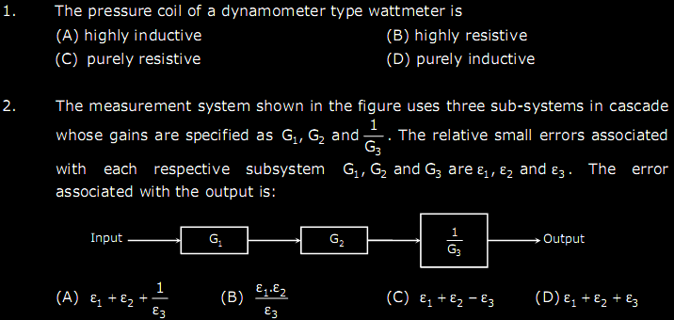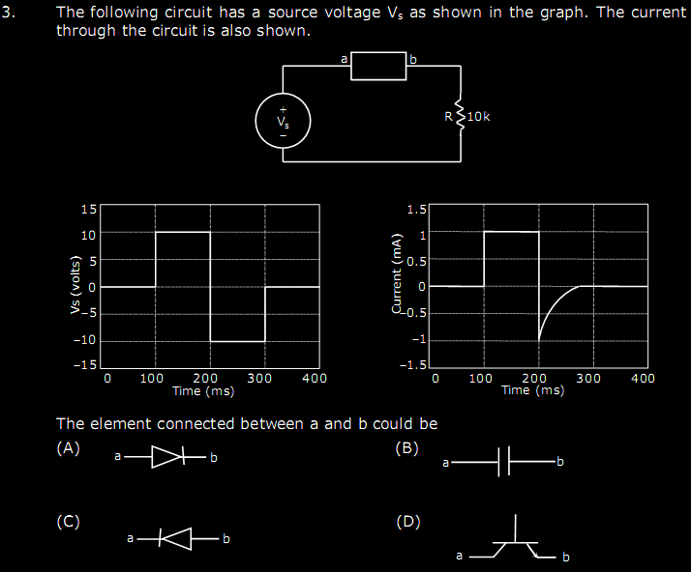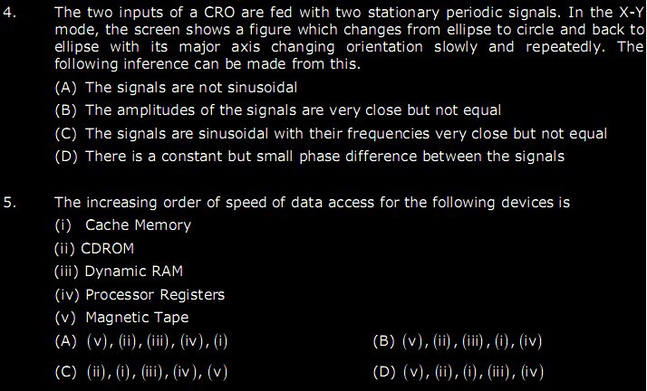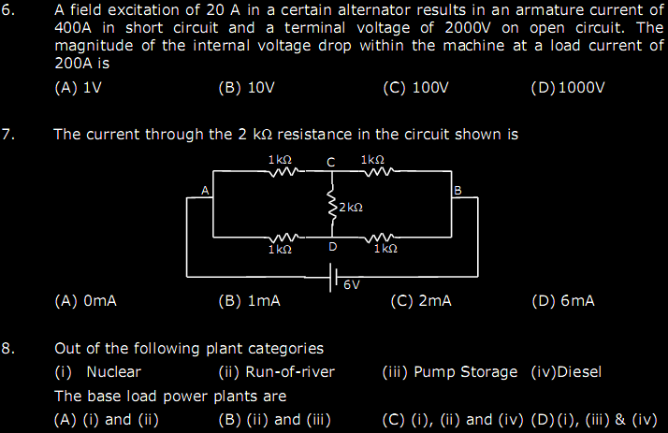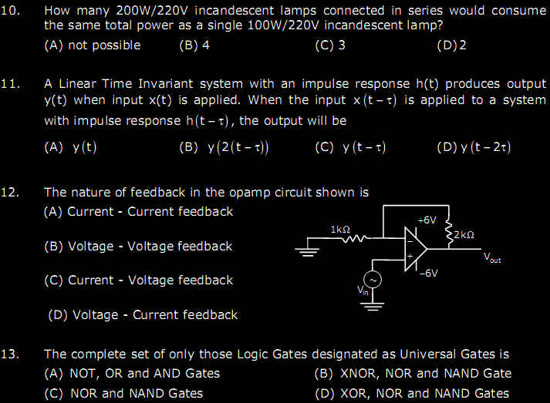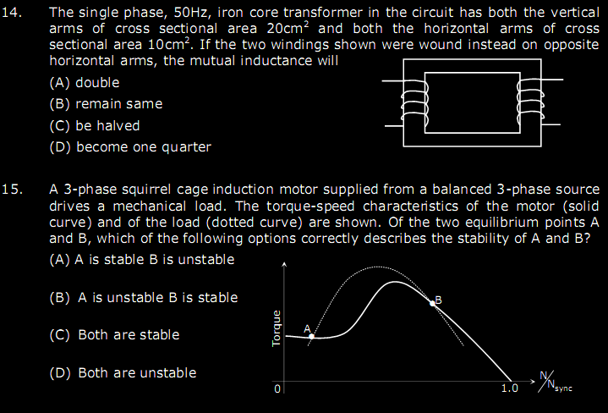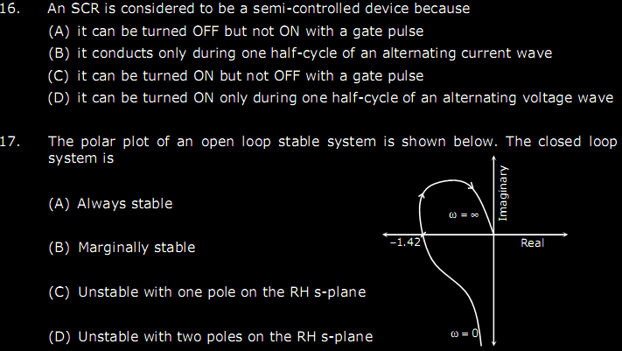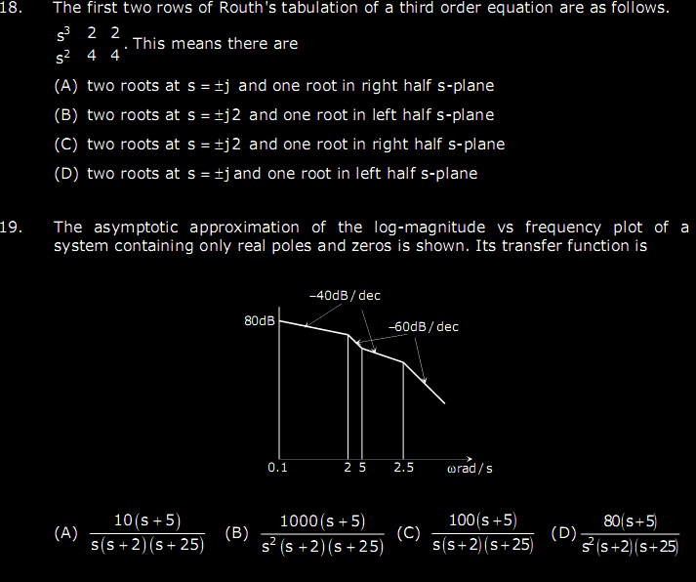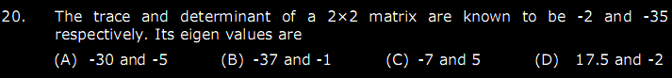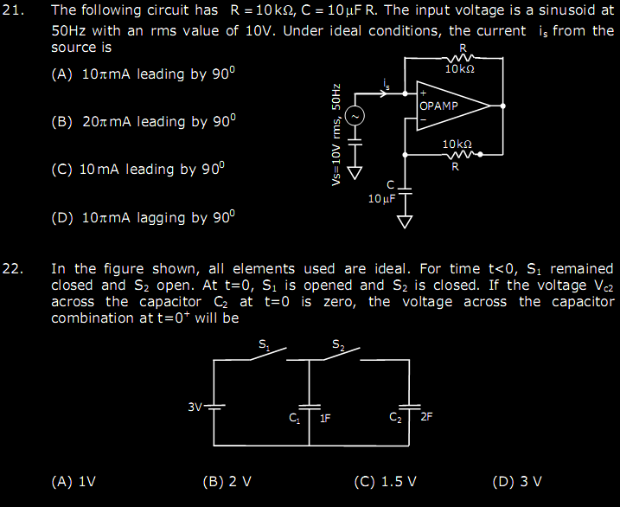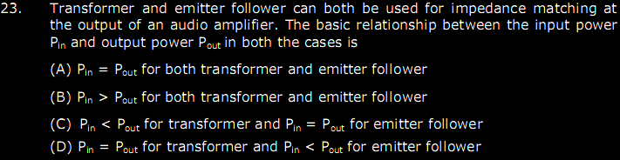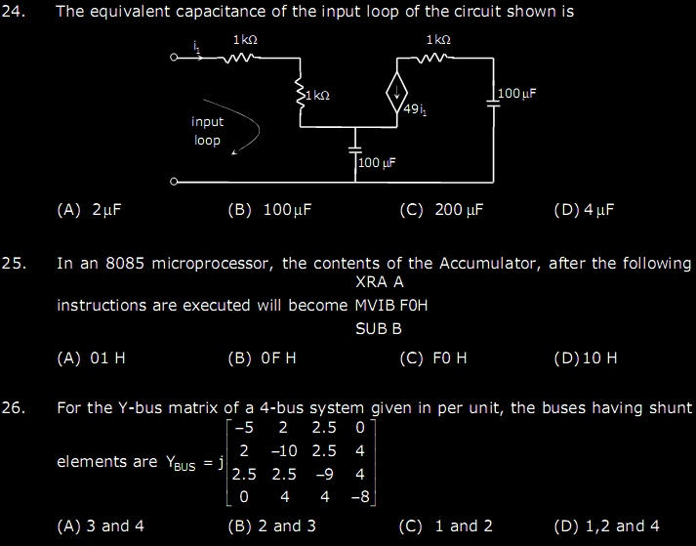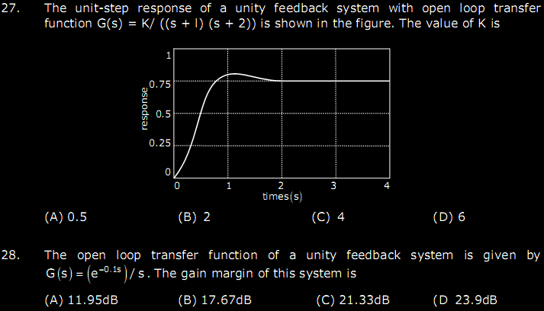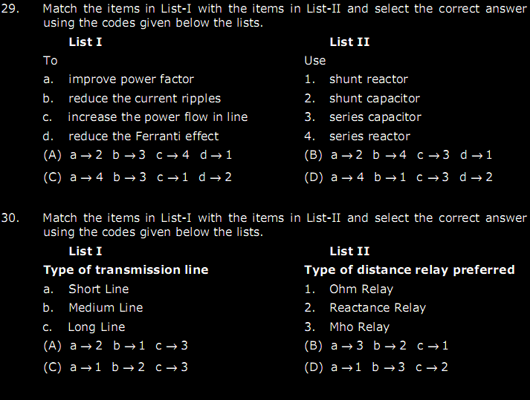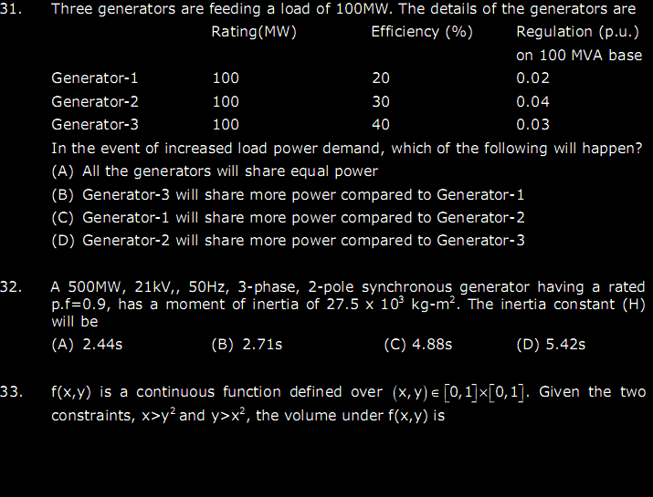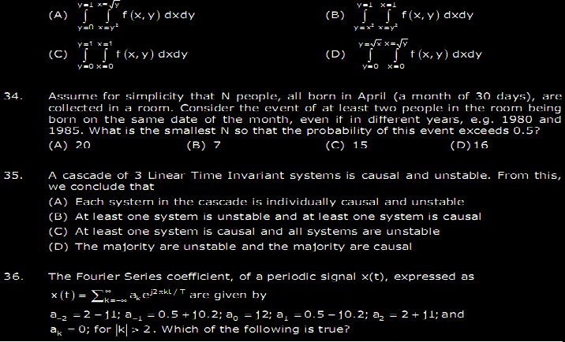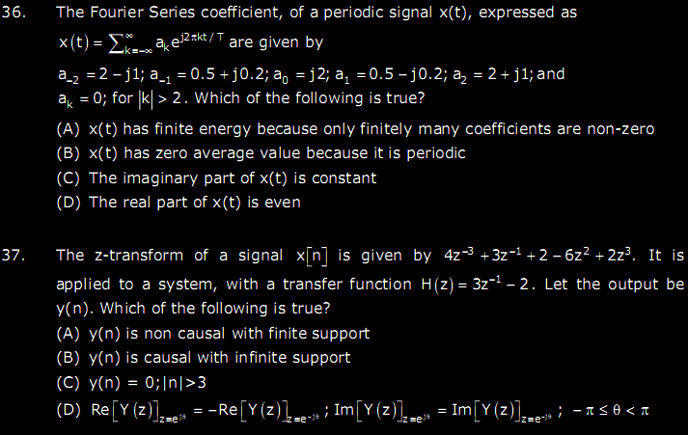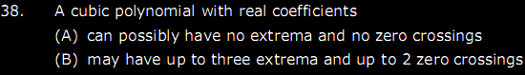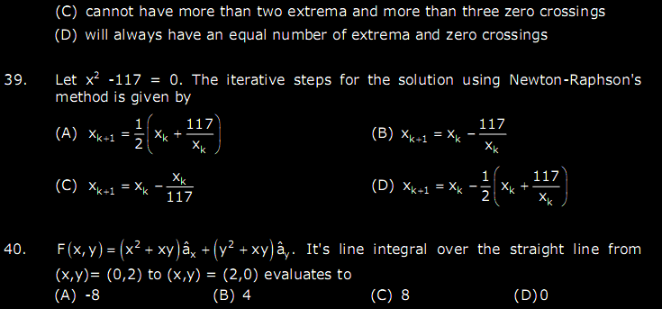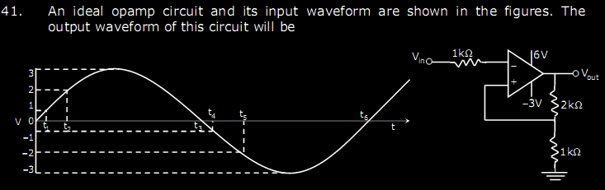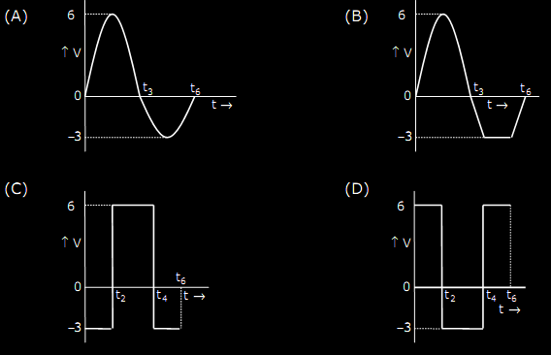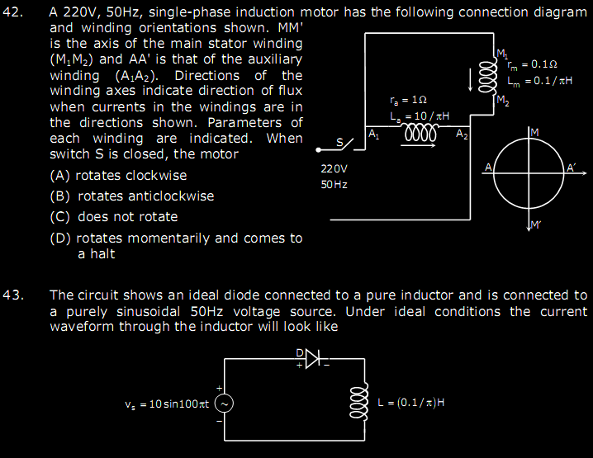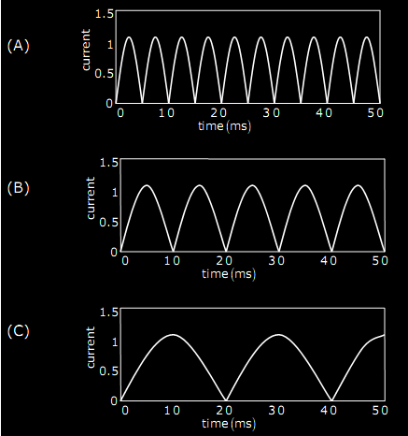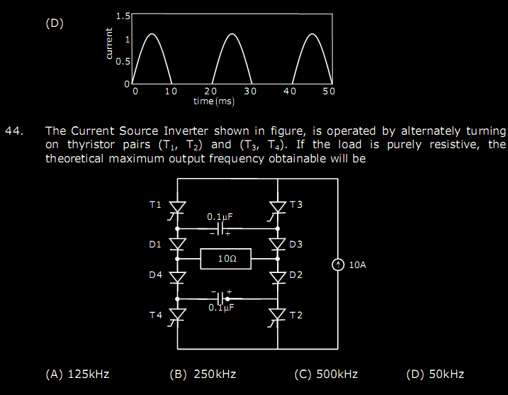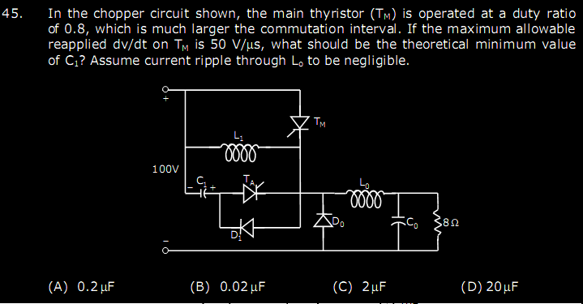

Answer Keys
1 B 2 C 3 A 4 D 5 B 6 D 7 A
8 A 9 B 10 D 11 D 12 B 13 A 14 C
15 B 16 C 17 C 18 D 19 B 20 C 21 D
22 C 23 A 24 A 25 D 26 C 27 D 28 D
29 B 30 C 31 C 32 A 33 A 34 B 35 B
36 A 37 A 38 C 39 A 40 D 41 D 42 C
43 A 44 C 45 A 46 C 47 B 48 C 49 A
50 A 51 B 52 C 53 D 54 A 55 C 56 B
57 A 58 A 59 B 60 D

