2011
PAPER V
Time : 3 HoursMax. Marks: 150

Note:
- The candidate has to answer 15 questions @ 5 questions from each section. Each question carries 10 marks.
- Give the steps of calculation in each question.
- Calculators, not programmable, are allowed in the examination.

SECTION I

  - The average (arithmetic mean) of a list of 6 numbers is 20. If we remove one of the number, the average of the remaining numbers is 15. What is the number that was removed?
OR
  - The average score of a cricketer in certain number of innings is 15. When he scored a duck in one innings his average dropped to 13.5. How many innings have been played totally including the latest one?

  - The average marks of 3 students A, B and C are 48. Another student D joins the group and the new average becomes 44 marks. If another student E, whop has 3 marks more than D, joins the group, the average of the 4 students B, C, D and E becomes 43 marks. Find how many marks A got in the exam.
OR
  - There are five containers in a truck’s hold. The weight of the first container is 150 kg and the weight of the second container is 30% higher than the weight of the 3rd container, whose weight is 20% lighter than the first container’s weight. The weight of the fourth container is equal to the average weight of the first and the 3rd container and the weight of the 5th container is equal to the average of the weight of 2nd and 4th container. Find the average of the 4 lighter containers and the 4 heavier containers.

  - 3 different numbers are chosen such that when each of the numbers is added to the average of the remaining 2, it given 65, 69 and 76 as a result. What is the average of the 3 original number?
OR
  - Davinder scored a total of 252 point in 28 basketball games. Raman played 10 fewer games than Davinder and his scoring average was 0.5 points per game higher than Davidern’s scoring average. How many points, in total did Raman score.

  - A passenger train covers the distance between stations X and Y, 50 minutes faster than a goods train. Find this distance if the average speed of the passenger train is 60 kmph and that of the goods train is 20 kmph.
OR
  - Jim travels the first 3 hours of his journey at 60 mph speed and the remaining 5 hours at 24 mph speed. What is the average speed of Jim’s travel in mph?

  - 3 Math classes X, Y and Z taken an algebra test. The average score in class X is 83. The average score in class Y is 76. The average score in class Z is 85. The average score of all students in classes X and Y together is 79.The average score of all students in classes Y and Z together is 81. What is the average for all the 3 classes?
OR
  - The average wages of a worker during a fortnight comprising 15 consecutive working days was Rs. 90 per day. During the first 7 days, his average wages was Rs. 87/day and the average wages during the last 7 days was Rs. 92/day. What was his wage on the 8th day?

SECTION II

  - If A + B means A is the mother of B; A — B means A is the brother of B; A ÷ B means A is the father of B and A x B means A is the sister of B, how do you encode "P is the maternal uncle of Q" ?
OR
  - B5D means B is the father of D.
B9D means B is the sister of D.
B4D means B is the brother of D.
B3D means B is the wife of D.
How do you represent, "F is the mother of K" ?

  - Study the following line graph and answer the questions:
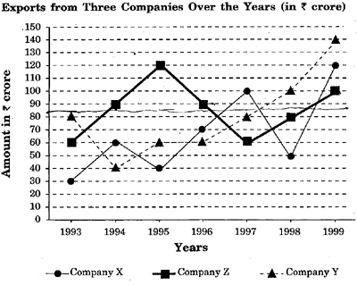
    - For which of the following pairs of years are the total exports from the 3 companies together equal ?
    - Average annual exports during the given period for company Y is approximately what percent of the average annual exports for company Z ?
    - In which year was the difference between the exports from companies X and Y the minimum ?
    - What was the difference between the average exports of the 3 companies in 1993 and the average exports in 1998 ?
    - In how many of the given years, were the exports from company Z more than the average annual exports over the given years ?
OR
  - The following line graph gives the ratio of the amount of imports by a company to the amount of exports from that company over the period from 1995 to 2001
Ratio of Value of Imports to Exports by a Company Over the Years
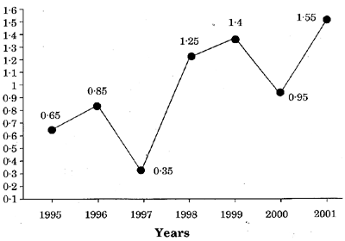
    - If the imports in 1998 was 250 crores and the total exports in the years 1998 and 1999 together was 500 crores, then what was the imports in 1999 ?
    - The imports were minimum proportionate to the exports of the company in which of the years ?
    - What was the % increase in imports from 1997 to 1998 ? Is the data sufficient to answer this question ? If not, why ?
    - If the imports of the company in 1996 was 272 crores, what was the exports from the company in 1996 ?
    - In how many of the given years were the exports more than the imports ?

  - Study the following table and answer the questions based on it:
Expenditures of company (in lakh rupees) per annum over the given years
Year | Item of Expenditure |  |  |  | Taxes
 | Salary | Fuel and Transport | Bonus | Interest on loans
1998 | 288 | 98 | 3 | 23.4 | 83
1999 | 342 | 112 | 2.52 | 32.5 | 108
2000 | 324 | 101 | 3.84 | 41.6 | 74
2001 | 336 | 133 | 3.68 | 36.4 | 88
2002 | 420 | 142 | 3.96 | 49.4 | 98

    - What is the average amount of interest per year which the company had to pay during this period?
    - The total amount of bonus paid by the company during the given period is approximately what % of the total amount of salary paid during this period?
    - Total expenditure on all these items in 1988 was approximately what % of the total expenditure in 2002?
    - What is the total expenditure of the company on these items during the year 2000?
    - What is the approximate ratio between the total expenditure on taxes for all the years and the total expenditure on fuel and transport for all the years?
OR
  - Study the following table and answer the questions:
Number of candidates who appeared and qualified in a competitive examination from different states over the years
State | Item of Expenditure
 | 1997 |  | 1998 |  | 1999 |  | 2000 |  | 2001
 | App. | Qual. | App. | Qual. | App. | Qual. | App. | Qual. | App. | Qual.
M | 5200 | 720 | 8500 | 980 | 7400 | 850 | 6800 | 775 | 9500 | 112 5
N | 7500 | 840 | 9200 | 1050 | 8450 | 920 | 9200 | 980 | 8800 | 10 20
P | 6400 | 780 | 8800 | 1020 | 7800 | 890 | 8750 | 1010 | 9750 | 1 250
Q | 8100 | 980 | 9500 | 1240 | 8700 | 980 | 9700 | 1200 | 8950 | 9 95
R | 7800 | 870 | 7600 | 940 | 9800 | 1350 | 7600 | 945 | 7990 | 88 5

    - Total number of candidates qualified from all the states together in 1997 is approximately what % of the total number of candidates qualified from all the states together in 1998 ?
    - What is the average of candidates who appeared from state Q during the given years ?
    - In which of the given years the number of candidates who appeared from state P has maximum % of qualified candidates ?
    - What is the % of candidates qualified from state N for all the years together, over the candidates appeared from state N during all the years together ?
    - What is the % of total number of qualified candidates to the total number of appeared candidates among all the 5 states in 1999 ?

  - The bar graph given below shows the sales of books (in thousand numbers) from 6 branche of a Publishing Company during 2 consecutive years 2000 and 2001
Sales of Books (in thousand numbers) from Six Branches - B1, B2, B3 B4, B5 and B6 of a Publishing Company in 2000 and 2001
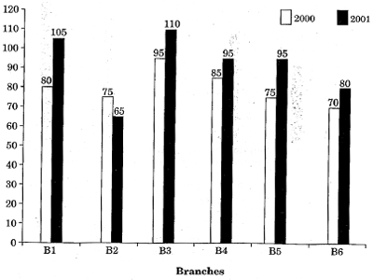
    - What is the ratio of total sales of branch B2 for both years to the total sales of branch B4 for both years.?
    - Total sales of branch B6 for both the years is what % of the total sales of branch B3 for both the years ?
    - What % of the average sales of branches B 1, B2 and B3 in 2001 is the average sales of branches B 1, B3 and 136 in 2000 ?
    - What is the average sales of all the branches (in thousand numbers) for the year 2000 ?
    - What is the total sales of branches Bl, B3 and B5 together for both the years (in thousand numbers) ?
OR
  - The bar graph given below shows the data of the production of paper (in lakh tonnes) by 3 different companies X, Y and Z over the years
Production of Paper (in lakh tonnes) by Three Companies X, Y and Z over the Years
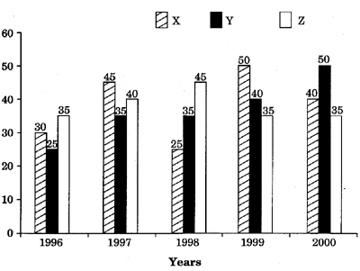
    - For which of the following years, the % rise/fall in production from the previous year is the maximum for company Y?
    - What is the ratio of the average production of company X in the period 1998 — 2000 to the average production of company Y in the same period ?
    - The average production for 5 years was maximum for which company?
    - In which year was the % of production of company Z to the production of company Y the maximum?
    - What is the % increase in the production of company Y from 1996 to 1999 ?

  - The following pie-chart shows the % distribution of the expenditure incurred in publishing a book. Study the pie-chart and then answer the questions based on it
Various Expenditures (in percentage) Incurred in Publishing a Book
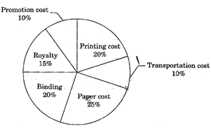
    - If for a certain quantity of books, the publisher has to pay Rs. 30,600 as printing cost, then what will be the amount of royalty to be paid for these books ?
    - What is the central angle of the sector corresponding to the expenditure incurred on royalty?
    - The price of the book is marked 20% above the C.P If the marked price of the book is Rs. 180, then what is the cost of the paper used in a single copy of the book?
    - If 5500 copies are published and the ,transportation cost on them amounts to Z 82,500, then What should be the selling price of the book so that the publisher can earn a profit of 25% ?
    - By how much is the royalty on the book less than the printing cost ?
OR
  - The following pie charts show the distribution of students of graduate an post-graduate levels in seven different institutes in a town:
Distribution of students at graduate and post-graduate levels ir seven institutes
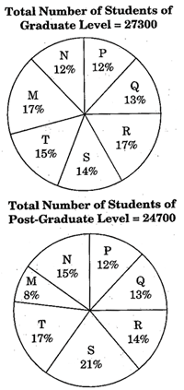
    - What is the total number of graduate and post-graduate level students in institute R ?
    - What is the ratio between the number of students studying at post-graduate and graduate levels respectively from institute S ?
    - How many students of institutes M and S are studying at graduate level ?
    - What is the ratio between the number of students studying at post-graduate level from institute S and the number of students studying at graduate level from institute Q ?
    - What is the total number of students studying at post-graduate level from institutes N and P ?

SECTION III

  - In this series what number should come next ?
2, 1, (1/2), (1/4),_______
  - In this series what number should come next ?
7, 10, 8, 11, 9, 12, ______
  - In this series which pair of numbers comes next ?
42, 40, 38, 35, 33, 31, 28, _______
  - What number should fill the blank in the series ? F2, ____, D8, C16, B32
  - Look at this series : V, VIII, XI, XIV,_______ , XX. What number should fill the blank?
OR
  - In this series 8, 12, 9, 13,10, 14, 11,_________which pair of numbers comes next ?
  - Fill the blank in the series : SCD, TEF, UGH,______, WKL
  - Odometer is to Mileage as Compass is to
  - Marathon is to Race as Hibernation is to ?
  - Window is to Pane as Book is to

  - If KEDGY is coded as EKDYG then how will LIGHT be coded ?
  - If RAVE is coded as SXWB then how will SCAW be coded ?
  - If PURSER is coded as UPSRRE then how will PERIODIC be coded ?
  - If STRAY is coded as TUSBZ then how will MOURN be coded ?
  - If BINARY is coded as DHPZTK then how will KIDNAP be coded ?
OR
  - If RASCAL is coded as QZRBZK then how will SOLDER be coded ?
  - If MAPLE is coded as VOKZN then how will CAMEL be coded ?
  - What is the odd number out of : 126, 32, 81, 24, 18, 45, 69 ?
  - What is the odd number out of : 46080, 3840, 384, 48, 24, 2, 1 ?
  - What is the odd number out of : 5, 16, 6, 16, 7, 16, 9 ?

  - Find the day on 23rd May 1957.
  - Find the day on 22nd December 1987.
  - An accurate clock shows 8 o'clock in the morning. Through how many degrees will the hour hand rotate when the clock shows 2 o'clock in the afternoon ?
OR
  - What is the reflex angle between the hands of a clock at 10-25 ?
  - A, P, R, X, S and Z are sitting in a row. S and Z are in the centre. A and P are at the ends. R is sitting to the left of A. Who is to the right of P ?
  - A, B, C, D and E are sitting on a bench. A is sitting next to B, C is sitting next to D, D is not sitting with E who is on the left end of the bench. C is on the second position from the right. A is to the right of B and E. A and C are sitting together. In which position is A sitting ?

  - "What really matters in the leadership of business and organisations is getting results, reaching benchmarks, and achieving success." Discuss the extent to which you agree or disagree with the statement above. Support your views with reasons and/or examples from your own experience, education, observation, or reading.
OR
  - When someone achieves greatness in any field such as the arts, science, politics or business — that person's achievements are more important than any of his or her personal faults. Discuss.

  - Canopy of Nature
Dad decided last Sunday that we should all go on a camping trip. He read an article in the Sunday paper about camping and how it "brings families together under the canopy of nature". "Overrated," I joked. "What about the canopy of television or the canopy of resaurant food ?" "This will be good for us," Dad said, sliding the magazine across the coffee table. "Let's go next week-end." I shot a quick look over at my little brother, Paul. He gave me a slow eyebrow raise which meant, "This will probably not go off completely as planned." My smile back said, "But it will surely be fun." I started to think back. Once Dad decided "We should all learn how to canoe." We borrowed two canoes from our friends, hoisted them on the van and drove for 3 hours to a secluded lake in Virginia. Once we got there, we discovered that we had forgotten the paddles. Paul and I got in a canoe with Dad, and our 2 younger sisters got in a canoe with Mom. We floated aimlessly around the lake for hours, then we all jumped in with our life jackets on. We pushed the canoes back to shore. It was a fantastic trip. Another time, Dad decided "We should all learn how to ski." All of us hate the cold so we spent the week-end huddled by the fire, drinking hot cocoa in the ski lodge and playing board games. It was great. We had a blast. When I stopped day-dreaming, Mom was saying, "Sweetheart, we don't have a tent." "We don't need one !" Dad said happily. "We'll take all the seats out of the van when we get to the campsite and put in an air mattress." I don't know what the punch line will be on this excursion, but I am sure with Mom, Dad and the four of us kids scrunched up in a van at some national park, we are bound to have a good time.
    - Why might the narrator say that the camping trip will have a punch line ?
    - "Then we all jumped in with our life jackets on. We pushed the canoes back to shore." Combine the above sentences and phrase it differently.
    - What literary term best describes the narrator's daydreams ?
    - Suggest another title that fits this passage best.
    - What lesson does the narrator's family seem to live by ?
OR
  - Elizabeth was brooding in her room. She had sought asylum there since spurious gossip began circulating about her at Seagrove Academy last week. Not that Elizabeth had ever been considered a social butterfly. She preferred to live vicariously through the brazen stories of her friends: late night partying, fraternizing with boys, childish pranks. Still, she has taken to being more by herself than usual since the allegations surfaced. Up for consideration for the highly coveted Blauvelt Award, a scholarship recognising "academic integrity and promise," an anonymous student had given headmaster Billings the "tip" that Elizabeth had cheated on several tests this year. The accusations were laughable. Elizabeth had long been a stellar student at Seagrove. She lacked a natural intelligence — this was true. However, she more than made up for this deficit through diligence and perseverance. Still, the accusations had given the recommendation committee pause. Elizabeth had been called to Mr. Billings' grand office on Friday and asked copious questions about her recent exams. The experience was quite traumatic. Seagrove is an elite school. Most of its students come from privileged backgrounds. This was not the case for Elizabeth. Her family had little money. She attended Seagrove on a full scholarship. The Blauvelt Award would help her family pay for college. So, it was with the same diligence with which she applied herself to her studies that Elizabeth planned to unmask her accuser. She opened the school directory on her bed and began combing through the names. Seagrove was such a small and insular community. Twenty-one kids would be in her graduating class. Elizabeth knew it was inevitable that the person spreading rumours about her would come to light. It was just a matter of time.
    - "However, she more than made up for his deficit through diligence and perseverance." Paraphrase the above sentence.
    - Why should cheating have likely knocked Elizabeth out of the running for the Blauvelt Award ?
    - How is Elizabeth different than many of her peers ?
    - What does the reader learn about the kind of school Seagrove Academy is ?
    - What do you learn about the student who accused Elizabeth of cheating ?

