Eamcet 2007 Solved Paper
Some physical constants are given in List-I and their dimensional formulas are given in List-II. Match the following
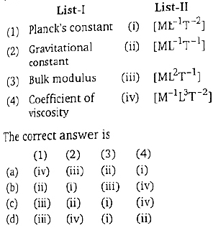
A. a
B. b
C. c
D. d
Velocity and acceleration vectors of charged particle moving perpendicular to the direction of magnetic field at a given instant of time are respectively. Then the value of c is
A. 3
B. 1.5
C. -1.5
D. -3
A block of mass m = 25 kg sliding on a smooth horizontal surface with a velocity v = 3 meets the spring constant k = 100 N/m fixed at one end as shown in figure. The maximum compression of the spring and velocity of block as it return to the original position respectively are
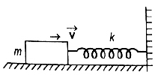
A.
B.
C.
D.
A rifle of 20 kg. Mass can fire 4 bullets per second. The mass of each bullet is and its final velocity is Then what force must be applioed on the rifle so that it does not move backward while firing the bullets?
A. 80 N
B. 28 N
C. -112 N
D. -56 N

An object of mass 2 m is projected with speed of at an angle 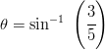to the horizontal. At the highest point, the object breaks into two pieces of the same mass m and the first one comes to rest. The distance between the point of projection and the point of landing of the bigger piece (in metre) is
(given, )
A. 3840
B. 1280
C. 1440
D. 960
Two bodies of 6 kg and 4 kg masses have their velocity and respectively. Then the velocity of their centre of mass is
A.
B.
C.
D.
In two separate collisions, the coefficient of restitutions and are in the ratio 3:1, In the first collision the relative velocity of approach is twice the relative velocity of separation, then the ratio between relative velocity of approach and the relative velocity of separation in the second collision is
A 1:6
B. 2:3
C. 3:2
D. 6:1
A man slides down on a telegraphic pole with an acceleration equal to one-fourth of acceleration due to gravity. The frictional force between man and pole is equal to in terms of man’s weight w
A.
B.
C.
D. w
A bucket filled with water is tied to a rope of length 0.5 m and is rotated in a circular path in vertical plane. the least velocity it should have at the lowest point of circle so that water does not spill is,
A.
B.
C.
D.
Two solid sphere (A and B) are made of metals of different densities and respectively. If their masses are equal, the ratio of their moments of inertia about their respective diameter is
A. 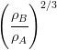
B. 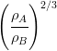
C.
D.
The mass of a planet is half of the earth and the radius of the planet is one-fourth that of earth. If we plan to send an artificial satellite from the planet, the escape velocity will be, (escape velocity on earth )
A.
B.
C.
D.
The magnitude of maximum acceleration is times that of maximum velocity of a simple harmonic oscillator. The time period of the oscillator in seconds is
A. 4
B. 2
C. 1
D. 0.5
When a wire of length 10 m is subjected to a force of 100 N along its length, the lateral strain produced is The Poisson’s ratio was found to be 0.4 If the area of cross-section of wire is its Young’s modules is
A.
B.
C.
D.
A liquid does not wet the solid surface if the angle of contact is
A. zero
B. equal to
C. equal to
D. greater than
A horizontal pipe of non-uniform cross-section allows water to flow through it with velocity when pressure is 50 kPa at a point. If the velocity of flow has to be at some other point, the pressure at that point should be
A. 50 kPa
B. 100 kPa
C. 48.5 kPa
D. 24.25 kPa
A clock which keeps correct time at is subjected to If coefficient of linear expansion of the pendulum is How much will it gain or lose time ?
A. 10.3 s/day
B. 20.6 s/day
C. 5 s/day
D. 20 min/day
Two gases A and B having some pressure P, Volume V and absolute temperature T are mixed. If the mixture has the volume and temperature as V and T respectively, then the pressure of the mixture is
A. 2 P
B. P
C.
D. 4P
The temperature of the system decrease in the process of
A. free expansion
B. adiabatic expansion
C. isothermal expansion
D. isothermal compression
Two cylinder A and B fitted with pistons, contain equal number of moles of an ideal mono atomic gas at 400 K. The piston of A is free to move while that of B is held fixed. Same amount of heat energy is given to the gas in each cylinder. if the rise in temperature of the gas in A is 42 K, the rise in temperature of the B is
A. 25.2 K
B. 35 K
C. 42 K
D. 70 K
A black body radiates energy at the rate of E watt/ at high temperature T K. When the temperature is reduced to 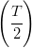K, the radiant energy is
A.
B. 2E
C.
D.
A whistle of frequency 540 Hz rotates in a horizontal circle of radius 2 m at an angular speed of 15 rad/s. The highest frequency heard by a listener at rest with respect to the centre of the circle (velocity of sound in air )
A. 590 Hz
B. 594 Hz
C. 598 Hz
D. 602 Hz
A segment of wire vibrates with a fundamental frequency of 450 Hz under a tension of 9 kg wt. Then tension at which the fundamental frequency of the same wire becomes 900 Hz is
A. 36 kg-wt
B. 27 kg-wt
C. 18 kg-wt
D. 72 kg-wt
Match the following
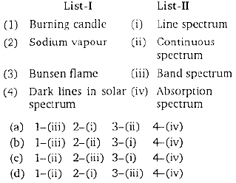
A. a
B. b
C. c
D. d
The refractive index of the material of a double convex lens is 1.5 and its focal length is 5 cm. If the radii of curvature are equal, the value of the radius of curvature (in cm) is
A. 5.0
B. 6.5
C. 8.0
D. 9.5
In Ramsden eyepiece, the two planoconvex lenses each of focal length f are separated by a distance 12 cm. The equivalent focal length (in cm) of the eyepiece is
A. 10.5
B. 12.0
C. 13.5
D. 15.5
In Huygen’s eyepiece
A. The cross wires are outside the eyepiece
B. Condition for achormatism is satisfied
C. condition for minimum spherical aberration is not satisfied
D. The image formed by the objective is a virtual image
A bar-magnet of moment of inertia vibrates in a magnetic field of induction The time period of the vibration is 8.8 s. The magnetic moment of the bar magnet is
A.
B.
C.
D.
A bar magnet of magnetic moment M and moment of inertia I is freely suspended such that the magnetic axial line is in the direction of magnetic meridian. If the magnet is displaced by a vuery small angle the angular acceleration is (Magnetic induction of earth’s horizontal field )
A. 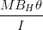
B. 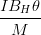
C. 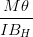
D. 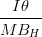
Along with x-axis, there charges and are placed at and respectively. The resultant electric potential at a point P located at a distance r from the charge is ( is the premittivity of free space)
A. 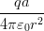
B. 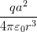
C. 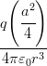
D. 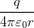
Two unit negative charges are placed on a straight line. A positive charge q is placed exactly at the mid point between these unit charges. If the system of these three charges is in equilibrium, the value of q (in C) is
A. 1.0
B. 0.75
C. 0.5
D. 0.25
In a metre bridge experiment, the ratio of the left gap resistance to the right gap resistance is 2 : 3, the balance point from the left is
A. 60 cm
B. 50 cm
C. 40 cm
D. 20 cm
n aluminium (resistivity ) wire of a diameter 1.4 mm is used to make a resistor. The length of the wire is
A. 220 m
B. 1000 m
C. 280 m
D. 1 m
An aluminium (resistivity ) wire of a diameter 1.4 mm is used to make a resistor. The length of the wire is
A. 220 m
B. 1000 m
C. 280 m
D. 1 m
Temperature of cold junction in a thermocouple is and netural temperature is then the temperature of inversion is
A.
B.
C.
D.
Two wires A and B are of length 40 cm and 30 cm. A is bent into a circle of radius r and B into an arc of radius r. A current is passed through A and through B. To have same magnetic inductions at the centre, the ratio of is
A. 3:4
B. 3:5
C. 2:3
D. 4:3
The natural frequency of an L-C circuit is 1,25,000 cycle/s. Then the capacitor C is replaced by another capacitor with a dielectric medium of dielectric constant K. In this case, the frequency decreases by 25 kHz. The value of K is
A. 3.0
B. 2.1
C. 1.56
D. 1.7
An electron beam travel with a velocity of perpendicularly to magnetic field of intensity 0.1 T. The radius of the path of the electron beam
A.
B.
C.
D.
The work function of the nickel is 5 eV. When a light of wavelength 2000 falls on it, it emits photo electrons in the circuit. Then the potential differences necessary to stop the fastest electrons emitted is (given )
A. 1.0 V
B. 1.75 V
C. 1.25 V
D. 0.75 V
In an experiment on photoelectric emission from a metallic surface, wavelength of incident light is and stopping potential is 2.5 V. The threshold frequency of the metal (in Hz) approximately (charge of electron Planck’s constant )
A.
B.
C.
D.
In Sun, the important source of energy is
A. proton-proton cycle
B. carbon-nitrogen cycle
C. carbon-carbon cycle
D. nitrogen-nitrogen cycle
In an n-type semiconductor, the fermi energy level lies
A. in the forbidden energy gap nearer to the conduction band
B. in the forbidden energy gap nearer to the valence band
C. in the middle of forbidden energy gap
D. outside the forbidden energy gap
Identify ‘B’ in the following reaction
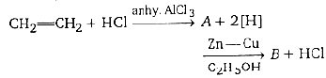
A.
B.
C.
D.
Which of the following pair of transition metal ions, have the same calculated value of the magnetic moment ?
A.
B.
C.
D.
The formula of the product formed, when sodium thiosulphate solution is added to silver bromide is
A.
B.
C.
D.
The chemical fo Assertion (A) : NaCl is less soluble in heavy water than in ordinary water.
Reason® : Dielectric constant of ordinary water is more than that of heavy water.
The correct answer is
A. Both (A) and® are true and® is the correct explanation of (A)
B. Both (A) and® are true but® is not the correct explanation of (A)
C. (A) is true, but® is not true
D. (A) is not true, but® is true
rmula of feldspar is Calculate enthalpy for formation of ethylene from the following data
(I).
(II). 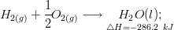
(III).
A. 54.1 kJ
B. 44.8 kJ
C. 51.4 kJ
D. 48.4 kJ

A radioactive substance (IIA) emits and particles to form “Y”. To which group of long form of the periodic table does “Y” belong ?
A. IVA
B. VA
C. VIA
D. VIIA
An oxide of an element is a gas and dissolves in water to give an acidic solution. The element belongs to
A. II group
B. IV group
C. VIII group
D. zero group
Assertion (A) : Equal moles of different substances contain same number of constituent particles.
Reason ( R) : Equal weight of different substances contain the same number of constituents particles
The correct answer is
A. Both (A) and ( R) are true and ( R) is the correct explanation of (A)
B. Both (A) and ( R) are true but ( R) is not the correct explanation of (A)
C. (A) is true, but ( R) is false
D. (A) is false, but ( R) is true
Which of the following is not a conjugate acid-base pair ?
A.
B.
C.
D.
The functional group present in ‘salol’ are
A.
B.
C.
D.

A.
B.
C.
D.
What is ‘Y’ ?
A.
B.
C.
D.
The wavelength of a spectral line emitted by hydrogen atom in the Lyman series is 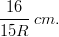
What is the value of ? (R = Rydberg constant)
A. 2
B. 3
C. 4
D. 1
The decreasing order of bond dissociation energies of C-C, C-H and H-H bonds is
A. H- H > – C – H > – C – C -
B. – C – C – > C – H > H – H
C. – C – H > – C – C – > H – H
D. – C – C – > H – H > – C – H
138 g of ethyl alcohol is mixed with 72 g of water. The ratio of mole fraction of alcohol to water is
A. 3 : 4
B. 1 : 2
C. 1 : 4
D. 1 : 1
Which of the following statement is correct ?
A. Silicon doped with boron is an n-type semiconductor
B. Silicon doped with arsenic is a p-type semiconductor
C. Metal are good conductor of electricity
D. Electrical conductivity of a semiconductor decreases with increasing temperature
Which of the following is a biodegradable polymer ?
A. Polythene
B. Bakelite
C. PHBV
D. PVC
In the above reactions ‘A’ and ‘B’ respectively are
A.
B.
C.
D.
Hybridisation of oxygen in diethyl ether is
A. sp
B.
C.
D.
Match the following
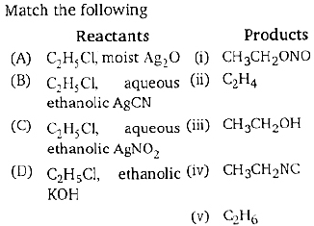
The correct match is
A. A-v, B-III, C-iv, D-i
B. A-i, B-ii, C-iii, D-iv
C. A-iii, B-iv, C-i, D-ii
D. A-iv, B-i, C-ii, D-v
The IUPAC name of the compound is
A. 5-methyl-hex-3-en-2-ol
B. 2-methyl-hex-3-en-5-ol
C. 2-hydroxy-5-methyl-3-hexene
D. 5-hydroxy-2-methyl-3-hexene
Which one of the following noble gases is used in miner’s cap lamps ?
A. Helium
B. Neon
C. Argon
D. Krypton
The following are some statement related to VA group hydrides,
I. Reducing property increase from to
II. Tendency to donate lone pair decreases from to
III. Thermal stability of hydrides decreases from to
IV. Bond angle of hydrides decreases from to
The correct statement are
A. I, II, III, and IV
B. I, III, and IV
C. I, II and IV
D. I and IV
Which one of the following salts give an acidic solution in water ?
A.
B.
C.
D.
Which of the following is an example of interstitial hydride ?
A.
B.
C.
D.
Assertion (A) : A catalyst increase the rate of a reaction.
Reason ( R) : In presence of catalyst, the activation energy of the reaction increases.
The correct answer is
A. Both (A) and ( R) are true and ( R) is the correct explanation of (A)
B. Both (A) and ( R) are true but ( R) is not the correct explanation of (A)
C. (A) is true, but ( R) is not true
D. (A) is not true, but ( R) is true
The maximum number of sub-levels, orbitals and electrons in N shell of an atom are respectively
A. 4, 12, 32
B. 4, 16, 30
C. 4, 16, 32
D. 4, 32, 64
Which of the following is not tetrahedral ?
A.
B.
C.
D.
A certain mass of gas occupies a volume of 2L. at STP. To what temperature the gas must be heated to double its volume, keeping the pressure constant?
A. 100 K
B. 273 K
C.
D.
Calculate the emf of the cell
Given
A. +0.46 V
B. +1.14 V
C. +0.57 V
D. -0.46 V
Which of the following biomolecules acts as specific catalysts in biological reaction ?
A. Carbohydrates
B. Lipids
C. Vitamins
D. Enzymes
Nitrobenzene on reduction with zinc and gives
A. azobenzene
B. aniline
C. hydrazobenzene
D. N-phenyl hydroxylamine
An organic compound ‘X’ on treatment with pyridinium chloro chormate in dichlormethane gives compound ‘Y’. Compound ‘Y’, reacts will and alkali to from triiodomethene. The compound ‘X’ is
A.
B.
C.
D.
Aqueous solution of man organic compound, ‘A’ on electrolysis liberates acetylene and at anode. ‘A’ is
A. potassium acetate
B. potassium succinate
C. potassium citrate
D. potassium maleate
Bhopal gas tragedy of 1984 was caused by
A. carbon monoxide
B. phosgene
C. methyl cyanate
D. methyl isocyanate
Which of the following is not a peroxy acid ?
A. Perphosphoric acid
B. Pernitric acid
C. Perdisulphuric acid
D. Perchloric acid
Calorific value of producer gas is low because of
A. high percent of
B. Low percent of
C. high percent of
D. Low percent of
Among the following, which is water insoluble ?
A. Sodium fluoride
B. Potassium fluoride
C. Beryllium fluoride
D. Magnesium fluoride
Which of the following is not correct ?
A. Milk is a naturally occurring emulsion
B. Gold sol is a lyophilic sol
C. Physical adsorption decreases with rise in temperature
D. Chemical adsorption is uni layered
The equilibrium constant for the reaction 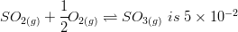atm.
would be
A. 100 atm
B. 200 atm
C.
D.
If Q denotes the set of all rational number and 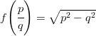for any 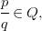then observe the following statements.
I. 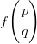is real for each
II. is a complex number for each
Which of the following is correct ?
A. Both I and II are true
B. I is true, II is false
C. I is false, II is true
D. Both I and II are false
If and is defined by 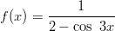for each then the range of f is
A. (1 / 3, 1)
B. [1 / 3, 1]
C. (1, 2)
D. [1, 2]
If and are defined by and for where [x] is the greatest integer not exceeding x, then for every is equal to
A. x
B. 0
C. f (x)
D. g (x)
is equal to
A. 1
B. 2
C. 3
D. 4
If the value of 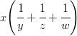is
A.
B.
C.
D.
If and then
A.
B.
C.
D.
The number of ways of arranging 8 men and 4 women around a circular table such that no two women can sit together is
A. 8!
B. 4!
C. 8! 4!
D.
If a polygon of n side has 275 diagonals, then n is equal to
A. 25
B. 35
C. 20
D. 15
If is the coefficient of in the expansion of for then is equal to
A.
B.
C.
D.
The sum of the series
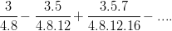
A. 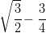
B. 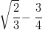
C. 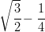
D. 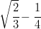
If 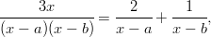then a : b is equal to
A. 1 : 2
B. -2 : 1
C. 1 : 3
D. 3 : 1
The coefficient of in the expansion of 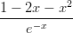is
A. 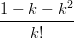
B. 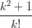
C. 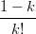
D.
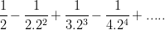is equal to
A.
B. 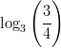
C. 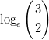
D. 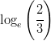
If and are the roots of the equation and, if has roots 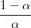and 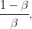then r is equal to
A. a + 2b
B. a + b + c
C. ab + bc + ca
D. abc
The set of values of x for which the inequalities hold simultaneously, is
A. (-2, 5)
B. (2, 8)
C. (-2, 8)
D. (2, 5)
If 1, 2, 3 and 4 are the roots of the equation then a + 2b + c is equal to
A. -25
B. 0
C. 10
D. 24
If are the roots of then the value of is
A. -7
B. -5
C. -3
D. 0
f 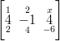is a singular matrix, then x is equal to
A. 0
B. 1
C. -3
D. 3
If A is a square matrix such that A(adj A) = 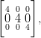then det(adj A) is equal to
A. 4
B. 16
C. 64
D. 256
he number of non-trivial solution of the system
is
A. 0
B. 1
C. 2
D. 3
If 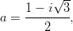then the correct matching of ‘List-I from List-II is
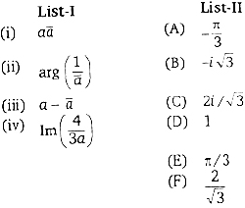
Correct match is
A. (i)-D, (ii)-E, (iii)-C, (iv)-B
B. (i)-D, (ii)-A, (iii)-B, (iv)-F
C. (i)-F, (ii)-E, (iii)-B, (iv)-C
D. (i)-D, (ii)-A, (iii)-B, (iv)-C
The locus of the point satisfying 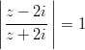is
A. x-axis
B. y-axis
C. y = 2
D. x = 2
A value of such that 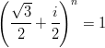is
A. 12
B. 3
C. 2
D. 1
If lies in the first quadrant and then 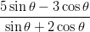is equal to
A.
B.
C.
D. 0
If and then which one of the following is true ?
A. 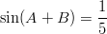
B. 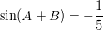
C. 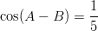
D. 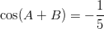
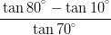is equal to
A. 0
B. 1
C. 2
D. 3
is equal to
A. 0
B. 2
C. 1
D. -1
If a, b, c are in AP, b – a, c – b and a are in GP, then a : b : c is
A. 1 : 2 : 3
B. 1 : 3 : 5
C. 2 : 3 : 5
D. 1 : 2 : 4
The value of x, where x > 0 and 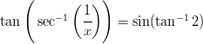is
A.
B.
C. 1
D. 2/3
is equal to
A. 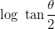
B. 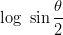
C. 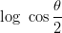
D. 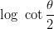
If the angles of ABC are and then the ratio of the smallest and the greatest sides are
A.
B.
C.
D.
In ABC, (a + b + c) 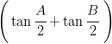is equal to
A. 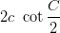
B. 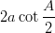
C. 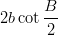
D. 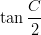
In ABC, with usual notation, observe the two statement given below :
(I)
(II)
Which of the following is correct ?
A. Both I and II are true
B. I is true, II is false
C. I is false, II is true
D. Both I and II are false
The angle of elevation of an object from a point P on the level ground is Moving d metres on the ground towards the object, the angle of elevation is found to be Then the height (in metres) of the object is
A.
B.
C. 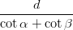
D. 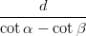
If the point whose position vectors are and are collinear, then the value of p is
A. 2
B. 4
C. 6
D. 8
The ratio in which divides the join of and is
A. 2 : 1
B. 2 : 3
C. 3 : 4
D. 1 : 4
If and and the orthogonal projection of on is 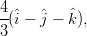then is equal to
A. 0
B. 2
C. 12
D. -1
The volume (in cubic units) of the tetrahedron with edges and is
A. 4
B. 2/3
C. 1/6
D. 1/3
Let
Assertion (A) : the identify
holds for
Reason ( R) :
Which of the following is correct ?
A. Both (A) and ( R) are true and ( R) is the correct reason for (A)
B. Both (A) and ( R) are true but ( R) is not the correct reason for (A)
C. (A) is true, ( R) is false
D. (A) is false, ( R) is true
Four numbers are chosen at random from {1, 2, 3, ......, 40}. The probability that they are not consecutive, is
A. 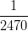
B. 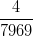
C. 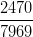
D. 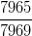
If A and B are mutually exclusive events with then is equal (Here is the complement of the event B)
A. 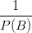
B. 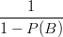
C. 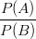
D. 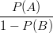
A bag contain 6 white and 4 black balls. Two balls are drawn at random. The probability that they are of the same colour, is
A. 1/15
B. 2/5
C. 4/15
D. 7/15
The mean and standard deviation of a binomial variate x are 4 and respectively. Then is equal to
A. 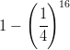
B. 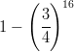
C. 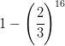
D. 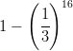
The probability distribution of a random variable X is given by
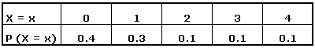
The variance of X is
A. 1.76
B. 2.45
C. 3.2
D. 4.8
In order to eliminate the first degree terms from
the point to which origin is to be shifted, is
A. (1, -3)
B. (2, 3)
C. (-2, 3)
D. (1, 3)
The angle between the line joining the points (1, -2), (3, 2) and the line is
A.
B.
C.
D.
If A (2, -1) and B(6, 5) are two points the ratio in which the foot of the perpendicular from (4, 1) to AB divides it, is
A. 8 : 15
B. 5 : 8
C. -5 : 8
D. -8 : 5
n the triangle with vertical at A(6, 3), B(-6, 3) and C(-6, -3), the median through A meets BC at p, the line AC meets the x-axis at Q, while R and S respectively denote the orthocentre and centroid of the triangle. Then the correct matching of the coordinates of point in List-I to List-II is
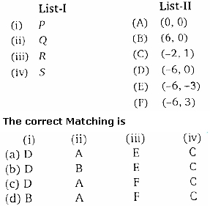
A. (a)
B. (b)
C. (c)
D. (d)
the angle between the pair of straight line formed by joining the points of intersection of and to the origin is right angle. The is equal to
A. 20
B. 13
C. 1/5
D. 5
If the lines
and are concurrent, then the value of is
A. 0
B. 1
C. -1
D. 2
The ratio in which yz-plane divides the line segment joining (-3, 4, -2) and (2, 1, 3) is
A. -4 : 1
B. 3 : 2
C. -2 : 3
D. 1 : 4
The cosine of the angle A of the triangle with vertices A(1, -1, 2), B(6, 11, 2), C(1, 2, 6) is
A. 63/65
B. 36/65
C. 16/65
D. 13/64
The equation of the circle of radius 3 that lies in the fourth quadrant and touching the lines x = 0 and y = 0 is
A.
B.
C.
D.
The inverse point of (1, 2) with respect to the circle is
A. (0, 0)
B. (1, 0)
C. (0, 1)
D. (1, 1)
The condition for the coaxial system where is a parameter and c is a constant, to have distinct limiting points, is
A. c = 0
B. c < 0
C. c = -1
D. c > 0
For the parabola
(I) The vertex is (-2, -3)
(II)The directrix is y + 3 = 0
Which of the following is correct ?
A. Both I and II are true
B. I is true, II is false
C. I is false, II is true
D. Both I and II are false
The value of k, if (1, 2), (k, -1) are the conjugate points with respect to the ellipse is
A. 2
B. 4
C. 6
D. 8
If the line lx + my = 1 is normal to the hyperbola
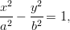then 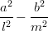is equal to
A.
B.
C.
D.
The area (in square unit) of the triangle formed by the points with polar coordinates 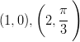and 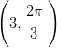is
A. 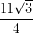
B.
C.
D.
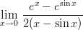
A. -1/2
B. 1/2
C. 1
D. 3/2
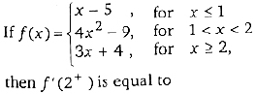
A. 0
B. 2
C. 3
D. 4
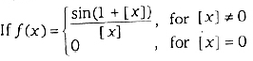
Where [X] denotes the greatest integers not exceeding x, then is equal to
A. -1
B. 0
C. 1
D. 2
If then is equal to
A. 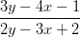
B. 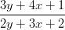
C. 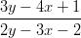
D. 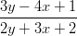
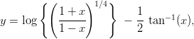then is equal to
A. 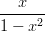
B. 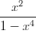
C. 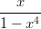
D. 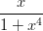
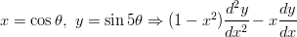is equal to
A. -5y
B. 5y
C. 25y
D. -25y
The length of tangent, subtangent, normal and subnormal for the curve at (1, 1) are A,B,C and D respectively, then their increasing order is
A. B, D, A, C
B. B, A, C, D
C. A, B, C, D
D. B, A, D, C
The condition to have no extreme value, is
A.
B.
C. 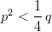
D.
The circumference of a circle is measured as 56 cm with an error 0.02 cm. The percentage error in its area is
A. 1/7
B. 1/28
C. 1/14
D. 1/56
Observe the statement given below :
Assertion (A) : has the maximum at x = 1
Reason ( R) : and
Which of the following is correct ?
A. Both (A) and ( R) are true and ( R) is the correct reason for (A)
B. Both (A) and ( R) are true but ( R) is not the correct reason for (A)
C. (A) is true, ( R) is false
D. (A) is false, ( R) is true
If then 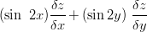is equal to
A. 1
B. 2
C. 3
D. 4
If 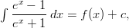then is equal to
A.
B.
C.
D.
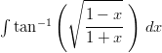is equal to
A. 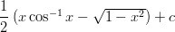
B. 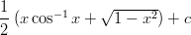
C. 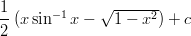
D. 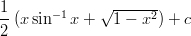
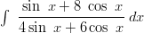is equal to
A. 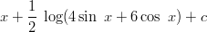
B.
C.
D. 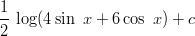
If 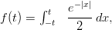then is equal to
A. 1
B.
C. 0
D. -1
is equal to
A.
B.
C. 0
D.
The area (in square unit) of the region enclosed by the curves and is
A.
B.
C.
D. 1
The differential equation obtained by eliminating the arbitrary constants a and b from is
A. 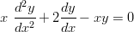
B. 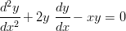
C. 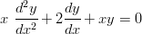
D. 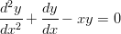
The solution of 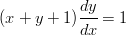is
A.
B.
C.
D.
The solution of 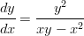is
A.
B.
C.
D.
The solution of 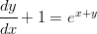is
A.
B.
C.
D.

