Indian Institute of Foreign Trade - Solved Paper - 2010
Find the sum of the following series:
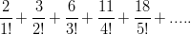
A. 3e-1
B. 3(e-1)
C. 3(e+1)
D. 3e+1
How many positive integers ‘n’ can we form using the digits 3,4,4,5,6,6,7 if we want ‘n’ to excess 6.000.000 ?
A. 320
B. 360
C. 540
D. 720
A techno company has 14 Machines of equal efficiency in its factory. The annual manufacturing costs are Rs. 42,000 and establishment charges are Rs. 12,000. The annual output of the company is Rs. 70,000. the annual manufacturing cost are directly proportional to the no. of machines. The share holders get 12.5% profit which is directly proportional to the annual output of the company. If 7.14% machines remain closed throughout the year, then the percentage decrease in the amount of profit of the share holders would be.
A. 12%
B. 12.5%
C. 13.0%
D. None of these
Sun life insurance company issues standard, preferred and ultra-preferred policies. Among the company’s policy holders of certain age, 50% are standard with a probability of 0.01 of dying in the next year, 30% are preferred with a probability of 0.008 of dying in the next year, and 20% are ultra-preferred with a probability of 0.007 of dying in the next year. If a policy holder of the age dies in the next year, what is the probability of the deceased being a preferred policy holder ?
A. 0.1591
B. 0.2727
C. 0.375
D. None of these
A Small confectioner bought a certain number of pastries flavoured Pineapple, Mango and Black-forest from the bakery, giving for each pastry as many rupees as there were party of that kind. altogether. he bought 23 pastries and spent Rs. 211; find the number of each kind of pastry that he bought, if mango pastry are cheaper than Pineapple pastry and dearer than black-forest pastry.
A. (10, 9, 4)
B. (11, 9, 3)
C. (10, 8, 5)
D. (11, 8, 4)
Find the root of the quadratic equation
A. 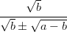
B. 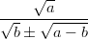
C. 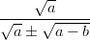
D. 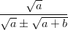
Three professors Dr. Gupta, Dr Sharma and Dr. Singh are evaluating answer scripts of a subject. Dr. Gupta is 40% more efficient than Dr. Sharma, who is 20% more efficient than Dr. Singh. Dr. Gupta takes also 10 days less than Dr. Sharma to complete the evaluation work. Dr. Gupta starts the evaluating work and works for 10 days and then Dr. Sharma takes over. Dr. Sharma evaluate for next 15 days and then stops. In how many days, Dr. Singh can complete the remaining evaluation work.
A. 7.2 days
B. 9.5 days
C. 11.5 days
D. None of these
If [x] is the greatest integers less than or equal to ‘x’, then find the value of the following series
A. 4389
B. 4839
C. 3498
D. 3489
What is the values of if
A. -5/3
B. 2
C. 5/3
D. 1
Three pipes A, B and C are connected to a tank. These pipes can fill the tank separately in 5 hrs, 10 hrs and 15 hrs respectively. When all the three pipes were opened simultaneously, it was observed that pipes A and B were supplying water at of their normal rates for the first hour which they supplied water at the normal rate. Pipe C supplied water at of its normal rate of 2 hours, after which it supplied at its normal rate. In how much time tank would be filled.
A. 1.05 Hrs
B. 2.05 Hrs
C. 3.05 Hrs
D. None of these
The Minimum value of is
A. 2
B. 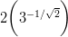
C.
D. None of these
In a B-School there are three levels of faculty positions i.e. Professors, Associate professors and Assistant Professors. It is found that the sum of the ages of all faculty present is 2160. their average age is 36; the average age of the professors and Associate Professor is 39; of the Associate Professors and Assistant Professors is of the professors and Assistant professors is Had each Professors is year older, each Associate Professors 6 year older, and each Assistant professors 7 year older, then their average age would increase by 5 years. What will be the number of facility at each level and their average ages ?
A. (16, 24, 20 : 45, 35, 30 Years)
B. (18, 24, 20 : 42, 38, 30 Years)
C. (16, 20, 24 : 50, 30, 30 Years)
D. None of these
log, 2 is
A. An Integers
B. A rational number
C. A prime number
D. An irrational number
In a square of the side 2 meters, isosceles triangle of equal area cut from the corners to form a regular Octagon. Find the perimeter and area of the regular Octagon.
A. 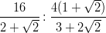
B. 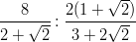
C. 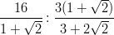
D. None of these
The smallest perfect square that is divisible that is divisible by 7!
A. 44100
B. 176400
C. 705600
D. 19600
A survey shows that 61% 46% and 29% of the people watched “3 idiots”, “Rajneeti” and “Avtar” respectively. 25% people watched exactly two of the three movies and 3% watched none. What percent of people watched all the three movies ?
A. 39%
B. 11%
C. 14%
D. 7%
In a triangle ABC the length of side BC is 295. If the length of side AB is perfect square, then the length of side AC is a power of 2, and the length of side AC is twice the length of side AB. Determine the perimeter of the triangle
A. 343
B. 487
C. 1063
D. None of these
In a Green view apartment, the houses of a row are numbered consecutively from 1 to 49. Assuming that there is a value of ‘x’ such that the sum of the number of the houses preceding then house numbered ‘x’ is equal to the sum of the number of the house following it. Then what will be the value of ‘x’ ?
A. 21
B. 30
C. 35
D. 42
To star a new enterprise. Mr. Yogesh has borrowed a total of Rs. 60,000 from two money lenders with the interest being compounded annually. to be repaid at the end of two years. Mr. Yogesh repaid Rs. 38,800 more to the first money lenders compared to the second money lenders at the end of two years. the first money lender charged an interest rate, which was 10% mo0re than what was charged by the second money lender. If Mr. Yogesh had instead borrowed Rs. 30,000 from each their respective initial rates for two years, he would have paid Rs. 7,500 more to the first money lender compared to the second. then money borrowed by Mr. Yogesh from first money lender is.
A. 20,000
B. 35,000
C. 40,000
D. 42,000
Find the coefficient of in the expansion of
A. 113
B. 119
C. 125
D. 132
Mukesh, Suresh and Dinesh travel from Delhi to Mathura to attend Janmasthmi Utsav. They have a bike which can carry only two riders at a time as per traffic rules. Bike can be driven only by Mukesh. Mathura is 300km from Delhi. All of them can walk at 15Km/hr. All of them start their journey from Delhi simultaneously and are the required to reach Mathura at the same time. If the speed of bike is 60Km/hr then what is the shortest possible time in which all three can reach Mathura at the same time.
A. 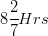
B. 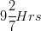
C.
D. None of these
In a rocket shape firecracker, explosive powder is to be filled upside the metallic enclosure. The metallic enclosure is made up of a cylinder base and conical top with the base of radius 8 centimeter. the ratio of height of cylinder and cone is 5 : 3. A cylindrical hole is drilled through the metal solid with height one third the height of metal solid. What should be the radius of the hole, so that volume of the hole (in which gun powder is to be filled up) is half of the volume of the metal solid after drilling ?
A.
B. 4.0 cm
C. 3.0 cm
D. None of these
A Small and medium enterprise imports two components A and B from taiwan and china respectively and assembles them with other components to form a toy. component A contribute to 10% of production cost. Company B contributes to 20% of the production cost. Usually the company sells this toy at 20% above the production cost. Due to increase in the raw material and labour cost in both the countries component A became 20% costlier and component B became 40% costlier. Owing to these reasons the company increased its selling price by 15%. Considering that cost of other components does not change, what will be the profit percentage, if the toy is solid at the new price ?
A. 15.5%
B. 25.5%
C. 35.5%
D. 40%
What is the value of in the given figure, where the radius of the circle is ‘a’ unit.
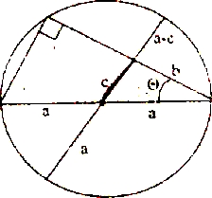
A.
B.
C.
D. None of these
How many subsets of {1,2,3,.... 11} contain at least one even integer ?
A. 1900
B. 1964
C. 1984
D. 2048
Directions for next five questions: Read the following information and choose the right alternative in the questions that following:
During the culture week of an institute six competitions were conducted. The cultural week was inaugrated in the morning of October, Wednesday and continued till October. In the span of 8 days six competitions namely debate, folk dance, fash-p, street play, rock band, and the group song, were organized along with various other cultural programs. The information available from the institute is:
i. Only one competition was held in a day.
ii. Rock band competition was not conducted on the closing day.
iii. Fash-p was conducted on the day prior to debate competition
iv. Group song competition was conducted neither on Wednesday nor on Sunday.
v. None of the competition was conducted on Thursday and Sunday.
vi. Street play competition was held on Monday.
vii. There was gap of two days between debate competition and group competitions
The culture week started with which competitions ?
A. Fash-p competition
B. Debate competitions
C. Street Play competitions
D. Rock band competition
How many days gap is there between rock band competitions and group song competition ?
A. Two
B. Three
C. Four
D. Five
Which pair of competitions was conducted on Wednesday ?
A. Rock band competition and debate competition
B. Debate competition and fash-p competitions
C. Rock band competitions and Folk dance competition
D. None of these
Which competition exactly precedes the street play competition ?
A. Rock band compition
B. Group song competition
C. Debate competition
D. Fash-p competition
Fash-p competition follow which competition ?
A. Debate competition
B. Street play competition
C. Rock band competition
D. None of these
Directions for next three questions: Read the information given below and answer the question that follow the information.
A parking lot can accommodate only six cars. The six cars are parked in two rows in such a way that the front of the three cars packed in in one row is facing the other three cars in the other row.
i. Alto is not parked in the beginning of any row
ii. Esteem is second to the right of i10.
iii. Punto, who is the neighbor of Alto is parked diagonally opposite to i10.
iv. Swift is parked in front of Alto.
v. SX4 is parked to the immediate right of Alto.
If SX4 and Esteem exchange their positions mutually then car (s) adjacent to Esteem is (are) ?
A. i10 and Swift
B. Only Swift
C. Only Alto
D. Alto and Punto
If Alto change position with i10 and Punto changes position with SX4 and Swift shift one position to the right to accommodate Beatle then the car (s) parked adjacent to Beatle is (are) ?
A. Punto only
B. i10 and Alto
C. Punto and Alto
D. Alto and Swift
In the original parking scheme four new cars enter the parking lot such that wagon-R is second to the right of i10 and Zen is second to the left of SX4. Jazz is parked second to the left to Wagon-R and Beat is parked to the right of Alto then the cars that moved out are ?
A. Esteem and Swift
B. Punto and Alto
C. i10 and Alto
D. Punto and SX4
Directions for next five questions: Read the information given below and answer the next for question that follow:
i. Six friends Rahul, Kabeer, Anup, Raghu, Amit and Alok were engineer graduates. All six of them were placed in six different companies and were posted six different locations, namely Tisco-jamsedpur, Telco-Pune, Wipro-Bangalore, HCL-Noida, Mecon-Ranchi and Usha Martin-Kolkata. Each of them has their Rediffmail, Yahoo, Hotmail, Sancharnet, through not necessarily in the same order.
ii. The one having e-mail account with Sancharnet works in Noida and then have an e-mail account with Indiatimes works for Tisco.
iii. Amit does not stay in Bangalore and does not work for Mecon, the one who work for Mecon has an e-mail id with Gmail.
iv. Rahul has an e-mail id with Rediffmail and works at Pune.
v. Alok does not work for Mecon and the one who works for Wipro does not have an e-mail account with Yahoo.
vi. Kabeer is posted in Kolkata, and does not have an account with Hotmail.
vii. Neither Alok nor Raghu works in Noida.
viii. The one who is posted in Ranchi has an e-mail id which is not an account Rediffmail or Hotmail.
ix. Anup is posted in Jamshedpur.
The man who work in Wipro has an e-mail account with ?
A. Sancharnet
B. Yahoo
C. Rediffmail
D. None of these
Which of the following e-mail place of posting-person combination is correct ?
A. Kabeer-Kolkata-Rediffmail
B. Alok-Bangalore-Indiatimes
C. Amit-Noida-yahoo
D. Raghu-Ranchi-Gmail
Which of the following is true ?
A. Amit is posted at Ranchi
B. Raghu is posted at Jamshedpur
C. Kabeer has an e-mail id with Yahoo
D. Rahul has an e-mail id with Indiatimes
Which of the following sequence of location represent Alok, Kabeer, Anup, Rahul, Raghu and Amit in the same order ?
A. Bangalore, Noida, Pune, Jamshedpur, Ranchi, Kolkata
B. Bangalore, Kolkata, Jamshedpur, Pune, Noida, Ranchi.
C. Kolkata, Bangalore, Jamshedpur, Pune, Noida, Ranchi
D. None of these
People who have e-mail with Indiatimes, Sancharnet, and Yahoo work for which companies, in the same sequence as the e-mail accounts mentioned ?
A. Usha Martin, HCL, Wipro
B. Tisco, Wipro, Usha Martin
C. HCL, Tisco, Wipro
D. Tisco, HCL, Usha Martin
How many ‘zeroes’ are there in the following sequence which are immediately preceded by a nine but not immediately followed by seven ?
7090070890702030045703907
A. One
B. Two
C. Three
D. Four
A Retail chain has seven branches in a city namely R1, R2, R3, R4, R5, R6, R7 and a central distributor center (DC) The nearest branch to the DC is R6 which is in the south of DC and is 9km away from DC. R2 is 17 km away from DC in the west. The branch R1 is 11 km away from R2 further in the west. The branch R3 is 11km in the North east of R1. R4 is 13 km away from R3 in the east. R5 is 11km in the north east of the distributors center. In the north east of R6 is R7 and distance between them is 15km. The distance between R1 and R6, R2 and R6, R6 and R5 is 23km, 19km, 13km respectively. R3 is 14km away from the DC in the north west direction, while R2 is also 14km away from R4 in the north east direction of R2. A truck carrying some goods starts from the distribution center and has to cover at least four stores in a single trip. There is an essential good that has to be delivered in the store R7, but the delivery at R7 has to be done in the end, so what is the shortest distance the truck would travel ?
A. 55
B. 56
C. 63
D. 66
Which retailer shows the sharpest decline in cost per square feet and in which year ?
A. Westside, 2005
B. Pantaloon, 2008
C. S.Stop. 2009
D. Vishal, 2010
Which retailer has shows the maximum increase in its cost per square feet and in which year ?
A. S. Stop, 2006
B. S. Stop, 2007
C. Pantaloon, 2006
D. Vishal, 2006
What is the average rate of change in the cost per square feet of the retailer sector, if the sector is represented by the above four retailers in the period FY07 to FY10E ?
A. -8.12
B. -10.86
C. -6.73
D. None of these
Directions for next four questions: The table below represent the information collected by TRAI about the service Area wise Access of (Wireless + Wire line) subscribers in India. On the basis of the information provided in the table answer the question that follow.
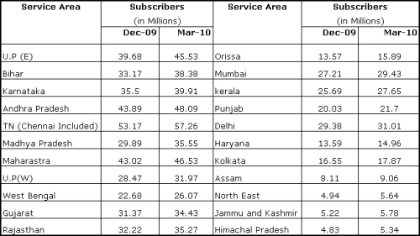
Which servuce area has observed maximum rate of change from Dec 2009 to March 2010 (in percentage)
A. U.P. (E)
B. Bihar
C. Orissa
D. Haryana
As a result of a decision to allow only two or three telecom operators in a particular service area, TRAI allocates R-Com and Vodafone to operate only the east India and Idea and Airtel operate only in south. R-Com has got 28% subscribers east while Vodafone has 72% subscribers, similarly Idea has 48% subscribers in south while Airtel has 52% subscribers. How many subscribers do these players have in 2010 ?
A. R-Com-28.03, Vodafone-73.22, Idea-86.22, Airtel-89.5
B. R-Com-30.03, Vodafone-72.82, Idea-85.02, Airtel-80.04
C. R-Com-28.03, Vodafone-76.24, Idea-84.01, Airtel-85.67
D. R-Com-30.03, Vodafone-77.22, Idea-82.99, Airtel-89.91
Due to operability issues early in 2010 Madhya Pradesh and entire UP added the eastern telecom circle. The telecom operations in Madhya Pradesh and entire namely R-Com, Vodafone and Idea had 28%, 40% and 32% subscribe respectively. What is the percentage of subscribers that each players has in the new formed eastern circle in March 2010 ?
A. R-Com-30.01%, Vodafone-55.72%, Idea-14.27%
B. R-Com-32.01%, Vodafone-53.72%, Idea-14.27%
C. R-Com-28%, Vodafone-55.72%, Idea-16.27%
D. None of these
The all India rate of change in number of subscribers from December 2009 to March 2010 is ?
A. 10.7%
B. 10.5%
C. 11.8%
D. 12.4%
Directions for next five questions:
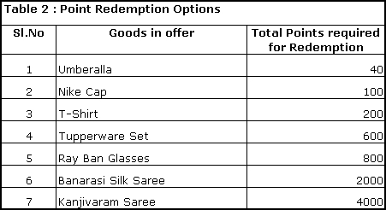
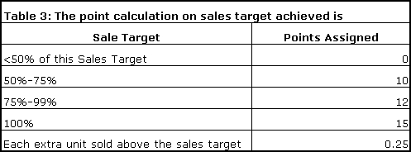
There are 10 multi brand dealers in Nasik and the sales that they have acheive the end of a quarter are :
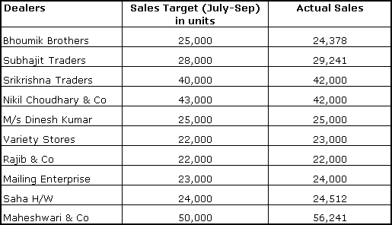
Maheshwari & Co has Company X signage along with other brand signage main entrance of the store, the exterior walls of the store have the painting company X, the side wall in the interior has the painting of Company X, The side wall in the interior has the painting of Company X. display of Company X is above the eye level with other brands while the of goods of company X in the back row of the shelves. The brand building when combined with the sales achieved points amounts to the total points, dealer can accumulate in a quarter. The number of Tupperware sales, Maheshwari & Co can redem after the quarter (July to September) is ?
A. 2
B. 3
C. 4
D. 5
Bhowmik Brothers has only other brands signage in the front of the store, and company X painting on the side wall in the exterior of the store, Company X painting on the side wall in the interior of the store, no POP display of any company and the goods of company X is staked in the front row with other brands. What is the total points Bhowmik Brothers need to accumulate to make them eligible for minimum redemption ?
A. 27
B. 37
C. 38
D. 33
The Brand building points of Saha H/W is 85, and Mr. Saha the proprietor of the store wants to redeem a Kanjivaram Saree the next quarter by carrying forward the points accumulated this quarter to the next quarter. the sales target of Saha H/W is 25,000 units in the next quarter. It is assumed the brand building points for the next quarter is also going to be 85. How many extra units Saha H/W has to sell order to get the Kanjivaram Saree ?
A. 14688
B. 12569
C. 13658
D. 15698
Mailing Enterprise exhausted all its points while redeeming three Nike Caps and an Umbrella, what is its brand building points ?
A. 75
B. 85
C. 95
D. 90
If Srikrishna Trader has 80 brands points then the goods that it can redeems are …... ?
A. Tupperware set, Kanjivaram
B. Umbrella and Tupperware set
C. Tupperware set, Nike Cap
D. Nike Cap and T-Shirt
If the word energy council formulate a norm for high emission countries to reduce their emission each year by 12.5% for the next two years then what would be the ratio of emission to per capita income of US. China and Japan after two years. The per capita income of china, Japan and US is expected to increase every year by 4%, 3% and 2% respectively.
A. 3.5, 3.8, 4.1
B. 3.4, 3.5, 3.9
C. 2.9, 3.1, 3.4
D. None
Refer to the following pie chart and answer the question that follows. The chart shows the no. of units produced in degree, by degree, by company X in different States of India for the quarter July-Sep 2010.
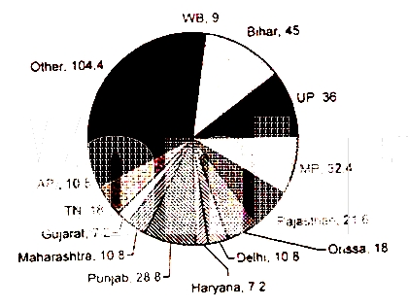
By how many units does the number of units produced in Bihar exceed the number of units produced in Madhya Pradesh, if the total production in the quarter is 72,000 units
A. 2300 units
B. 2520 units
C. 3516 units
D. 2860 units
In which years the percentage increase in the number of females over the previous year is highest ?
A. 1996
B. 1999
C. 2004
D. 2005
In 2002 if the ratio of number of educated male to professionally educated female was 5:4. If the number of educated males increased by 25% in 2003. What is the percentage change of uneducated females in 2003 ?
A. +25%
B. +30%
C. +34%
D. +56%
In years 2005 total Population living in urban area is equal to sixty eight percent of educated population. The ratio of number of people living in urban area to people living in rural area is 43:12 in 2010 of the rural populations in 2005 to that in 2010 ?
A. 0.8
B. 0.47
C. 2.05
D. None
displaying them-was going to become essentially free.
In 1999 Fishers resigned and Carp became the new CEO. In 2000, Carp’s first year as CEO, profit was about Flat, at $1.41 billion. Carp, too retired early, at age fifty-seven Carp had pursued Fisher’s basic strategy of “enhancing” the film business to make it last long as possible, while trying to figure out some way to get recurring revenue from the filmless, digital world. But the temporizing didn’t work any better carp than it had for fisher. Kodak talked, for instance, about getting customers to digitize and upload to the internet more of the 300 million rolls of film that kodak processed annually, as of 2000. Instead, customers increasing skipped the film part. In 2002, sales of digital cameras in the United State passed those of traditional cameras-even though Kodak in mid-1990s had projected that it would take twenty years for digital technology to eclipse film. The move to digital in the 2000s happened so fast that, in 2004. Kodak introduced a film camera that won a “camera of the year” award, yet was discontinued by the time Kodak collected the award Kodak staked out a position as one of the major seller digital cameras, but being “one of” is a lot different from owning 70 petrcent to 80 percent of a market, as Kodak had with film, chemicals, and processing. In 2002 competition in the digital market as Kodak had with film chemicals, and processing. in 2002 competition in the digital market, was so intense that Kodak lost 75 percent of its stock-market value over the past decade. falling to a level about half of what it was when the reporter suggested to carp that he might sell the company. As of 2005, Kodak employee less than a third of the number who worked for it Twenty years earlier. To see what might have been, looked at Kodak’s principal competitors in the film and paper markets. Agfa temporized on digital technology, then solid its film and paper business to private equity inverters in 2004. The business went into bankruptcy proceeding the following year, but that wasn’t Agfa’s problem. It had cashed out at a halfway reasonable price.
As per the passage which of the following truly refracts the real theme of the passage
A. Moore’s law predicted that cost per unit of computing power world exhibit a standard deviation of 25% per annum.
B. Popularity of removable media and internet lead to high demand for Computers.
C. Kodak managers were able to predict the flow of digital technology and their critical value drivers.
D. Kodak did not have a vision to plough back the profits from the old technology to research and development in new technology
Which of the following statement is not true.
I. Kodak bought sterling drug as a strategic choice for a chemical business as it was already in the business of chemically treated photo paper.
II. The chemical business was in syne with existing business of Kodak running across the customers segment, delivery channel and the regulatory enviornment.
III. Kodak committed a mistake by selling sterling in prices at a loss of 50%.
IV. Kodak’s diversification attempt with purchase of sterling to strengthen its core business and shift to digital world was a shift from its strategic focus.
A. Only I & II
B. Only II & III
C. Only III & IV
D. Only I, II, III
Kodak lost a big piece of its market share to its competitors because of the following best explained reason.
I. When Carp became the CEO the digital Technology eclipsed film technology business and further Carp had been with the company for twenty nine years and had no background in technology.
II. Carp in 2004 introduced a film camera that won camera of the year award, yet it was discontinued by the time Kodak collected the award.
III. Kodak moved from traditional retail photo processing system into digital world installing several thousands of image magic kiosks that failed to deliver real benefit to the cutomers.
IV. Phillipe Khan led the advent of cell phone camera and Kodak lost out on the print business and ability to share images became a free feature with no additional charge.
A. I & II
B. II & III
C. I & IV
D. III & IV
Arrange the given statement in the correct sequence as they appear in the passage.
I. Kodak lost to its competitors a big pie of its market share.
II. Kodak venture into chemical business to strengthen its digital technology business.
III. Kodak downsized its workforce drastically.
IV. Kodak tied up with business firms for photo processing.
A. I, II, III, IV
B. III, IV, II, I
C. II, IV, I, III
D. I, III, II, IV
Match the following :
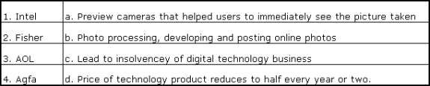
A. I-d, 2-a, 3-b, 4-c
B. I-a, 2-d, 3-c, 4-b
C. I-c, 2-b, 3-a, 4-d
D. I-d, 2-c, 3-a, 4-b
out of the stock market that month. to the end of that year, the GDP growth figures had been revised down significantly (unofficially, a minimum of a dozen times, and officially at least twice.) The market rockted ahead to new highs to August 1997, but a lot of investors had related to the sidelines on the preliminary bad news. The advice of a world champion chess player when asked how to avoid making a bad move. His answer, “Sit on your hands”. But professional investors don’t sit on their hands; they dance on tiptoe, ready to flit after the least particle of information as if it were a strongly documented trend. The law of small numbers, in such cases, result in decisions sometimes boarding on the inane. Tversky and Kahneman’s findings, which have been repeatedly confirmed, are particular important to our understanding of some stock market errors and lead to another rule that investors should follow.
Which statement does not reflect the true essence of the passage
I. Tversky and Kaheman understood that small representative group bias the research theories to generalize result that can be categorized a meaningful result and people simplify the real impact of passable portray of reality by small number of supporting facts.
II. Government economic releases on macroeconomic indicators fetch blind faith from investors who appropriately discount these announcements which are ideally reflected in the stock and bond market prices.
III. Investors take into considerations myopic gain and make it meaningful investment choice and fail to see it as a chance of occurrence.
IV. Irrational overreaction to key regulator expression is same as intuitive statistician stumbling disastrously when unable to sustain spectacular performance.
A. Only I
B. Only IV
C. II & III
D. Only III
The author of the passage suggest the anomaly that leads to systematic errors in predicting future. Which of the following statement does not least describe the anomaly as suggested in the passage above.
I. The psychological pressures account for the anomalies just like soothsayers warning about the natural disaster and market crashes.
II. Contrary to several economic and financial theories investors are not good intuitive statistician, especially under difficult conditions and are unable to calculate the odds properly when making investments choice.
III. Investors are swamped with information and they react to this avalanches of data by adopting shortcut or rules of thump rather than formally calculating odds of given outcome.
IV. The distortions produced by subjectively calculated probabilities are large systematic and difficult to eliminate even when investors are fully aware of them.
A. Only I
B. Only IV
C. I & III
D. II & IV
“Tversky and Kahneman’s findings… lead to another rule that investors should fillow”. Which rule is the author talking about ?
I. Not to be influenced by short term and occasional records of a money manger, brokers, analysts, or no matter how impressive.
II. To accept cursory economic or investment news without significant substantiation but supported by statistical evidence even if limited in data sufficiency.
III. In making decisions we become overly immersed in the details of a particular situation and consider all the outcomes of similar experience in our past.
IV. None of the above.
A. Only IV
B. Only I
C. Only III
D. I, II & III
According to the passage which statement written below in farthest in explaining that meaning of the passage above ?
I. Market letter writers have been wrong in their judgments many times but they continue to express their opinion as dramatic predictions and well time call results in huge rewards to analysts, journalist and popular writers.
II. Public opinion polls are fairly accurate because they are based on randomly selected diminutive respective groups and hence are more meaningful than intuitive statistics of an outcome.
III. People generally limit the need for the hefty statistical evidence as it satisfy their intuition without reflecting the reality.
IV. None of the above.
A. Only IV
B. Only II
C. II & III
D. Only I
value their relationship with people, groups, organizations, and Institutions and therefore value fair treatment from the other party to the relationship. Specifically highly committed member should have especially negative reactions to felling that they were treated unfairly, more so than (1) less-committed group member or (2) highly committed members who felt that they were fairly treated.
The prediction that people will react especially negatively when they previously felt highly committed but felt that they were treated unfairly also is consistent with literature on psychological contracts. Rousseau suggested that over time, the member of work organizations develop feeling of entitlement, i.e. perceived obligations that their employers have towards them. Those who highly committed to the organization believed that they are fulfilling their contract obligations. However, if the organization acted unfairly, then highly committed individuals are likely believe that the organization did not live up its end of the bargain.
The hypothesis mentioned in passage test atleast one of the following ideas.
A. People continue to show loyalty only if they were initially committed to the organization.
B. Our experiences influence post-experience loyalty but certainly underwhelm the relationship between pre-experienced and post-experience loyalty.
C. Pre-experience committed always has inverse relationship with the post-experience committed
D. None of these idea are being tested by the hypothesis.
There is only one term in the left column which matches with the option given the second column. Identify the correct pair from the following table:.
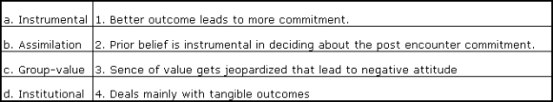
A. a-1 and 4
B. b-3 and 4
C. c-2 and 4
D. d-1 only
For summarizing the passage, which of the following is most appropriate ;
A. The study explored how citizen’s commitment to legal authorities changed as a function of their initial level of commitment and their perceptions of how fairly they were treated in their recent encounter with legal authorities.
B. The influence of individuals’ prior commitment to an institution on their reactions to the perceived fairness of decision rendered by the institutions was examined.
C. Given the generally positive consequences to organizations of having committed employees, it may be that unfair managerial practice would begin to alienate the very employees, that the organization would least wish to alienate.
D. The passage aims at understanding how people define happiness and these definitions include instrumental view-points.
Though part of him is a showman or preacher, he is essential a private person. Peter Lynch, the mutual-fund wizard visited Buffett in the 1980s and was struck by the tranquility in his inner sanctum. His archives, neatly alphabetized in metal filling cabinets, looked as files had in another era. he had no computer-only a newspaper clipping from 1929 and an antique ticker under a glass dome. the two of them paced the floor, recounting their stories histories, what they had bought, what they had sold. Where Lynch had kicked out his losers every few weeks, Buffett had owned mostly the same few stocks for years and years. Lynch felt a pang, as though he had traveled back in time. Buffett’s one concession to modernity is a private jet. Otherwise, he derives little pleasure from spending his fabulous wealth. He has no art collection or snazzy car, and he has never lost his taste for hamburgers. He consuming passion – and pleasure – is his work, or, as he calls it, his canvas. It is there than he revealed the secrets of his trade, and left in a self portrait.
“Saddle show and Vietnam”, as expressed in the passage, refers to;
I. Dernier cri and Vietnam war
II. Growth of leather footwear industry and Vietnam shoe controversy
III. Modern U.S population and traditional expatriates
IV. Industrial revolution and Vietnam Olympics
V. Fashion and Politics
A. I & V
B. II & IV
C. III & V
D. II & III
Identify the correct sequence:
I. Depression -> Eisenhewer -> Microsoft
II. California -> New York -> Omaha
III. J.P Morgan -> Buffett -> Bill Gates
IV. Mutual funds -> Hedge funds -> Brokers
A. I & II
B. I & III
C. II & IV
D. III & IV
Choose the most appropriate answer. according to the author, Warren Buffett was
I. Simple and outmoded
II. Against planned economy and technology
III. Deadpan
IV. Spiritually raw
A. I & IV
B. II & IV
C. III & IV
D. I & III
Directions for next six questions: From the given pair of words select the most appropriate pair that fill the gaps and makers the sentences more meaningful.
These issues are extremely …................ and any knee jerk reaction will ultimately result in a loss of …................ for all shareholders
A. Unassociated, curarc
B. Ambiguous, plutocracy
C. Nuanced, opportunity
D. Contexed, serendipity
Growth under this government has been ….................... high and remarkably ….................. even during the worst global economic crists.
A. Impededly, flippant
B. relatively, intractable
C. Obstructedly, rigid
D. Sustainedly, resilient
There are different and …................ version about what happened in the city, but one thing is certain. It is a dastardly act that must be condemned ….................
A. Dissimilar, concertedly
B. Contrary, obviously
C. Conflicting, unequivocally
D. Unique, without confliet
They …................ their seat away from the curved wall panels to give themselves more space as the flight attendant brought drinks from the gallery, which was ….................. with family’s favorite and beverages.
A. Swiveled, stocked
B. Hinged, lacquered
C. Pended, embellished
D. Retracted, thronged
Caim cannon ….................. bring into picture some …............... outside which has little experience and necessary consent’s to deal in the oil field.
A. Peremptorily, ascribed
B. Complaisantly, enclosed
C. Democratically, aberrant
D. Arbitrarily, unrelated
.............. by serious policy reforms.
A. Growth, blowed
B. Boom, berated
C. Recession, reduced
D. Dirigisme, boosted
Directions for next three questions: Each sentence has a part which is underlined. Beneath the sentence you will find the four way of phrasing the underlined part. Follow the requirements of the standard written English to choose your answer. Selection should make the sentence clear, exact and free of grammatical error. It should minimize awkwardness, ambiguity and redundancy.
Large and experienced firms are more efficient at acquiring smaller and distressed firms than are large and inexperienced firms, and converting them to profitable ventures.
A. Large and experienced firms are more efficient at acquiring smaller and distressed firms than large and inexperienced firms.
B. Large and experienced firms are more efficient than large and inexperienced firms at acquiring smaller and distressed firms
C. Large and experienced firms, acquire smaller and distressed firms more efficiently than large and inexperience firms
D. Large and experienced firms, more efficient than large and inexperienced firms at acquiring smaller and distressed firms
The economic growth increased from 7 to 9 percent in November 2010, supporting the expectations that industrial growth rate in October-December quarter more than doubled that of the 4 per cent growth rate in industrial growth for the previous quarter.
A. That industrial growth in the October-December quarter, that it more than the doubled that of
B. of industrial growth in the October-December quarter, than it more doubled
C. of industrial growth in the October-December quarter, that it would more than double that of
D. that industrial growth in October-December quarter would more than double.
As a result of surging financial greed, the international rating agencies upgraded the rating of the credit derivative instruments, and hence analyst recommended a strong buy, ignoring the advice of Waren Buffett who warned that these instrument would prove not only dangerous but infective in the long-run
A. who warned that those instrument would prove to be both dangerous and
B. warning that these instrument would prove not only dangerous and also
C. warning that these instrument would prove itself to be both dangerous and
D. who was warning that these instrument would prove not only dangerous but
Directions for next two questions: From the given option identify the word pair which is unrelated to the given word pair.
IMPUISSANCE : DESECRATE
A. Decrepit : Desolate
B. Effete : Sacrilege
C. Ornery : Contort
D. Bedraggled : Profanity
INSOUCIANT : GOSSAMER
A. Nymphs : Gehenna
B. Perfunctory : Diaphanous
C. Pococurante : Pellucid
D. Nonchalant : Tiffany
Directions for next two questions: Select the pair of wrongly spelt word from the given set of choice
A. Conscientious : Oleaginous
B. Obstreperous : Supercilious
C. Diletante : Reminiscence
D. Tergiversation : Interstice
Select the pair of wrongly spelt word from the given set of choice
A. Irascible : Surreptitious
B. Proclivity : Vicissitude
C. Lassitude : Imperturbable
D. Munificent : Pusillanimous
Directions for next six questions: Each question consist of a number of sentences that need to be properly sequence to form a meaningful and coherent paragraph/sentences. choose the most logical order of sentences from the choice given below.
I. of course it isn’t anywhere near as simple as this in real life
II. The diagram is commonly called ‘the stack’, and the people in the computer industry love to talk about it.
III. at the base are components that are assembled into finished hardware products; operating systems, middle-ware, and software application sit above the hardware; and it’s all topped off by a whole range of services
IV. the stack shows most of the major pieces in a typical computing envioronment
A. II, I, III. IV
B. II, IV, III, I
C. III, IV, II, I
D. II, III, I, IV
I. as a skeptical empiricist.
II. i do not want to be the turkey
III. Since we do not observe
IV. so i do not want to focus
V. solely on specific organs in the brain
VI. brain function very well
A. I, II, III, IV, V, VI
B. II, I, IV, III, V, VI
C. I, VI, IV, III, V, II
D. I, II, IV, V, III, VI
I. knowledge, even when it is exact
II. because we tend to forget what we know
III. if we do not play attention
IV. or forget how to process it properly
V. does not often lead to appropriate actions
VI. even when we are experts
A. I, V, II, IV, III, VI
B. I, V, III, IV, II, VI
C. VI, V, II, I, III, IV
D. III, VI, I, II, V, IV
I. in the classroom
II. once they are let out on streets
III. statisticians, it has most trivial inferential errors
IV. and engage in most trivial inferential errors
V. tend to leave their brains
A. III, V, I. IV, II
B. II, III, V, I, IV
C. I, V, II, III, IV
D. III, I, V, IV, II
I. sure enough failed
II. I have tested myself and
III. by carefully setting a wide range
IV. even while consciously trying to be humble
V. as we will see the core of my professional activities
VI. and yet such underestimation happens to be
A. I, II, V, III, IV, VI
B. IV, II, I, III, V, VI
C. V, II, I, IV, III, VI
D. II, I, IV, III, VI, V
I. except that people got all excited
II. so i would not have cared
III. and talked quite a bit about
IV. the least about them
V. pouring verbal sauce around the forecasts
VI. what these figures were going to mean
A. I, II, IV, V, III, VI
B. I, III, II, IV, V, VI
C. II, IV, I, III, VI, V
D. V, II, IV, VI, I, III
Directions for next four questions: For each of the following question select the answer pair that express a relationship most similar to that expressed in the capitalized pair.
OMNISCIENT:KNOWLEDGE
A. Saturnine:energy
B. Boundless:expanse
C. Inquisitive:science
D. Complete:retraction
DISQUIETUDE:ANXIOUS
A. Nonplus:perplexed
B. Cupidity:bellicose
C. Embellishment:overstated
D. Magnitude:unabridged
DEVIATE:LECTURE::
A. Meander:drive
B. Disown:friend
C. Welcome:indifference
D. Entreat:solicitation
NEBULOUS:FORM::
A. Insincere:misanthrope
B. Benevolent:excellence
C. Insipid:taste
D. Composed:innocence
Directions for next two questions: Select the correct sentences from the following.
A. He made a blunder mistake.
B. I have learnt this lesson word by word.
C. She does not know swimming.
D. He got his daughter married.
Select the correct sentences from the following.
A. The average male investor expect to see all his investment stocks moving up, and they are often disappointed.
B. The people my country are smaller than in other countries
C. The number of failures of product in final quality inspection are increasing every year.
D. Before restructuring a firm, the CEO must consider the employees
Name the South Korean President who attended the Indian Republic Day parade in 2010 as a chief guest.
A. Kim Yoon – Ok
B. Ban Ki-Moon
C. Lee Myung-Bak
D. Chung Mong Koo
The Indian government auctioned the 3G spectrum in 22 telecom circles in 2010. Which three companies won the maximum number of circles in the auction ?
A. R-com
B. Airtel
C. Vodafone
D. Aircel
A. A, B & C
B. B, C & D
C. A, C & D
D. A, B & D
hich one of the following group of bank formed a joint venture in Life Insurance Sector ?
A. Canara Bank, HSBC, Oriental Bank of Commerce Limited
B. Canara Bank, HDFC, Syndicate Bank
C. HDFC, HSBC, Oriental Bank of Commerce Limited
D. Canara Bank, Axis Bank, HDFC
Match the International Organization Location-Country
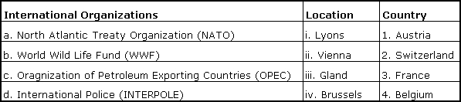
A. a-iii-2, b-iv-4, c-i-3, d-ii-1
B. a-iv-4, b-iii-2, c-ii-1, d-i-3
C. a-ii-4, b-iv-3, c-iii-1, d-i-2
D. a-i-4, b-iii-1, c-ii-3, d-iv-2
Match the Women CEO in 2010 and their respective Company and its location.
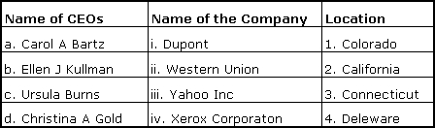
A. a-ii-4, b-iii-3, c-iv-1, d-i-2
B. a-iii-3, b-iv-4, c-i-1, d-ii-2
C. a-iii-2, b-i-4, c-iv-3,d-ii-1
D. a-ii-1, b-iii-2, c-i-4, d-iv-3
Match the Acquiring Company with its Target Company
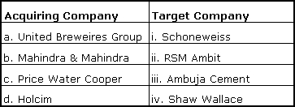
A. a-4, b-3, c-1, d-2
B. a-1, b-4, c-2, d-3
C. a-2, b-1, c-3, d-4
D. a-4, b-1, c-2, d-3
Match the Company and its Tagline
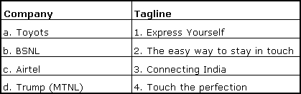
A. a-2, b-4, c-1, d-3
B. a-4, b-1, c-3, d-2
C. a-4, b-3, c-1, d-2
D. a-2, b-4, c-3, d-1
Match the name of the Indian Banks with their Brand Ambassadors for the year 2010
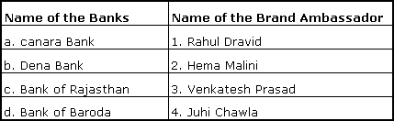
A. a-4, b-3, c-1, d-2
B. a-3, b-1, c-4, d-2
C. a-2, b-3, c-1, d-4
D. a-3, b-4, c-2, d-1
Match the following measure instrument to the formal test method which define the use of the Instrument.
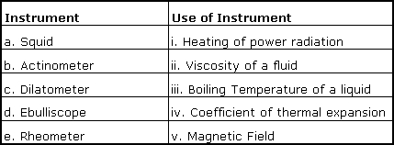
A. a-v, b-i, c-iv, d-iii, e-ii
B. a-ii, b-i, e-v, d-iii, e-iv
C. a-v, b-iv, c-i, d-ii, e-iii
D. a-iii, b-iv, c-v, d-i, e-ii
Name the Indian state having maximum number of Major Seaports.
A. West Bengal
B. Goa
C. Gujarat
D. Tamil Nadu
Match the National Highway route number to States that it cover ?
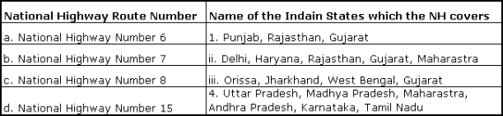
A. a-1, b-2, c-1, d-3
B. a-2, b-3, c-4, d-1
C. a-3, b-4, c-2, d-1
D. a-4, b-1, c-2, d-3
Match the old name to the new name of the countries.
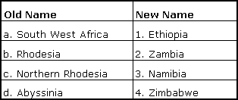
A. a-2, b-4, c-3, d-1
B. a-3, b-4, c-2, d-1
C. a-4, b-3, c-2, d-1
D. a-1, b-4, c-2, d-3
Match the Country, City and River.
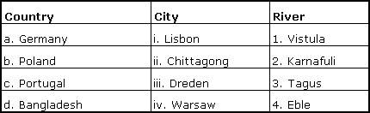
A. a-i-3, b-iv-1, c-iii-2, d-ii-4
B. a-iii-1, b-iv-3, c-i-4, d-ii-2
C. a-iv-4, b-iii-1, c-i-2, d-ii-3
D. a-iii-4, b-iv-1, c-i-3, d-ii-2
Match the Geographical Epithet to Country/City.
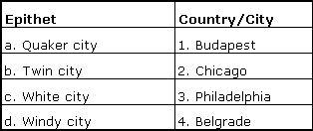
A. a-1, b-4, c-3, d-2
B. a-4, b-3, c-2, d-1
C. a-3, b-1, c-4, d-2
D. a-1, b-2, c-4, d-3
The State Bank of India was known as Imperial Bank of India in 1921, which was an amalgamation of three banks namely.
A. Bank of Bengal, Bank of Bombay and Bank of Madras
B. Bank of Bengal, Bank of Punjab, and Bank of Mysore
C. Bank of Bombay, Syndicate Bank and Union Bank
D. Bank of Madras, Mercantile Bank, Bank of Travarcore
The condition of which country has influenced the inclusion of the “Emergency Provision” in the Indian Constitution.
A. Germany
B. Canada
C. USA
D. Britain
Which of the following national park established by government of India is the relatively the latest one ?
A. Madhav National Park, Madhya Pradesh
B. Khangchendzonga National Park, Sikkim
C. Corbett National Park, Uttaranchal
D. Tadoba National Park, Maharastra
Who among the following is a recipient of the prestigious Dara Shikob award by Indo-Iran Society for contributing towards nurturing the value of peace, harmony and brotherhood in 2010.
A. Sheikh Hasina,
B. Sonia Gandhi
C. Shiela Dixit
D. Fatima Bhutto
Which of the following Indian Union Territory is having the legislative assembly as of 2010
A. Dadra and Nagar Haveli
B. Lakshadeep
C. Puducheery
D. Andaman and Nicobar Island
Match the Lt Governors-Indian Union Territories and the capital.
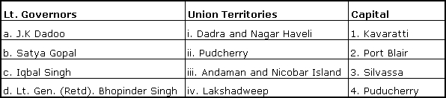
A. a-iii-2, b-i-3, c-iv-1, d-ii-4
B. a-ii-4, b-iii-2, c-iv-3, d-i-1
C. a-i-3, b-iv-1, c-ii-4, d-iii-2
D. a-iv-1, b-i-3, c-ii-4, d-iii-2
Which one of the following structure has been include in UNESCO in 2010 as world culture heritage list ?
A. Chhatarpati Shivaji Terminus
B. Jantar Mantar
C. Mahabodhi Temple Complex at Bodh Gaya
D. Red Fort Complex
Match the following Head of the Staff to the concerned Defense forces.
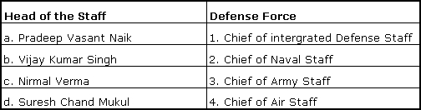
A. a-3, b-4, c-1, d-2
B. a-4, b-3, c-2, d-1
C. a-3, b-2, c-1, d-4
D. a-1, b-2, c-4, d-3
Which one of the following state is having maximum number of special economic zone (SEZ), notified under the SEZ Act, 2005.
A. Andhra Pradesh
B. Maharashtra
C. Tamil Nadu
D. Karnataka
Match the following Brand to the Company.
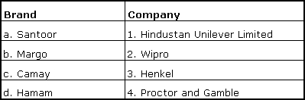
A. a-4, b-1, c-2, d-3
B. a-2, b-3, c-4, d-1
C. a-3, b-1, c-4, d-2
D. a-2, b-4, c-1, d-3
Match the Countries Name of the parliament-Currency.
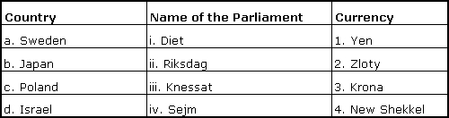
A. a-iii-2, b-iv-1, c-i-4,. d-ii-3
B. a-ii-3, b-i-1, c-iv-2, d-iii-4
C. a-iv-2, b-iii-1, c-ii-4, d-i-3
D. a-ii-3, b-i-1, c-iii-4, d-iv-2
Name the sports personality who is not an ambassador for the Common Wealth Games 2010 ?
A. Samarnath Jung
B. Sushil Kumar
C. MC Mary Kom
D. Tejeswini Sawant
Match the Central Sector Enterprises in India and their position
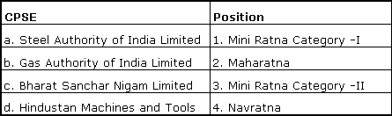
A. a-3, b-2, c-4, d-1
B. a-2, b-4, c-1, d-3
C. a-2, b-4, c-3, d-1
D. a-4, b-2, c-1, d-3
Select the country that has maximum share in FDI equity inflow in India as on June 2010
A. Germany
B. UAE
C. France
D. Netherland
Which sector attracted minimum FDI equity inflow in India in the year 2009-2010 ?
A. Construction activities
B. Housing and real estate
C. Telecommunication
D. Power
Match the Indian TV Channel to its Owner’s Parent Company
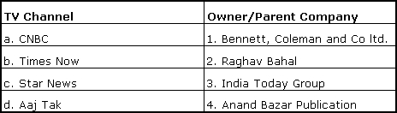
A. a-2, b-4, c-3, d-1
B. a-2, b-1, c-4, d-3
C. a-2, b-3, c-4, d-1
D. a-3, b-1, c-4, d-2

