SNAP Papers 2009
A dice is rolled three times and sum of three numbers appearing on the uppermost face is 15.
1/5
2/5
1/6
None of these
A boat covers a distance of 30 kms. downstream in 2 hours while it takes 6 hours to cover the same distance upstream. What is the speed of the boat in kms per hour?
18
7.5
13
5
A five digit number is formed by using the digits 1, 2, 3, 4 and 5 without repetitions. What is the probability that the number is divisible by 4?
5/6
4/5
1/5
None of these
If the algebraic sum of deviations of 20 observations measured from 23 is 70, mean of these observations would be
24
25
26
None of these
An alloy of gold and silver weighs 50 gms. It contains 80% gold. How much gold should be added to the alloy so that percentage of gold is increased to 90?
60 gms
30 gms
50 gms
40 gms
Weekly incomes of two persons are in the ratio of 7 : 3 and their weekly expenses are in the ratio of 5 : 2. If each of them saves Rs. 300 per week, then the weekly income of the first person is
Rs. 5400
Rs. 4500
Rs. 7500
Rs. 6300
Wheat is now being sold at Rs. 27 per kg. During last month its cost was Rs. 24 per kg. Find by how much per cent a family reduces its consumption so as to keep the expenditure fixed.
There are 10 stations on a railway line. The number of different journey tickets that are required by the authorities is
92
90
91
None of these
The radius of circle is so increased that its circumference increased by 5%. The area of the circle then increases by
In how many ways can the letters of the word ABACUS be rearranged such that the vowels always appear together?
In how many ways can the letters of the word ABACUS be rearranged such that the vowels always appear together?
Directions for Question Nos. 12 – 14:
At the start of a game of cards, J and B together had four times as much money as T, while T and B together had three times as much as J.
At the end of the evening, J and B together had three times as much money as T, while T and B together had twice as much as J. B lost Rs. 200.
What fraction of the total money did T have at the beginning of the game?
1/8
1/5
1/3
2/9
What fraction of the total money did J win/lost?
Lost 1/3
Won 1/5
Lost 1/6
Won 1/12
What amount did B start with?
Rs. 375
Rs. 275
Rs. 575
Rs. 825
If a and b are negative, and c is positive, which of the following statement/s is/are true?
I) a-b < a-c
II) if a < b, then a/c < b/c
III) a/b < a/c
II only
III only
II and III only
I only
The diagonal of a square is 4 2 cm. The diagonal of another square whose area is double that of the first square is
cm
16 cm
cm
8 cm
The maximum length of a pencil that can be kept in a rectangular box of dimensions 8 cm Ã— 6 cm Ã— 2 cm, is -
cm
cm
cm
cm
Directions for Question Nos. 18 to 19: based on the information given below
The Venn diagram given below shows the estimated readership of 3 daily newspapers (X, Y & Z) in a city. The total readership and advertising cost for each of these papers is as below
Newspapers | Readership (lakhs) | Advertising cost (Rs. per sq. cm)
X  Y  Z | 8.7  9.1  5.6 | 6000  6500  5000
The total population of the city is estimated to be 14 million. The common readership (in lakhs) is indicated in the given Venn diagram
!{width:200px}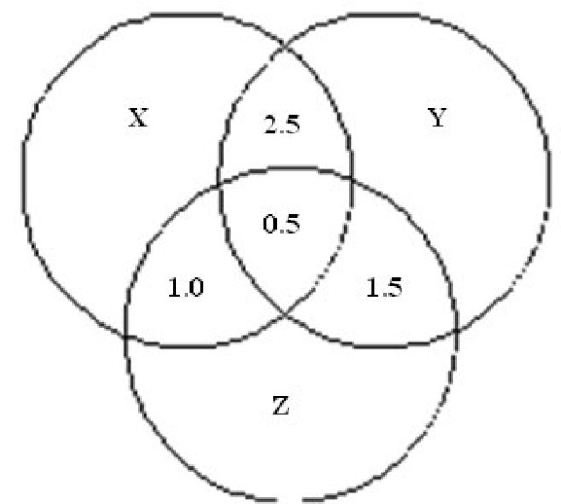
The number of people (in lakhs) who read at least one newspaper is
23.4
17.4
4.7
11.9
The number of people (in lakhs) who read only one newspaper is
17.4
4.7
11.9
23.4
Sonali invests of her monthly salary in insurance policies. She spends of her monthly salary in shopping and on household expenses. She saves the remaining_amount_of_Rs.12,750._What_is_Sonali’s_monthly income?
Rs. 35,500
Rs. 42,500
Rs. 40,000
Rs. 38,800
How many kgs. of tea worth Rs. 25 per kg must be blended with 30 kgs. Of tea worth Rs. 30 per kgs so that by selling the blended variety at Rs. 30 kgs there should be a gain of 10%?
42 kgs
32 kgs
36 kgs
40 kgs
In an examination, out of students of the girls and of the boys passed. How many boys appeared in the examination if total pass percentage was ?
340
360
320
370
300 gms of salt solution has salt in it. How much salt should be added to make it in the solution?
60 kgs
80 kgs
40 kgs
70 kgs
What number should replace the question mark in the image below?
!{width:150px}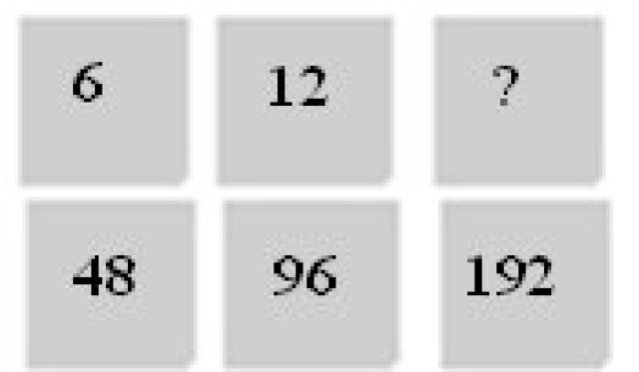
24
22
18
20
What image from bottom row should replace the question mark?
!{width :200px}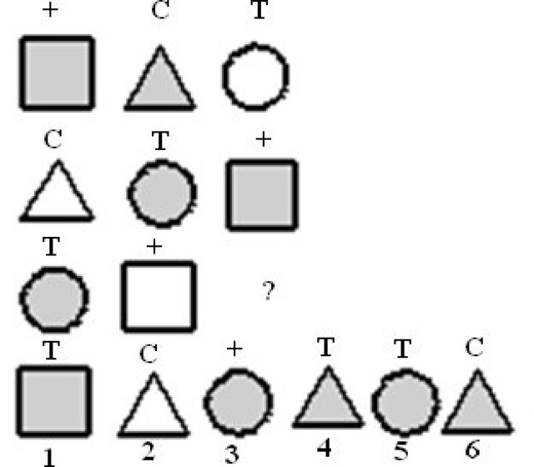
4
1
6
None
A five-digit number divisible by 3 is to be formed using numerical 0, 1,2,3,4 and 5 without repetition. The total number of ways this can be done is:
122
216
217
210
A contract is to be completed in 50 days and 105 men were set to work, each working 8 hours a day. After 25 days, 2/5 th of the work is finished. How many additional men be employed so that the work may be completed on time, each man now working 9 hours a day?
35
34
37
36
A can built up a structure in 8 days and B can break it in 3 days. A has worked for 4 days and then B joined to work with A for another 2 days only. In how many days will A alone built up the remaining part of the structure?
12 days
9 days
10 days
None of these
The first two terms of a geometric progression add up to 12. The sum of the third and the fourth terms is 48. If the terms of the geometric progression are alternately positive and negative, then the first term is
-12
-2
8
-4
The mean of the numbers a, b, 8, 5, 10 is 6 and the variance is 6.80. Then which one of the following gives possible values of a and b?
a = 3, b = 4
a = 5, b = 2
a = 0, b = 7
a = 2, b = 4
An agent sells goods of value of Rs. 15,000. The commission which he receives at the ratio of 12 Â½ % is
Rs. 1875
Rs. 2125
Rs. 2700
Rs. 2000
equal to
0.73
0.50
0.75
0.64
Directions for Question Nos. 33 – 35:
The table below shows the number of people who responded to a survey about their favourite style of music. Use this information to answer the following questions to the nearest whole percentage.
!{width : 350px}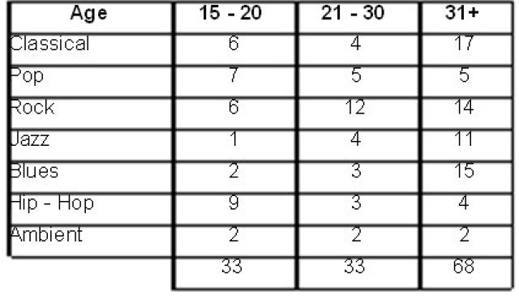
What percentage of respondents under 31 indicated that Blues is their favourite style of music?
7.1
14.1
8.3
7.6
What percentage of respondents aged 21-30 indicated a favourite style other than Rock music?
What percentage of the total sample indicated that Jazz is their favourite style of music?
Directions for Question Nos. 36 – 40:
The pie charts below show the percentage of students in each faculty at North West University and the number of non-US students in the Arts faculty. These percentages have been rounded to the nearest whole number. There are a total of 1049 students in Arts faculty. Use this information to answer the following questions.
1.!{width :200px}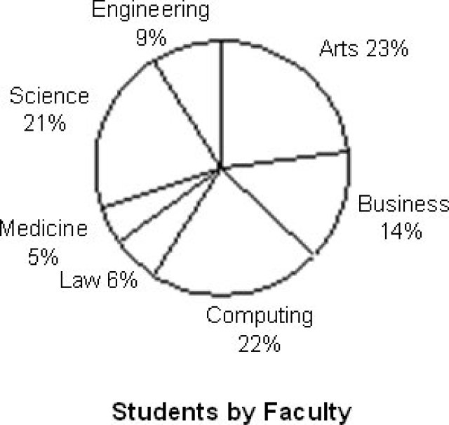 2.!{width :250px}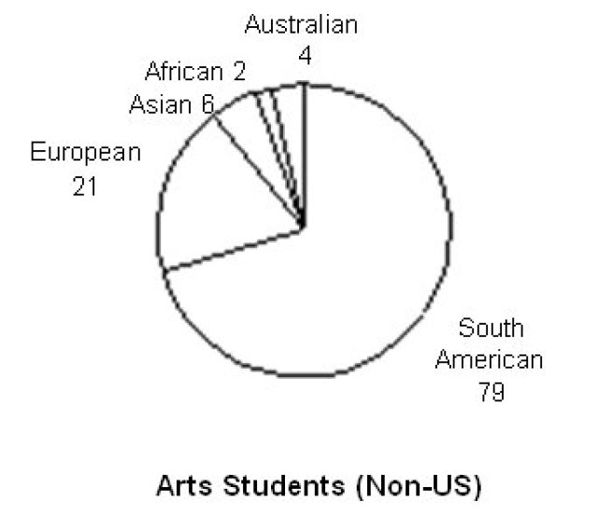
What percentage of students in the Arts faculty are non-US students?
30%
How many students are there in the Engineering faculty?
420
410
390
440
How many students are there at the University?
4560
4640
4650
4450
If six percent of Science students are Asian. How many Asian students are studying Science?
48
120%
57%
66
If six percent of Science students are Asian. How many Asian students are studying Science?
There are 3 societies A, B, C having some tractors each. A gives B and C as many tractors as they already have. After some days B gives A and C as Many tractors as they have. After some days B gives A and C as many tractors as they have. Fianlly each has 24 tractors. What is the original No. Of tractors each had in the beginning?
A-29, B-21, C-12
A-21, B-12, C-29
A-21, B-12, C-39
A-39, B-21, C-12
Although_most_of_the_fastest_growing_jobs_in_today’s_economy_will_require_a_college_degree,_many_of_the_new jobs being created from home health aide to desktop publisher require knowledge other than gained from earning a degree. For workers in those jobs, good basic skills in reading, communication, and mathematics play a important role in getting a job and developing a career.
From_the_information_given_above_it_can_be_validly_concluded_that,_in_today’s_economy
Skills in reading, communication and mathematics play an important role in developing a career as a desktop publisher.
The majority of the new jobs being created require knowledge other than that gained from earning a college degree
A job as a home health aide will rely more on communication skills than on a basic skills in reading and mathematics
If a job is one of the fastest growing jobs, it will require a college degree.
According to the National Agricultural Aviation Society (NAAS), without the use of crop protection products to control insects, weeds, and diseases, crop yields per acre will drop by more than 50 percent. The first aerial application_ of_ insecticide_ occurred_ in_ 1921,_ and_ it_ was_ a_ huge_ success._ By_ contrast,_ in_ today’s_ economy_ all_ aircraft that are classified as aerial applicators do more than just apply insecticide; today, they also spread sees and apply fertilizer.
From the information given above it CANNOT be validly concluded that
In_ today’s_ economy any aircraft that cannot be used to apply fertilizer cannot be classified as an aerial applicator
According to NAAS, if crop yields per acre drop by more than 50 percent, then crop protection products have not been used to control insects, weeds, and diseases.
In_today’s_economy,if_an_aerial_applicator_is_used,_then_it_will_be_able_to_spread_seed_and_to_apply_fertilizer
According to the NAAS, if crop yields per acre never drop by more than 50 parcent, then crop protection products have been used to control insects, weeds, and diseases.
Lou observes that if flight 409 is cancelled, then the manager could not possibly arrive in time for the meeting. But the flight was not cancelled. Therefore, Lou concludes, the manager will certainly be on time. Evelyn replies that_even_if_Lou’s_premises_true,his_argument_is_fallacious._And_therefore,_she_adds,_the_manages_will_not_arrive on time after all.
Which of the following is the strongest thing that we can properly say about this discussion?
Since_Evelyn_is_right_about_Lou’s_argument,_her_own_conclusion_is_well_supported.
Evelyn_is_mistaken_in_thinking_Lou’s_argument_to_be_fallacious,_and_so_her_own_conclusion_is_unwarranted.
Evelyn_is_right_about_Lou’s_argument,but_nevertheless_her_own_conclusion_is_unwarranted.
Since_Evelyn_is_mistaken_about_Lou’s_argument,_her_own_conclusion_must_be_false
Cars are safer than planes. Fifty percent of plane accidents result in death, while only one percent of car accidents result in death.
Which of the following, if true, would most seriously weaken the argument above?
The number of car accidents is several hundred thousand times higher than the number of plane accidents.
Planers are inspected more often than cars.
Plane accidents are usually the fault of air traffic controllers, not pilots.
Pilots never fly under the influence of alcohol, while car drivers often do.
Directions for Question Nos. 46 – 48
Refer to the chart below showing annual production and answer the questions that follow.
!{width :450px}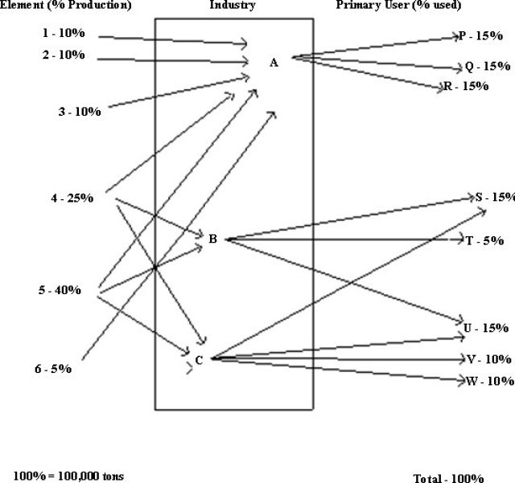
Which industry /industries contribute /contributes to company S?
Industry A and B only
Smallest plant
B and C only
A and C only
Industry B processes what percentage of the total production of listed elements?
Cannot be determined
Of the listed elements processed by the Industry A, how many tons are produced annually?
50,000
100,000
55,000
30,000
Directions for Question Nos. 49 – 52: In each of the following questions there are two blanks marked I & II. The words to fill in these blanks are given against I as (A,B,C,D) and II as (P,Q,R,S) RESPECTIVELY. The right words to fill in these blanks are given as four alternatives. The words on either side of the sign (: :) have a similar relationship. That alternative which signifies this relationship is your answer.
I : Increase : : Descend : II
I. (A) Grow (B) Ascend (C) Rise (D) Price
II. (P) Reduce (Q) Down (R) Decrease S) Mountain
CP
AR
RB
DQ
Modern : I : : II : Old
I. (A) Ancient (B) Death (C) Famous (D) Civilization
II. (P) Industrialisation (Q) Young (R) Fashion (S) Western
AQ
AS
CR
BP
Part : I : : Class : II
I. (A) Section (B) Whole (C) School (D) Students
II. (P) Student (Q) School (R) Teachers (S) Room
AR
DS
BQ
CP
Summit : Apex : I : II
I. (A) beautiful (B) Picture (C) Attractive (D) Enhancing
II. (P) Comfortable (Q) Pretty (R) Healthy (S) Brave
AQ
DS
CR
BP
If in a certain code beautiful is coded as 573041208, BUTTER as 504479, How is FUTURE coded in that code?
204079
204097
201497
704092
How many Mondays are there in particular month of a particular year if the month ends on Wednesday?
3
4
5
Cannot be specified
Directions for Question Nos. 55 – 56:
There are two rows of numbers in each question. The upper row is complete and in the lower one number is missing. Find a suitable number to fill the blank space so that the symmetry with the upper row is maintained.
!{width:120px}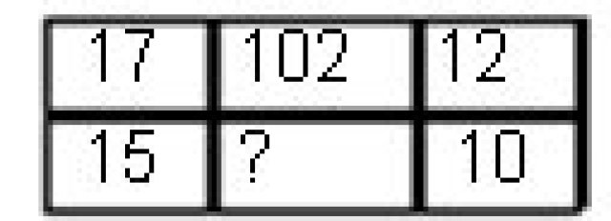
117
75
211
125
!{width : 120px}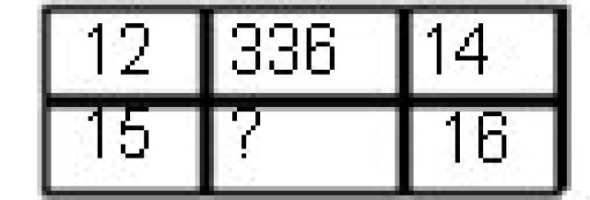
220
125
450
480
Directions for Question Nos. 57 – 58
Seven People A, B, C, D, E, F, G are planning to enjoy boating. There are only two boats, and the following conditions are to be kept in mind.
(I) A will go in the same boat in which E is to go.
(II) F cannot go in the same boat in which C is, unless D is also accompanying.
(III) Neither B nor C can be given the boat in which G is.
(IV) The maximum number of persons in one boat can be four only.
If F and B are in one boat, which of the following statements is true?
D is in the other boat
E is with F and B in one boat
G is in the other boat
C is in the other boat
If E gets the boat with F, which of the following is the complete and accurate list of the people who must be sitting in one boat?
D and A
F and E
C,D and B
G and A
59. Directions for Question Nos. 59 – 60
A series of figures has been shown on the left. Find the figure in the place of ? from the figures on the right.
!{width : 300px}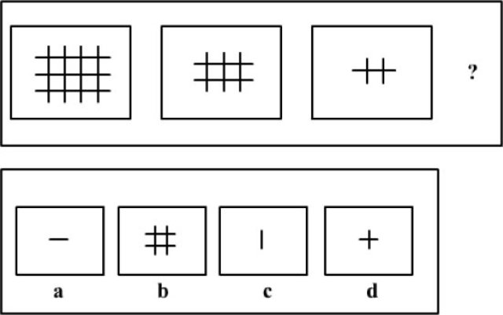
b And c
Only c
a And b
Only b
!{width :250px}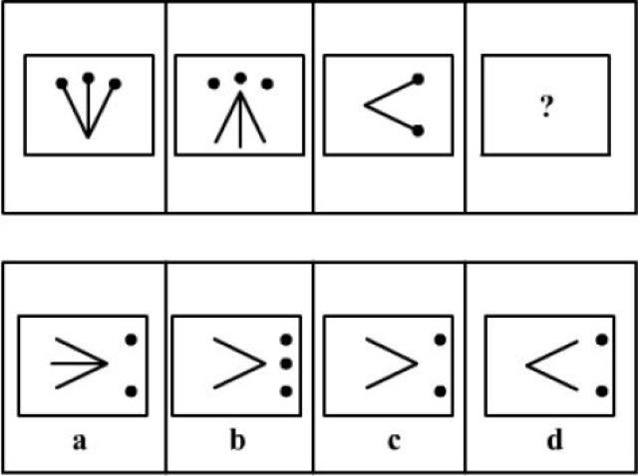
a and b
b and d
Only a
Only c
Complete the following series.
(GMSY, IOVA, KQWC, ?)
NSYE
MYTE
MSYE
MSYF
Directions for Question Nos. 62 – 65:
Following_is_a_new_plan_called_’Airtel_One’,introduced_by_Airtel(GSM_service_Provider)_for_its_post-paid customers.
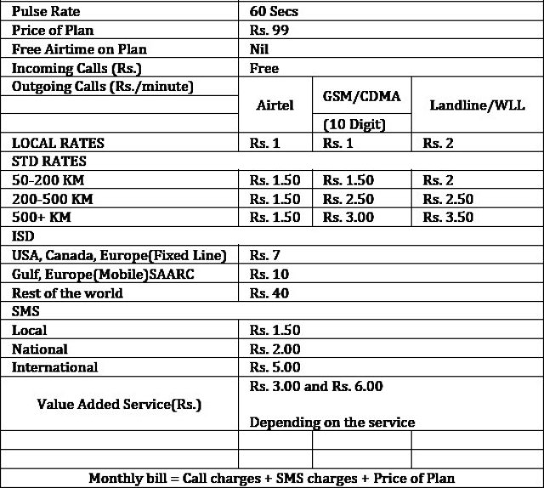
If Mohan made STD calls (within 100 kms) for 30 min and spent 100 min on local calls with 30% on landline. 40% in GSM and 30% on Airtel, and Rohan spent 18 min on STD within 150 Kms and spent 120 min on local calls with 30%, 40% and 30% on GSM, landline and Airtel respectively, then who spent more?
Rohan
Cannot be determined.
Both spent the same amount.
Mohan
A new SMS scheme was introduced @60p/local SMS, with an additional monthly charge of Rs.35. Who will not benefit from the scheme? A Person sending
60 local SMS a month
40 local SMS a month
59 local SMS a month
38 local SMS a month
A bill of Rs 199/Month is definitely not possible when you make only
10 STD calls (250 Kms) each to Airtel, GSM and landline respectively and 30 calls in a month
8, 4 and 7 calls to Airtel GSM and landline respectively on STD (500+Kms) and 55 local calls in a month
30 calls to Airtel on STD (500+Kms) and 55 local calls in a month
16 calls to Airtel on STD (15 Kms and 76 local calls in a month)
A person makes 12 minutes of ISD calls in a month. If 80% of his ISD bill from calling the rest of the world, then the ISD calls for the minimum duration were made to which of the following group of countries?
USA, Canada, Europe (Fixed Line)
Rest of the world
Gulf, Europe (Mobile), SAARC
Cannot be determined.
Directions for Question Nos. 66 – 67:
These questions are based on the graph which shows the demand and production statistics of 5 T.V. companies
!{width : 400px}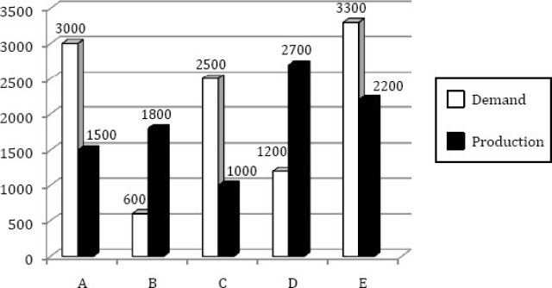
What is the difference between the average demand and the average production of the five companies taken together?
138
1400
400
280
The production of the company D is how many times of the production of the company A?
1.5
1.11
2.5
1.8
Directions for Question Nos. 68 – 69:
The following questions are based on the pie-chart given below which gives the expenditure incurred in printing a magazine:
!{width :250px}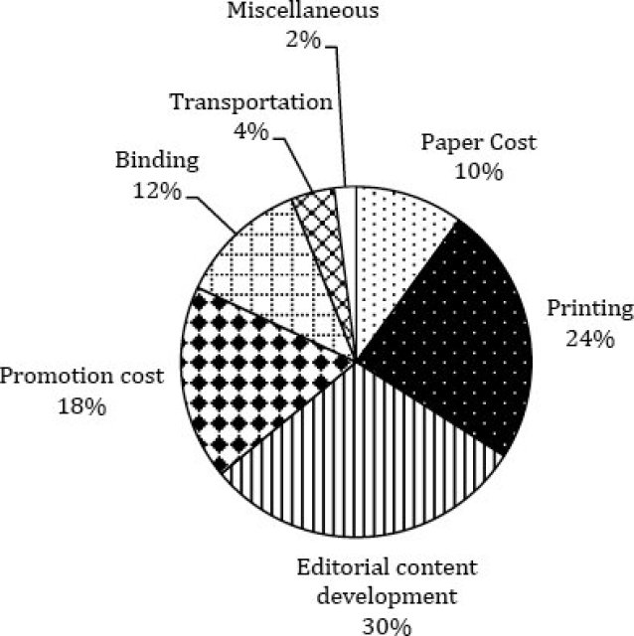
What is the angle for the sector representing paper cost?
23.5 degrees
45 degrees
10 degrees
36 degrees
For a given issue of the magazine, the 2% of the cost is Rs. 2,000 and the print-run is 12,500 copies. What should be the sale price if the publisher desires a profit of 5 percent?
Rs. 8.40
Rs. 7.5
Rs. 8
Rs. 5
If_’water’is_called‘food’,‘food’_is_called‘tree’,_’tree’_is_called‘sky’,_’sky’_is_called‘wall’_,_on_which_of_the_following does_a_’fruit’_grow?
Water
Food
Tree
Sky
Dendrochronology is
The method of scientific dating based on the analysis of tree-ring growth patterns.
Is the study of glaciers or more generally ice and natural phenomena that involve ice.
The scientific study of landforms and the processes that shape them.
A core sample from the accumulation of snow and ice over many years that have re-crystallized and have trapped air bubbles from previous time periods.
Which company launched the first mobile phone operation in India?
Essar
Max Touch
Modi Telstra
Bharti Airtel
Which is the longest running English language TV cartoon in history, first launched by Warner Brothers in 1969 exclusively for television, and is now popular fare on the Cartoon Network?
Scooby Doo
Tom and Jerry
Popeye
Johnny Bravo
The expansion for BIFR, in the context of the Indian Industry is:
Bureau for Investment and Financial Reconstruction
Board for Industrial and Financial Reconstruction
Board for Investment and Financial Reconstruction
Bureau for Industrial and Financial Reconstruction
What is Ekistics?
The water sports related study
The art of card tricks
The science of Body Mass
The science of human settlements
What is Red Herring in an IPO?
Minimum Offer per Share
Submission of Form
Prospectus
Funds Generated during IPO
Eight_O’clock_Coffee,_a_US_based_coffee_marketer,_is_a_group_company_of
Unilever
Tata
Britannia
ITC
Bio-diesel is extracted from the following plant:
Aloe Vera
Hibiscus
Jatropha
Chamomile
Which woman tennis player won the maximum number of Grand Slam singles titles in the history of tennis?
Steffi Graf
Billi Jean King
Martina Navratilova
Margaret Court
What is the nickname of New York city?
Big Sweet Lime
Big Grape
Big Apple
None of the above
Which was the first Indian company to be listed in NASDAQ?
Cognizant
Wipro
TCS
Infosys
“TAREGNA”_- a village in Bihar was in the news because of
Rahul_Gandhi’s_election_campaign
Viewing of the solar eclipse
A visit by Hillary Clinton
The Naxal massacre of tribals
The_driver_for_Formula_One’s_Force_India_Team_is
Adrian Sutil
Jensen Button
Mark Webber
Felipe Massa
(MDRT) – Million Dollar Round Table consists of
World’s_richest_industrialists
World’s_richest_sports_persons
Global Association of Life Insurance professionals
World’s_most_powerful_golfers
Who declares_the_”Credit_Policy”_of_India?
The_Indian_Bank’s_Association
The Commerce Ministry
The Finance Ministry
Reserve Bank of India
Name of the body which regulates the stock Exchanges in India is
SEBI
CID
SHCIL
CBI
Rafflesia_arnoldii_is_its_botanical_name_and_it_holds_a_world_record_in_the_plant_world._What’s_the_record?
Longest surviving tree
Largest bloom
Tallest cacti
Smallest plant
Temujin was a famous historical character of the world, but we know him by a different name. Which one?
Kublai Khan
Babur
Empereor Nero
Genghis Khan
What is Short Selling in stock market lingo?
Selling a share after owning it for a short period of time.
Selling all the shares in your booty which are not productive.
Selling the shares which you do not own.
Selling of shares which are quoted for a short period of time.
Mahatma Gandhi was nominated for Nobel Peace prize for the first time in the year 1937 and last time in the year 1948. How many times in between these two years was he nominated?
1
3
0
2
Which organization instituted the Nobel Prize in Economics?
Svenska Handelsbanken
Sveriges Riksbank
Economics Department of Oxford University
International Monetary Fund
Film stars have been endorsing Lux beauty soap since ages. Who was the first actress of Bollywood to do so?
Suraiya
Leela Naidu
Leela Chitnis
Madhubala
India’s_interstate cricket tournament is named after Kumar Shri Ranjitsinghji Vibhaji Jadeja or in short Ranji, the great cricket legend. He played his cricket in England and also played for English national team. Which county he used play for in the league cricket of England?
Somerset
Surrey
Essex
Sussex
As a practice, all major states capitals have offices of Reserve Bank of India with only one exception. Which city of India has an office of RBI without being a state capital?
Pune
Allahabad
Nagpur
Baroda
This distinguished Indian was born on 28th December 1937 in Surat. He has completed the Advanced Management Program at Harvard Business School, USA. He turned down a job offer from IBM to join his family business and today he is one the top business leaders of India. Name the tycoon.
Anil Ambani
Ratan Tata
Anand Mahindra
Azim Premji
t’s_known_to_be_used_in_Egypt_in_3000_BC,but_its_name_had_been_derived_from_old_French_expression._It_is_made from the fermentation of ethanol in a process that yields its key ingredient, ethanoic acid. What is it?
Vinegar
Tobasco Sauce
Soya Sauce
Phenol
The_name_of_this_Japanese_company_literally_means_”three_diamonds”._Which_one?
Sanyo
Mutsuhito
Mitsubishi
Suzuki
Who were the first twins to ply test cricket?
Steve and Mark Waugh
Merv and Kim Hughes
Ian and Greg Chappel
Surinder and Mohinder Amarnath
Which country has the largest rail network in the world?
China
U.K.
U.S.A
India
Who won the 2009 French open tennis ladies title?
Kristina Mladenovic
Maria Sharapova
Venus Williams
Svetlana Kuznetsova
Who invented the microchip?
Robert Noyce and Jack Kilby
Gordon Moore & Robert Noyce
Saber Bhatia
Larry Page and Sergey Brin
Which is the largest landlocked country in the world?
Mongolia
Switzerland
China
Kazakhstan
hich country makes Panama hats?
Ecuador
Bolivia
Cuba
Panama
Who was the Prime Minister of India when the 42 nd Amendment Bill bringing in the changes in the Constitution was passed?
Indira Gandhi
V.P. Singh
Rajiv Gandhi
Morarji Desai
Which one of the following planets lost its planet status recently?
Pluto
Neptune
Saturn
Moon
One barrel of oil is approximately equivalent to how many litres?
200
150
120
160
Five year plans in India are finally approved by the :
Union Cabinet
President on the advice of prime minister
Planning commission
National Development Council
Many a time we read in the newspapers about Southern Cone of South America which includes Argentina, Chile, Paraguay, Uruguay and Peru. Which is the most spoken language of this geographical area?
Portuguese
English
Spanish
French
Which one of the following is not a member of the organization of petroleum exporting countries (OPEC)?
Brazil
Ecuador
Algeria
Nigeria
Who_invented_’computer_laptop’?
Q. Daimler – Germany
Arthur Wynna – USA
Sinclair – Britain
None of the above
Choose the correct option to fill the blank for correct grammatical use.
She is a close friend of …......................
MY
Me
Mine
I
He took care of her ___ she was restored to health.
Till
Before
After
When
Choose the correct option:
The man ____ his appearance completely since then .
Changed
Has changed
Is changed
Is changing
From the options below, choose the word with the incorrect spelling:
Diaper
Dichotomy
Diarrhea
Dias
Choose the word spelt correctly :
Superintendant
Allotted
Sieve
Dissipate
Direction for Question Nos. 76 – 79
Fill in the blanks with the correct pair of words :
He lives __ Bangaluru __115, Richmond Road.
In On
At On
At In
In At
‘Aurally_challenged’is_a___for_the__.
Euphemism – Deaf
Simile – Disable
Synonym – Dump
Metaphor – Blind
If error is a _, fault is ____.
Blunder – To blame
Slip – An inaccuracy
Mistake – A defect
Defect – A mistake
The man has _ the rules of ethical conduct; he is __ a beast.
Ignored – Basically
Flouted – Virtually
Flaunted – Literally
Broken – As
Part of Australia is known to the natives as The Outback.
Hypen
Semicolon
Comma
Inverted commas
I know that you want to learn to drive Rima but you are too young.
Semicolon
Hypen
Inverted Commas
Comma
Select as option the word closest in meaning to the given word: Veracious
False
Truthful
Varied
Image
Select as option the word closest in meaning to the given word: Perturb
Turn around
Compatible
Stipulate
Disturb greatly
Direction for Question Nos. 82 – 83
Choose the option that is the closest in meaning to the phrases in bold :
He was a king who ruled his subjects with a high hand.
Oppressively
Sympathetically
Generously
Democratically
I racked my brains to solve this difficult problem.
I consulted several people.
I used my commonsense.
I subjected my mind to hard thinking.
I read a large number of books.
Direction for Question Nos. 86 – 87
Select the most appropriate meaning of the underlined idiomatic phrase :
I was supposed to give a speech to my English class, but I got cold feet and_I_didn’t_go.
I_got_too_nervous_and_I_didn’t_go.
It was winter time and I had no snacks for my feet.
My_feet_got_cold_so_I_didn’t_go.
My English class-room makes my feet feel too cold
Take care of what u say! You will have to eat your words!
You will have to take back what you have said.
You have no food to eat.
None of the above.
You are not good with your language.
Which two sentences convey the same idea?
1. Shouldn’t_they_have_checked_your_tickets?
2. I wonder if they should have checked your tickets.
3. I want to know if they checked your tickets.
4. They should have checked your tickets.
2, 3
2, 4
1, 4
1, 2
Direction for Question Nos. 89 – 90
Choose a single word which is opposed to the meaning contained in the sentence.
He was magnanimous and his benevolence made him give to charity.
Snobbish
Tyrannical
Cruel
Mean
Biannual is
Once in two years
After every two years
Twice a year
Every year
Choose the odd one out :
Eternal
Ephemeral
Transient
Temporal

Choose the correct option :
If_’inter’_means_between_as_in_interstate,‘intra’_as_in_intravenous means __.
Without
Onto
Within
Into

Question 133 of 150
Match the part of speech (in bold) to their usage(down)
1. Adjective |  | 5. The fire engine came rushing down the hill.
2. Preposition |  | 6. He has seen the ups and downs of life.
3. Noun |  | 7. Down with the tyrant!
4. Verb |  | 8. The porter was hit by the down train.
 | 1-8, 2-5, 3-6, 4-7
 | 1-6, 2-5, 3-8, 4-7
 | 1-5, 2-7, 3-6, 4-8
 | 1-5, 2-6, 3-7, 4-8
Match the items in the column A with those in column B. Choose the correct answer combination given below.
A. |  | B.
1. As deaf as |  | 5. gall
2. As bitter as |  | 6. an eel
3. As unpredictable as |  | 7. a post
4. As Slippery as |  | 8. the weather
 | (1 – 8), (3 – 5), (3 – 5), (4 – 7)
 | (1 – 5), (2 – 7), (3 – 6), (4 – 8)
 | (1 – 7), (3 – 8), (3 – 8), (4 – 6)
 | (1 – 7), (2 – 6), (3 – 8), (4 – 5)
Match the part of speech (in bold) to their usage.
1. Adjective |  | 5. Rain comes from above.
2. adverb |  | 6.His conduct is above suspicious.
3. Noun |  | 7. Look above the mantel piece.
4. preposition |  | 8. The above information is for the public.
 | (1 – 8), (2 – 5), (3 – 6), (4 – 7)
 | (1 – 6), (2 – 8), (3 – 5), (4 – 7)
 | (1 – 7), (2 – 6), (3 – 5), (4 – 8)
 | (1 – 8), (2 – 7), (3 – 5), (4 – 6)
Direction for Question Nos. 96 – 97
Choose_the_segment_with_error.If_there_is_no_error,_choose_‘d’
A. Idli and Sambar
B. Make the breakfast
C. In the South
D. No error
Only B
A and B
Only D
Only C
Choose_the_segment_with_error.If_there_is_no_error,_choose_‘d’
A. Your account should
B. Have been credited
C. With_three_month’s_interest.
D. No error
C and D
Only A
Only D
A and B
Choose the sentence where the underlined word is used appropriately.
Does he know whom to about the hotel reservations?
Who’s car are you planning to borrow ?
Whoseplanning to have a birthday party ?
He is the person who you met at the junction.
Choose
1. Can you imagine his forgetting his own birthday?
2. Can you imagine him forgetting his own birthday?
If_both_sentences_are_correct
If_the_first_sentence_is_correct
If_the_second_sentence_is_correct
If_both_sentences_are_wrong.
Choose
1. Recently I read about a unique wedding that took place in the newspaper.
2. Recently I read in the newspaper about a unique wedding that took place
If_the_first_sentence_is_correct
If_the_second_sentence_is_correct
If_both_sentences_are_wrong.
If_both_sentences_are_correct
Complete the given sentence by choosing the correct phrase.
You cannot succeed unless
you will work hard.
you work hard.
you shall not work hard.
you do not work hard.
Re -arrange the scrambled segments in logical order to make a complete sentence.
1. to place where more opportunities are available
2. and so there is a great demand for English
3. for professional and economic growth
4. because_it_takes_one_outside_one’s_own_community
5. English is language of opportunities
1, 2, 5, 3, 4
2, 1, 3, 5, 4
5, 4, 1, 3, 2
3, 1, 4, 2, 5
Choose the best construction :
If_you_take_care_you_wouldn’t_have_got typhoid.
If_you_had_taken_care_you_wouldn’t_have_got_typhoid.
If_you_would_have_taken_care_you_wouldn’t_have_got_typhoid.
If_you_took_care_you_wouldn’t_have_got_typhoid.
At times,we are all _ _ to be mistaken.
Considered
Apt
Likely
Able
He hardly cares, _?
Won’t_he
Will he
Doesn’t_he
Does he
dentify the figures of speech in the following sentences:
As proud as a peacock.
Epigram
Apostrophe
Metaphor
Simile
ath lays his icy hand on kings.
Personification
Exclamation
Simile
Anticlimax
Direction for Question Nos. 108 – 110
Read the passage carefully and answer within the context.
“__way_to_deal_with_frozen_feelings”
Every child experiences all that happens around him with total awareness. In the first seven years the child’s brain is like a sponge, taking in all sensory inputs and building his idea of his surroundings. As long as the environment is safe, the child learns with incredible speed. However, when the environment is scary or stressful, the child unlearns past learning just as rapidly.
In the early years of every child’s life, whenever there is shock, violence, fear or pain, these intense emotions are imprinted deeply into memory. Whenever the same activity or situation is repeated, the nervous system and body subconsciously re-experience the memory of that trauma.
Any emotional situation that takes us out of the present and into the past means that whenever the same kind of emotion crops up later in our life we return to the past for our reference point. If that point was at age three, we find ourselves behaving like a three-year-old. We feel childish and we behave childishly. Our feelings are the cause of this ‘glitch’ in our learning process. We know we should be able to make a positive change, but that doesn’t change anything.
The process of change need not be traumatic. We couldn’t have done any better because we didn’t know how to. But we should realise that was then and this is now! We can choose to choose again. It’s up to us. It’s our movie!
The_”Frozen_Feelings”_being_talked_about_are_about
Childhood learning patterns
Inability to learn as an adult
Negative childhood experiences
None of the above.

A_’glitch’_is
Learning patterns
Sudden malfunction or breakdownn
A ditch
Uneasy emotions
dentify the correct sentence, based on the paragraph
We feel childish and we behave childishly.
Both sentences are incorrect.
The process of change needs to be traumatic.
Both the sentences are correct.

