SNAP Paper 2008
Match the following idiomatic references to parts of the human anatomy
1) palm |  | 5) could not tolerate the insult
2) foot |  | 6)to look at with envy and desire
3) eye |  | 7) to put the blame on someone else
4) stomach |  | 8) forced to pay the bill
 | 1-5, 2-7, 3-6, 4-8
 | 1-7, 2-8, 3-6, 4-5
 | 1-6, 2-8, 3-5, 4-7
 | 1-8, 2-6, 3-5, 4-7
Find the maximum number of times any one of the given words fits the sets of sentences RAISE
ARISE
AROSE
RISE
i) Opportunities will _, and you must grab them.
ii) A hot wind _ from the desert.
iii) I _ at dawn on most days.
iv) A mood of optimism _ among the people.
In 2 sentences
In all four sentences
In 1 sentence
In 3 sentences
Which two sentences in the following convey the same idea? Choose from the combinations listed below:
1). He is in a foolâ€˜s paradise
2). He canâ€˜t see the wood for the trees
3).He canâ€˜t distinguish between reality and fancy.
4).He is unable to separate unimportant details from the really important ones
2, 4
1, 4
1, 3
2, 3
Find the correct match of grammatical function with usage for the word THEN.
Function
Usage
1) Noun |  | 5) He was the then King of Nepal.
2) Adjective |  | 6) I have not heard about him since then.
3) Adverb |  | 7) He is not feeling well, then how can he possibly go for the picnic.
4) Conjunction |  | 8) He was not a graduate then.
 | 1-8, 2-5, 3-7, 4-7
 | 1-7, 2-5, 3-6, 4-8
 | 1-6, 2-5, 3-8, 4-7
 | 1-8, 2-7, 3-6, 4-5
We can never make our beliefs regarding the world certain. Even scientific theory of a most rigorous and well-confirmed nature is likely to change over a decade or even tomorrow. If we refuse to even try to understand, then it is likely resigning from the human race. Undoubtedly life of an unexamined kind is worth living in other respectsâ€”as it is no mean thing to be a vegetable or an animal. It is also true that a man wishes to see this speculation domain beyond his next dinner.
From the above passage it is clear that the author believes that
Men are different from animals as far as their reasoning abilities are concerned.
Progress in the scientific field is impossible
Men would do well not to speculate
One should live life with the dictum â€—what will be will beâ€˜
Directions for Question no. 6-11: Read the passage and answer within its context.
Rajendra K. Pachauri, head of the Intergovernmental Panel on Climate Change, is getting nightmares because of the Nano, Tataâ€˜s soon-to-be-launched Rs. One lakh car. Sunita Narain of the centre for science and Environment (CSE) says that it isnâ€˜t the Nano by itself but cars overall that gives her nightmares. The villains in my nightmares are either the Nano nor cars overall, but stupid government policies that subsidize and encourage pollution, adulteration and congestion
Sanctimonious greens call the Nano disastrous because of its affordability millions more will now clog roads and consume more fossil fuel. This is elitism parading as virtue. Elite greens own cars, but cannot stand the poorer masses becoming mobile, since the consequent will eat into the time of the elite!
More logical would be a protest against big cars that use more space and fuel, or highly polluting old cars. Instead green hypocrites aim at a new car with the lowest cost, best mileage and least emissions. The Nano will not burden us with too many cars. India has very few cars per person by world standards. London and New York have ultra-high car densities, yet have clearer air than Delhi. Our problem is too many policies, not too many cars.
We subsidize vehicles on a gargantuan scale invisible to lay folk. Roads and flyovers cost crores to build and maintain, yet road use is free(save on a few toll roads). Traffic police and lights are costly, yet are provided free. These invisible subsidies starve cities of funds to expand roads and public transport.
Land in cities now costs lakhs per square metre. Yet parking is free in the suburbs, and often costs just Rs. 10 day per day in city centres. A single parking space of 23 square meters land worth Rs. 40 lakhs. A car occupies more space than an office desk, yet the desk space pays full commercial rent while parking space costs just about Rs. 10 per day.
Daily parking charges range from $30(RS.630) in Washington to $30(Rs. 1260) in New York, CSE launched a sensible campaign to raise parking fees in Delhi to Rs. 120 per day, but was foiled. So, parking space now exceeds green space, a scathing comment on priorities.
The world price of crude oil has risen 13 fold since 1998 to over %139 per barrel, but Indian petrol prices have barely doubled. Left Front politicians, who once wanted to soak the rich, now want to subsidize them. Under-recoveries of oil companiesâ€˜ total may be Rs. 2,00,000 crore, even after a recent price hike. This is far more than the cost of Sarve Shiksha Abhiyan (education for all) and the Employment Guarantee Scheme put together.
We sanctimoniously lecture rich countries to reduce their green house emissions, yet subsidize our own. Diesel is subsidized to be cheaper than petrol. So, Indian car makers produce the highest proportion of diesel cars in the world. Diesel fumes contain suspended particles that are highly toxic. This subsidy kills.
So does kerosene provided at throwaway prices, ostensibly to benefit poor villagers. One third of all kerosene is used to adulterate petrol and diesel. This causes horrendous pollution even in the greenest of cars.
Whatâ€˜s the way forward? We must abolish subsidies and raise taxes on vehicles and fuels to reflect their full social cost. The biggest but least visible subsidy is for parking, and we should start there.
Many car owners in the West take public transport to work since parking space downtown is costly and scarce. We should levy parking fees on an hourly, not daily, basis. Rs. 10 per hour could be a starting point in the metros.
In parts of Tokyo, you cannot own a car unless you own a private parking space. This is too extreme for India, but indicates the future path. If we charge owners the full social cost of parking, people will buy smaller and perhaps fewer vehicles, and fewer still will take them to work. That will slash congestion and pollution.
Cities should levy stiff annual taxes on vehicles, not a one-time tax, and use the revenue to constantly expand public transport and roads. This will create economic synergy: Private transport will finance public transport. London and New York have high density public transport as well as high car density.
Apart from underground rail, cities need elevated roads to ease congestion and pollution. Lata Mangeshkar helped kill a proposal for an elevated road near her Mumbai flat: perhaps she felt her throat and singing would be affected. She did not care that the throats of poor people living on the pavements were far worse affected by fumes, and might get relief if some fumes were diverted to a higher level. What elitism!
Next, some medicine that will be really bitter, politically. The excise duty on all automotive vehicles should be raised to reflect their social costs. Fuel subsidies should be abolished. Price differentials between petrol, diesel and kerosene should be removed, ending incentives for adulteration. Diesel cars should bear a heavy additional cess to finance improve healthcare for those affected by their emission of harmful particulate matter.
That is a long, politically difficult agenda. Only part of it will ever be achieved. Yet that is the way to go, rather than agitate the Nano.
By â€—Sanctimonious greensâ€˜ the writer refers to
The rich
Those who decry deforestation
Aristocratic environmentalists
Environmentalists with a â€—holier than thouâ€˜ attitude
The elite are
Afraid of traffic jams and depletion of fossil fuel
Afraid of reaching their destinations late
Jealous of Nano owners
Full of disdain that the poor can afford cars
he paradox of the situation is that
London and New York have more cars and less pollution
Bigger cars mean more fuel, more space and more pollution
Though India has fewer cars the Nano will bring more pollution
Though India is smaller than the US its cars cause more pollution
In saying 23 square metres of parking space costs 40 lakhs, the writer is _
Caustic
Sarcastic
Ironical
Exaggerating
The writer blames India for
Subsidizing diesel
For increasing the cost of parking by the hour
For not making it mandatory for car owners to own parking space
Subsidizing kerosene whereby greenhouse emissions are indirectly subsidized
The most suitable title for this passage is
No No Nano
Polluting Politics
More Cars, Less Pollution
Submerge Subsidies
The plural of Virus is
Viruses
Virae
Virii
Virus
If the following segments of a sentence are to be rearranged in logical order as A, B, C, D where would â€—3â€˜ be placed
1).To see that students do not altogether forget to write especially during exam time
2). The education groups are now asking for hand writing classes
3). Thanks to mobile testing and computer literacy
4). Writing in long hand is becoming a vanishing art
C
B
D
A
If leaf is to leaves and knife is to knives, then belief is to -
Belief
Believes
Believing
Beliefs
Choose the sentence where the underlined word is used correctly.
Every week we are forced to listen to a pedestrian lecture.
This is the pedestrian highway.
This latest novel is a pedestrian story about spies.
The exam paper is not pedestrian but difficult.
When the fire alarm rang _ left the building immediately
Every person
all
Everyone
All the people
In the following sentence choose the erroneous segment/s
A
B
C
He is one of those people / who thinks / he owns the world
Error in segment B
Error in segment B & C
Error in segment A
Error in segment A & C
Choose the correct meaning for the word: cynic
The person who is selfish
The person who isnâ€˜t misanthropic
The person who is concerned about others
The person who believes that people always act from selfish motives
Choose the word with correct spelling
Categories
Diarrhea
Omission
Inaugurate
Pick out the right sentences.
1. I will go with you.
2. There was nobody I could go with.
3. I have a glass with painting on it.
4. The curtains do not match with the furniture.
1 & 4
1 & 2
2 & 3
All
About the following pair of phrases, choose the correct option.
i. A two daysâ€˜ visit
ii. A two dayâ€˜s visit
The second phrase is erroneous
Both phrases are erroneous
The first phrase is erroneous
Both phrases are correct
Directions for Question No. 22 â€“ 24: Read the following passage and answer within its context.
Nearly two thousand years have passed since a census decreed by Caesar Augustus became part of the greatest story ever told. Many things have changed in the intervening years. The hotel industry worries more about overbuilding than overcrowding, and if they had to meet an unexpected influx, few inns would have managed to accommodate the weary guests. Now it is the census taker that does the travelling in the fond hope that a highly mobile population will stay put long enough to get a good sampling. Methods of gathering, recording and evaluating information have presumably been improved a great deal. And where then it was the modest purpose of Rome to obtain a simple head count as an adequate basis for levying taxes, now batteries of complicated statistical series furnished by governmental agencies and private organizations are eagerly scanned and interpreted by sages and seers to get a clue for future events.
The Bible does not tell us how the Roman census takers made out, and as regards our more immediate concern, the reliability of present-day economic forecasting, there are considerable differences of opinion. They were aired at the celebration of the 125th anniversary of the American Statistical Association. There was the thought that business forecasting might well be on its way from an art to a science, and some speakers talked about new-fangled computers and high-faulting mathematical systems in terms of excitement and endearment, which we, at least in our younger years when these things mattered, would have associated more readily with the description of a fair maiden.
But others pointed to a deplorable record of highly esteemed forecasts and forecasters with a batting average below that of the Mets and the President-elect of the Association cautioned that â€•highpowered statistical methods are usually in order where the facts are crude and inadequate, statisticians assume.â€–
We left his birthday party somewhere between hope and despair and with the conviction, not really newly acquired, that proper statistical methods applied to ascertainable facts have their merits in economic forecasting as long as neither forecaster nor public is deluded into mistaking the delineation of probabilities and trends for a prediction of certainties of mathematical exactitude.
According to the passage, taxation in Roman times were based on
Census takers
Mobility
Wealth
Population
The author refers to the Mets primarily in order to
Indicate the changes in attitudes from Roman days to the present
Show that sports do not depend on statistics
Contrast verifiable and unverifiable methods of record keeping
Illustrate the failure of statistical predictions.
The authorâ€˜s tone can best be described as
Jocular
Pessimistic
Humanistic
Scornful
Disinterested is closest in meaning to
Unbiased
Indifferent
Not interested
Bored
Choose the option which is the nearly opposite in meaning to BERATE
Refer
Praise
Purchase
Grant
rrange the following in the right order to make a complete sentence
i. with interconnected vibrating balls and springs
ii. in a naÃ¯ve sense, a field in physics may be envisioned as if space were filled
iii. as the displacement of a ball from its rest position
iv. and the strength of the field can be visualized
iii, iv, i, ii
ii, i, iv, iii
i, ii, iii, iv
iv, iii, ii, i
Find the odd one out
Latent
Inherent
Natural
Inborn
He told the teacher that ___.
You were liked by the whole class
He is liked by the whole class
You are liked by the whole class
He was liked by the whole class
Match the several meanings of the word COMPLEX with their appropriate usages.
Meaning |  |  | Usage
1) complicated |  |  | 5) A new sports complex is coming up for the Common Wealth Games.
2) abnormal state of mind |  |  | 6) Culture is a complex whole of many things.
3) group of structures |  |  | 7) She has a complex about being overweight.
4) mixture |  |  | 8) His motives in carrying out the crime were complex.
 | 1-8, 2-5, 3-6, 4-7
 | 1-8, 2-7, 3-5, 4-6
 | 1-5, 2-7, 3-6, 4-8
 | 1-6, 2-8, 3-7, 4-5
Which does not make a sensible word/phrase when added to the word:
Honey
Comb
Pot
Suckle
Taste
Directions for Question No. 32-34: Read the passage carefully and answer within the context.
In September of 1929, traders experienced a lack of confidence in the stock marketâ€˜s ability to continue its phenomenal rise. Prices fell. For many inexperienced investors, the drop produced a panic. They had all their money tied up in the market, and they were pressed to sell before the prices fell even lower. Sell orders were coming in so fast that the ticker tape at the New York Stock Exchange could not accommodate all the transactions.
To try the reestablish confidence in the market, a powerful group of New York bankers agreed to pool their funds and purchase stock above current market values. Although the buy orders were minimal, they were counting on their reputations to restore confidence on the part of the smaller investors, thereby affecting the number of sell orders. On Thursday, October 24, Richard Whitney, the Vice President of the New York Stock Exchange and a broker for the J.P. Morgan Company, made the effort on their behalf. Initially it appeared to have been successful, then, on the following Tuesday, the crash began again and accelerated. By 1932, stocks were worth only twenty percent oftheir value at the 1929 high. The results of the crash had extended into every aspect of the economy,causing a long and painful depression, referred to in American history as the Great Depression.
The New York bankers counted on â€“
Current market values
The number of sell orders
Confidence
Their reputation
The cause of downfall of share market wasa.
Inexperienced investors
Phenomenal decrease
Lack of confidence in stock marketâ€˜s ability
Panic amongst investors
Choose the word in the passage that is an antonym of the â€—minimalâ€˜
Significant
Negligible
Maximal
Minimum
Identity the correct sentence.
The office is opposite from the bank.
The office is opposite of the bank.
The office is opposite the bank.
The office is opposite to the bank.
Which of the following is a legal right and not a fundamental right
Right against exploitation
Right to Liberty of thought and expression
Right to practice religion
Right to property
What is Dry Ice?
Solidified Carbon Dioxide
Chemically treated ice to make it dry.
Transparent plastic decoy which looks like ice
Sulfur dioxide at -57 degree Celsius
A band passes around all the wheels so that they can be turned by the driving wheel. When the driving wheel turns in the direction shown. Which way will the wheel B turn?
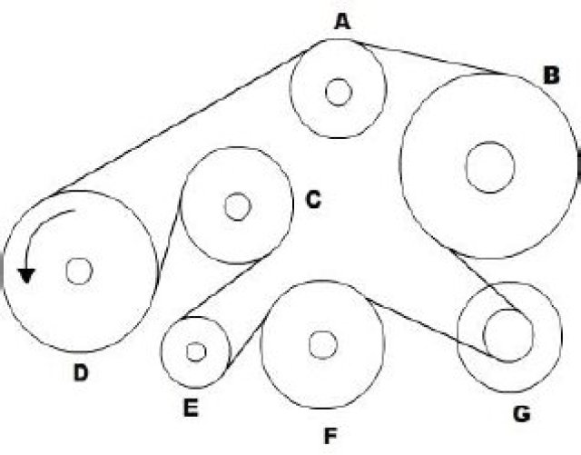
Either way
Anti-clockwise
Clockwise
Cannot move
In a certain language, (A) ‘Sun shines brightly’ is written ‘ba lo sul’; (B) ‘Houses are brightly lit’ is written as ‘kado udo ari ba’; and© ‘Light comes from sun’ as ‘dapi kup lo nro’. What words will be written for ‘sun’ and ‘brightly’?
ba, lo
Lo, ba
snl, lo
ba, sul
Given are the following three equations:
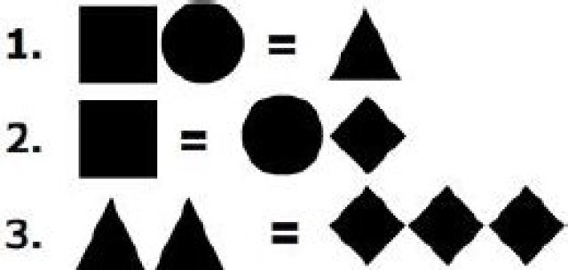
How many circles are equivalent to a square, as per the ratios in the three given equations?
Each child in a family has at least 4 brothers and 3 sisters. What is the smallest number of children the family might have?
7
10
8
9
In the following question two statements are followed by two conclusions numbered I and II. Assume the two statements are true even if they are at variance with commonly known facts. Then pick the correct answer from the choices given below.
A. Only conclusion I follows.
B. Only conclusion II follows
C. Both conclusions I & II follow
D. Neither conclusion I nor conclusion II follows
Statements: Some doctors are fools. Joshi is a doctor.
Conclusions: I. Joshi is a fool.
II. Some fools are doctors.
C
A
D
B
Debu walks towards the east then towards North and turning 45Â° right walks for a while and lastly turns towards left. In which direction is he walking now?
North
East
South-East
North-East
Read the following instructions and answer.
I. There is a rectangular wooden block of length 4 cm, height 3 cm and breadth 3 cm.
II. The two opposite surfaces of 4 cm Ã— 3 cm are painted yellow on the outside
III. The other two opposite surfaces of 4 cm Ã— 3 cm are painted red on the outside.
IV. The remaining two surfaces of 3 cm Ã— 3 cm are painted green on the outside.
V. Now, the block is cut in such a way that cubes of 1 cm Ã— 1 cm Ã— 1 cm are created.
How many cubes will have only one colour?
12
10
14
18
Read the following instructions and answer.
I. There is a rectangular wooden block of length 4 cm, height 3 cm and breadth 3 cm.
II. The two opposite surfaces of 4 cm Ã— 3 cm are painted yellow on the outside
III. The other two opposite surfaces of 4 cm Ã— 3 cm are painted red on the outside.
IV. The remaining two surfaces of 3 cm Ã— 3 cm are painted green on the outside.
V. Now, the block is cut in such a way that cubes of 1 cm Ã— 1 cm Ã— 1 cm are created.
How many cubes will have no colour?
8
4
1
2
Read the following instructions and answer.
I. There is a rectangular wooden block of length 4 cm, height 3 cm and breadth 3 cm.
II. The two opposite surfaces of 4 cm Ã— 3 cm are painted yellow on the outside
III. The other two opposite surfaces of 4 cm Ã— 3 cm are painted red on the outside.
IV. The remaining two surfaces of 3 cm Ã— 3 cm are painted green on the outside.
V. Now, the block is cut in such a way that cubes of 1 cm Ã— 1 cm Ã— 1 cm are created.
How many cubes will have any two colours?
16
12
34
24
Read the following about the grid given below and answer.
1. The cells in this grid contain the digits 1 to 0 in random order.
2. Column A contains no odd digits.
3. Cell C3 minus Cell C2 equals 4.
4. The sum of three digits in Row 1 is 17.
5. Number 7 is in Column B; its left hand neighbor is not 4.
6. The digits of Column C add upto 14.
7. 2 is not in the same horizontal row as 8; and 9 is not immediately below 3.
Which cell holds the number 9?
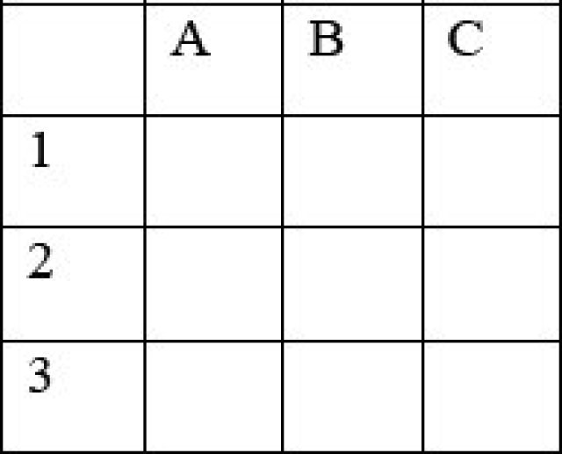
B1
B3
C2
C1
Replace the question mark with the right option. 4, 32, 288, ?, 31680
2880
25600
7420
10000
In the Sunday bazzar, Jamuna sells her lemons at Rs. 0.50 for two. Her neighbor Seema has a little smaller lemons; she sells hers at Rs. 0.50 for three. After a while, when both ladies have the same number of lemons left, Seema is called away. She asks her neighbor to take care of her goods. To make things simple, Jamuna puts all lemons in one big pile, and starts selling five lemons per one rupee. When Seema returns, at the end of the day, all lemons have been sold. But when they start dividing the money, there appears to be a shortage of Rs. 3.50. Supposing they divide the money equally, how much does Jamuna lose with deal?
Rs. 42.00
Rs. 10.50
Rs. 52.50
Rs. 11.50
There are two cups, one containing orange juice and one containing an equal amount of lemonade. One teaspoon of the orange juice is taken and mixed with the lemonade. Then a teaspoon of this mixture is mixed back into the orange juice. Is there more lemonade in the orange juice or more orange juice in the lemonade?
More lemonade in the orange juice
None of the above
More orange juice in the lemonade
Equal amount of each juice between the two cups
Consider the statement and decide which of the assumptions are implicit:-
â€•In the present period of economic hardships, education and small family norm may lead the nation to progress and prosperity
Assumptions: A. Education and small family norms are directly related to nationâ€˜s progress.
B. Big families find it difficult to bear the cost of education.
Neither A nor B is implicit.
Only A is implicit.
Both A and B are implicit
Only B is implicit.
Fill in the blanks to find out two words that are synonyms
MS, NT
MS,DN
None of them
KS, ST
ST, DN
Beautiful beaches attract people, no doubt about that. Just look at the cityâ€˜s most beautiful beaches, which amongst the most overcrowded places in the state.
Which of the following exhibits a pattern of reasoning similar to the one exhibited in the argument above?
Moose and bear usually appear at the same drinking hole at the same time of the day. Therefore, moose and bear must be feeling thirsty at about the same time.
During warm weather my dog suffers more fleas than during cool weather. Therefore, fleas must thrive in a warm environment.
Tally accounting software helps increase the work efficiency of its users. As a result, these users have more time for other activities.
Children who are scolded severely tend to misbehave more often than other children. Hence if a child is not scolded severely, that child is less likely to misbehave.
Abdul, Mala and Chetan went bird watching. Each of them saw one bird that none of the others did. Each pair saw one bird that the third did not. And one bird was seen by all three. Of the birds Abdul saw, two were yellow. Of the birds mala saw, three were yellow. Of the birds Chetan saw, four were yellow. How many yellow birds were seen in all? How many non-yellow birds were seen in all?
5 yellow birds and 2 non yellow birds
4 yellow birds and 2 non yellow birds
7 yellow birds and 3 non yellow birds
3 yellow birds and 2 non yellow birds
In each of the following two sets I & II, find the word or pair of words different from the other three words or pair of words:
I-J | , II-J

I-K | , II-M

I-K | , II-J

I-J | , II-K

A, B, C and D are standing on the four corners of a square field as shown in the figure. From the positions shown in the figure, A walks to North position and B walks to the East position while C decides to walk two sides in anticlockwise direction. B walks to North and then changes his mind to take the previous position. Identify the choice with correct positions.
B & C are diagonally opposite positions.
A & B occupy the same position.
C & D occupy the same position.
D & B are in their original positions.
A gambler bet on a horse race, but the bookee wouldnâ€˜t tell him the results of the race. The bookee gave clues as to how the five horses finished â€“ which may have included some ties â€“ and wouldnâ€˜t pay the gambler off unless the gambler could determine how the five horses finished based on the following clues:
1. Penn Fe finished before Night Marvel and after Wish Bones.
2. Wish Bones tied with Penn Fe if and only if Hallelujah did not tie with Sundae
3. Penn Fe finished as many places after Sundae as Sundae finished after Wish Bones if and only if Wish Bones finished before Night Marvel.
The gambler thought for a moment, then answered correctly. How did the five horses finish the race?
Wish Bones came in first. Sundae and Hallelujah tied for second place. Penn Fe came in fourth. Night Marvel came in fifth.
Penn Fe came in first. Night Marvel and Hallelujah tied for second place. Wish Bones came in fourth. Sundae came in fifth.
Wish Bones came in first. Sundae and Penn Fe tied for second place. Hallelujah came in fourth. Night Marvel came in fifth.
Sundae came in first. Wish Bones and Hallelujah tied for second place. Penn Fe came fourth. Night Marvel came in fifth.
In a school drill, a number of children are asked to stand in a circle. They are evenly spaced and the 6th child is diametrically opposite the 16th child. How many children are made to stand in the circle?
None of the above
16
20
22
In this question insert the missing number at the sign of interrogation.
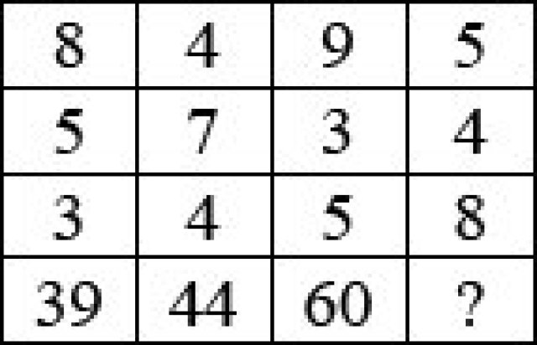
72
70
62
60
Steel cylinders are made so that each one has a large and small hole through the middle. In the drawing six cylinders have been stacked on top of each other. To stop the cylinders from rolling on the smooth floor they are wedged by heavy blocks at each side of bottom row. If the heavy blocks are removed what would be the position of the cylinder when they stopped rolling?
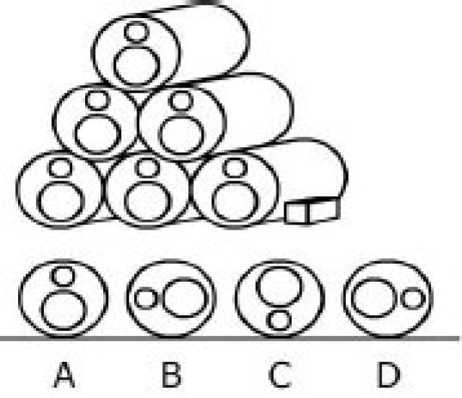
C
D
B
A
Use the information given below to answer.
i. There is a group of 5 persons A, B, C, D and E
ii. In the group there is one badminton player, one chess player and one tennis player
iii. A and D are unmarried ladies and they do not play any games
iv. No lady is a chess player or a badminton player
v. There is a married couple in the group of which E is the husband
vi. B is the brother of C and is neither a chess player nor a tennis player
Which of the groups has only ladies?
CDE
None of the above
BCD
ABC
Use the information given below to answer.
i. There is a group of 5 persons A, B, C, D and E
ii. In the group there is one badminton player, one chess player and one tennis player
iii. A and D are unmarried ladies and they do not play any games
iv. No lady is a chess player or a badminton player
v. There is a married couple in the group of which E is the husband
vi. B is the brother of C and is neither a chess player nor a tennis player
Who is the tennis player
D
C
E
B
Use the information given below to answer.
i. There is a group of 5 persons A, B, C, D and E
ii. In the group there is one badminton player, one chess player and one tennis player
iii. A and D are unmarried ladies and they do not play any games
iv. No lady is a chess player or a badminton player
v. There is a married couple in the group of which E is the husband
vi. B is the brother of C and is neither a chess player nor a tennis player
Who is the wife of E?
A
None of the above
D
B
Consider the following statements and answer the question.
M, N, O and P are all different individuals.
M is the daughter of N.
N is the son of O.
O is the father of P.
Which among the following statements is contradictory to above premises?
P is the father of M.
O has three children.
M has one brother.
M is the daughter of O.
The Drawing shows a cross section where the land meets the sea. The section covered is 5 kilometers. On a hot day, in which direction, indicated by four arrows, is the wind most likely to blow?
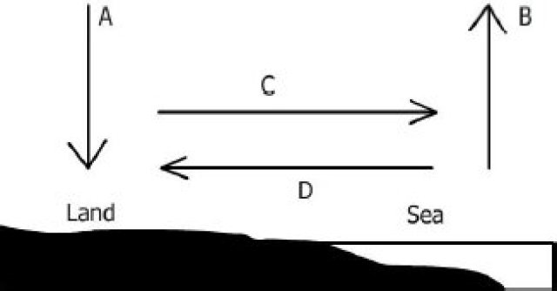
B
A
C
D
In the diagram below, the circle stands for â€—educatedâ€˜, square stands for â€—hard workingâ€˜, triangle for â€—urban peopleâ€˜ and rectangle for â€—honestâ€˜. The different regions of the diagram are numbered from 1 to 12. Study the diagram carefully and answer the questions:
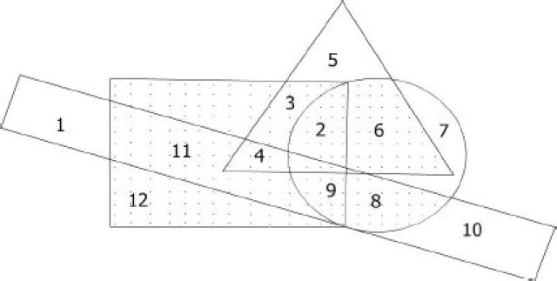
Uneducated urban hardworking and honest people are indicated by:
4
9
11
3
In the diagram below, the circle stands for â€—educatedâ€˜, square stands for â€—hard workingâ€˜, triangle for â€—urban peopleâ€˜ and rectangle for â€—honestâ€˜. The different regions of the diagram are numbered from 1 to 12. Study the diagram carefully and answer the questions:
Non-urban educated people who are neither hard-working nor honest are indicated by:
7
5
11
10
A. M. Touring award is considered as the Nobel Prize in the field of computers, given annually by Association for Computing Machinery co-sponsored by Intel and Google. Who was A. M. Touring in whose memory the award was instituted?
First Chairman of Intel.
An US cognitive scientist in the field of artificial Intelligence (AI) and co-founder of Massachusetts Institute of Technologyâ€˜s AI laboratory.
The legendary Dean of Stanford who revolutionized the computer education in the US.
A British Mathematician
Find the most accurate description of â€—Bt Cottonâ€˜.
A genetically modified crop of cotton whose DNA has been designed in the lab.
A Variety of cotton that grows fast
A genetically modified crop of cotton whose DNA has been altered by introducing an extra gene.
A variety of cotton that is immune to diseases.
Las Vegas, US-based tour operator AMX Company has filed a trademark patent for which of the following Tagline?
“Gods Own Country”
“Come Alive with India”
“Heaven on Earth”
“Discover Incredible India”
Which out of the following holds the highest number of shares of ICICI Bank?
Banks Financial Institutes and Insurance
FIIs
General public
Private Corporate Bodies
Indian Standard time is based on the longitude of 82.5 degrees passing through which of the following places?
Mirzapur, U.P.
Nagpur, Maharashtra
Jabalpur, M.P.
Jaipur, Rajasthan
The Black Box of an aircraft is an important part as all the conversations and data are recorded therein. Although it is named black box, but its color is not black. What is the color of the black box in a commercial airplane?
Yellow
Red
Orange
Brown
Find the person who plays the odd sport out of the following.
a. Navaratilova
b. Michael Phelps
c. David Beckham
d. Prakash Padukone
bc
ca
ab
cd
Sariska and Ranthambore are the reserves for which of the following animals?
Tiger
Lion
Bear
Deer
March, 2008 witnessed a turning point in the history of which of the following Himalayan Kingdoms when democracy was ushered in replacing monarchy?
Bhutan
Sikkim
Nepal
None of these
Neil Armstrong brought back a rock from the moon. On earth
The weight of the rock will change
None of the above
The mass of the rock will change
Mass and weight will change
Milk, Cheese and Eggs are the source of
Vitamin B & C
Vitamin A & D
Vitamin C & D
Vitamin C & A
In August 2008, Indiaâ€˜s longest runway for the passenger aircraft was commissioned in:
Hyderabad
Bangalore
Mumbai
New Delhi
The first ever public hearing in India, almost like a referendum, on the fate of SEZ was held during the month of September 2008 in / at ____
POSCO India, Steel SEZ Phase II, Orissa.
Haryana for Reliance Haryana SEZ.
Verna IT/ ITeS SEZ in Goa.
Pen, Maharashtra.
Al Ahram is
A Small mountain range in Jordan.
A University in Damascus.
A Newspaper in Cairo.
A Mosque in Riyadh.
Indiaâ€˜s largest and first multi-national pharmaceutical giant Ranbaxy is being bought over by ___
Matrix Pharma.
Merck.
None of these.
GVK Bio-sciences.
Find the odd product out of the following:
Pamper
Dove
Tide’
Pantene
In the internet sphere, â€—Operaâ€˜ is the name of a :
Web browser.
Software for webinars
Web conference site
Web advertising firm.
Which of the following pair is not correct?
Rashid Khan: Vocal Music
Ayaan Ali Khan: Sarod
Romu Muzumdar: Guitar
Shahid Parvez: Sitar
At what frequency SENSEX calculation is carried out?
Every half an hour.
Every hour.
Real time.
6 times a day.
The second largest manufacturer of CDâ€˜s, DVDâ€˜s and other optical media in the world is:
Sony
Moser Baer
Philips
Intel
The term Net Shot is associated with
Badminton
Tennis
Table Tennis
Volley Ball
The rail-based mass rapid transit system in Mumbai has been awarded to a consortium of companies led by:
GMR Infrastructure
Lanco Infrastructure
Reliance Industries
Reliance Infrastructure
If bilirubin is high in a human body, which organ is most affected?
Pancreas
Liver
Kidney
Large Intestine
Who of the following is one of the most celebrated Photo Journalists in India?
Anjii Reddy
Raghu Rai
Sudhir Das
Gautam Rajadhyaksha
Inflation implies
Rise in general price index
Rise in budget deficit
Rise in money supply
Rise in price of consumer goods
The India-US Nuclear Deal is called 123 Agreement. What does 123 denote?
The deal governed by the clause number 123 of International Atomic Energy Agency, in the context of peaceful use of atomic energy
This is the simple number related to chain reaction for creation of atomic energy.
Section 123 of the US Atomic Energy Act.
This number denotes a cluster of clauses of Hyde Act of US Government
In the United States of America, the President is elected
By the U.S. congress
By the two national political parties
By the electoral college
By the electorate
The term â€•Uruguay Roundâ€– is associated with an important world organization. Which one?
WTO
World Bank
GATT
UNDP
Siebel is a software firm that is now taken over by:
IBM
Oracle
Gartner
Accenture
First Indian motion picture insured by a General Insurance company is
Dil Se
Ashoka
Taal
Hum Apke Hain Kaun
Indiaâ€˜s first coalition government in New Delhi was formed under the leadership of:
V. P. Singh
Morarji Desai
Atal Behari Vajpayee
P. V. Narasimharao
WiMax stands for:
Wireless internet for microwave access
Worldwide internet for microwave access
Worldwide inter-operability for microwave access
Wireless inter-operability for microwave access
El Nino is
A Sea storm
A war ocean current
Another name of typhoon
A tropical disturbance
A factory is to commission two production lines. Production line 1 is to use existing technology. Production line 2 is to use the latest innovation in technology and, while promising to achieve considerable advances in productivity, it will take longer to start and is likely to experience teething problems. Graph indicates the productive record of each product line. Refer to the graph to answer the following
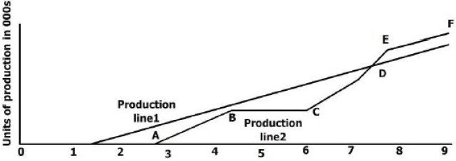
A. Can the duration of reported breakdown be established?
B. Can the loss of production b e quantified?
Both questions A and B can be answered
Only A question can be answered
Only B question can be answered
Neither question can be answered
From a book, a number of consecutive pages are missing. The sum of the page numbers of these pages is 9808. Which pages are missing?
The pages 291 up to and including 322 are missing
The Pages 291 up to 322 are missing.
The page 9808 is missing.
Either a or c.
In the following series find the one number that is wrong
2, 3, 13, 37, 86, 167, 288.
86
3
13
37
Two sea trawlers left a sea port simultaneously in two mutually perpendicular directions. Half an hour later, the shortest distance between them was 17 km and another 16 minutes later, one sea trawler was 10.5. Km farther from the original than the other. Find the speed of each sea trawler.
16 km/hr, 30 km/hr
18 km/hr, 36 km/hr
18 km/hr, 24 km/hr
20 km/hr. 22 km/hr
The image below indicates the number of residents at 5 hotels on 1 Feb and 1 July 1998. Which hotel had the greatest increase in the total number of adult residents on 1 July 1998 compared with 1 Feb of that year?
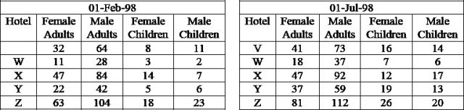
Y
V
Z
W
This question consists of a question and two statements numbered I and II. Decide whether the data given in the statements are sufficient to answer the question. What is the 57th number in a series of numbers?
I. Each number in the series is three more than the preceding number.
II. The tenth number in the series is 29.
If the data in both Statements I and II together is necessary to answer the question.
The data in Statement II alone is sufficient to answer the question, while the data in Statement II alone is not sufficient to answer the question.
The Data in Statement I alone is sufficient to answer the question while the data in Statement II alone is not sufficient to answer the question.
If the data either in Statement I or Statement II alone are sufficient to answer the question.
The cost of levelling and turfing a square field at Rs. 160 per hectare is Rs. 2624.40 The cost of surrounding it with a railing costing 25 paise per metre is:
Rs. 400
Rs. 375
Rs. 350
Rs. 405
When the Sun rayâ€˜s inclination from 30Â° and 60Â°, the length of the shadow of a tower decreases by 60 m. Find the height of the tower.
51.96 m
50.9 m
48.8 m
None of these
A survey of movie goers from five cities A, B, C, D and E is summarized below. The first column gives the percentage of viewers in each city who watch less than one movie a week. The second column gives the total number of viewers who view one or more than movies per week.
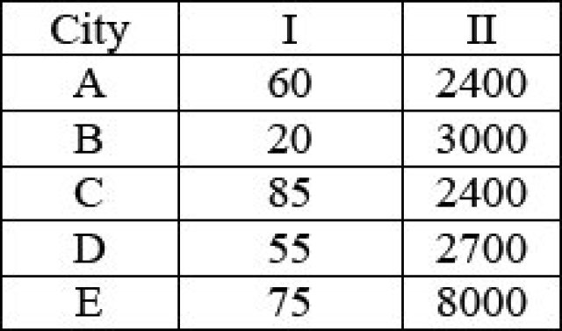
How many viewers in the city C watch less than one movie a week?
3600
2040
16000
13600
A survey of movie goers from five cities A, B, C, D and E is summarized below. The first column gives the percentage of viewers in each city who watch less than one movie a week. The second column gives the total number of viewers who view one or more than movies per week.
Which city has the highest number of viewers who watch less than one movie a week?
City D
City C
City E
City B
A survey of movie goers from five cities A, B, C, D and E is summarized below. The first column gives the percentage of viewers in each city who watch less than one movie a week. The second column gives the total number of viewers who view one or more than movies per week.
A city with second lowest number of movie watchers is
City B
City E
City D
City C
A survey of movie goers from five cities A, B, C, D and E is summarized below. The first column gives the percentage of viewers in each city who watch less than one movie a week. The second column gives the total number of viewers who view one or more than movies per week.
The total number of all movie goers in the five cities who watch less than one movie per week is
18500
45250
50000
36000
The term of the sequence a, b, b, c, c, c, d, d, d, dâ€¦ is
v
u
x
w
The inequality of can be satisfied if:
Answer the question based on the following Table.
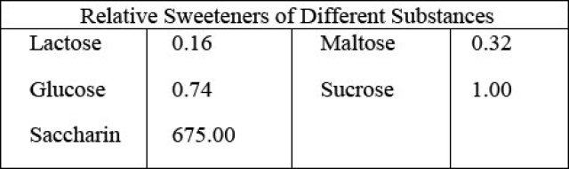
What is the ratio of glucose to lactose in a mixture as sweet as maltose?
8: 21
3: 2
16: 9
1: 3
A colourless cube is painted blue and then cut parallel to sides to form two rectangles solids of equal volume. What percentage of surface area of each of new solids is not printed blue?
16
25
18
20
There are 10 stations on a railway line. The number of different journey tickets that are required by the authorities is
101
90
10
81
A and B throw one dice for a stake of Rs.11, which is to be won by the player who first throws a six. The game ends when stake is won by A or B. If A has the first throw, what are their respective expectations?
10 and 1
6 and 5
5 and 6
11 and 10
Which investment gives a better return, assuming the face value of shares to be Rs. 10?
A. stock at ., subject to . income tax
B. . stock at ., tax free
None of these
A
B
Both A and B
Four stacks containing equal number of chips are to be made from 11 orange, 9 white, 13 black and 7 yellow chips. If all of these chips are used and each stack contains at least one chip of each color, what is the maximum number of white chips in any one stack?
3
5
4
6
A 14.4 kg. gas cylinder runs for 104 hours when the smaller burner on the gas stove is fully opened while it runs for 80 hours when the larger burner on the gas stove is fully opened. Which of these values are closest to the percentage difference in the usage of gas per hour, of the smaller burner over the larger burner?
Study the questions and the statements given below. Decide whether any information provided in the statement(s) is redundant and/or can be dispensed with, to answer it.
If 7 is added to numerator and denominator each of fraction a/b, will the new fraction be less than the original one?
Statement I: a = 73, b = 103
Statement II: The average of a and b is less than b
Statement III: a âˆ’ 5 is greater than b – 5
Any two of them
Only I or II
Only one of them
None of them
II and either I or III
Coefficient of variation is useful to study
All of the above
Consistency
Disparity
Risk
A cyclist drove one kilometer, with the wind in his back, in three minutes and drove the same way back, against the wind in four minutes. If we assume that the cyclist always puts constant force on the pedals, how much time would it take him to drive one kilometer without wind?
2 3/7
2 1/3
3 3/7
3 7/12
A, B and C started a business by investing , and of the capital respectively. After of the total time, A withdrew his capital completely and after of the total time B withdrew his capital. C kept his capital for the full period. The ratio in which total profit is to be divided amongst the partners is
2: 1: 2
1: 2: 2
4: 1: 4
1: 2: 1
A number lock consists of 3 rings each marked with 10 different numbers. In how many cases the locks cannot be opened?
A person buys 18 local tickets for Rs. 110. Each first class ticket costs Rs. 10 and each second class ticket costs Rs. 3. What will another lot of 18 tickets in which the number of first class and second class tickets are interchanged cost?
112
118
124
121
A clock loses 12 minutes every 24 hours. It is set right at 7:25 p.m. on Monday. What will be the time when clock shows 1:45 p.m. the following day?
None of these
1:35:50 p.m.
1:25:35 p.m.
1:20:35 p.m.
In a row at a bus stop, A is from the left and B is from the right. They both interchange their positions. A becomes 11the from the left. How many people are there in the row?
19
20
18
21
A merchant wants to make profit by selling food grains. Which of the following will maximize his profit?
I. Sell product at 30% profit
II. Increase the price by 15% over the cost price and reduce weight by 15%
III. Use 700 gm of weight instead of 1 kg.
IV. Mix 30% impurities in grains and sell it at cost price
All give the same profit
II and I
II
III
Study the following chart carefully and answer.
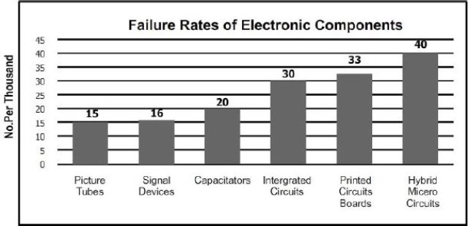
From the failure data of electronics components presented here, which statement is true?
Integrated circuits and Printed circuit boards are more reliable.
The least reliable component is Hybrid Micro circuits.
Capacitors are more reliable than pictures tubes.
Higher number of components failures is likely to be due to pictures tubes.
Study the following chart carefully and answer.
Which of the following components has a failure rate 25% more than that of signal devices
Capacitors
Integrated circuits
Printed Circuits boards.
Pictures tubes
Study the following chart carefully and answer.
Lowest priority for investing in any changes or additions to the component manufacturing units, in the company’s investment plans, may be given to the following:
Pictures tubes and signal devices
Signal devices and capacitors
Capacitors and integrated circuits.
Printed circuits boards and hybrid micro circuits.
Study the following chart carefully and answer.
For the equipments using Integrated Circuit Board: 400, Capacitors: 240 and Printed Circuits boards: 120 to run with minimum downtime, how many spares should be kept in the store respectively?
5, 12, 4
12, 5, 4
12, 4, 4
12, 4, 3
The water from a roof, 9 sq. metres in area, flows down to a cylindrical container of 900 cm2 base. To what height will the water rise in cylinder if there is a rainfall of 0.1 mm?
0.1cm
0.1 metre
0.11 cm
1 cm

