BITSAT Physics 2010 Sample Paper
The field at distance r from the center of a charge conducting sphere of radius R and charge Q is given by the expression (r < R)
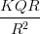
zero
An electron of 10 eV kinetic energy will travel the distance through an electric field 0.25 N/C :
2.5 m
20 m
4 m
40 m
The length of potentiometer wire is 10 cm. and resistance is A battery of 2 Volt enf and internal resistance is connected to the wire will be:
Two coils are placed very near to each other. If the current in primary coil is I = I0 sin t and coefficient of mutual induction is M, the induced emf in secondary coil will be :
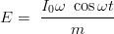
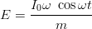
Choke coil is:
induction coil of high resistance and high inductance
induction coil of high resistance and low inductance
induction coil of low resistance and high inductance
induction coil of low resistance and low inductance
The voltage difference between P and Q is:
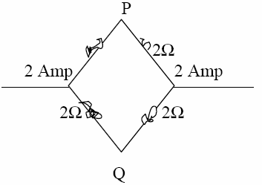
2 volt
1 volt
- 1 volt
- 2 volt
In the circuit current in resistance is:
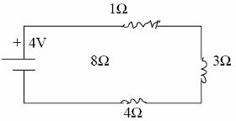
2 amp.
1 amp.
0.5 amp.
1.25 amp.
Which is correct for inside charged sphere:
The magnetic force experienced charge q in magnetic field moving with velocity V, will maximum when the angle between V and B is:
A parallel plate condenser is charged with a battery. After changing of the condenser battery is removed and two plates are separated from each other with the help of insulating handles, than:
capacitance decreases
capacitance increases
charge on plates increases
voltage between plates increase
The electrical flux from a semi spherical will be:
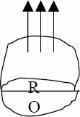
In closed organ pipe the produced harmonics are:
no harmonics is produced
even and odd both
odd only
even only
In this wave equation Y = 5 sin (4t – 0.02x) the wave velocity of wave is:
50 m/sec.
150 m/sec.
200 m/sec.
100 m/sec.
Light velocity in vacuum depends upon:
wavelength
frequency
intensity
none of these
In a coil the current changes from 2A to 4A, 0.05 sec. and the induced enf is 8 volt, the coefficient of self induction will be:
8H
0.02 H
0.2 H
0.8 H
The resistance of a galvanometer is and maximum current which can pass through it 0.001 A. The value of shunt to change this galvanometer into voltmeter of 12 volt range will be:
The AC voltage is given by the equation if an inductance is connected in the circuit the RMS value of voltage in the circuit will be:
In wattles current phase difference between current and voltage is:
zero
The ionization potential of hydrogen is 13.6 eV. The total energy of an electron in its third orbit will be:
3.4 eV
– 3.4 eV
1.5 eV
– 1.5 eV
In radioactive dis-integration the element shift by one place further after the emission of the particle:
A metal surface emitted electrons of 3 eV, when a light of 4 eV are made to incident on the same metal surface the energy of the emitted photons will be:
3 eV
4 eV
5 eV
2 eV
If for an electron , velocity is , the uncertainty in the position of electron will be of the order of:
Forbidden energy gap in Ge is:
0.75 eV
2.5 eV
1.1 eV
5 eV
A rod of length L and mass M is suspended from its one end and execute oscillations the time period of vibrations will be:
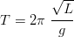
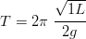
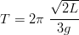
Two masses are attached to the ends of a string by a weight loss rod of of length The MI of this system about the axis passing through the center of mass and perpendicular to its length will be:
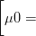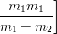
The energy of monatomic gas is:
only rotational
only vibrational
only translatory
all the above
The work done in increasing the size of a bubble by (T = 25 dyne 1 cm.)
A geostationary satellite is at a distance of 8 Re revolving around the earth and another satellite is revolving round the earth at 3.5 Re distance, its revolution period will be:
8.5 hrs.
12 hrs.
18 hrs.
8.5 hrs.
The work done per unit extension in length of a wire will be (L = length, A = area of cross section) :
The total energy of a body at distance r from the earth will be:
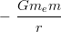
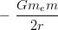
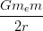
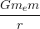
The kinetic energy of a particle executing SHM is changed by frequency f , the frequency of its motion will be:
f/2
f
2f
4f
A body of mass m is projected at an angle with velocity v from the horizontal the angular momentum acceleration at the heighest point of he motion will be:
mv
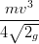
The mass of bob of simple pendulum is m. This bob is life by ehight h and than set free; the work done in displacement of the bob from one end to another will be:
2 mgh
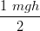
mgh
zero
A boy is revolving on a dice with spreading hands. Suddenly the boy brings his near his body, the change in the system will be:
angular velocity increases
angular velocity decreases
angular velocity unchanged
angular momentum decreases
A body moving with 50 m/sec. Velocity collides elastically with another body at rest. After the collision the velocity of first body changes to 30 m/sec., the velocity of the second body will be:
30 m/sec.
60 m/sec.
80 m/sec.
50 m/sec.
The radius of a circular aperture is variable. The light of wavelength is made to incident on the aperture a screen is placed at distance b from the aperture. When one increases the radius of the aperture, the value of the radius of aperture for which second time dark point will be obtained on the screen will be:
The length of a sonometer wire is and tension T and frequency is n. If the length and tension on sonometer wire are doubled the frequency will become:
2n
Fundamental frequency of an open pipe is:
15 Hz
20 Hz
30 Hz
10 Hz
If charge Q is placed at the center of a cube, the emergent flux from one of the face of the cube will be:
Two equal charges each of value q are placed on a straight line, another charge Q is placed at mid of the distance between the system will be most stable is:
An electron passes through an electric field 3200 v/m. of length 0.1 m. with speed The deflection produced in the path of electron will be :
3.52 mm.
1.35 mm.
0.88 mm.
1.76 mm.
A rectangular coil placed in a magnetic field 0.25 T. The area of coil is 96×10-4 m2, no. of turns are 50 and current is 2A, the torque experienced by the coil will be:
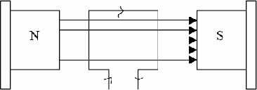
0.24 N-m.
0.48 N-m.
0.36 N-m.
0.96 N-m.
If two charged conductors are short circuited by a wire, the current will now flow:
sizes are equal
capacitances are equal
charges are equal
potential are equal
Two coils X and Y are placed near to other according to the figure. If current is passed through X, the direction of induced current in Y will be:
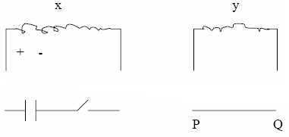
carit be determined
no current induce
Q to P
P to Q
Which quantity doesn’t remains constant in simple harmonic motion:
time period
velocity
frequency
amplitude
A pot filled with water is revolved in the circular path of radius R, the minimum velocity at which the water will not come out of the pot will be:
gR
A spring is extended by length, then the force is:
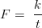
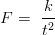
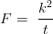
The velocity at which a body will escape from the earth surface is ( = mass of earth = radius of earth):
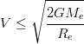
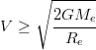
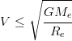
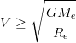
The initial temperature of a gas is C. The gas is compressed adiabatically to of its initial volume, the final temp. of the gas will:
The workdone in expanding a gas from at one atmospheric pressure will be:
The mean kinetic energy of the molecule at a given temp. will be max. fo r:
Hydgrogen
Oxygen
Helium
Equal for all
Kind of bonding in is:
covalent
vander waals
ionic
metallic
The density of iron is and breaking stress is the max, length of the wire which will unable to break the wire from its own weight will be:
Four bodies solid sphere, solid cylinder, disc and ring have same mass and same cross sectional area, the MI about the axis shown by a point in the figure will be max. for the body (the axis is perpendicular to the plane of the bodies):
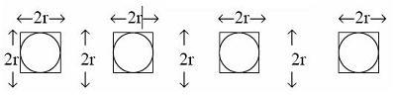
only disc
sphere and ring
disc and cylinder
only ring
A cylinder rools down the inclined plane of length 0.15 m. If the mass of cylinder is 0.1 kg. The velocity at the bottom of the inclined plane will be:
3.5 m/sec.
2 m/sec.
1.4 m/sec.
2.4 m/sec.
A stopper is attached in the middle of glass tube. Two bubbles of radius 2 cm. and 4 cm. are formed at the end of the glass tube. If one opens the stopper:
small bubble will reduce and large will increase
both will increase
both will reduce
small will increase and large will reduce
A 500 F capacitor is charged with a battery of 100 volt and it is discharged through 10 resistance the heat produced in resistance will be:
1.25 J
5 J
10 J
2.5 J
Two condensers of 1 F are connected in series with a battery of 6 volt, the total charge on condensers will be:
Transformer changes:
DC current
DC voltage
AC voltage
AC & DC voltage
Lenzis law is based upon:
law of conservation of energy
law of conservation of angular momentum
law of conservation of momentum
law of conservation of charge
Two thin wires are separated by distance r and parallel to each other. If the current in each wire is I, the force per unit length experienced by one wire due to current in the other will be:
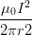
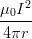
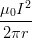
The relation between current and maximum current at half power points in resonant circuit will be:
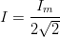
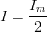
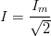
In LCR circuit the voltage and current are given by the equations: t and than which statement is correct :
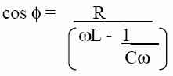
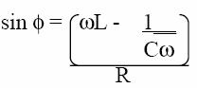
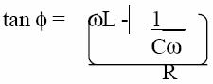
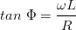
he potential due to electric dipole a point is:
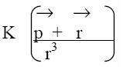
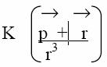
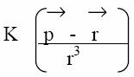
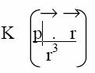
The magnetic field due to a current carrying wire element will be maximum when the angle between the current element and position vector is:
zero
A straight current carrying wire and loop are placed according to the figure. If the current is according to the figure: 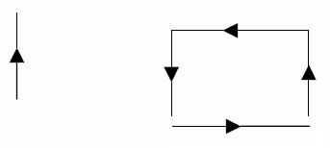
loop will move towards the wire
loop will move away from the wire
loop will rotate around the wire
no change
The rate of heat produced in resistance of 10 in a.c. circuit is 250 watt per sec. the current in the resistance will be:
0.5 amp.
2.5 amp.
5 amp.
1.25 amp.
The mean life of a radioactive substance is equal to:
The half life of a radioactive substance is 25 days. The 25 gm. sample of this substance will reduce is 150 days to:
0.375 gm.
0.75 gm.
1.5 gm.
4 gm.
The wavelengths associated with photons and electron are same, the ratio of their momentum will be:
1 : 1
2 : 1
1 : 3
1 : 3
Work function for a surface is equal to:
= fermi energy – binding energy
=fremi energy
= binding energy – fermi energy
= binding energy
If the pressure of a gas is doubled at constant temperature, then the velocity of sound in the gas becomes:
unchanged
times
half
double
In black body radiations for maximum emission the wavelength shifted with increase of temperature of black body:
at some temp. towards shorter side and others towards longer side
towards higher wavelength
towards shorter wavelength
no shift
If the temp. of a body is make amount of radiated energy will become:
16 times
half
two times
four times
If light ray is reflected from the denser medium, the path difference produced in the reflected ray will be:
zero
The one mole of an ideal gas is compressed adiabatically from temp. C to 1020 C the work done in the process will be: (r = 1.5)
1000.25 J
– 1245 J
-928.75 J
-622.5 J
The absence of atmosphere on the surface of any planet is:
is greater than escape velocity
Average kinetic energy gas molecules is negligible to the gravitational force on the planet
less than escape velocity
None
In a closed container the mass of molecule is and velocity of molecule is 10 m/sec. If the no. of molecules in the container is the pressure will be:
The heat given a system is Q and change in internal energy of system is du and if work done is W, the correct relation between all three quantit ies:
Absorption coefficient of an ideal blackbody is:
less then 1
1
zero
infinity
The of O2 at C is V on the same temp. the Vrms of atomic oxygen is V’ than:
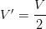
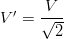
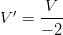
If one gm. of water at 1000 C converted into vapour of 1000 C the external work done in this process will be:
2100 watt
2100 erg
2100 J
2100 cal
Of which the velocity is equal to light velocity:
cathode ray
X-rays
positive ray
all
In young double slit experiment the two coherent sources are separated by 2 mm. the distance of screen is 1m. If the fringe width is 0.03 cm. the wavelength of light will be:
The max. value of magnetic field in a electric field 3.2 x v/m (max. value) :
1 amu is equal to:
931 MeV
931 eV
9.30 eV
931 KeV
1 amp. current flow is a circuit when a cellisconnected to 1 resistance and 0.5 amp. to a 3 resistance. The internal resistance of cell is:
Function of a grid in a triode is:
to increase plate voltage
to decrease plate voltage
to reduce the effect of space charge
None
If mho if triode is used as an amplifier and then voltage amplification is:
40
60
20
30
Ge at absolute temp is a:
super cond.
conductor
semi conductor
insulator
Two forks of approximately equal frequencies are used to produce Lissajou figures. If the Lissajous figure changes its shape once in 1 sec. If the f requency of one of the tuning fork is 1000 Hz, the frequency of second fork will be:
1000 Hz
1002 Hz
2000 Hz
1001 Hz

