Eamcet 2006 Solved Paper

This practice EAMCET solved question papers is designed to prepare you for the EAMCET 2011. Find the information related to EAMCET 2011 Notification, EAMCET Key.
If C, R, L and I denote capacity, resistance, inductance and electric current respectively, the quantities having the same dimension of time are :
(1) CR
(2)
(3)
(4)
A. (1) and (2) only
B. (1) and (3) only
C. (1) and (4) only
C. (1), (2) and (3) only
A man standing on road has to hold his umbrella at with the vertical to keep the rain away. He throws the umbrella and starts running at 10km/h. He finds that raindrops are hitting his head vertically. The actual speed of raindrops is :
A. 20 km/h
B.
C.
D. 10 km/h
A body projected from the earth at angle of with horizontal with some initial velocity. If its range is 20 m, the maximum height reached by it is : (in metres)
A.
B. 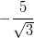
C. 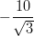
D.
A motor is used to deliver water at a certain rate through a given horizontal pipe. To deliver n-times the water through the same pipe in the same time the power of the motor must be increased as follows:
A. n-times
B. -times
C. -times
D. -times
A bullet of mass 10 g is fired horizontally with a velocity from a rifle situated at a height 50 m above the ground. if the bullet reached the ground with a velocity the work done against air resistance in the trajectory of bullet is :
A. 5005 J
B. 3755 J
C. 3750 J
D. 17.5 J
A man of 50 kg is standing at one end on a boat of length 25 m and mass 200 kg. If he starts running and when he reached the other end, he has a velocity with respect to the boat. The final velocity of the boat is
A.
B.
C.
D.
For a system to follow the law of conservation of linear momentum during a collision, the condition is :
(1). total external force acting on the system is zero
(2). total external force acting on the system is finite and time collision is negligible.
(3). total internal force acting on the system is zero
A. (1) only
B. (2) only
C. (3) only
D. (1) or (2)
When the angle of inclination of an inclined plane is 0, an object slides down with uniform velocity. If the same object is pushed up with a initial velocity u on the same inclined plane; it goes up the plane and stops at a certain distance on the plane. Thereafter the body:
A. Slides down the inclined plane and reaches the ground with velocity u.
B. Slides down the inclined plane and reaches the ground with velocity less than u.
C. Slides down the inclined plane and reaches the ground with velocity greater than u.
D. Stay at rest on the inclined plane and will not slide down.
A uniform rod of length 8a and mass 6m lies on a smooth horizontal surface. Two point masses m and 2m moving in the same plane with speed 2v and v respectively strike the rod perpendicularly at distance a and 2a from the mid point of the rod in the opposite directions and stick to the rod. The angular velocity of the system immediately after the collision is:
A.
B.
C.
D.
Assume the earth’s orbit around the sun as circular and the distance between their centres as D. Mass of the earth is M and its radius is R. If earth has an angular velocity with respect to its centre and with respect to the centre of the sun. the totakl kinetic energy of earth is:
A. 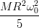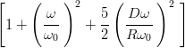
B. 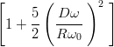
C. 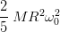
D.
Assertion (A): A particular of mass m dropped into a hole made along the diameter of the earth from one end to the other posses simple harmonic motion.
Reason ( R): Gravitational force between any two particles is inversely proportional to the square of the distance between them.
A. Both (A) and ( R) are true and ( R) is the correct explanation of (A)
B. Both (A) and ( R) are true but ( R) is not the correct explanation of (A)
C. (A) is true but ( R) is false
D. (A) is false but ( R) is true
To the free end of the spring hanging from the rigid support, a block of mass m is hung and slowly allowed to come its equilibrium position. Then stretching in the spring is d. If the same block is attached to the same spring and allowed to fall suddenly, the amount of stretching is: (force constant, k)
A.
B. 2 d
C.
D. 4 d
Assertion (A): Ductile metals are used to prepare thin wires.
Reason ( R): In the stress-strain curve of the ductile metals, the length between the points representing elastic limit and breaking point is very small.
A. Both (A) and ( R) are true and ( R) is the correct explanation of (A)
B. Both (A) and ( R) are true but ( R) is not the correct explanation of (A)
C. (A) is true but ( R) is false
D. (A) is false but ( R) is true
Two soap bubbles combine to form a single bubble. In this process, the change in volume and surface area are respectively V and A. If P is the atmospheric pressure, and T is the surface tension of the soap solution, the following relation is true.
A. 4PV + 3TA = 0
B. 3PV – 4TA = 0
C. 4PV – 3TA = 0
D. 3PV + 4TA = 0
An air bubble of radius 1 cm rises from the bottom portion through a liquid of density 1.5 g/cc at a constant speed of . If the density of air neglected, the coefficient of viscosity of the liquid is approximately, (In Pas):
A. 13000
B. 1300
C. 130
D. 13
Two block of masses 1 kg and 2 kg are connected by a metal wire going over a smooth pulley as shown in figure. The breaking stress of metal is What should be the minimum radius of the wire used if it is not break ? Take
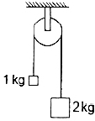
A.
B.
C.
D.
The temperature of a thin uniform circular disc, of one metre diameter is increased by The percentage increased ion moment if inertia of the disc about an axis passing through its centre and perpendicular to the circular face : (linear coefficient of expansion = )
A. 0.0055
B. 0.011
C. 0.022
D. 0.044
A given mass of a gas is compressed isothermally until its pressure is doubled. It is then allowed to expand adiabatically until its original volume is restored and its pressure is then found to be 0.75 of its initial pressure. The ratio of the specific heats of the gas is approximately:
A. 1.20
B. 1.41
C. 1.67
D. 1.83

A cyclic process ABCD is shown below in the given p-v diagram. In the following answers the one that represents the same process as in p-v diagram :
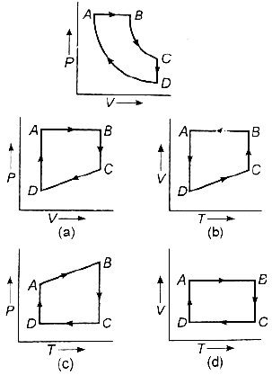
Two solid sphere A and B made of the same material have radii and respectively. Both the sphere are cooled from the same temperature under the conditions valid for Newton’s law of cooling. The ratio of the rate of change of temperature of A and B is:
A.
B.
C.
D.
Two string A and B of lengths, and respectively are used separately in sonometer. The ratio of their densities is 0.81. The diameter of B is one-half that of A. If the string have the same tension and fundamental frequency the value of x is:
A. 33
B. 102
C. 144
D. 130
An observer is standing 500 m away from a vertical hill. Starting between the observer and the hill, a police van sounding a siren of the frequency 1000 Hz moves towards the hill with a uniform speed. If the frequency of the sound heard directly from the siren is 970 Hz, the frequency of the sound heard after reflection from the hill (in Hz) is about, (velocity of sound = ):
A. 1042
B. 1032
C. 1022
D. 1012
The two surfaces of a biconvex lens has same radii of curvatures. This lens is made of glass of refractive index 1.5 and has a focal length 10 cm in air. The lens is cut into two equal halves along a plane perpendicular to its principal axis to yield two Plano-convex lenses. The two pieces are glued such that the convex surface touch each other. If this combination lens is immersed in water (refractive index = 4/3), its focal length (in cm) is:
A. 5
B. 10
C. 20
D. 40
Dispersive power depends on the following:
A. Material of the prism
B. Shape of the prism
C. Size of the prism
D. Size, shape and material of the prism
Match the appropriate pairs from List I and II :
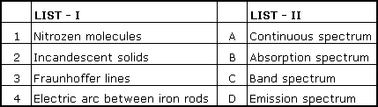
A. 1-C, 2-A, 3-B, 4-D
B. 1-B, 2-A, 3-D, 4-C
C. 1-D, 2-A, 3-B, 4-C
D. 1-A, 2-C, 3-D, 4-B
In young’s double slit experiment, first slit has width four times the width of the second slit. The ratio of the maximum intensity to the minimum intensity in the interference fringe system is:
A. 2 : 1
B. 4 : 1
C. 9 : 1
D. 8 : 1
The effect due to uniform magnetic field on a freely suspended magnetic needle is as follows:
A. both torque and net force are present
B. torque is present but no net force
C. both torque and net force are absent
D. net force is present but not torque
Two short magnets AB and CD are in the X-Y plane and are parallel to X-axis and co-ordinates of their centres respectively are (0, 2) and (2, 0). Line joining the north-south poles of CD is opposite to that AB and lies along the positive X-axis. The resultant field induction due to AB and CD at a point P(2, 2) is When the poles of the magnet CD are reserved, the resultant field induction is The value of magnetic moments of AB and CD (in ) are:
A. 300 : 200
B. 600 : 400
C. 200 : 100
D. 300 : 150
The bob of simple pendulum is hanging vertically down from a fixed identical bob by means of sting of length l. If both bobs are charged q each, time period of the pendulum is : (ignore the radii of the bobs)
A. 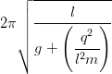
B. 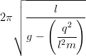
C. 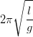
D. 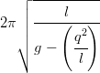
Along the X-axis, three charges and are placed at x = 0, x = a and x = 2a respectively. The resultant electric potential at x = a + r (if a << r) is : ( is the permittivity of free space)
A. 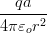
B. 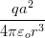
C. 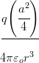
D. 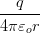
One end each of resistance r capacitor C and resistance 2r are connected together. The other ends are respectively connected to the positive terminals of batteries, P, Q, R having respectively emfs E, E and 2 E. The negative terminals of the batteries are then connected together, In this circuit, with steady current the potential drop across the capacitors is:
A.
B.
C.
D. E
Twelve cells, each having emf E volts are connected in series and are kept in a closed box. Some of these cells are wrongly connected with positive and negative terminals reversed. This 12 cells battery is connected in series with an ammeter, an external resistance R ohms and a two-cells battery (two cells of the same type used earlier, connected perfectly in series). The current in the circuit when the 12-cell battery and 2 cells battery aid each other is 3A and is 2A when they appose each other. then, the number of cells in 12-cell battery that are connected wrongly is:
A. 4
B. 3
C. 2
D. 1
If the cold junction is held at the same thermo emf V of a thermocouple varies as 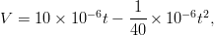where t is the temperature of the hot juction in The neutral temperature and the maximum value of thermo emf are respectively:
A.
B.
C.
D.
When a positively charged particle enters a uniform magnetic field with uniform velocity, its trajectory can be :
(1) a straight line
(2) a circle
(3) a helix
A. (1) only
B. (1) or (2)
C. (1) or (3)
D. any one of (1), (2) and (3)
A rectangular loop of length l and breadth b is placed at distance of x from infinitely long wire carrying current i such that the direction of current is parallel to breadth. If the loop moves away from the current wire in a direction perpendicular to it with a velocity v, the magnitude of the emf in the loop is: ( permeability of free space)
A. 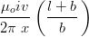
B. 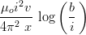
C. 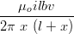
D. 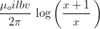
A small square loop of wire of side l is placed inside a large square loop of side L(L>>l). If the loops are coincide, the mutual induction of the system is directly proportional to:
A.
B.
C.
D.
A oil drop having a mass and charge stand still between two charged horizontal plates separated by a distance of 1 cm. If now the polarity of the plates is changed, instantaneous acceleration of the drop is :
A.
B.
C.
D.
A proton, a deuteron (nucleus of ) and an -particle with same kinetic energy enter a region of uniform magnetic field moving at right angles to the field. moving at right angles to the field. The ratio of the radii of their circular paths is:
A. 1 : 2 : 4
B.
C.
D. 1 : 1 : 2
A free neutron decays spontaneously into:
A. a proton, an electronic and anti-neutrino
B. a proton, an electron and a-neutrino
C. a proton and electron
D. a proton, and electron, a neutrino and an anti-neutrino
Consider a p-n junction as a capacitor, formed with p and n-materials acting as thin metal electrodes and depletion layer width acting as separation between them. Basing on this, assume that a n-p-n transistor is working as an amplifier in CE configuration. If and are the base-emitter and collector-emitter junction capacitances, then:
A.
B.
C.
D.
The standard reduction potentials of are respectively -0.76, 0.34 and 0.8 V. The following cells were constructed :
*What is the correct order of of these cells ?
A. 2 > 3 > 1
B. 2 > 1 > 3
C. 1 > 2 > 3
D. 3 > 1 > 2
What is the correct order of spin only magnetic moment (in BM) of and
A.
B.
C.
D.
A molecule (X) has (i) four sigma bonds formed by the overlap of and s orbitals (ii) one sigma bond formed by and orbitals and (iii) one bond formed by and orbitals. Which of the following is X ?
A
B.
C.
D.
Which of the following is used for making optical instruments?
A.
B. Si
C.
D. SiC
Which of the following is not correct?
A. 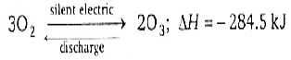
B. Ozone undergoes addition reaction with unsaturated carbon compounds
C. Sodium thiosulphate reacts, with to form sodium tetrathionate and sodium iodide
D. Ozone oxidises lead sulphide to lead sulphate.
Which of the following reaction can produce aniline as main product?
A.
B.
C.
D.
Observe the following statements :
1. The physical and chemical properties of elements are periodic functions of their electronic configuration.
2. Electronegativity of fluorine is less than the Electronegativity of chlorine
3. Electropositive nature decreases from top to bottom in a group.
The correct answer is:
A. 1, 2 and 3 are correct
B. only 1 is correct
C. only 1 and 2 is correct
D. only 2 and 3 are correct
Which of the following reagents when heated with ethyl chloride, forms ethylene?
A. Aqueous KOH
B. Zn/HCl
C. Alcoholic KOH
D. Hl
Which of the following statement is not correct?
A. In oxyhaemoglobin is paramagnetic
B. During respiration the size of increases when it changes from diamagnetic to paramagnetic state
C. Four heme group are present in hemoglobin
D. Heme is the prosthetic group and it is non – protein part.
The uncertainties in the velocities of two particles A and B are 0.05 and 0.02 respectively. The mass of B is five times to that of mass A. What is the ratio of Uncertainties 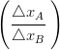in their positions?
A. 2
B. 0.25
C. 4
D. 1
The energy of a photon is ergs. What is its wavelength in nm ?
A. 662
B. 1324
C. 66.2
D. 6.62
What is the time (in sec) required for depositing all the silver present in 125mL of solution by passing a current of 241.25 A ? (IF = 96500 coulombs)
A. 10
B. 50
C. 1000
D. 100
is responsible for the decomposition of ozone to oxygen. Which of the following reacts with ozone to form oxygen?
A.
B.
C.
D.
The disperse phase, dispersion medium and nature of colloidal solution (lyophilic or lyophobic) of ‘gold sol’ respectively are:
A. solid, solid, lyophobic
B. liquid, liquid, lyophobic
C. solid, liquid, lyophobic
D. solid, liquid, lyophilic
Electrolysis of X gives Y at anode. Vacuum distillation of Y gives The number of peroxy (O-O) bonds present in X and Y respectively are:
A. 1, 1
B. 1, 2
C. Zero, 1
D. Zero, Zero
AB is an ionic solid. The ionic radii of and are respectively and Lattice energy of AB is proportional to:
A.
B.
C.
D. 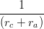
Which of the following set of variables give a straight line with negative slope when plotted ?
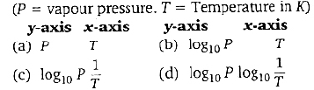
A. ( a)
B. ( b)
C. ( c)
D. ( d)
Which of the following is not a characteristic property of chemical equilibrium?
A. Rate of forward reaction is equal to rate of backward reaction at equilibrium.
B. After reaching the chemical equilibrium, the concentrations of reactants and product remain unchanged with time.
C. For If this reaction is carried out in presence, of catalyst, the value of decreases
D. After reaching the equilibrium, both forward and backward reaction continue to take place
The rate constant of a first order reaction at The temperature coefficient of this reaction is 2. What is the rate constant at for this reaction?
A.
B.
C.
D.
The concentration of oxalic acid is ‘x’ mol 40 mL of this solution reacts with 16 mL of 0.05 M acidified What is the pH of ‘x’ M oxalic acid solution ? (Assume that oxalic acid dissociates completely)
A. 1.3
B. 1.699
C. 1
D. 2
Which of the following is added to chloroform to slow down its aerial oxidation in presence of light?
A. Carbonyl chloride
B. Ethyl alcohol
C. Sodium hydroxide
D. Nitric acid
At T(K), 100 L of dry oxygen is present in a sealed containers. it is subjected to silent electric discharge, till the volumes of oxygen and ozone become equal. What is the volume (in litres) of ozone formed at T (K)?
A. 50
B. 60
C. 30
D. 40
Which of the product is formed when acetone is reacted with barium hydroxides solution ?
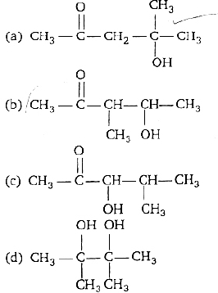
A. ( a)
B. ( b)
C. ( c)
D. ( d)
Which of the following is not correct?
A. Nuclei of atoms participate in nuclear reactions
B. and are isotones
C. 1 amu of mass defect is approximately equal to 931.5 MeV
D. Uranium series is known as (4n + 2) series
When acetaldehyde is heated with fehling solution, a red precipitate is formed. Which of the following is that?
A.
B. Cu
C. CuO
D.
The volume-temperature graphic of a given mass of an ideal gas at constant pressure are shown below. What is the correct order of pressure ?
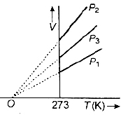
A.
B.
C.
D.
Match the following lists :
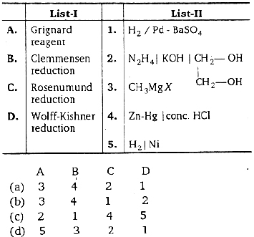
A. ( a)
B. ( b)
C. ( c)
D. ( d)
What is the correct order of occurrence (% by weight) in air of Ne, Ar and Kr?
A. Ne > Ar > Kr
B. Ar > Ne > Kr
C. Ar > Kr > Ne
D. Ne > Kr > Ar
Observe the following statements :
I. Bleaching powder is used in the preparation of chloroform.
II. Bleaching powder decomposes in the presence of to liberate
III. Aqueous is used in the preparation of fluorine.
The correct combination is:
A. I, II and III are correct
B. Only II is correct
C. Only I and III are correct
D. Only I and II are correct
Which of the following compounds when heated with Co at and 500 atm pressure in presence of forms ethyl proportionate?
A.
B.
C.
D.
Identify the reaction for which
A. S (rhombic)
B.
C.
D. 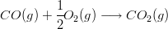
Which of the following reacts with benzene in presence of anhydrous aluminum chloride and forms acetophenone?
A.
B.
C.
D.
Assertion (A) : A current of 96.5 A is passed into aqueous solution for 100 s. The weight of silver deposited is 10.8 g (At. wt. of Ag = 108)
Reason ( R) : The mass of a substance deposited during the electrolysis of an electrolyte is inversely proportional to the quantity of electricity passing through the electrolyte
The correct answer is:
A. Both (A) and ( R) are true and ( R) is the correct explanation of (A)
B. Both (A) and ( R) are true but ( R) is not the correct explanation of (A)
C. (A) is true but ( R) is false
D. (A) is false but ( R) is true
When compound X is oxidised by acidified potassium dichormate, compound Y is formed. Compound Y on reduction with gives X, X and Y respectively are:
A.
B.
C.
D.
Hydrolysis of gives and X. Which of the following of X?
A.
B.
C.
D.
What are the metal ions present in carnallite?
A. Mg, K
B. Al, Na
C. Na, Mg
D. Zn, Mg
Ethyl chloride reacts with solution ethoxide to form a compound A. Which of the following reactions also yield A?
A.
B.
C. (dry ether)
D.
Which of the following reactions does not liberate gaseous product?
A.
B.
C.
D.
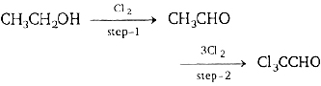
In above reactions the role of in step-1 and step-2 receptively is:
A. oxidation, chlorinate
B. reduction, chlorinate
C. oxidation, addition
D. reduction, substitution
The Number of sigma and pi bonds present in benzene respectively are:
A. 12, 6
B. 6, 6
C. 6, 12
D. 12, 3
If is defined by 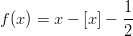for where [x] is the greatest integer not exceeding x, then 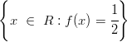is equal to :
A. Z, the set of all integers
B. N. the set of all natural numbers
C. the empty set
D. R
If is defined by for where [x] is the greatest integer not exceeding x, then the range of f is :
A.
B.
C.
D.
If is defined by
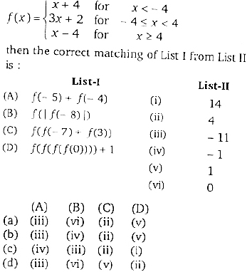
A. ( a)
B. ( b)
C. ( c)
D. ( c)
If 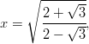then is equal to :
A. 7
B. 4
C. 2
D. 1
is equal to :
A.
B.
C.
D.
for all integers which of the following is divisible by 9 ?
A.
B.
C.
D.
Eight difference letters of an alphabet are given. Words of four letters from these are formed. The number of such words with at least one letters repeated is :
A.
B.
C.
D.
The number of natural numbers less than 1000, in which no two digits are repeated, is:
A. 738
B. 792
C. 837
D. 720
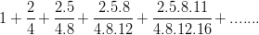is equal to
A.
B.
C.
D.
The correct matching of List I from the List II is :
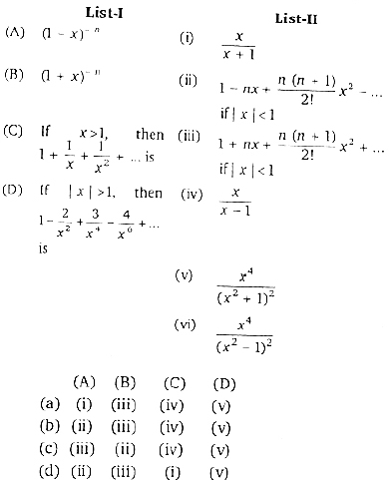
A. ( a)
B. ( b)
C. ( c)
D. ( d)
If 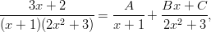then A + C – B is equal to :
A. 0
B. 2
C. 3
D. 5
The coefficient of in 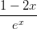is :
A. 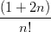
B. 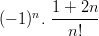
C. 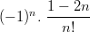
D. 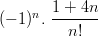
If and 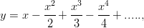then x is equal to:
A. 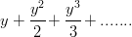
B. 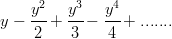
C. 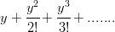
D. 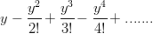
If then :
A. 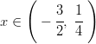
B. 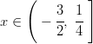
C. 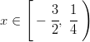
D. 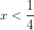
The differences between two roots of the equations is 2. Then the roots of the equation are :
A. -3, 5, 7
B. -3, -7, -9
C. 3, -5, 7
D. -3, -7, 9
If are the roots of the equation then is equal to :
A. 80
B. 84
C. 90
D. -84
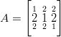then is equal to :
A. 0
B. A
C. -A
D. 1
If A is an invertible matrix of order n, then the determinant of adj A is equal to :
A.
B.
C.
D.
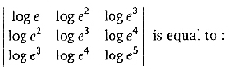
A. 0
B. 1
C.
D.
The locus of the point z = x + iy satisfying the equation 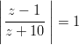is given by :
A. x = 0
B. y = 0
C. x = y
D. x + y = 0
The equation of the locus of z such that 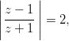where z = x + iy is a complex number, is
A.
B.
C.
D.
The product of the distinct (2n)th roots of is equal to :
A. 0
B.
C.
D.
is equal to :
A. 1
B. -1
C.
D. 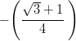
is equal to :
A.
B.
C.
D.
If then the maximum value of is :
A. 12
B.
C.
D. 13
The quadratic equation whose roots are and is :
A.
B.
C.
D.
For all values of the values of 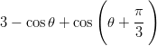lie in the interval :
A. [-2, 3]
B. [-2, 1]
C. [2, 4]
D. [1, 5
If and then :
A. x < y < z
B. y < z < x
C. z < x < y
D. x < z < y
is equal to :
A.
B.
C.
D.
If, in a 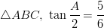and 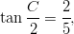then a,b,c are such that :
A.
B. 2b = a + c
C. 2ac = b(a + c)
D. a + b = c
The angles of a triangle are in the ratio 3 : 5 : 10. Then the ratio of the smallest side to the greatest side is :
A.
B.
C.
D.
If b + c = 3a, then 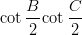is equal to :
A. 3
B. 1
C. 4
D. 2
The elevation of an object on a hill is observed from a certain point in the horizontal plane through its base. to be After walking 120 metres towards it on level ground the elevation is found to be Then the height of the object (in metres) is :
A. 120
B.
C.
D. 60
If and and then the angle between and is :
A.
B.
C.
D.
The position vector of a point lying on the line joining the points whose positions vectors are and is :
A.
B.
C.
D.
If and are coplanar, then is equal to :
A. -1
B. 1/2
C. -3/2
D. 2
If the volume of parallelopiped with conterminus edges and is 34 cubic units, then p is equal to :
A. 4
B. -13
C. 13
D. 6
then is equal to :
A.
B.
C.
D.
If A and B are two independent events such that 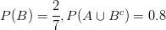then P(A) is equal to :
A. 0.1
B. 0.2
C. 0.3
D. 0.4
A number n is chosen at random from {1, 2, 3, 4, ....., 1000}. The probability that n is a number that leaves remainder 1 when divided by 7, is :
A.
B. 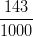
C.
D. 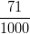
In the random experiment of tossing two unbiased dice let E. be the event of getting the sum 8 and F be the event of getting even numbers on the both the dice. Then:
I. 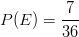
II. 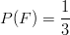
Which of the following is a correct statement?
A. Both I and II are true
B. Neither I nor II is true
C. I is true, II is false
D. I is false, II is true
Seven balls are drawn simultaneously from a bag containing 5 white and 6 green balls. The probability of drawing 3 white and 4 green ball is:
A.
B. 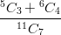
C. 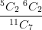
D. 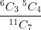
In a book of 500 pages, it is found that there are 250 typing errors. Assume that Poisson law hold for the number of errors per page. then, the probability that a random sample of 2 pages will contain no error, is :
A.
B.
C.
D.
The transformed equation of when the axes are rotated through an angle is :
A.
B.
C.
D.
The line x – y – 2 = 0, x + y – 4 = 0 and x + 3y = 6 meet in the common point.
A. (1, 2)
B. (2, 2)
C. (3, 1)
D. (1, 1)
The equation of the line passing through the point of intersection of the lines x – 3y + 2 = 0 and 2x + 5y – 7 = 0 and perpendicular to the line 3x + 2y + 5 = 0 is :
A. 2x – 3y + 1 = 0
B. 6x – 9y + 11 = 0
C. 2x – 3y + 5 = 0
D. 3x – 2y + 1 = 0
Let O be the origin and A be a point on the curve Then the locus of the mid point of OA is :
A.
B.
C.
D.
The lines represented by the equation are :
A. x + y – 1 = 0, x – y + 2 = 0
B. x – y – 2 = 0, x + y + 1 = 0
C. x + y + 2 = 0, x – y – 1 = 0
D. x – y + 1 = 0, x + y – 2 = 0
The centroid of the triangle formed by the pair of straight lines and the line is :
A. 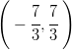
B. 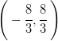
C. 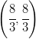
D. 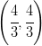
If OA is equally inclined to OX, OY and OZ and if A is units from the origin, then A is :
A. (3, 3, 3)
B. (-1, 1, -1)
C. (-1, 1, 1)
D. (1, 1, 1)
If the direction cosines of two lines are such that l + m + n = 0, then the angle between them is :
A.
B.
C.
D.
The number of common tangents to the two circles and is :
A. 1
B. 2
C. 3
D. 4
Observe the following statements:
I. The circle touches y-axis.
II. The circle touches x-axis.
which of the following is a correct statement ?
A. Both I and II are true
B. Neither I nor II is true
C. I is true, II is false
D. I is false, II is true
The length of the tangent drawn to the circle from the point (1, 3) is :
A. 1
B. 2
C. 3
D. 4
If b and c are the lengths of the segments of any focal chord of a parabola then the length of the semi-latus recturm is:
A. 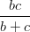
B.
C. 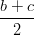
D. 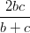
Equations of the latus recturm of the ellipse are :
A.
B.
C.
D.
The sides of the rectangle of the greatest area that can be inscribed in the ellipse are :
A.
B.
C.
D.
If the eccentricity of a hyperbola is then the eccentricity of its conjugate hyperbola is :
A.
B.
C.
D.
The polar equation of the circle with centre 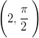and radius 3 unit is :
A.
B.
C.
D.
If then 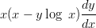is equal to :
A.
B.
C.
D.
then is equal to :
A.
B.
C.
D.
If o < p < q, then is equal to :
A. e
B. p
C. q
D. o
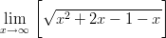is equal to :
A.
B.
C. 4
D. 1
f 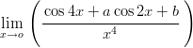is finite, then the value of a, b are respectively :
A. 5, -4
B. -5, -4
C. -4, 3
D. 4, 5
If and 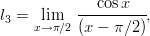then :
A.
B.
C.
D.
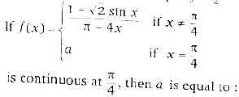
A. 4
B. 2
C. 1
D. 1/4
If is the angle between the curves xy = 2 and then is equal to :
A. 1
B. -1
C. 2
D. 3
In the interval (-3, 3) the function 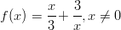is :
A. Increasing
B. Decreasing
C. Neither increasing nor decreasing
D. partly increasing and partly decreasing
The perimeter of a sector is a constant. If its area is to be maximum, the sectorial angle is :
A.
B.
C.
D.
f 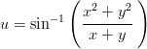then 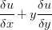is equal to :
A.
B.
C.
D.
If 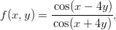then 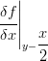is equal to :
A. -1
B. 0
C. 1
D. 2
If 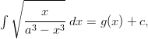then g(x) is equal to:
A. 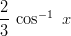
B. 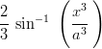
C. 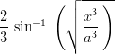
D. 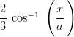
If 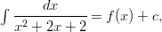then f(x) is equal
A.
B.
C.
D.
Observe the following statements:
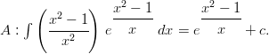
Then the which of the following is true ?
A. Both A and R are true and R is not the correct reason for A
B. Both A and R are true and R is the correct reason for A
C. A is true, R is false
D. A is false, R is true
Dividing the intervals [0. 6] into 6 equal parts and by using trapezoidal rule the value of is approximately :
A. 330
B. 331
C. 332
D. 333
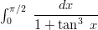is equal to :
A.
B.
C.
D.
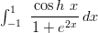is equal to :
A. 0
B. 1
C. 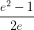
D. 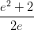
The solution of is :
A.
B.
C.
D.
The solution of 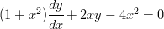is :
A.
B.
C.
D.
The solution of 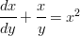is :
A. 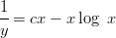
B. 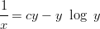
C. 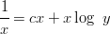
D. 