IIT-JEE-2007-Physics-Paper2
PAPER - II
_________________________________________________________
1. In the experiment to determine the speed of sound using a resonance column,
(A) prongs of the tuning fork are kept in a vertical plane
(B) prongs of the tuning fork are kept in a horizontal plane
(C) in one of the two resonances observed, the length of the resonating air column is close to the wavelength of sound in air
(D) in one of the two resonances observed, the length of the resonating air column is close to half of the wavelength of sound in air

2. A student performs an experiment to determine the Young's modulus of a wire, exactly 2 m long, by Searle's method. In a particular reading, the student measures the extension in the length of the wire to be 0.8 mm with an uncertainty of +0.05 mm at a load of exactly 1.0 kg. The student also measures the diameter of the wire to be 0.4 mm with an uncertainty of +0.01 mm. Take g = 9.8 m/s² (exact). The Young's modulus obtained from the reading is
(A) (2.0 + 0.3) × 1011 N/m²
(B) (2.0 + 0.2) × 1011 N/m²
(C) (2.0 + 0.1) × 1011 N/m²
(D) (2.0 + 0.05) × 1011 N/m²

3. A particle moves in the X-Y plane under the influence of a force such that its linear momentum is p(t) = A[i cos (kt) - j cos (kt)] where A and k are constants. The angle between the force and the momentum is
(A) 0º
(B) 30º
(C) 45º
(D) 90º

4. A small object of uniform density rolls up a curved surface with an initial velocity v. It reaches up to a maximum height of 3v² / 4g with respect to the initial position. The object is
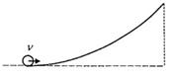
(A) ring
(B) solid sphere
(C) hollow sphere
(D) disc

5. Water is filled up to a height h in a beaker of radius R as shown in the figure. The density of water is r, the surface tension of water is T and the atmospheric pressure is P0. Consider a vertical section ABCD of the water column through a diameter of the beaker. The force on water on one side of this section by water on the other side of this section has magnitude
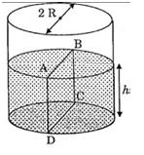
(A) |2 P₀ Rh + Π R² ρ g h - 2RT|
(B) |2 P₀ Rh + R ρ g h² - 2RT|
(C) |P₀ Π R² + R ρ g h² - 2RT|
(D) |P₀ Π R² + R ρ g h² + 2RT|
7. Positive and negative point charges of equal magnitude are kept at (0, 0, a/2) and (0, 0, -a/2), respectively. The work done by the electric field when another positive point charge is moved from (-a, 0, 0) to (0, a, 0) is
(A) positive
(B) negative
(C) zero
(D) depends on the path connecting the initial and final positions

8. A magnetic field vector B = B₀ j⁻ exists in the region a < x < 2a and vector B = -B₀ j⁻, in the region 2a < x < 3a, where B₀ is a positive constant. A positive point charge moving with a velocity vector v = v₀ i⁻, where v₀ is a positive constant, enters the magnetic field at x = a. The trajectory of the charge in this region can be like,
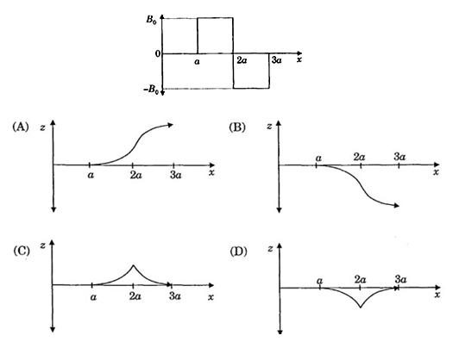

9. Electrons with de-Broglie wavelength λ fall on the target in an X-ray tube. The cut-off wavelength of the emitted X-rays is
(A) λ₀ = 2mcλ² /h
(B) λ₀ = 2h/mc
(C) λ₀ = 2m²c²λ³/h²
(D) λ₀ = λ

10. STATEMENT-1
If there is no external torque on a body about its center of mass, then the velocity of the center of mass remains constant.
because
STATEMENT-2
The linear momentum of an isolated system remains constant.
(A) Statement-1 is True, Statement-2 is True, Statement-2 is a correct explanation for statement-1.
(B) Statement-1 is True, Statement-2 is True, Statement-2 is not a correct explanation for statement-1.
(C) Statement-1 is True, Statement-2 is False
(D) Statement-1 is False, Statement-2 is True

11. STATEMENT-1
A cloth covers a table. Some dishes are kept on it. The cloth can be pulled out without dislodging the dishes from the table.
Because
STATEMENT-2
For every action there is an equal and opposite reaction.
(A) Statement-1 is True, Statement-2 is True, Statement-2 is a correct explanation for statement-1.
(B) Statement-1 is True, Statement-2 is True, Statement-2 is not a correct explanation for statement-1.
(C) Statement-1 is True, Statement-2 is False
(D) Statement-1 is False, Statement-2 is True
12. STATEMENT-1
A vertical iron rod has a coil of wire wound over it at the bottom end. An alternating current flows in the coil. The rod goes through a conducting ring as shown in the figure. The ring can float at a certain height above the coil.
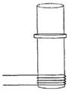
Because
STATEMENT-2
In the above situation, a current is induced in the ring which interacts with the horizontal component of the magnetic field to produce an average force in the upward direction.
(A) Statement-1 is True, Statement-2 is True, Statement-2 is a correct explanation for statement-1.
(B) Statement-1 is True, Statement-2 is True, Statement-2 is not a correct explanation for statement-1.
(C) Statement-1 is True, Statement-2 is False
(D) Statement-1 is False, Statement-2 is True

13. STATEMENT-1
The total translational kinetic energy of all the molecules of a given mass of an ideal gas is 1.5 times the product of its pressure and its volume.
Because
STATEMENT-2
The molecules of a gas collide with each other and the velocities of the molecules change due to the collision
(A) Statement-1 is True, Statement-2 is True, Statement-2 is a correct explanation for statement-1.
(B) Statement-1 is True, Statement-2 is True, Statement-2 is not a correct explanation for statement-1.
(C) Statement-1 is True, Statement-2 is False
(D) Statement-1 is False, Statement-2 is True

14. The speed of sound of the whistle is
(A) 340 m/s for passengers in A and 310 m/s for passengers in B
(B) 360 m/s for passengers in A and 310 m/s for passengers in B
(C) 310 m/s for passengers in A and 360 m/s for passengers in B
(D) 340 m/s for passengers in both the trains

15. The distribution of the sound intensity of the whistle as observed by the passengers in train A is best represented by
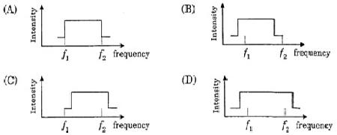

16. The spread of frequency as observed by the passengers in train B in
(A) 310 Hz
(B) 330 Hz
(C) 350 Hz
(D) 290 Hz

17. Light travels as a
(A) parallel beam in each medium
(B) convergent beam in each medium
(C) divergent beam in each medium
(D) divergent beam in one medium and convergent beam in other medium

18. The phases of the light wave at c, d, e and f are Φ_{c}, Φ_{d}, Φ_{e} and Φ_{f} respectively. It is given that Φ_{c} ≠ Φ_{f}.
(A) Φ_{c} cannot be equal to Φ_{d}
(B) Φ_{d} can be equal to Φ_{e}
(C) (Φ_{d} - Φ_{f}) is equal to (Φ_{c} - Φ_{e})
(D) (Φ_{d} - Φ_{c}) is not equal to (Φ_{f} - Φ_{e})
19. Speed of light is
(A) the same in medium-1 and medium-2
(B) larger in medium-1 than in medium-2
(C) larger in mediu-2 and than in medium-1
(D) different at b and d

20. Column I described some situations in which a small object moves. Column II describes some characteristics of these motions. Match the situations in Column I with the characteristics in Column II.
Column I |  | Column II
(A) | The object moves n the  x-axis under a conservative force in such a way that its "speed" and "position" satisfy v = c₁ √(c₂ - x² ) , where c₁ and c₂ are positive constants. | (p) | The object exercises a simple harmonic motion.
(B) | The object moves on the x-axis in such a way that its velocity and its displacement from the origin satisfy v = -kx, where k is a positive constant. | (q) | The object does not change its direction.
(C) | The object is attached to one end of a mass-less spring of a given spring constant. The other end of the spring is attached to the ceiling of an elevator. Initially everything is at rest. The elevator starts going upwards with a constant acceleration a. The motion of the object is observed from the elevator during the period it maintains this accelerations. | (r) | The kinetic energy of the object keeps on decreasing.
(D) | The object is projected from the earth's surface vertically upwards with a speed 2√(GM_{e}/R_{er}) , where, M_{e} is the mass of the earth and Re is the radius of the earth. Neglect forces from objects other than the earth. | (s) | The object can change its direction only once.

21. Two wires each carrying a steady current I are shown in four configurations in Column I. Some of the resulting effects are described in Column II. Match the statements in Column I with the statements in Column II.
Column I |  |  | Column II
(A) | Point P is situated midway between the wires. | 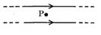 | (p) | The magnetic fields (B) at P due to the currents in the wires are in the same direction.
(B) | Point P is situated at the mid-point of the line joining the centers, of the circular wires, which have same radii. | 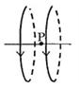 | (q) | The magnetic fields (B) at P due to the currents in the wires are in opposite directions.
(C) | Point P is situated at the mid-point of the line joining the centers of the circular wires, which have same radii. | 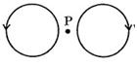 | (r) | There is no magnetic field at P.
(D) | Point P is situated at the common center of the wires. | 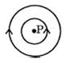 | (s) | The wires repel each other.

22. Column I gives some devices and Column II gives some processes on which the functioning of these devices depend. Match the devices in Column I with the processes in Column II.
Column I |  | Column II
(A) | Bimetallic strip | (p) | Radiation from a hot body.
(B) | Steam engine | (q) | Energy conservation
(C) | Incandescent lamp | (r) | Melting
(D) | Electric fuse | (s) | Thermal expansion of solids

