IIT-JEE-Mathematics–Screening-2005
SCREENING
_______________________________________________________________________
1. The area of the equilateral triangle, in which three coins of radius 1 cm are placed, as shown in the figure, is:
(a) 6 + 4√3
(b) 4√3 – 6
(c) 7 + 4√3
(d) 4√3
2. The area bounded by the curves y = (x – 1)², y = (x + 1)² and y = 1/4 is:
(a) 1/3
(b) 2/3
(c) 1/4
(d) 1/5
3. The value of ∫₋₂⁰[x³+3x²+3x+3+(x+1)cos(x+1)dx] is:
(a) 0
(b) 3
(c) 4
(d) 1
4. The tangent at (1, 7) to the curve x² = y – 6 touches the circle x² + y² + 16x + 12y + c = 0 at :
(a) (6, 7)
(b) (–6, 7)
(c) (6, –7)
(d) (–6, –7)
5. If dy/dx=xy/(x²+y² ), y(1) = 1, then one of the values of x₀ satisfying y(x₀) = e is given by
(a) e√2
(b) e√3
(c) e√5
(c) e/√2
6. The locus of the centre of circle which touches (y -1)² + x² = 1 externally also touches x axis is:
(a) x² = 4y È (0, y), y < 0
(b) x² = y
(c) y = 4x²
(d) y² = 4x È (0, y), y Î R
7. If ∫_{sin x}¹ t² f(t) dt = 1 – sin x ∀ x ∈ [0, Π/2] then f(1/√3) is:
(a) 3
(b) √3
(c) 1/3
(d) none of these
8.
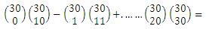
(a) ³⁰C₁₁
(b) ⁶⁰C₁₀
(c) ³⁰C₁₀
(d) ⁶⁵C₅₅
9. A variable plane x/a + y/b + z/c = 1 at a unit distance from origin cuts the coordinate axes at A, B and C. Centroid (x, y, z) satisfies the equation 1/x² + 1/y² + 1/z² = K. The value of K is :
(a) 9
(b) 3
(c) 1/9
(d) 1/3
10. Let f(x) = ax² + bx + c, a ¹ 0 and D = b² - 4ac. If a + b, a² + b² and a³ + b³ are in G.P., then :
(a) Δ ≠ 0
(b) bΔ ≠ 0
(c) cΔ ≠ 0
(d) bc ≠ 0
11. Tangent at a point of the ellipse x²/a² + y²/b² = 1 is drawn which cuts the coordinate axes at A and B. The minimum area of the triangle OAB is (O being the origin) :
(a) ab
(b) (a³ + ab + b³)/3
(c) a² + b²
(d) ((a² + b²))/4
12. A fair die is rolled. The probability that the first time 1 occurs at the even throw is :
(a) 1/6
(b) 5/11
(c) 6/11
(d) 5/36
13. If xdy = y (dx + ydy), y(1) = 1 and y(x) > 0. Then y(–3) = :
(a) 3
(b) 2
(c) 1
(d) 0
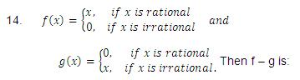
(a) one-one and into
(b) neither one-one nor onto
(c) many one and onto
(d) one-one and onto
15. A rectangle with sides (2n – 1) and (2m – 1) is divided into squares of unit length. The number of rectangle which can be formed with sides of odd length is :
(a) m² n²
(b) mn(m + 1) (n + 1)
(c) 4^{m + n – 1}
(d) none of these
16. The minimum value of |a + bω + cω²|, where a, b and c are all not equal integers and ω(≠ 1) is a cube root of unity, is:
(a) √3
(b) 1/3
(c) 1
(d) 0
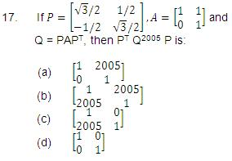
18. The shaded region, where
P ≡ (–1, 0), Q ≡ (–1 + √2,√2)
R ≡ (–1 + √2, – √2), S ≡ (1, 0) is represented by:
(a) |z + 1| > 2, |arg (z + 1)|< π/4
(b) |z + 1| < 2, |arg (z + 1)|< π/2
(c) |z – 1| > 2, |arg (z + 1)|> π/4
(d) |z – 1| < 2, |arg (z + 1)|> π/2
19. The number of ordered pairs (α, β), where α, β ∈ (–Π, Π) satisfying cos (α – β) = 1 and cos (α + β) = 1/e is :
(a) 0
(b) 1
(c) 2
(d) 4
20. Let f(x) = |x|–1, then points where f(x) is not differentiable is/(are) :
(a) 0, + 1
(b) + 1
(c) 0
(d) 1
21. The second degree polynomial f(x), satisfying f(0) = 0, f(1) = 1, f’(x) > 0 for all x ∈ (0, 1) :
(a) f(x) = φ
(b) f(x) = ax + (1 – a) x²; ∀ a ∈ (0, ∞)
(c) f(x) = ax + (1 – a) x²; ∀ a ∈ (0, 2)
(d) no such polynomial
22. If f is a differentiable function satisfying f(1/n) = 0 for all n > 1, n ∈ I, then :
(a) f(x) = 0, x ∈ (0, 1]
(b) f’(0) = 0 = f(0)
(c) f(0) = 0 but f’(0) not necessarily zero
(d) |f(x)| < 1, x ∈ (0, 1]
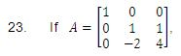
6A⁻¹ = A² + cA + dI, then (c, d) is:
(a) (–6, 11)
(b) (–11, 6)
(c) (11, 6)
(d) (6, 11)
24. In a ΔABC, among the following which one is true?
(a) (b + c) cos A/2 = a sin ((B+C)/2)
(b) (b + c) cos ((B+C)/2) = a sin A/2
(c) (b – c) cos ((B-C)/2) = a cos (A/2)
(d) (b – c) cos A/2 = a cos ((B-C)/2)
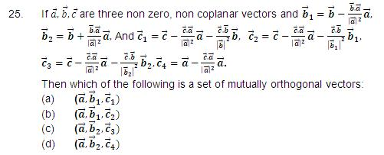
26. If y = f(x) and y cos x + x cos y = Π, then the value of f’(0) is :
(a) Π
(b) – Π
(c) 0
(d) 2Π
27. Let f be twice differentiable function satisfying f(1) = 1, f(2) = 4, f(3) = 9, then :
(a) f’(x) = 2, ∀ x ∈ (R)
(b) f’(x) = 5 = f’’ (x), for some x ∈ (1, 3)
(c) There exists at least one x ∈ (1, 3) such that f’(x) = 2
(d) none of these
28. If X and Y are two non-empty sets where f : X --> Y is function is defined such that
f(c) = {f(x) : x ∈ C} for C ⊆ X
and f⁻¹ (D) = {x : f(x) ∈ D} for D ⊆ y,
for any A ⊆ X and B ⊆ Y then :
(a) f⁻¹ (f(A)) = A
(b) f⁻¹ (f(A)) = A only if f(X) = Y
(c) f(f⁻¹ (B)) = B only if B ⊆ f(x)
(d) f(f⁻¹ (B)) = B

