IIT-JEE-Physics–2005
1. A particle moves in a circular path with decreasing speed. Choose the correct statement :
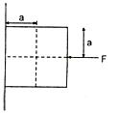
(a) Angular momentum remains constant
(b) Acceleration (a) is towards the centre
(c) Particle moves in a spiral path with decreasing radius
(d) The direction of angular momentum remains constant
2. A block of mass m is at rest under the action of force F against a wall as shown in figure. Which of the following statement is incorrect?
(a) f = mg [where f is the frictional force]
(b) F = N [where N is the normal force]
(c) F will not produce torque
(d) N will not produce torque
3. A simple pendulum has time period T₁. The point of suspension is now moved upward according to the relation y = Kt₂, (K = 1 m/s²) where y is the vertical displacement. The time period now becomes T2. The ratio of (T₁²)/(T₂² ) is (g = 10 m/s²).
(a) 6/5
(b) 5/6
(c) 1
(d) 4/5
4. From a circular disc of radius R and mass 9M, a small disc of radius R/3 is removed from the disc. The moment of inertia of the remaining disc about an axis perpendicular to the plane of the disc and passing through O is:
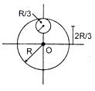
(a) 4MR²
(b) 40/9 MR²
(c) 10 MR²
(d) 37/9 MR²
5. Which of the following sets have different dimensions?
(a) Pressure, Young’s modulus, Stress
(b) Emf, Potential difference, Electric potential
(c) Heat, Work done, Energy
(d) Dipole moment, Electric flux, Electric field
6. The given graph shows the variation of velocity with displacement. Which one of the graph given below correctly represents the variation of acceleration displacement?
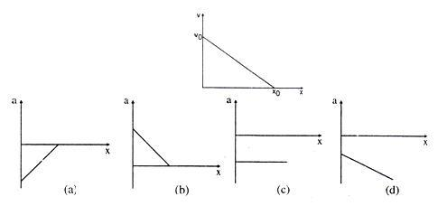
7. Three infinitely long charge sheets are placed as shown in figure. The electric field at point P is :
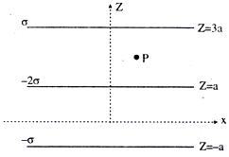
(a) 2σ/ε₀ k
(b) -2σ/ε₀k
(c) 4σ/ε₀ k
(d) -4σ/ε₀ k
8. A photon collides with a stationary hydrogen atom in ground state inelastically. Energy of the colliding photon is 10.2 eV. After a time interval of the order of micro second another photon collides with same hydrogen atom inelastically with an energy of 15 eV. What will be observed by the detector?
(a) 2 photon of energy 10.2 eV
(b) 2 photon of energy of 1.4 eV
(c) One photon of energy 10.2 eV and an electron of energy 1.4 eV
(d) One photon of energy 10.2 eV and another photon of energy 1.4 eV
9. A moving coil galvanometer of resistance 100 Ω is used as an ammeter using a resistance 0.1 Ω. The maximum deflection current in the galvanometer is 100 μA. Find the minimum current in the circuit so that the ammeter shows maximum deflection :
(a) 100.1 mA
(b) 1000.1 mA
(c) 10.01 mA
(d) 1.01 mA
10. The pressure of a medium is changed from 1.01 × 10⁵ Pa to 1.165 × 10⁵ Pa and change in volume is 0% keeping temperature constant. The Bulk modulus of the medium is :
(a) 204.8 × 10⁵ Pa
(b) 102.4 × 10⁵Pa
(c) 51.2 × 10⁵Pa
(d) 1.55 × 10⁵ Pa
11. An open pipe is in resonance in 2nd harmonic with frequency f₁. Now one end of the tube is closed and frequency is increased to f₂ such that the resonance again occurs in nth harmonic. Choose the correct option :
(a) n = 3, f₂ = 3/4 f₁
(b) n = 3, f₂ = 5/4 f₁
(c) n = 5, f₂ = 5/4 f₁
(d) n = 5, f₂ = 3/4 f₁
12. Water of volume 2 litre in a container is heated with a coil of 1kW at 27ºC. The lid of the container is open and energy dissipates at rate of 160 J/s. In how much time temperature will rise from 27ºC to 77ºC [Given specific heat of water is 4.2 kJ/kg] :
(a) 8 min 20 s
(b) 6 min 2 s
(c) 7 min
(d) 14 min
13. Water is filled in a cylindrical container to a height of 3 m. The ratio of the cross sectional area of the orifice and the beaker is 0.1. The square of the speed of the liquid coming out from the orifice is (g = 10 m/s²) :
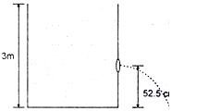
(a) 50 m²/s²
(b) 50.5 m²/s²
(c) 51 m²/s²
(d) 52 m²/s²
14. In Young’s double slit experiment intensity at a point is (1/4) of the maximum intensity. Angular position of this point is :
(a) sin^{–1} (λ/d)
(b) sin^{–1} (λ/2d)
(c) sin^{–1} (λ/3d)
(d) sin^{–1} (λ/4d)
15. In which of the following process, convection does not take place primarily :
(a) sea and land breeze
(b) boiling of water
(c) warming of glass of bulb due to filament
(d) heating air around a furnace
16. A container is filled with water (μ = 1.33) upto a height of 33.25 cm. A concave mirror is placed 15 cm above the water level and the image of an object placed at the bottom is formed 25 cm below the water level. The focal length of the mirror is:
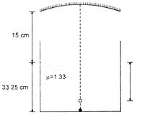
(a) 10 cm
(b) 15 cm
(c) 20 cm
(d) 25 cm
17. Variation of radiant energy emitted by sun, filament of tungsten lamp and welding arc as a function of its wavelength is shown in figure. Which of the following option is the correct match?
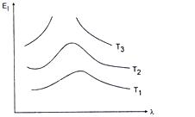
(a) Sun-T₁, tungsten filament-T₂, welding arc-T₃
(b) Sun-T₂, tungsten filament-T₁, welding arc-T₃
(c) Sun-T₃, tungsten filament-T₂, welding arc-T₁
(d) Sun-T₁, tungsten filament-T₃, welding arc-T₂
18. Calorie is defined as the amount of heat required to raise temperature of 1 g of water by 1ºC and it is defined under which of the following conditions?
(a) From 14.5ºC to 15.5ºCat 760 mm of Hg
(b) From 98.5ºC to 99.5ºC at 760 mm of Hg
(c) From 13.5ºC to 14.5ºC at 76 mm of Hg
(d) From 3.5ºC to 4.5ºC at 76 mm of Hg
19. A convex lens is in contact with concave lens. The magnitude of the ratio of their focal length is 2/3. Their equivalent focal length is 30 cm. What are their individual focal lengths?
(a) –75, 50
(b) –10, 15
(c) 75, 50
(d) –15, 10
20. K_{α} wavelength emitted by an atom of atomic number Z = 11 is λ. Find the atomic number for an atom that emits K_{α} radiation with wavelength 4λ.
(a) Z = 6
(b) Z = 4
(c) Z = 11
(d) Z = 44
21. A rigid container with thermally insulated walls contains a coil of resistance 100Ω, carrying current 1A. Change in internal energy after 5 minute will be:
(a) 0 kJ
(b) 10 kJ
(c) 20 kJ
(d) 30 kJ
22. A beam of electron is used in an YDSE experiment. The slit width is d. When the velocity of electron is increased, then :
(a) no interference is observed
(b) fringe width increases
(c) fringe width decreases
(d) fringe width remains same
23. A tuning fork of 512 Hz is used to produce resonance in a resonance tube experiment. The level of water at first resonance is 30.7 cm and at second resonance is 63.2 cm. The error in calculating velocity of sound is:
(a) 204.1 cm/s
(b) 110 cm/s
(c) 58 cm/s
(d) 80 cm/s
24. Find out the value of current through 2 Ω resistance for the given circuit.
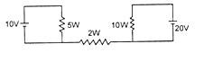
(a) 5 A
(b) 2 A
(c) zero
(d) 4 A
25. A 4μF capacitor, a resistance of 2.5 MΩ is in series with 12 V battery. Find the time after which the potential difference across the capacitor is 3 times the potential difference across the resistor. [Given In (2) = 0.693]
(a) 13.86 s
(b) 6.93 s
(c) 7 s
(d) 14 s
26. An infinitely long cylinder is kept parallel to an uniform magnetic field B directed along positive z axis. The direction of induced current as seen from the z axis will be :
(a) clockwise of the +ve z axis
(b) anticlockwise of the +ve z axis
(c) zero
(d) along the magnetic field
27. If a star can convert all the He nuclei completely into oxygen nuclei. The energy released per oxygen nuclei is: [Mass of the nucleus is 4.0026 amu and mass of oxygen nucleus is 15.9994 amu]
(a) 7.6 MeV
(b) 56.12 MeV
(c) 10.24 MeV
(d) 23.9 MeV
28. A body with area A and temperature T and emissivity e = 0.6 is kept inside a spherical black body. What will be the maximum energy radiated?
(a) 0.60 eAT⁴
(b) 0.80 eAT⁴
(c) 1.00 eAT⁴
(d) 0.40 eAT⁴

