IIT-JEE-Physics-Screening-2004
1. White light is incident on the interface of glass and air as shown in the figure. If green light is just totally internally reflected then the emerging ray in air contains.
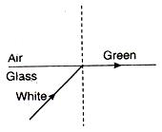
(a) yellow, orange, red
(b) violet, indigo, red
(c) all colours
(d) all colours except green
2. Liquid oxygen at 50 K is heated to 300 K at constant pressure of 1 atm. The rate of heating is constant. Which of the following graphs represents the variation of temperature with time ?
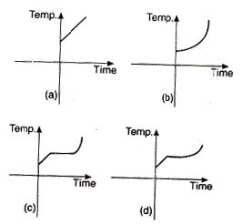
3. A ray of light is incident on an equilateral glass prism place on a horizontal table. For minimum deviation which of the following is true?
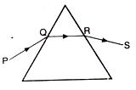
(a) PQ is horizontal
(b) QR is horizontal
(c) RS is horizontal
(d) Either PQ or RS is horizontal
4. An ideal gas expands isothermally from a volume V₁ to V₂ and then compressed to original volume V₁ adiabatically. Initial pressure is P₁ and final pressure is P₃. The total work done is W. Then
(a) P₃ > P₁, W > 0
(b) P₃ < P₁, W < 0
(c) P₃ > P₁, W < 0
(d) P₃ = P₁, W = 0
5. A block P of mass m is placed on a frictionless horizontal surface. Another block Q of same mass is kept on P and connected to the wall with the help of a spring of spring constant k as shown in the figure. µ_{s} is the coefficient of friction between P and Q. The blocks move together performing SHM of amplitude A. The maximum value of the friction force between P and Q is
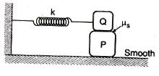
(a) kA
(b) kA/2
(c) zero
(d) µ_{s}mg
6. After 280 days, the activity of a radioactive sample is 6000 dps. The activity reduces to 3000 dps after another 140 days. The initial activity of the sample in dps is
(a) 6000
(b) 9000
(c) 3000
(d) 24000
7. The energy of a photon is equal to the kinetic energy of a proton. The energy of the photon is E. Let λ₁ be the de-Broglie wavelength of the proton and λ₂ be the wavelength of the photon. The ratio λ₁/λ₂ is proportional to
(a) Eº
(b) E^{1/2}
(c) E⁻¹
(d) E⁻²
8. A closed organ pipe of length L and an open organ pipe contain gases of densities ρ₁ and ρ₂ respectively. The compressibility of gases are equal in both the pipes. Both the pipes are vibrating in their first overtone with same frequency. The length of the open organ pipe is
(a) L/3
(b) 3L/3
(c) 4L/3 √(ρ₁/ρ₂)
(d) 4L/3 √(ρ₁/ρ₂)
9. In the relation
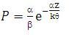
P is pressure, Z is distance, k is Boltzmann constant and q is the temperature. The dimensional formula of b will be
(a) [M⁰L²T⁰]
(b) [M¹L²T¹]
(c) [M¹L⁰T⁻¹]
(d) [M⁰L²T⁻¹]
10. A particle is placed at the origin and a force F = kx is acting on it (where k is a positive constant). If U(0) = 0, the graph of U(x) versus x will be (where U is the potential energy function)
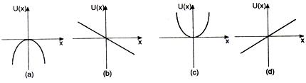
11. Consider the charge configuration and a spherical Guassian surface as shown in the figure. When calculating the flux of the electric field over the spherical surface, the electric field will be due to
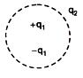
(a) q₂
(b) only the positive charges
(c) all the charges
(d) +q₁ and - q₁
12. The variation of induced emf (e) with time (t) in a coil if a short bar magnet is moved along its axis with a constant velocity is best represented as
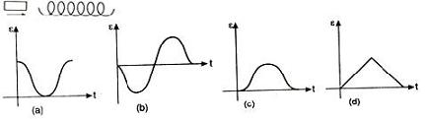
13. Six equal resistances are connected between points P, Q and R as shown in the figure. Then the net resistance will be maximum between
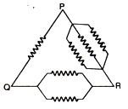
(a) P and Q
(b) Q and R
(c) P and R
(d) any two points
14. Six charges, three positive and three negative of equal magnitude are to be placed at the vertices of a regular hexagon such that the electric field at O is double the electric field when only one positive charge of same magnitude is placed at R. Which of the following arrangements of charges is possible for P, Q, R, S, T and U respectively?
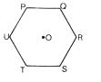
(a) +, -, +, -, -, +
(b) +, -, +, -, +, -
(c) +, +, -, +, -, -
(d) -, +, +, -, +, -
15. A source of sound of frequency 600 Hz is placed inside water. The speed of sound in water is 1500 m/s and in air it is 300 m/s. The frequency of sound recorded by an observer who is standing in air is
(a) 200 Hz
(b) 3000 Hz
(c) 120 Hz
(d) 600 Hz
16. A point object is placed at the centre of a glass sphere of radius 5 cm and refractive index 1.5. The distance of the virtual image from the surface of the sphere is
(a) 2 cm
(b) 4 cm
(c) 6 cm
(d) 12 cm
17. In a YDSE bi-chromatic light of wavelengths 400 nm and 560 nm are used. The distance between the slits is 0.1 mm and the distance between the pane of the slits and the screen is 1 m. The minimum distance between two successive regions of complete darkness is
(a) 4 mm
(b) 5.6 mm
(c) 14 mm
(d) 28 mm
18. A particle starts from rest. Its acceleration (a) versus time (t) is as shown in the figure. The maximum speed of the particle will be
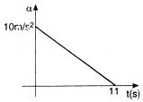
(a) 110 m/s
(b) 55 m/s
(c) 550 m/s
(d) 660 m/s
19. Two identical conducting rods are first connected independently to two vessels, one containing water at 100ºC and the other containing ice at 0ºC. In the second case, the rods are joined end to end and connected to same vessels. Let q₁ and q₂ g/s be the rate of melting of ice in the two cases respectively. The ratio q1/q2 is:
(a) 1/2
(b) 2/1
(c) 1/4
(d) 4/1
20. Three discs, A, B and C having radii 2m, 4m and 6m respectively are coated with carbon black on their outer surfaces. The wavelengths corresponding to maximum intensity are 300 nm, 400 nm and 500 nm respectively. The power radiated by them are Q_{A}, Q_{B} and Q_{C} respectively
(a) Q_{A} is maximum
(b) Q_{B} is maximum
(c) Q_{C} is maximum
(d) Q_{A} = Q_{B} = Q_{C}
21. The figure shows the variation of photocurrent with anode potential for a
photo-sensitive surface for three different radiations, Let I_{a}, I_{b} and I_{c} be the intensities and f_{a}, f_{b} and f_{c} be the frequencies for the curves a, b and c respectively
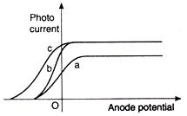
(a) f_{a} = f_{b} and I_{a} ≠ I_{b}
(b) f_{a} = f_{c} and I_{a} = I_{c}
(c) f_{a} = f_{b} and I_{a} = I_{b}
(d) f_{b} = f_{c} and I_{b} and I_{c}
22. A disc is rolling (without slipping) on a horizontal surface C is its centre and Q and P are two points equidistant from C. Let V_{P} and V_{Q} and V_{C} be the magnitude of velocities of points P, Q and C respectively, then
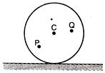
(a) V_{Q} > V_{C} > V_{P}
(b) V_{Q} < V_{C} < V_{P}
(c) V_{Q} = V_{P}, V_{C} = 1/2 V_{P}
(d) V_{Q} < V_{C} > V_{P}
23. An electron moving with a speed u along the positive x-axis at y = 0 enters a region of uniform magnetic field vector B =- B₀K which exists to the right of y-axis. The electron exits from the region after some time with the speed v at ordinate y, then
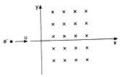
(a) v > u, y < 0
(b) v = u, y > 0
(c) v > u, y > 0
(d) v = u, y < 0
24. A wire has a mass 0.3 + 0.003 g, radius 0.5 +0.005 mm and length 6 + 0.06 cm. The maximum percentage error in the measurement of its density is
(a) 1
(b) 2
(c) 3
(d) 4
25. A small block slides without friction down an inclined plane starting from rest. Let s_{n} be the distance travelled from time t = n - 1 to t = n. Then sn/sn+1 is
(a) 2n-1/2
(b) 2n+1/2n-1
(c) 2n-1/2n+1 ;
(d) 2n/2n+1
26. A child is standing with folded hands at the centre of a platform rotating about its central axis. The kinetic energy of the system is K. The child now stretches his arms of that the moment of inertia of the system doubles. The kinetic energy of the system now is
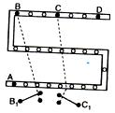
(a) 2K
(b) k/2
(c) k/4
(d) 4K
27. In an RC circuit while charging, the graph of In I versus time is as shown by the dotted line in the adjoining diagram where I is the current. When the value of the resistance is doubled, which of the solid curves best represents the variation of In I versus time?
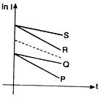
(a) P
(b) Q
(c) R
(d) S
28. For the post office box arrangement to determine the value of unknown resistance, the unknown resistance should be connected between
(a) B and C
(b) C and D
(c) A and D
(d) B₁ and C₁

