IIT-JEE-Chemistry-Screening-2003
SCREENING _______________________________________________________________
1. Among the following the molecule with the highest dipole moment is :
(a) CH₃CI
(b) CH₂CI₂
(c) CHCI₃
(d) CCI₄
2. Which of the following are isoelectronic and isostructural?
NO₃⁻, C O₃²⁻, CI O₃⁻, SO₃
(a) N O₃⁻, C O₃²⁻
(b) SO₃, N O₃⁻
(c) CI O₃⁻, C O₃²⁻
(d) C O₃²⁻, SO₃
3.
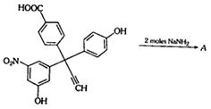
The product A will be
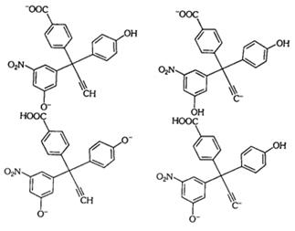
4. [X] + H₂SO₄ → [Y] a colourless gas with irritating smell
[Y] + K₂CrO₇ + H₂SO₄ ® green solution
[X] and [Y] is:
(a) S O₃²⁻, SO₂
(b) CI⁻, HCI
(c) S²⁻, H₂S
(d) C O₃⁻, CO₂
5. For H₃PO₃ and H₃PO₄ the correct choice is:
(a) H₃PO₃ is dibasic and reducing
(b) H₃PO₃ is dibasic and non-reducing
(c) H₃PO₄ is tribasic and reducing
(d) H₃PO₃ is tribasic and non-reducing
6. When MnO₂ is fused with KOH, a coloured compound is formed, the product and its colour is :
(a) K₂MnO₄, purple green
(b) KMnO₄, purple
(c) Mn₂O₃, brown
(d) Mn₃O₄ black
7. Rate of physiorption increases with :
(a) decrease in temperature
(b) increase in temperature
(c) decrease in pressure
(d) decrease in surface area
8. Which of the following represent the given mode of hybridization
sp² - sp² - sp - sp from left to right?
(a) H₂C = CH - C ≡ N
(b) HC ≡ C - C ≡ CH
(c) H₂C = C = C = CH₂
(d)
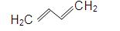
9.
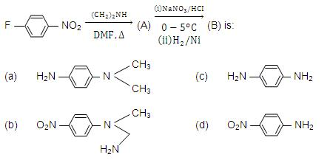
10. The product of acid hydrolysis of P and Q can be distinguished by :
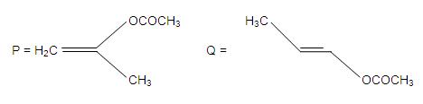
(a) Lucas Reagent
(b) 2, 4-DNP
(c) Fehling's solution
(d) NaHSO₃
11.
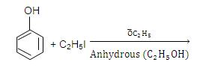
(a) C₆H₅OC₂H₅
(b) C₂H₅OC₂H₅
(c) C₆H₅OC₆H₅
(d) C₆H₅I
12. Which has maximum number of atoms?
(a) 24g of C (12)
(b) 56 g of Fe (56)
(c) 27g of AI (27)
(d) 108 g of Ag (108)
13.
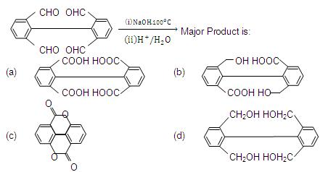
14. In the electrolytic cell, flow of electrons is from :
(a) cathode to anode in solution
(b) cathode to anode through external supply
(c) cathode to anode through internal supply
(d) anode to cathode through internal supply
15. In a first order reaction the concentration of reactant decreases from 800 mol/dm³ to 50 mol/dm³ is 2 × 10⁴ sec. The rate constant of reaction in sec⁻¹ is :
(a) 2 × 10⁴
(b) 3.45 × 10⁻⁵
(c) 1.386 × 10⁻⁵
(d) 2 × 10⁻⁴
16. During depression of freezing point in a solution the following are in equilibrium :
(a) liquid solvent, solid solvent
(b) liquid solvent, solid solute
(c) liquid solute, solid solute
(d) liquid solute solid solvent
17. H₃BO₃ is :
(a) Monobasic and weak Lewis acid
(b) Monobasic and weak Bronsted acid
(c) Monobasic and strong Lewis acid
(d) Tribasic and weak Bronsted acid
18.
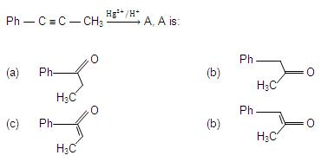
19.
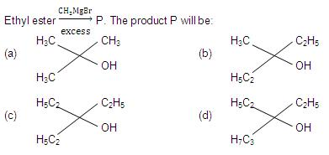
20. Mixture X = 0.02 mol of [Co(NH₃)₅ SO₄]Br and 0.02 mol of [Co(NH₃)₅Br]SO₄ was prepared in 2 litre of solution.
1 litre of mixture X + excess AgNO₃ → Y
1 litre of mixture X + excess BaCI₃ → Z
Number of moles of Y and Z are :
(a) 0.01, 0.01
(b) 0.02, 0.01
(c) 0.01, 0.02
(d) 0.02, 0.02
21. Which of the reaction defines ΔH_{f}⁰:
(a) C_{diamond} + O_{2(g)} → CO_{2(g)}
(b) 1/2 H_{2(g)} + 1/2 F_{2(g)} → HF_{(g)}
(c) N_{2(s)} + 3H_{2(g)} → 2NH_{3(g)}
(d) CO_{(g)} + 1/2 O_{2(g)} → CO_{2(g)}
22. ²³Na is the more stable isotope of Na. Find out the process by which ²⁴Na₁₁ can undergo radioactive decay:
(a) b⁻ emission
(b) a emission
(c) b⁺ emission
(d) K electron capture
23. (Me)₂ SiCI₂ on hydrolysis will produce :
(a) (Me)₂ Si(OH)₂
(b) (Me)₂ Si = O
(c) -[-O-(Me)₂ Si-O-]_{n}-
(d) Me₂SiCl(OH)
24. A solution which is10⁻³ M each in Mn²⁺, Fe²⁺, Zn²⁺ and Hg²⁺ is treated with 10⁻¹⁶ M sulphide ion. If K_{sp} of MnS, FeS, ZnS and HgS are 10⁻¹⁵, 10⁻²³, 10⁻²⁰ and 10⁻⁵⁴ respectively, which one will precipitate first?
(a) FeS
(b) MgS
(c) HgS
(d) ZnS
25. In the process of extraction of gold,
Roasted gold ore + CN⁻ + H₂O → O₂ → [X] + OH⁻
[X] + Zn → [Y] + Au
Identify the complexes [X] and [Y] :
(a) X = [Au(CN)₂]⁻, Y = [Zn(CN)₄]²⁻
(b) X = [Au(CN)₄]³⁻, Y = [Zn(CN)₄]²⁻
(c) X = [Au(CN)₂]⁻, Y = [Zn(CN)₆]⁴⁻
(d) X = [Au(CN)₄]⁻, Y = [Zn(CN)₄]²⁻
26. Positive deviation from ideal behaviour takes place because of :
(a) Molecular interaction between atom and PV/nRT > 1.
(b) Molecular interaction between atom and PV/nRT < 1.
(c) Finite size of atom and PV/nRT > 1
(d) Finite size of atoms and PV/nRT < 1
27.
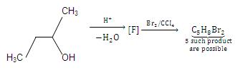
How many structures of F is possible?
(a) 2
(b) 5
(c) 6
(d) 3
28. An enantiomerically pure acid is treated with racemic mixture of an alcohol having one chiral carbon. The ester formed will be:
(a) Optically active mixture
(b) Pure enantiomer
(c) Meso Compound
(d) Racemic mixture

