IIT-JEE-Physics-Screening-2002
1. A simple pendulum is oscillating without damping. When the displacement of the bob is less than maximum, its acceleration vector vector a is correctly shown in
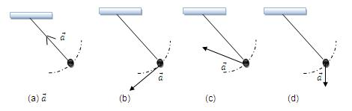
2. A wooden block, with a coin placed on its top, floats in water as shown in figure. The distance l and h are shown there. After some time the coin falls into the water. Then
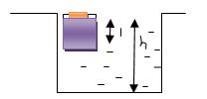
(A) l decreases and h increases
(B) l increases and h decreases
(C) Both l and h increase
(D) Both l and h decrease
3. A cylinder rolls up an inclined plane, reaches some height, and then rolls down (without slipping throughout these motions). The directions of the frictional force acting on the cylinder are
(A) Up the incline while ascending and down the incline while descending.
(B) Up the incline while ascending as well as descending.
(C) Down the incline while ascending and up the incline while descending.
(D) Down the incline while ascending as well as descending.
4. A circular platform is free to rotate in a horizontal plane about a vertical axis passing through its centre. A tortoise is sitting at the edge of the platform. Now the platform is given an angular velocity ω₀. When the tortoise move along a chord of the platform with a constant velocity (with respect to the platform ), the angular velocity of the platform ω_{t}) will vary with time t as
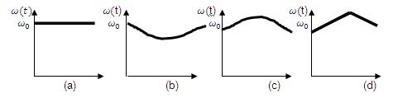
5. Two blocks of masses 10 kg and 4 kg are connected by a spring of negligible mass and placed on a frictionless horizontal surface. An impulse gives a velocity of 14 m/s to the heavier block in the direction of the lighter block. The velocity of the centre of mass is
(A) 30m/s
(B) 20m/s
(C) 10m/s
(D) 5m/s
λ) 2λ 2λ/3 λ/3 λ
6. A particle, which is constrained to move along the x-axis, is subjected to a force in the same direction which varies with the distance x of the particle from the origin as F(x)= - kx + ax³ . Here k and a are positive constants. For x ≥ 0 the functional value of the potential energy U(x) of the particle is
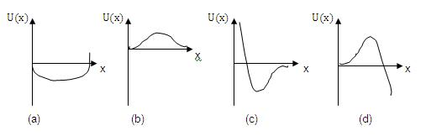
7. A siren placed at railway platform is emitting sound of frequency 5 kHz. A passenger sitting in a moving train A records a frequency of 5.5 kHz while the train approaches the siren. During his return journey n a different train B he records a frequency of 6.0 kHz while approaching the same siren. The ratio of the velocity of train B to that train A is
(A) 242/252
(B) 2
(C) 5/6
(D) 11/6
8. A sonometer wire resonates with a given tuning fork forming standing waves with five antinodes between the two bridges when a mass of 9 kg is suspended from the wire. When this mass is replaced with mass M, the wire resonates with the same tuning fork forming three antinodes for the same positions of the bridges. The value of M is
(A) 25 kg
(B) 5 kg
(C) 12.5 kg
(D) 1/25 kg
9. An ideal spring with spring-constant k is hung from the ceiling and a block of mass M is attached to its lower end. The mass is released with the spring initially unstretched. Then the maximum extension in the spring is
(A) 4Mg/k
(B) 2Mg/k
(C) Mg/k
(D) Mg/2k
10. A geo-stationary satellite orbits around the earth in a circular orbit of radius 36,000 km. then, the time period of a spy satellite orbiting a few hundred km above the earth's surface (R_{earth} =6400km) will approximately be
(A) 1 / 2 hr
(B) 1 hr
(C) 2 hr
(D) 4 hr
λ) 2λ 2λ/3 λ/3 λ
11. The effective resistance between points P and Q of the electrical circuit shown in the figure is
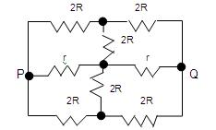
(A) 2Rr/(R+r)
(B) 8R(R+r)/(3R+r)
(C) 2r+4R
(D) 5R/2 + 2r
12. A particle of mass m and charge q moves with a constant velocity v along the positive x-direction. It enters a region containing a uniform magnetic field B directed along the negative z-direction, extending from x=a to x=b. The minimum value of v required so that the particle can just enter the region x>b is
(A) qbB/m
(B) q(b-a)B/m
(C) qaB/m
(D) q(b+a)B/m
13. Two equal point charges are fixed at x=-a and x=+a on the x-axis. Another point charge Q is placed at the origin. The change in the electrical potential energy of Q , when it is displaced by a small distance x along the x-axis, is approximately proportional to
(A) x
(B) x²
(C) x³
(D) 1/x
14. A long straight wire along the z-axis carries a current I in the negative z-direction, the magnetic vector field vector B at a point having coordinate (x, y) on the z=0 plane is
(A) μ₀i(yi - xj)/ 2π (x'² + y'²)
(B) μ₀i(xi + yj)/ 2π (x'² + y'²)
(C) μ₀i(xj - yi)/ 2π (x'² + y'²)
(D) μ₀i(xi - yj)/ 2π (x'² + y'²)
15. As shown in the figure, P and Q are two coaxial conducting loops separated by some distance. When the switch S is closed, a clockwise current I_{p} flows in P (as seen by E) and an induced current I_{Q1} flows in Q. The switched remains closed for a long time. When S is opened, a current I_{Q2} flows in Q. Then the direction I_{Q1} and I_{Q2} (as seen by E) are
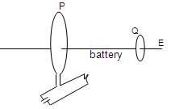
(A) Respectively clockwise and anti-clockwise
(B) Both clockwise
(C) Both anti-clockwise
(D) Respectively anti-clockwise and clockwise
λ) 2λ 2λ/3 λ/3 λ
16. A 100 W bulb B₁, and two 60 W bulbs B₂ and B₃, are connected to a 250 V source, as shown in the figure. Now W₁, and W₂ and W₃ are output powers of the bulbs B₁, B₂ and B₃ respectively. Then
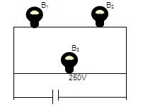
(A) W₁>W₂ =W₃
(B) W₁>W₂ >W₃
(C) W₁<W₂ =W₃
(D) W₁<W₂<W₃
17. Two identical capacitors have the same capacitance C. One of them is charged to potential V₁ and the other to V₂. The negative ends of the capacitors are connected together. When the positive ends are also connected, the decrease in energy of the combined system is
(A) 1/4 [C ( V₁² - V₂² )]
(B) 1/4 [C ( V₁² + V₂² )]
(C) 1/4 [C ( V₁ - V₂ )²]
(D) 1/4 [C ( V₁ + V₂ )²]
18. A short circuited coil is placed in a time-varying magnetic field. Electrical power is dissipated due to the current induced in the coil. If the numbers of turns were to be quadrupled and the radius halved, the electrical power dissipated would be
(A) Halved
(B) The same
(C) Doubled
(D) Quadrupled
19. The magnetic field lines due to a bar magnet are correctly shown in
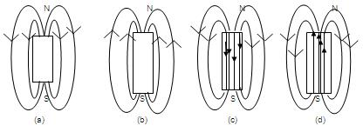
20. An ideal gas is taken through the cycle A → B → C → A as shown in figure. If the net heat supplied to the gas in cycle is 5J, the work done by the gas in the process C → A is
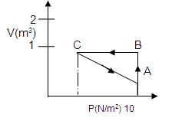
(A) 5 J
(B) -10 J
(C) -15 J
(D) -20 J
λ) 2λ 2λ/3 λ/3 λ
21. Which of the following graphs correctly represents the variation of β = - (dv/dp)/ V with P for an ideal gas at constant temperature?
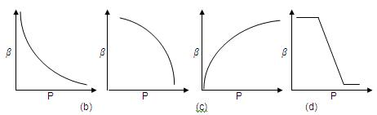
22. The potential difference applied to an X-ray tube is 5kV and the current through it is 3.2 mA. Then the number of electrons striking the target per second is
(A) 2 x 10¹⁶
(B) 5 x 10⁶
(C) 1 x 10¹⁷
(D) 4 x 10¹⁵
23. An ideal black-body at room temperature is thrown into a furnace. It is observed that
(A) Initially it is the darkest body and at later times the brightest.
(B) It is the darkest body at all times.
(C) It cannot be distinguished at all times.
(D) Initially it is the darkest body and at later times it cannot be distinguished.
24. A hydrogen atom and a Li⁺⁺ ion are both in the second excited state. If l_{H} and l_{Li} are their respective electronic angular momenta, and E_{H} and E_{Li} their respective energies then
(A) l_{H} > l_{Li} and | E_{H} | > | E_{Li} |
(B) l_{H} = l_{Li} and | E_{H} | < | E_{Li} |
(C) l_{H} = l_{Li} and | E_{H} | > | E_{Li} |
(D) l_{H} < l_{Li} and | E_{H} | < | E_{Li} |
25. The half-life of ²¹⁵At is 100μs. The time taken for the radioactivity of a sample of ²¹⁵At to decay to 1/16th of its initial value is
(A) 400 μs
(B) 63 μs
(C) 40 μs
D) 300 μs
26. Which of the following processes represents a Υ-decay?
(A) ^{A}X_{Z} + Υ → ^{A}X_{Z-1} + a + b
(B) ^{A}X_{Z} +¹n₀ → ^{A-3}X_{Z-2} + c
(C) ^{A}X_{Z} → ^{A}X_{Z} + f
(D) ^{A}X_{Z} + e₋₁ → ^{A}X_{A-1} + g
27. An observer can see through a pin-hole the top end of a thin rod of height h, placed as shown in the figure. The beaker height is 3h and its radius h. when the beaker is filled with a liquid up to a height 2h, he can see the lower end of the rod. Then the refractive index of the liquid is
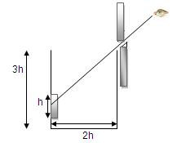
(A) 5/2
(B) √5/2
(C) √3/2
(D) 3/2
λ) 2λ 2λ/3 λ/3 λ
28. Which one of the following spherical lenses does not exhibit dispersion? The radii of curvature of the surfaces of the lenses are as given in the diagrams.
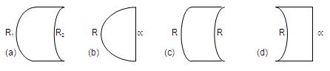
29. In the ideal double-slit experiment, when a glass-plate (refractive index 1.5) of thickness t is introduced in the path of one of the interfering beams (wave-length λ) , the intensity at the position where the central maximum occurred previously remains unchanged. The minimum thickness of the glass-plate is
(A) 2λ
(B) 2λ/3
(C) λ/3
(D) λ
30. Two plane mirrors A and B are aligned parallel to each other, as shown in the figure. A light ray is incident at an angle 30⁰ at a point just inside one end of A. the plane of incidence coincides with the plane undergoes reflections (including the first one) before it emerges out is
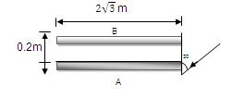
(A) 28
(B) 30
(C) 32
(D) 34

