IIT-JEE-Physics-Screening–2001
SCREENING
______________________________________________________________________
1. Three positive charges of equal value q are placed at the vertices of an equilateral triangle. The resulting lines of force should ne sketched as in :
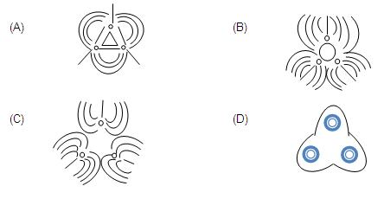
2. When a block of iron floats in mercury at 00C, a fraction k1 of its volume is submerged, while at the temperature 600 C, a fraction k2 is seen to be submerged. If the coefficient of volume expansion of iron γ_{Fe} and that of mercury is γ_{Hg}, then the ratio k1 / k2 can be expressed as :
(A) (1+60 γ_{Fe} )/(1+ 60 γ_{Hg} )
(B) (1-60 γ_{Fe} )/(1+ 60 γ_{Hg} )
(C) (1+60 γ_{Fe} )/(1- 60 γ_{Hg} )
(D) (1+60 γ_{Hg} )/(1+ 60 γ_{Fe} )
3. Three rods made of the same material and having the same cross-section have been joined as shown in the figure. Each rod is of the same length. The left and right ends are kept at 0⁰C and 90⁰C respectively. The temperature of the junction of the three rods will be:
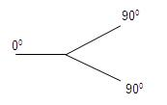
(A) 45⁰C
(B) 60⁰C
(C) 30⁰C
(D) 20⁰C
4. In a given process of an ideal gas, dW = 0 and dQ <0.Then for the gas :
(A) The temperature will decrease
(B) The volume will increase
(C) The pressure will remain constant
(D) The temperature will increase
5. The electron emitted in beta radiation originates from :
(A) Inner orbits of atoms
(B) Free electrons existing in nuclei
(C) Decay of a neutron in a nucleus
(D) Photon escaping from the nucleus
6. The transition from the state n = 4 to n =3 in a hydrogen like atom results in ultraviolet radiation. Infrared radiation will be obtained in the transition :
(A) 2→1
(B) 3→2
(C) 4→2
(D) 5→4
7. In the given circuit with steady current the potential drop across the capacitor must be :
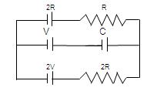
(A) V
(B) V/2
(C) V/3
(D) 2V/3
8. The intensity of X- Rays from a Coolidge tube is plotted against wavelength λ as shown in the figure. The minimum wavelength found is λ_{C} and the wavelength of the kC line is λ_{K}. As the accelerating voltage is increased :
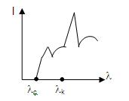
(A) λ_{K} – λ_{C} increases
(B) λ_{K} – λ_{C} decreases
(C) λ_{K} increases
(D) λ_{K} decreases
9. Two beams of light having intensities I and 4 I interfere to produce a fringe pattern on a screen. The phase difference between the beans is π/2at point A and π at point B. Then the difference between the resultant intensities at A and B is :
(A) 2 I
(B) 4 I
(C) 5 I
(D) 7 I
10. A non –planar loop of conducting wire carting a current I is placed as shown in the figure. Each of the straight sections of the loop is of length 2a. The magnetic field due to this loop at the point P (a,0,a) points in the direction :
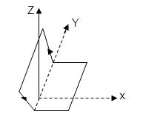
(A) 1/√2 (-ĵ+k)
(B) 1/√3 (-ĵ+k+ î )
(C) 1/√3 (i+ĵ+k)
(D) 1/√2 (î+k )
11. A particle executes simple harmonic motion between X= - A and X= + A. The time taken for it to go from 0 to A/2 is T1 and to go from A/ 2 to A is T2. Then :
(A) T₁ < T₂
(B) T₁ > T₂
(C) T₁= T₂
(D) T₁=2 T₂
12. In a Young’s double slit experiment, 12 fringes are observed to be formed in a certain segment of the screen when light of wavelength 600nm is used. If the wavelength of light is changed to 400nm, number of fringes observed in the same segment of the screen is given by :
(A) 12
(B) 18
(C) 24
(D) 30
13. A quantity X is given by ∈0 L ∆V/∆t where ∈0 is the permittivity of free space. L is a length, ∆V is a potential difference and 8k is a time interval. The dimensional formula for X is same as that of :
(A) Resistance
(B) Charge
(C) Voltage
(D) Current
14. Consider the situation shown in the figure. The capacitor A has a charge q on it whereas B is uncharged. The charge appearing on the capacitor B a long time after the switch is closed is :
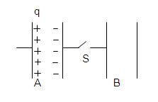
(A) Zero
(B) q/2
(C) q
(D) 2q
15. A uniform electric field pointing in positive X-direction exists in a region. Let A be the origin, B be the point on the x-axis at x=+1 cm and C be the point on the y-axis at y= +1 cm. Then the potentials at the potentials at the points A, B and C satisfy :
(A) V_{A} < V_{B}
(B) V_{A} > V_{B}
(C) V_{A} < V_{c}
(D) V_{A} > V_{c}
16. A coil having N turns is wound tightly in the form of spiral with inner and outer radii and b respectively. When a current passes through the coil, the magnetic field at the centre is:
(A) (μ₀ NI)/b
(B) (2μ₀ NI)/a
(C) (μ₀ NI)/(2(b-a)) ln b/a
(D) (μ₀ I^{N})/(2(b-a)) ln b/a
17. A radioactive sample consists of two distinct species having equal number of atoms initially. The mean life of one species is τ and that of the other is 5τ. The decay products in both cases are stable. A plot is made of the total number of radioactive nuclei as a function of time. Which of the following figures best represents the form of this plot :
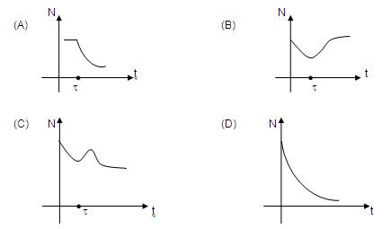
18. In the given circuit, it is observed that the current I is independent of the value of the resistance R₆ .The resistance values must satisfy :
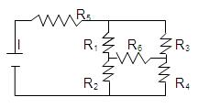
(A) R₁ R₂ R₅= R₃ R₄ R₆
(B) 1/( R₅)+ 1/R₆ = 1/(R₁+ R₂ )+1/(R₃+ R₄)
(C) R₁ R₄ = R₂ R₃
(D) R₁ R₃= R₂ R₄
19. A metallic square loop ABCD is moving in its own plane with velocity V in a uniform magnetic field perpendicular to its plane s shown in the figure, Electric field is induced :
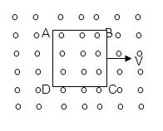
(A) in AD, but not in BC
(B) in BC, but not in AD
(C) neither in AD nor in BC
(D) in both AD and BC
20. A simple pendulum has a time period T₁ when on the earth’s surface, and T₂ when taken to a height R above the earth’s surface where R is the radius of the earth. The value of T₂/T₁ is :
(A) 1
(B) √2
(C) 4
(D) 2
21. Two particles of masses ma and m2 in projectile motion have velocities vectors v₁ < v₂ respectively at time t=0. They collide at time t₀. Their velocities become v'₁ and v'₂ at time 2t₀ while still moving in air. The value of |(m₁ v'₁+ m₂v'₂ ) - (m₁ v₁+ m₂v₂ )| is:
(A) Zero
(B) (m₁ + m₂) gt₀
(C) 2(m₁ + m₂) gt₀
(D) 1/2(m₁ + m₂) gt₀
22. One quarter section is cut from a uniform circular disc of radius R. This section has a mass M. It is made to rotate about a line perpendicular to is its plane and passing through the centre of the original disc. Its moment of inertia about the axis of rotation is :
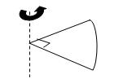
(A) 1/2 MR²
(B) 1/4 MR²
(C) 1/8 MR²
(D) √2MR²
23. A small block is shot into each of the four tracks as shown below. Each of the tracks rises to the same height. The speed with which the block enters the track is the same in all cases. At the highest point of the track the normal reaction is maximum in :
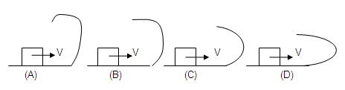
24. A ray of light passes through four transparent media with refractive indices μ1, μ2 , μ3 and μ4 as shown in the figure. The surfaces of all media are parallel. If the emergent ray CD is parallel to the incident ray AB, we must have :
(A) μ1= μ2
(B) μ2= μ3
(C) μ3= μ4
(D) μ4= μ1
25. A given ray of light suffers minimum deviation in an equilateral prism P. Additional prism Q and R of identical shape and of the same material as P are now added as shown in the figure. The ray will suffer :
(A) Greater deviation
(B) No deviation
(C) Same deviation as before
(D) Total internal refection.
26. A wire of length L and 3 identical cells of negligible internal resistances are connected in series. Due to the current, the temperature of the wire is raised by ∆T in a time t. A number N of similar cells is now connected in series with a wire of the same material and cross-section but of length 2L. The temperature of the wire is raised by the same amount ∆T in the same time. The value of N is :
(A) 4
(B) 6
(C) 8
(D) 9
27. An insect crawls up a hemispherical surface very slowly (see the figure). The coefficient of friction between the surface and the insect is 1/3. If the line joining the centre of the hemispherical surface to the insect makes an angle α wit the vertical, the maximum possible value of is α given by:
(A) cot α = 3
(B) tan α =3
(C) sec α=3
(D) cosec α=3
28. A string of negligible mass going over a clamped pulley of mass m supports a block of mass M as shown in the figure. The force on the pulley by the clamp is given by:
(A) √2 Mg
(B) √2 mg
(C) √((M+m)²+m² g)
(D) √((M+m)²+M² g)
29. The pulleys and strings shown in the figure are smooth and of negligible mass. For the system to remain in equilibrium, the angle θ should be:
(A) 0⁰
(B) 30⁰
(C) 45⁰
(D) 60⁰
30. The ends of a stretched wire of length L are fixed at x =0 and x =L. In one experiment the displacement of the wire is y₁= A sin(πx/L) sin ωt and energy is E₁ and in other experiment its displacement is y₂= A sin(2πx/L) sin 2ωt and energy is E₂ . Then :
(A) E₂=E₁
(B) E₂=2E₁
(C) E₂=4E₁
(D) E₂=16E₁
31. P-V plots for two gases during adiabatic processes are shown in the figure. Plots 1 and 2 should correspond respectively to :
(A) He and O₂
(B) O₂and He
(C) He and Ar
(D) O₂ and N₂
32. Two pulses in a stretched string, whose centres are initially 8 cm apart, are moving towards each other as shown in the figure. The speed of each pulse is 2 cm / s. After 2 seconds the total energy of the pulses will be :
(A) Zero
(B) Purely kinetic
(C) Purely potential
(D) Partial kinetic and partly potential
33. A hemispherical portion of radius R. The volume of the remaining cylinder is V and mass M. It is suspended by a string in a liquid of density ρ where it stays vertical. The upper surface of the cylinder is at a depth h below the liquid surface. The force on the bottom of the cylinder by the liquid is:
(A) Mg
(B) Mg -Vρg
(C) Mg +πR²h ρg
(D) ρg(V + πR²h)
34. Two particles A and B of masses m_{A} and m_{B} respectively and having the same charge are moving in a plane. A uniform magnetic field exists perpendicular to this plane. The speeds of the particles are v_{A} and v_{B} respectively and the trajectories are as shown in the figure. Then :
(A) m_{A} v_{A} < m_{B} v_{B}
(B) m_{A} v_{A} > m_{B} v_{B}
(C) m_{A} < m_{B} and v_{A} < v_{B}
(D) m_{A} = m_{B} and v_{A} = v_{B}
35. Two circular coils can be arranged in any of the three situations shown in the figure. Their mutual inductance will be :
(A) Maximum in situation (a)
(B) Maximum in situation (b)
(C) Maximum in situation (c)
(D) The same in all situations

