IIT-JEE-Physics-Screening–2000
SCREENING
_______________________________________________________________________
1. Electrons with energy 80keV are incident on the tungsten target of an X-Ray tube. K-shell electrons of tungsten have -72.5keV energy. X-rays emitted by the tube contain only.
(A) a continuous X-ray spectrum (Bremsstrahlung) with a minimum wavelength of ~0.155 Å.
(B) A continuous X-ray spectrum (Bremsstrahlung) with all wavelengths.
(C) The characteristic X-ray spectrum of tungsten.
(D) A continuous X-ray spectrum (Bremsstrahlung) with a minimum wavelength of ~0.155 Å and the characteristic X-ray spectrum of tungsten.
2. A uniform but time varying magnetic field B (t) exists in a circular region of radius a and is directed into the plane of the paper as shown. The magnitude of the induced electric field at point P at a distance r from the center of the circular region
3. A large open tank has two holes in the wall. One is a square hole of side L at a depth y from the top and the other is a circular hole of radius R at a depth 4y from the top. When the tank is completely filled with water, the quantities of water flowing out per second from both holes are the same. Then, R is equal to
(A) L/√2π
(B) 2πL
(C) L
(D) L/2π
4. An equilateral triangle ABC formed from a uniform wire has two small identical beads initially located at A. The triangle is set rotating about the vertical axis AO. Then the beads are released from rest simultaneously and allowed to slide down; One along AB and the other along AC as shown. Neglecting frictional effects, the quantities that are conserved as beads slides down are
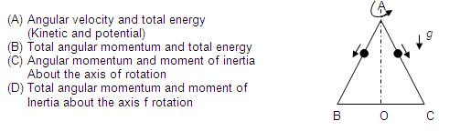
5. A cubical block of side L rests on a rough horizontal surface with coefficient of friction μ. A horizontal force F is applied on the block as shown. If the coefficient of friction is sufficiently high so that the block does not slide before toppling, the minimum force required to topple the block is
(A) Infinitesimal
(B) mg/4
(C) mg/2
(D) mg(1-μ)
6. Imagine an atom made up of proton and a hypothetical particle of double the mass of the electron but having the same charge as the electron. Apply the Bohr atom model and consider all possible transitions of this hypothetical particle to the first excited level. The longest wavelength photon that will be emitted has wavelength λ (given in terms of the Rydberg constant R for the hydrogen atom) equal to
(A) 9/5R
(B) 36/5R
(C) 18/5R
(D) 4/R
7. A monoatomic ideal gas, initially at temperature T₁, is enclosed in a cylinder fitted with a friction piston. The gas is allowed to expand adiabatically to a temperature T₂ by releasing the piston suddenly. If L₁ and L₂ are the lengths of the gas column before and after expansion respectively, then T₁ /T₂ is given by
(A) (L₁ ⁄ L₂ ) ^{2/3}
(B) (L₁ ⁄ L₂ )
(C) L₂ ⁄ L₁
(D) (L₂ ⁄ L₁ )^{2/3}
8. A point source of light B placed at a distance L in front of the centre of a mirror of width d, hangs vertically on a wall. A man walks in front of the mirror along a line parallel to the mirror at a distance 2L from it as shown. The greatest distance over which he can see the image of the light source in the mirror is
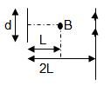
(A) d/2
(B) d
(C) 2d
(D) 3d
9. An infinitely long conductor PQR is bent to form a right angle as shown. A current I flows through PQR. The magnetic field due to this current at the point M is H1. Now, another infinitely long straight conductor QS is connected to Q so that the current is I/2 in QR as well as in QS, the current in PQ remaining unchanged. The magnetic field at M is now H2.The ratio of H1/H2 is given by
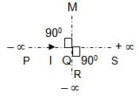
10. The plots of intensity versus wavelength for three black bodies at temperatures T1, T2 and T3 respectively are as shown. Their temperatures are such that
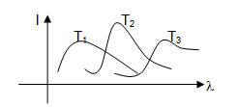
(A) T₁ > T₂ > T₃
(B) T₁ > T₃ > T₂
(C) T₂ > T₃ > T₁
(D) T₃ > T₂ > T₁
11. A train moves towards a stationary observer with speed 34 m/s. The train sounds a whistle and its frequency registered by the observer is F₁. If the train’s speed is reduced to 17 m/s, the frequency registered is F₂. If the speed of sound is 340 m/s then f₁/ f₂ is
(A) 18 / 19
(B) 1 / 2
(C) 2
(D) 19 / 18
12. A particle of charge q and mass m moves in a circular orbit of radius r with angular speed ω. The ratio of the magnitude of its magnetic moment to that of its angular momentum depends on
(A) ω and q
(B) ω, q and m
(C) q and m
(D) ω and m
13. The dimension of (1/2) Є₀ E² ( Є0 : permittivity of free space; E : electric field ) is
(A) MLT ⁻¹
(B) ML²T⁻²
(C) ML⁻¹ T ⁻²
(D) ML²T⁻¹
14. In a compound microscope, the intermediate image is
(A) Virtual, erect and magnified
(B) Real, erect and magnified
(C) Real, inverted and magnified
(D) Virtual, erect and reduced
15. The period of oscillation of a simple pendulum of length L suspended from the roof of the vehicle which moves without friction, down an inclined plane of inclination α, is given by
(A) 2π√(L/gcosα)
(B) 2π√(L/gsinα)
(C) 2π√(L/g)
(D) 2π√(L/gtanα)
16. In a double slit experiment instead of taking slits of equal widths, one slit is made twice as wide as the other, then in the interference pattern
(A) The intensities of both the maxima and minima increases
(B) The intensity of maxima increases and the minima has zero intensity
(C) The intensity of maxima decreases and that of minima increases
(D) The intensity of maxima decreases and the minima has zero intensity
17. Three charges Q, +q and –q are p;aced at the vertices of a right angle triangle (isosceles triangle) as shown. The net electrostatic energy of the configuration is zero if Q is equal to
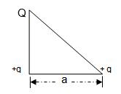
(A) (-q)/(1+√2)
(B) (-2q)/(2+√2)
(C) -2q
(D) +q
18. A long horizontal road has a bead which can slide along its length and is initially placed at a distance L from one end A of the rod. The rod is set in angular motion about A with a constant angular acceleration. If the coefficient of friction between the rod and the bead is μ, and gravity is neglected, then the time after which the bead starts slipping is
(A) √(μ/α)
(B) μ/√α
(C) 1/√μα
(D) Infinitesimal
19. Starting with the same initial conditions, an ideal gas expands from volume V1 to V2 in three different ways, the work done by the gas is W1 if the process is purely isothermal, W2 if purely isobaric and W3 if purely adiabatic, then
(A) W2> W1> W3
(B) W2> W3 >W1
(C) W1 >W2 >W3
(D) W1 >W3 >W2
20. A block of ice at -100C is slowly heated ahs converted to steam at 1000C. Which of the following curves represents the phenomenon qualitatively?
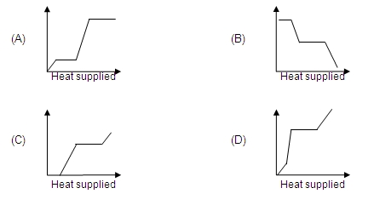
21. An ionized gas contains both positive and negative ions. If it is subjected simultaneously to an electric field along the + x direction and a magnetic field along the + z direction then
(A) Positive ions deflect towards +y direction and negative ions towards –y direction
(B) All ions deflect towards +y direction
(C) All ions deflect towards – y direction
(D) Positive ions deflect towards –y direction and negative ions towards +y direction
22. Two radioactive materials X₁ and X₂ have decay constants 10λ and λ respectively. If initially they have the same number of nuclei, then the ratio of the number. of nuclei of X₂ to that of X₂ will be 1/e after a time
(A) 1/10λ
(B) 1/11λ
(C) 11/10λ
(D) 1/9λ
23. A parallel plate capacitor of area A, plate separation d and capacitance C is filled with three different dielectric materials having dielectric constants k₁, k₂ and k₃ as shown. If a single dielectric material is to be used to have the same capacitance C in this capacitor then its dielectric constant k is given by
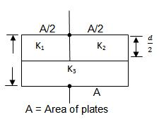
(A) 1/k = 1/k₁ + 1/k₂ + 1/(2k₃)
(B) 1/k = 1/(k₁ + k₂ ) + 1/(2k₃ )
(C) k = (k₁ k₂)/(k₁ + k₂ ) + 2k₃
(D) k = (k₁ k₃)/(k₁ + k₂ ) + (k₂ k₃)/(k₂ + k₂ )
24. A thin wire of length L and uniform linear mass density p is bent into a circular loop with centre at O as shown. The moment of inertia of the loop about the axis XX’ is
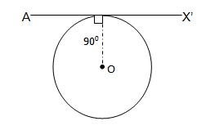
(A) (pL³)/(8π² )
(B) (pL³)/(16π² )
(C) (5pL³)/(16π² )
(D) (3pL³)/(8π² )
25. The electron in a hydrogen atom makes a transition from an excited state to the ground state. Which of the following statements is true
(A) Its kinetic energy increases and its potential and total energy decreases
(B) Its kinetic energy decreases, potential energy increases and its total energy remains the same
(C) Its kinetic and total energy decreases and its potential energy increases
(D) Its kinetic , potential and total energy decreases
26. An ideal gas is initially at temperature T and volume V. Its volume is increased by ΔV due to an increase in temperature ΔT, pressure remaining constant. The quantity δ = ΔV/VΔT varies with temperature as
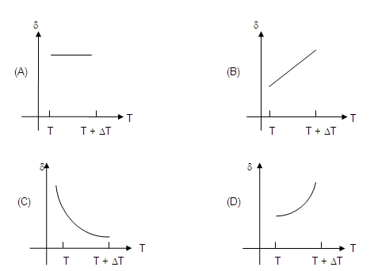
27. A wind-powered generator converts wind energy into electrical energy. Assume that the generator converts a fixed fraction of the wind energy intercepted by its blades into electrical energy. For wind speed V, the electrical power output will be proportional to
(A) v
(B) v²
(C) v³
(D) v⁴
28. A ball is dropped vertically from a height d above the ground. It hits the ground and bounces up vertically to a height d/2. Neglecting subsequent motion and air resistance, its velocity v varies with height h above the ground as
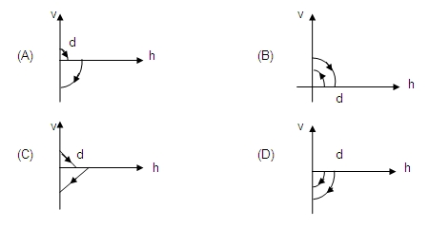
29. A coil of wire having finite inductance and resistance has a conducting ring placed co-axially within it. The coil is connected to a battery at time t= 0, so that a time dependent current I₁ (t) starts flowing through the coil. If I₂ (t) is the current induced in the ring, and B (t) is the magnetic field at the axis of the coil due to I₁ (t) then as a function of time (t > 0), the product I₂ (t) B (t)
(A) increases with time
(B) decreases with time
(C) does not vary with time
(D) passes through a maximum
30. A hollow double concave lens is made of very thin transparent material. It can be filled with air or either of two liquids L₁ or L₂ having refracting indices n1 and n2 respectively (n2 > n1 > 1). The lens will diverge a parallel beam of light if it is filled with
(A) air and placed in air
(B) air and immersed in L₁
(C) L₁ and immersed in L₂
(D) L₂ and immersed in L₁
31. Two long parallel wires are at a distance 2d a part. They carry steady equal currents flowing out of the plane of the paper as shown. The variation of the magnetic field B along the line XX’ is given by
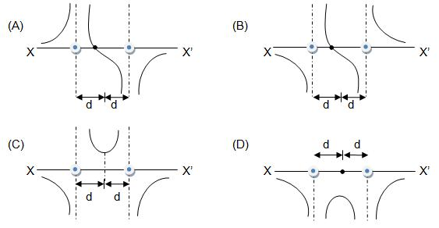
32. A diverging beam of light from a point source S having divergence angle α falls symmetrically on a glass slab as shown. The angles of incidence of the two extreme rays are equal. If the thickness of the glass slab is t and its refractive index is n, then the divergence angle of the emergent beam is
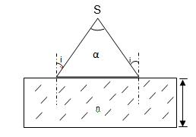
(A) Zero
(B) α
(C) sin^{–1} (1/n)
(D) 2sin^{–1} (1/n)
33. A rectangular glass slab ABCD of refractive index n1 is immersed in water of refractive index n2(n1 > n2). A ray of light is incident at the surface AB of the slab as shown. The maximum value of the angle of incidence αmax, such that the ray comes out only from the other surface CD, is given by
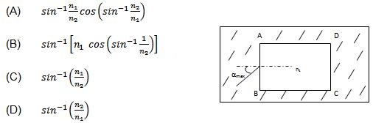
34. Two vibrating strings of the same material but lengths L and 2L have radii 2r and r respectively. They are stretched under the same tension. Both the strings vibrate in their fundamental modes, the one of length L with frequency v1. The ratio v1/v2 is given by
(A) 2
(B) 4
(C) 8
(D) 1
35. Two monoatomic ideal gases 1 and 2 of molecular masses m₁ and m₂ respectively are enclosed in separate containers kept at the same temperature. The ratio of the speed of sound is gas 1 to that in gas 2 is given by
(A) √(m₁ / m₂ )
(B) √(m₂ / m₁ )
(C) m₁ / m₂
(D) m₂ / m₁

