IIT-JEE-Mathematics–1999
Time : 3 hours Max. Marks : 200
______________________________________________________________________
SECTION I
DIRECTIONS: Select the most appropriate alternative A, B, C or D in questions 1-25.
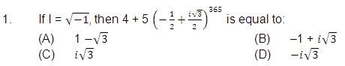
2. If x₁, x₂, x₃ as well as y₁, y₂, y₃ are in G.P. with the same common ratio, then the points (x₁, y₁), (x₂, y₂) and (x₃, y₃):
(A) lie on a straight line
(B) lie on the ellipse
(C) lie on a circle
(D) are vertices of a triangle
3. If the function f : [1, ∞) --> [1, -∞) is defined by f (x) = 2^{x(x–1)}, then f^{–1} (x) is : (A) (1/2)^{x(x-1)}
(B) 1/2 (1+√(1+4 log_2 x))
(C) 1/2(1-√(1+4 log₂ x))
(D) not defined
4. The harmonic mean of the roots of the equation :
(5 + √2 x² – (4 + √5) x + 8 + 2√5 = 0 is
(A) 2
(B) 4
(C) 6
(D) 8
5. The function f (x) = sin⁴ x + cos⁴ x increases if :
(A) 0 < x < π/8
(B) π/4 < x < 3π/8
(C) 3π/8 < x < 5π/8
(D) 5π/8 < x < 3π/4
6. The curve described parametrically by x = t₂ + t + 1, y = t₂– t + 1 represents :
(A) a pair of straight lines
(B) an ellipse
(C) a parabola
(D) a hyperbola
7. In a triangle PQR, ∠R = π/2. If tan (P/2) and tan (Q/2) are the roots of the equation ax² + bx + c = 0 (a ≠ 0), then :
(A) a + b = c
(B) b + c = a
(C) a + c = b
(D) b = c
8. If for a real number y, [y] is the greatest integer less than or equal to y, then the value of the integral ∫_{π/2} ^{3π/2} [2 sinx. dx ] is∶
(A) -π
(B) 0
(C) -π/2
(D) π/2
9. Let a₁, a₂, ……, a₁₀ be in A.P. and h₁, h₂, ……, h₁₀ be in H.P. If a₁ = h₁ = 2 and a₁₀ = h₁₀ = 3, then a₄ h₇ is :
(A) 2
(B) 3
(C) 5
(D) 6
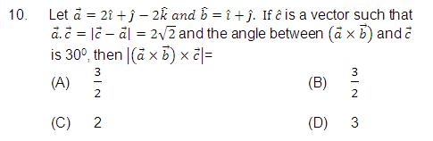
11. The number of real solutions of
tan^{–1} √(x(x+1)) + sin^{–1} √(x²+x+1)=π/2 is:
(A) zero
(B) one
(C) two
(D) infinite
12. Let P (a sec θ, b tan θ) and Q (a sec θ, b tan θ) where θ + θ = π/2, be two points on the hyperbola x²/a² -y²/b² = 1. If (h, k) is the point of intersection of the normals at P and Q, then K is equal to :
(A) (a²+b²)/a
(B) -((a²+b²)/a)
(C) (a²+b²)/b
(D) -((a²+b²)/b)
13. Let PQR be a right angled isosceles triangle, right angled at P (2, 1). If the equation of the line QR is 2x + y = 3, then the equation representing the pair of lines PQ and PR is :
(A) 3x² – 3y² + 8xy + 20x + 10y + 25 = 0
(B) 3x² – 3y² + 8xy – 20x – 10y + 25 = 0
(C) 3x² – 3y² + 8xy + 10x + 15y + 20 = 0
(D) 3x² – 3y² – 8xy – 10x – 15y – 20 = 0
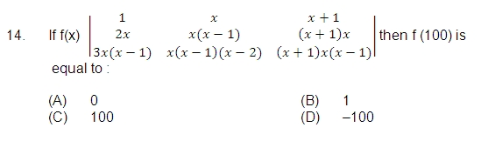
15. The function f(x) = [x]² – [x²] (where [y] is the greatest integer less than or
equal to y), is discontinuous at :
(A) all integers
(B) all integers except 0 and 1
(C) all integers except 0
(D) all integers except 1
16. If two distinct chords, drawn from the point (p, q) on the circle
x²+ y²=px + qy (where pq ≠ 0) are bisected by the x-axis, then :
(A) p² = q²
(B) p² = 8q²
(C) p² <8q²
(D) p² >8q²
17. The function f(x) = (x² – 1)|x² – 3x + 2|is NOT differentiable at:
(A) –1
(B) 0
(C) 1
(D) 2
18. If the roots of the equation x² – 2ax + a² + a – 3 = 0 are real and less than 3, then:
(A) a <2
(B) 2 < a < 3
(C) 3 <a < 4
(D) a >4
19. A solution of the differential equation (dx/dy)²-x (dx/dy) + y = 0 is :
(A) y = 2
(B) y = 2x
(B) y = 2x – 4
(D) y = 2x² – 4
20. lim_{x→0} (x tan2x - 2x tanx )/(1-cos2x )² is :
(A) y = 2
(B) y = 2x
(C) y = 2x – 4
(D) y = 2x² – 4
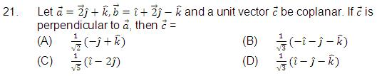
22. If in the expansion of (1 + x)n, the coefficients of x and x2 are 3 and –6 respectively, then m is :
(A) 6
(B) 9
(C) 12
(D) 24
23. ∫_{π/3}^{3π/4} dx/(1+cosx ) is equal to :
(A) 2
(B) –2
(C) 1/2
(D) -1/2
24. If x = 9 is the chord of contact of the hyperbola x² – y² = 0, then the equation of the corresponding pair of tangents is :
(A) 9x² – 8y² + 18x – 9 = 0
(B) 9x² – 8y² – 18x + 9 = 0
(C) 9x² – 8y² – 18x – 9 = 0
(D) 9x² – 8y² + 18x + 9 = 0
25. If the integers m and n are chosen at random between 1 and 100, then the probability that a number of the form 7m + 7n is divisible by 5 equals :
(A) 1/4
(B) 1/7
(C) 1/8
(D) 1/49
DIRECTIONS : Question numbers 26-35 carry 3 marks each and may have more than one correct answers. All correct answers must be marked to get any credit in these questions.
26. Let L1 be a straight line passing through the origin and L2 be the straight line x + y = 1. If the intercepts made by the circle x² + y² – x + 3y = 0 on L1 and L2 are equal, then which of the following equations can represent L1?
(A) x + y = 0
(B) x – y = 0
(B) x + 7y = 0
(D) x – 7y = 0
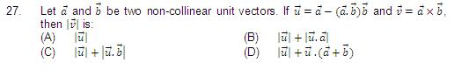
28. For a positive integer n, let a (n) = 1 + 1/2 + 1/3 + 1/4 +.……+ 1/((2^{n} )-1). Then :
(A) a (100) ≤ 100
(B) a (100) > (100)
(C) a (200) ≤ 100
(D) a (200) > 100
29. The function f(x) = ∫₋₁^{x}t (e^{t}-1)(t-1)(t-2)³ (t-3)⁵dt has a local minimum at x =
(A) 0
(B) 1
(C) 2
(D) 3
30. On the ellipse 4x2 + 9y2 = 1, the points at which the tangents are parallel to the line 8x = 9y are :
(A) (2/5,1/5)
(B) (-2/5,1/5)
(C) (-2/5,-1/5)
(D) (2/5,-1/5)
31. The probabilities that a student passes in Mathematics, Physics and Chemistry are m, p and c, respectively. Of these subjects, the student has a 75% chance of passing in atleast one, a 50% chance of passing in atleast two, and a 40% chance of passing in exactly two. Which of the following relations are true?
(A) p + m + c = 19/20
(B) p + m + c = 27/20
(C) pmc = 1/10
(D) pmc = 1/4
32. The differential equation representing the family of curves y² = 2c (x + √c), where c is a positive parameter, is of :
(A) order 1
(B) order 2
(C) degree 3
(D) 10
33. Let S₁, S₂ … be squares such that for each n ≥ 1, the length of a side of S_{n} equals the length of a diagonal of S_{n+1}. If the length of a side of S₁ is 10 cm, then for which of the following values of n is the area of Sn less than 1 sq. cm?
(A) 7
(B) 8
(C) 9
(D) 10
34. For which of the following values of m is the area of the region bounded by the curve y = x – x² and he line y = mx equals 9/2?
(A) –4
(B) –2
(C) 2
(D) 4
35. For a positive integer n., let f_n (θ)= (tan θ/2) (1 + secθ) (1 + sec2θ) (1 + sec 4θ) … (1 + sec 2^{n}θ). Then
(A) f₂ (π/16)=1 ;
(B) f₃ (π/32)=1
(C) f₄ (π/16)=1
(D) f₅ (π/128)=1
SECTION II
______________________________________________________________________
Instructions
There 12 questions in the section. Attempt ALL questions.
At the end of the anwers to a question, draw a horizontal line and start answer to the next question. The corresponding question number must be written in the left margin. Answer all parts of a question at one place only.
The use of Arabic numerals (0, 1, 2,…….9) only is allowed in answering the questions irrespective of the language in which you answer.
______________________________________________________________________
1. For complex numbers z and q, prove that |z|² w – |w|² z = z – w if and only if z = w or z w⁻ = 1.
2. Let a, b, c d be real numbers in G.P. If u, v, w satisfy the system of equations
u + 2v + 3 w = 6
4u + 5v + 6 w = 12
6u + 9v = 4
Then slow that the roots of the equation :
(1/u+1/v+1/w)x² + [(b – c)² + (c – a)² + (d – b)²] x + u + v + w = 0
and 20x² + 10 (a – d)² x – 9 = 0 are reciprocals of each other.
3. Let n be any positive integer. Prove that :
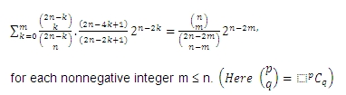
4. Let ABC be a triangle having O and I as its circumcentre and incentre respectively. If R and r are the circumradius and the inradius, respectively, then prove that (IO)² = R² – 2Rr. Further show that the triangle BIO is a right-angled triangle if and only if b is the arithmetic mean of a and c.
5. Let T₁, T₂ be two tangents drawn from (–2, 0) onto the circle C : x² + y² = 1. Determine the circles touching C and having T₁, T₂ as their pair of tangents. Further, find the equations of all possible common tangents to these circles, when taken two at a time.
6. Consider the family of circles x² + y² = r², 2 < r < 5. If in the first quadrant, the common tangent to a circle of this family and the ellipse 4x² + 25y² = 100 meets the co-ordinate axes at A and B, then find the equation of the locus of the mid point of AB.
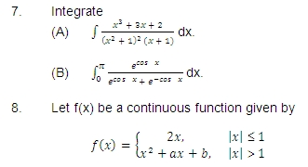
Find the area of the region in the third quadrant bounded by the curves x = –2y² and y = f(x) lying on the left on the line 8x + 1 = 0.
9. Find the co-ordinates of all the P on the ellipse x²/a² +y²/b² = 1, for which the area of the triangle PON is maximum, where O denotes the origin and N, the foot of the perpendicular from O to the tangent at P.
10. A curve passing through the point (1, 1) has the property that the perpendicular distance of the origin from the normal at any point P of the curve is equal to the distance of P from the x-axis. Determine the equation of the curve.
11. Eight players P₁, P₂, …… P₈ play a knock-out tournament. It is known that whenever the players Pi and Pj play, the play Pi will win if i < j. Assuming that the players are paired at random in each round, what is the probability that the player P4 reaches the final?
