IIT-JEE-Mathematics–1998
Time : 3 hrs. Max. Marks : 200
______________________________________________________________________
SECTION I
Instructions
1. You must first transfer the Question Paper Code given here on top of this section to your Answer Sheet in the appropriate box marked QUESTION PAPER CODE.
2. Answer Section-I only on the printed form on the third page of your answer book by writing the appropriate letters (A), (B), (C) or (D) against the question number in the table. Answers for Section-I written in this space alone will be awarded any marks.
3. Section-I consists of 40 obective-type questions.
4. This section should take about one hour to answer.
5. Each question in this section carries 2 marks.
6. Read question 1 to 40 carefully and choose from amongst the alternatives given below each question the correct lettered choice(s). A question may have ONE OR MORE correct alternatives. In order to secure any marks for a given question, ALL correct lettered alternative(s) must be chosen.
1. If ω is an imaginary cube root of unity, then (1 + ω – ω²)7 equals :
(A) 128 ω
(B) –128 ω
(C) 128 ω²
(D) –128 ω².
2. Let Tr be the rth term of an A.P., for r = 1, 2, 3, …… If for some positive integers m, n we have Tm = 1/n and Tn = 1/m, then Tmn equals :
(A) 1/mn
(B) 1/m+1/n
(C) 1
(D) 0
3. In a college of 300 students, every student reads 5 newspapers and every newspaper is read by 60 students. The number of newspaper is:
(A) at least 30
(B) at most 20
(C) exactly 25
(D) none of these
4. The diagonals of a parallelogram PQRS are along the lines x + 3y = 4 and 6x – 2y = 7. Then PQRS must be a :
(A) rectangle
(B) square
(C) cyclic quadrilateral
(D) rhombus
5. The number of common tangents to the circles x² + y² = 4 and x² + y² –6x–y=24 is :
(A) 0
(B) 1
(C) 3
(D) 4
6. Let f (x) = x – [x], for every real number x, where[x] is the integral part of x. Then ∫¹₋₁f (x) dx is :
(A) 1
(B) 2
(C) 0
(D) 1/2
7. If P = (x, y), F₁ = (3, 0), F2 = (–3, 0) and 16x² + 25y² = 400, then PF₁ + PF₂ equals1 :
(A) 8
(B) 6
(C) 10
(D) 12
8. If P (1, 2), Q(4, 6), R(5, 7) and S(a, b) are the vertices of a parallelogram PQRS, then :
(A) a = 2, b = 4
(B) a = 3, b = 4
(C) a = 2, b = 3
(D) a = 3, b = 5
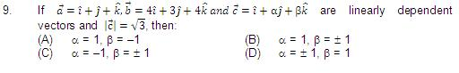
10. If from each of the three boxes containing 3 white and 1 black, 2 white and 2 black, 1 white and 3 black balls, one ball is drawn at random, then the probability that 2 while and 1 black ball will be drawn is:
(A) 13/32
(B) 1/4
(C) 1/32
(D) 3/16
11. The value of the sum∑_{n=1}¹³( i^{n}+i^{n+1} ), where i = √(-1), equals:
(A) i
(B) i – 1
(C) – i
(D) 0
12. The number of values of x where the function f(x) = cos x + cos (√2 x) attains its maximum is :
(A) 0
(B) 1
(C) 2
(D) infinite
13. If f (x) = (x²-1)/(x²+1), for every real number x, then the minimum value of f:
(A) does not exist because f is unbounded.
(B) is not attained even though f is bounded
(C) is equal to 1
(D) is equal to –1
14. Number of divisors of the form 4n + 2 (n ≥ 0) of the integer 240 is :
(A) 4
(B) 8
(C) 10
(D) 3
15. Lim _{x→1} √(1-cos² (x-1)) / (x-1) :
(A) exists and it equals √2 .
(B) exists and it equals -√2 .
(C) does not exist because x – 1 --> 0 .
(D) does not exist because left hand limit is not equal to right hand limit .
16. If in a triangle PQR, sin P, sin Q, sin R are in A. P., then :
(A) the altitudes are in A.P.
(B) the altitudes are in H.P.
(C) the medians are in G.P.
(D) the medians are in A.P.
17. If a_{n}=∑_{r=0}^{n} 1/ ^{n} C_{r} , then ∑_{r=0}^{n} r / ^{n} C_{r} equals :
(A) (n – 1) a_{n}
(B) n a_{n}
(C) 1/2 na_{n}
(D) none of these
18. If the vertices P, Q, R of a triangle PQR are rational points, which of the following points of the triangle PQR is/(are) always rational point(s).
(A) centroid &
(B) incentre
(C) circumcentre
(D) orthocenter
(A rational point is a point both of whose co-ordinates are rational numbers).
19. The number of values of c such that the straight line y = 4x + c touches the curve x²/4 + y² = 1 is :
(A) 0
(B) 1
(C) 2
(D) infinite.
20. If x > 1, y > 1, z > 1 are in G.P., then 1/(1+In x), 1/(1+In y),1/(1+ In z) are in :
(A) A.P.
(B) H.P.
(C) G.P.
(D) none of these
21. The number of values of x in the interval [0, 5π] satisfying the equation 3 sin2 x – 7 x + 2 = 0 is:
(A) 0
(B) 5
(C) 6
(D) 10
22. The order of the differential equation whose general solution is given by
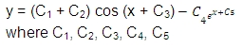
are arbitrary constants, is:
(A) 5
(B) 4
(C) 3
(D) 2
23. If g (f (x)) = |sin x| and f (g (x)) = (sin√x )², then :
(A) f (x) = sin² x, g (x) = √x
(B) f (x) = sin x, g (x) = |x|
(C) f (x) = x², g (x) = sin √x
(D) f and g cannot be determined
24. Let A0 A1 A2 A3 A4 A5 be a regular hexagon inscribed in a circle of unit radius. Then the product of the lengths of the line segments A0 A1 A0 and A0 A4 is :
(A) 3/4
(B) 3√3
(C) 3
(D) (3√3)/2
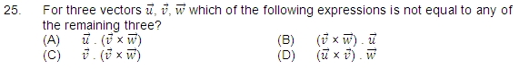
26. There are four machines and it is known that exactly two of them are faulty. They are tested, one by one, in a random order till both the faulty machines are identified. Then the probability that only two tests are needed is:
(A) 1/3
(B) 1/6
(C) 1/2
(D) 1/4
27. Let h (x) = min {x; x²}, for every real number of x. Then :
(A) h is continuous for all x
(B) h is differentiable for all x
(C) h’ (x) = 1, for all x > 1
(D) h is not differentiable at two values of x
28. If f (x) = 3x – 5, then f ⁻¹ (x)
(A) is given by 1/(3x-5) .
(B) is given by (x+5)/3 .
(C) does not exist because f is not one-one .
(D) does not exist because f is not onto. .
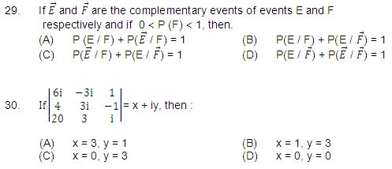
31. A fair coin is tossed repeatedly. If tail appears on first four tosses, then the probability of head appearing on fifth toss equals :
(A) 1/2 (B) 1/32
(C) 31/32 (D) 1/5
32. An n-digit number is a positive number with exactly n digits. Nine hundred distinct n-digit numbers are to be formed using only the three digits 2, 5 and 7. The smallest value of n for which this is possible is:
(A) 6 (B) 7
(C) 8 (D) 9
33. Seven white balls and three black balls are randomly placed in a row. The probability that no two black balls are placed adjacently equals :
(A) 1/2 (B) 7/15
(C) 2/15 (D) 1/3
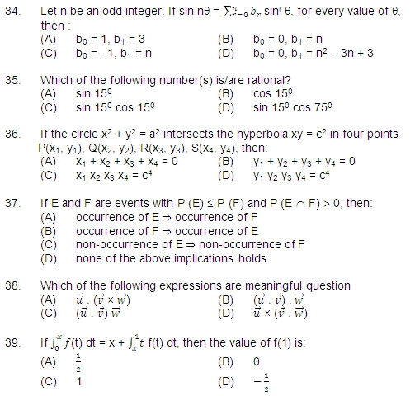
40. Let h (x) = f (x) – (f (x))2 + (f (x))3 for every real number x. Then:
(A) h is increasing whenever f is increasing
(B) h is increasing whenever f is decreasing
(C) h is decreasing whenever f is decreasing
(D) nothing can be said in general
_______________________________________________________________________
SECTION II
Instructions
There are 15 questions in this section. Each questions carries 8 marks.
At the end of the answer to a question, leave 3 cm blank space, draw a horizontal line and start the answer to the next question. The corresponding question number must be written in the left margin. Answer all parts of a question at one place only.
The use of only Arabic numerals (0, 1, 2, ……, 9) is allowed in answering the questions irrespective of the language in which you answer.
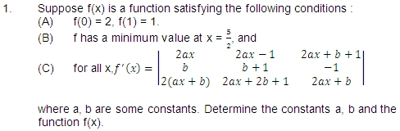
2. Let p be a prime and m a positive integer. By mathematical induction on m, or otherwise, prove that whenever r is an integer such that p does not divide r, p divides ^{mp}C_{r}.
[Hint : You may use the fact that (1 + x) ^{(m + 1)p} = [(1 + x)^{p} (1 + x)^{mp}]
3. A bird flies in a circle on a horizontal plane. An observer stands at a point on the ground. Suppose 60⁰ and 30⁰ are the maximum and the minimum angles of elevationof the bird and that they occur when the bird is at the points P and Q respectively on its path. Let θ be the angle of elevation of the bird when it is at a point on the arc of the circle exactly midway between P and Q. Find the numerical value of tan2 θ. (Assume that the observer is not inside the vertical projection of the path of the bird.)
4. Prove that a triangle ABC is equilateral if and only if tan A + tan B + tan C = 3√3.
5. Using co-ordinate geometry, prove that the three altitudes of any triangle are concurrent.
6. C₁ and C₂are two concentric circles, the radius of C₂being twice that of C₁. From a point P on C2. Tangents PA and PB are drawn to C₁. Prove that the centroid of the triangle PAB lies on C₁.
7. The angle between a pair of tangents drawn from a point P to the parabola y² = 4ax is 45⁰. Show that the locus of the point P is a hyperbola.
9. Prove that ∫₀¹ tan⁻¹ (1 – x+ x²) dx.
10. A curve C has the property that if the tangent drawn at any point P on Cmeet the co-ordinate axes at A and B, then P is the mid-point of AB. The curve passes through the point (1, 1). Determine the equation of the curve.
11. Three players A, B and C, toss a coin cyclically in that order (that is A, B, C, A, B, C, A, B, ………) till a head shows. Let p be the probability that the coin shows a head. Let α, β and y be, respectively, the probability that A, B and C gets the first head. Prov that β = (1 – p) α . Determine α, β and y (in terms of p).
12. Prove , by vector methods or otherwise, that the point of intersection of the diagonals of a trapezium lies on the line passing through the mid-points of the parallel sides. (You may assume that the trapezium is not a parallelogram.)
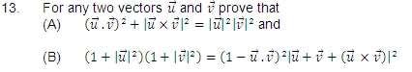
14. Let f(x) = Ax² + Bx + C where A, B, C are real numbers. Prove that if f(x) is an integer whenever x is an integer, then the numbers 2A, A + B and C are all integers. Conversely, prove that if the numbers 2A, A + B and C are all integers then f(x) is an integer whenever x is an integer.
15. Let C₁ and C₂ be the graphs of the function y = x² and y = 2x, 0 ≤ x ≤ 1 respectively. Let C₃ be the graph of a function y = f (x), 0 ≤ x ≤ 1, f(0) = 0. For a point P on C1, let the lines through P, parallel to the axes, meet C₂ and C₃ at Q and R respectively (see figure). If the for every position of P (on C₁), the areas of the shaded regions OPQ and ORP are equal, determine the function f(x).
