IIT-JEE-Mathematics–1997
Time : Three Hours Max. Marks : 100
_____________________________________________________________________
1. There are five sub-questions in this question. For answering each sub-question, four alternatives are given, and only one of them is correct. Indicate your answer for each sub-question by writing one of the letters A, B, C or D ONLY in the answer-book.
(i) If g (x)= ∫₀^{x}cos⁴ t dt, then g (x + π) equals :
(A) g (x)+ g (π) (B) g (x)- g (π)
(C) g (x)g (π) (D) (g (x))/(g (x))
(ii) If f (x)= x / sinx and g (x)= x / tanx , where 0 < x ≤ 1, then in this interval :
(A) Both f (x) and g (x) are increasing functions.
(B) Both f (x) and g (x) are decreasing functions.
(C) f (x) is an increasing function.
(D) g (x) is an increasing function.
(iii) The parameter, on which the value of the determinant does not depend upon is :
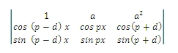
(A) a (B) p
(C) d (D) x
(iv) The graph of the function cos x (x + 2) – cos² (x + 1) is:
(A) a straight line passing through (0, – sin² 1) with slope 2
(B) a straight line passing through (0, 0)
(C) a parabola with vertex (1, – sin², 1)
(D) a straight line passing through the point (π/2,-sin² 1) and parallel to the x-axis.
(v)
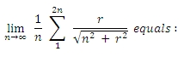
(A) 1 + √5 (B) – 1+ √5
(C) – 1 + √2 (D) 1 + √2
2. A tangent to the ellipse x² + 4y² = 4 meets the ellipse x² + 2y² = 6 at P and Q. Prove that the tangents at P and Q of the ellipse x² + 2y² = 6 are at right angles
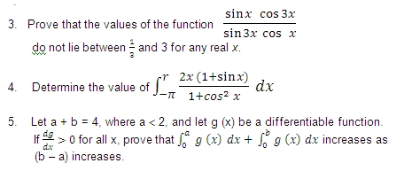
6. The question contained FIVE incomplete statements. Complete these statements so that the resulting statements are correct. Write ONLY the answers in your answer-book in the order in which the statement are given below.
(i) The sum of all the real roots of the equations |x-2|²+|x-2|-2=0 is ….. ……… .
(ii) Let p and q be roots of the equations x² – 2x + A = 0 and let r and s be the roots of the equation x² – 18 + B = 0. If p < q < r < s are in arithmetic progression the A = ………….. and B = …………

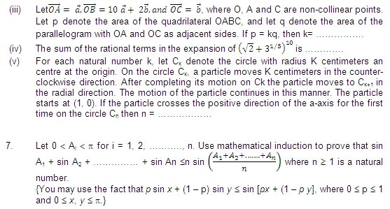
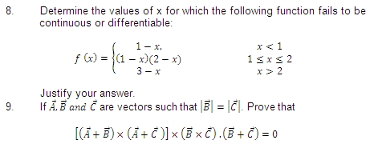
10. Let z¹ and z² be roots of the equation z² + pz + q = 0, where the co-efficients p and q may be complex numbers. Let A and B represent z¹ and z² in the complex plane. If If ∠AOB = α ≠ 0 and OA = OB, where O is the origin, prove that p² = 4q cos² (α/2).
11. The question contains FIVE incomplete statements. Complete these statements so that the resulting statements are correct. Write ONLY the answers in your answer-book in the order in which the statements are given below

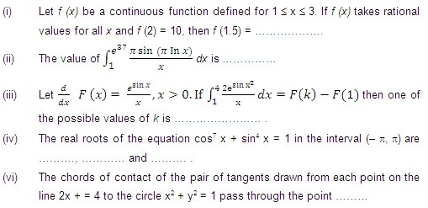
12. If p and q are chosen randomly from the set {1, 2, 3, 4, 5, 6, 7, 8, 9, 10}, with replacement, determine the probability that the roots of the equation x² + px + q = 0 are real.
13. Let u (x) and v (x) satisfy the differential equations du/dx + p (x) u = f (x) and dv/dx + p (x) v = g (x), where p (x) and g (x) are continuous functions. If u (x₁) > v (x₁) for some x₁ and f (x) > g (x) for all x > x₁, prove that any point (x, y) where x > x₁ does not satisfy the equations y = u (x) and y = v (x).
14. Let S be a square of unit area. Consider any quadrilateral which has one vertex on each side of S. If a, b, c and d denote the lengths of the sides of the quadrilateral,
prove that 2 ≤ a² + b² + c² + d² ≤ 4.
15. Let f (x) = Maximum {x², (1 – x)², 2x (1 – x)}, where 0 ≤ x ≤ 1. Determine the area of the region bounded by the curves y = f (x), x-axis, x = 0 and x = 1.
16. Prove that ∑_{k-1}^{n-1} (n-k) cos(n/2), where n ≥ 3 is an integer.
17. Let C be any circle with centre (0,√2). Prove that at the most two rational points can be there on C.
(A rational point is a point both of whose coordinates are rational numbers.)

