Guess Paper – 2010
Class – X
Subject – Science (Physics)

LIGHT
Q.When light falls on a surface of an object ,What will happen to it?1
Q.What type of image is formed in a plane mirror.1
Q.What should be the position of
Q.What kind of mirrors are used in shopping stores to watch activities of customers.?
Q.Where should an object be placed in order to use a convex lens as a magnifying glass.?1
Q. Differentiate between real image and virtual image.2
Q .Define 1 diopter of Power of a lens.1 '
Q.Define principal focus of a concave mirror.1
Q.What is the least distance of vision of a normal human eye.1
Q.What is the value of focal length of a plane mirror.1
Q.What is the nature of light.1
Q .Draw a ray diag. to show the complete path of the light ray that travels through rectangular
Glass slab:2
Q.No matter how far how you stand from a mirror your image appears erect. The mirror is likely to be?Ans.Plane or convex1
Q.One half of a concave lens is covered with black paper.Will this lens produces a complete image of the object. Explain your answer.2
Q.A doctor has prescribed a corrective lens of power + I .5Dfind the focal length of the lens. Is the Prescribed lens diverging or converging .Ans.0.67m Converging lens.2
Q.What is the velocity of light in vacuum.1
CONCEPT TUTOR POINT Cell:9983118799
Q.Which mirror has a larger field of view:? 1
QWhat is the basic cause of refraction?1
Q.The refractive index of water is 1.33 and the speed of light in air is 3 x 10⁸ ms⁻¹.Calculate the speed of light in water.2
Q.What will happen to a ray of light when it falls normally on a surface of a glass slab.1
Q.If a ray passes through the optical centre of a concave lens. What is the deviation associated?1
Q.A ray of light passing through centre of curvature of a concave mirror retraces its path on
reflection why?1
Q.Light enters from air to glass having refractive index 1.50.What is the speed of light in the glass.?The speed of light in vacuums 3 x 10 ⁻⁸ms⁻¹ Ans 2 x 10⁸ m/s.2
Q.Which type of mirror is used by dentists to see large images of the teeth of patients.1
Q.For what position of the object will a convex lens form a virtual and erect image.1
Q.A 5cm tall object is placed perpendicular to the principal axis of a convex lens of focal length 20cm .The distance of the object from the lens is 30 cm Find i)position ii) nature iii) size of the image.Ans. v = 60cmI =-10, real inverted.3
Q.An object 5 cm high is placed 20 cm in front of a concave mirror of focal length 15cm.At 'What distance from the mirror, should a screen be placed to obtain a sharp image? Calculate the size of the image formed.Ans v = -60,I = -15 m..3
QA concave lens of focal length 15 cm forms an image 10 cm from the lens. How far is the object placed from the lens ?Draw the ray diag.Ans30 cm.3
Q.The refractive index of water is 4/3and for glass is 3/2"with respect to air.What is the refractive index of glass with respect to water ? Ans .1.125, 2
Q.A convex lens of focal length 40 cm is placed in contact with a concave lens of focal length 25 cm.What is the power of the combination.
Q.How will you distinguish. between a plane mirror, a concave mirror and a convex mirror' (Without touching them)2
QDefine refraction of light.State the laws of refraction.Does a glass slab disperse the light?Relate, the emergent and incident angle of light.3
Q. Show that the refractive index of a medium 1 with respect to medium 2 is reciprocal to the refractive index of medium 2 with respect to 1 i.e. n12 = 1 / n21 2

The human eye and the colourfull world CONCEPT TUTOR POINT 9983118799
Q.What is angle of prism.1
Q.Why are the danger signal lights are red in colour.?2
Q.Define power of accommodation.1
Q .Why are the danger signal lights red in colour?1
QExplain why stars seems like twinkling. The sun is visible before the actual sunrise and after the actual sunset:3
Q. How do we see colours.2
Q.Why does the sky appear dark instead of blue to an astronaut?1
Q.Why do the planets not appear twinkling like the stars.2
Q.Why there is an advance sunrise and delayed sunset?3
Q.Why is the colour of sky appears reddish at the time of sunset or sunrise?2
QA coin kept in a bowl is not visible when seen from one side. But, when water is poured in the bowl, the coin becomes visible.2
QFind the nature position and relative size of the image formed by convex lens,Concave mirror for various position of the object with ray diag.2
Q. what is short sightedness or myopia ?What causes short sightedness?How is short sightedness corrected?5
Q.Draw a labeled diag of human eye .Define power of accommodation and colour blindness.5
Q.Why' does the colour of the sky appears blue.2
Q.Define Tyndall effect,Far Point ,Near point,Catract.3
Q. What is Presbyopia?3
Q.What is ment by dispersion of light.? Describe the formation of rainbow in the sky with the help of a diagram.
Q.A myopic person has been using spectacles of power - 1 D for clear vision.During old age he also need to use separate reading glasses of power +2 D.Explain what may have happened to his eye sight.3
Ans.v= -50cm.His near point is 50 cm away from his eyes.
Q.Far point of a myopic person is 40 cm.What type of lens should he wear so as to see the distant objects clearly?Calculate the focal length and the power of the lens he should use.3
Ans.-2.5D
Magnetic effect of.electric curent
Q.Write advantage of AC over DC. 2
Qa)What are magnetic field lines'? How is the direction of a magnetic field at a point is determined? .3
Q.What is the function of an earth wire? Why is it necessary to earth metallic appliances.?2
QExplain the principle of an A.C generator along with its labeled diagram.5
Q.Explain why house appliances are connected in parallel combination.2
Q.State Fleming left hand and Right hand rule.2
Q.Define Electro magnetic induction. 2
Q. You are given following current-time graphs from two different sources:3

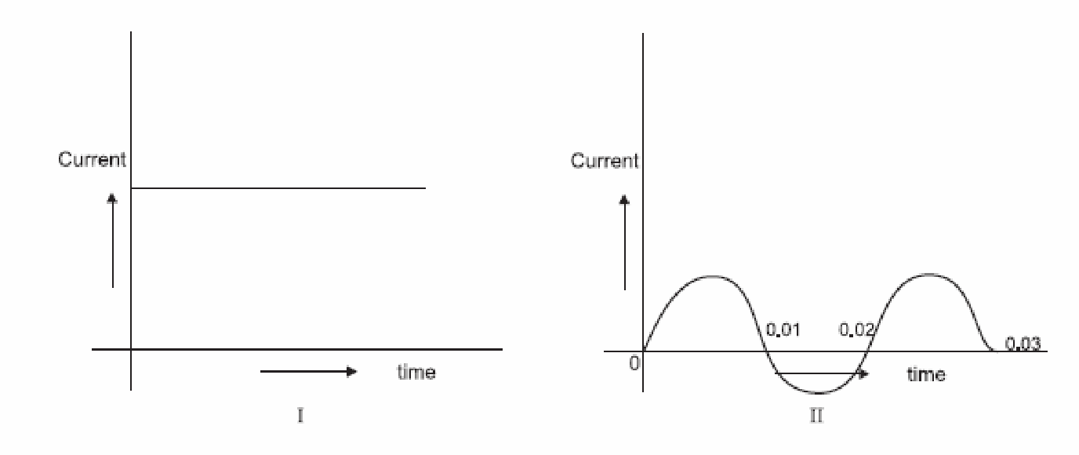

(i) Name the type of current in two cases.
(ii) Identify any one source for each type of these currents. (iii) What is the frequency of current in case II in India?

QDraw the pattern of lines of forces due to magnetic field associated with a current carrying straight conductor .State how the magnetic field produces changes 1 )With an increase in current In the conductorand,ii)In the distance from the conductor.3

